ABSN-2186 Teleservices contacts not importing
Environment | Prerequisites
Version: 9.08.00.RELEASE.p18  Environment=PRODUCTION  DBServerName=abs-srv16.internal.abslbs.com  DBSID= CUST19, CUST21  DBUser= AUS_ND90502, AUS_TELESERVDB  DBPassword= AUS_ND90502, AUS_TELESERVDB | - Modules: TELESERVICES,  ROUTEASSISTANTCONTACTSYNC  ROUTEASSISTANTFIREBASE  - System settings: ORACLETSEMAILADDRESS, CUSTOMERSERVICEEMAIL,  MAILUSERPASSWORD,  SMTPSERVERNAME, MAILPORT, MAILUSERNAME  - Others: BU 473

Contents
Reproducing before fix 1
Retesting after fix 7

Reproducing before fix

Pre-conditions:
System settings:
ORACLETSEMAILADDRESS : irina.fratila@abslbs.com
CUSTOMERSERVICEEMAIL: abs-ts@abslbs.com
MAILUSERPASSWORD: LaunDry$SW
SMTPSERVERNAME: 172.16.1.18
MAILPORT: 587
MAILUSERNAME: abssolute

Step 1) Create new contacts in the Oracle Teleservices (CUST19@AUS_TELESERVDB) database with customer_id= null or customer_id= string

Ran the bellow query and make new contacts:
select * from xxcs_rsr_app_tab_all x for update;

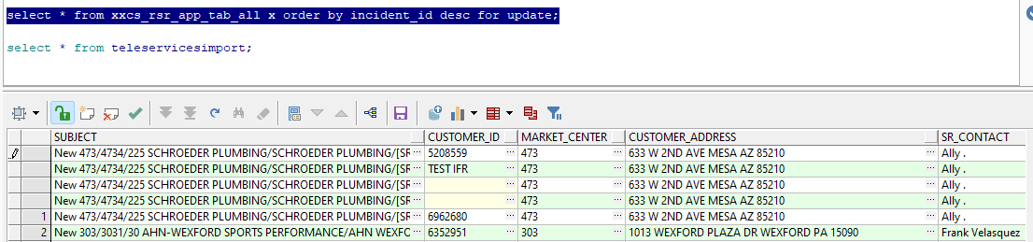

Step 2) Update the new contact created and change the system date of it to make sure that our contact it will be imported in Abssolute client.
Ran the bellow query :
update xxcs_rsr_app_tab_all x
set SR_CREATION_DATE = sysdate,
SR_LAST_UPDATE_DATE = sysdate,
TASK_LAST_UPDATE_DATE = sysdate,
TASK_CREATION_DATE = sysdate,
TASK_NOTE_CREATION_DATE = sysdate,
TASK_SCH_END_DATE = sysdate + 2
where x.note_id in (122993193, 122993194,122993195, 122993196);

Step3) Start the process scheduler Oracle Teleservices Import.
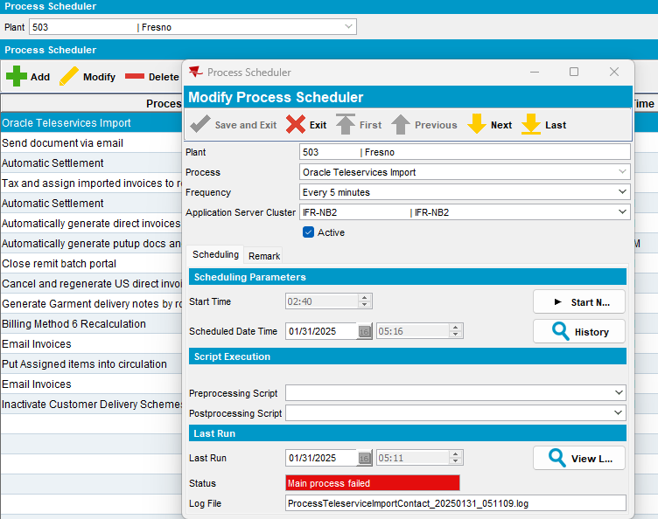
Server error log:
2025-01-31 07:11:17.805 Fail to execute process Oracle Teleservices Import
PlantProcess: ID=2265,plant=41,process=172
2025-01-31 07:11:17.805 2025-01-31T07:11:17.805222200 end schedule process PlantProcess: ID=2265,plant=41,process=172. Next scheduled date is 2025-01-31 07:16:09.0
2025-01-31 07:11:17.805
2025-01-31 07:11:17.844 *----> ABSSolute exception occurred <----*
When: Fri Jan 31 07:11:17 EST 2025
User: system
Error message: Fail to execute process Oracle Teleservices Import
PlantProcess: ID=2265,plant=41,process=172An unexpected exception occurred.
Additional error message: Cannot parse null string
Stack trace: java.lang.NumberFormatException: Cannot parse null string
at java.base/java.lang.Long.parseLong(Long.java:674)
at java.base/java.lang.Long.valueOf(Long.java:1163)
at absgroup.bl.applicationaccess.ContactTeleServicesProcessing.createNewContact(ContactTeleServicesProcessing.java:325)
at absgroup.bl.applicationaccess.ContactTeleServicesProcessing.processContact(ContactTeleServicesProcessing.java:133)
at java.base/jdk.internal.reflect.NativeMethodAccessorImpl.invoke0(Native Method)
at java.base/jdk.internal.reflect.NativeMethodAccessorImpl.invoke(NativeMethodAccessorImpl.java:77)
at java.base/jdk.internal.reflect.DelegatingMethodAccessorImpl.invoke(DelegatingMethodAccessorImpl.java:43)
at java.base/java.lang.reflect.Method.invoke(Method.java:568)
at org.springframework.aop.support.AopUtils.invokeJoinpointUsingReflection(AopUtils.java:343)
at org.springframework.aop.framework.ReflectiveMethodInvocation.invokeJoinpoint(ReflectiveMethodInvocation.java:196)
at org.springframework.aop.framework.ReflectiveMethodInvocation.proceed(ReflectiveMethodInvocation.java:163)
at org.springframework.aop.framework.CglibAopProxy$CglibMethodInvocation.proceed(CglibAopProxy.java:751)
at org.springframework.aop.aspectj.MethodInvocationProceedingJoinPoint.proceed(MethodInvocationProceedingJoinPoint.java:89)
at absgroup.dal.AbsTransactionAspect.invokeInNestedTransaction(AbsTransactionAspect.java:143)
at absgroup.dal.AbsTransactionAspect.adviceAroundAnyTransactional(AbsTransactionAspect.java:112)
at absgroup.dal.AbsTransactionAspect.adviceAroundTransactional(AbsTransactionAspect.java:58)
at jdk.internal.reflect.GeneratedMethodAccessor35.invoke(Unknown Source)
at java.base/jdk.internal.reflect.DelegatingMethodAccessorImpl.invoke(DelegatingMethodAccessorImpl.java:43)
at java.base/java.lang.reflect.Method.invoke(Method.java:568)
at org.springframework.aop.aspectj.AbstractAspectJAdvice.invokeAdviceMethodWithGivenArgs(AbstractAspectJAdvice.java:637)
at org.springframework.aop.aspectj.AbstractAspectJAdvice.invokeAdviceMethod(AbstractAspectJAdvice.java:627)
at org.springframework.aop.aspectj.AspectJAroundAdvice.invoke(AspectJAroundAdvice.java:71)
at org.springframework.aop.framework.ReflectiveMethodInvocation.proceed(ReflectiveMethodInvocation.java:173)
at org.springframework.aop.framework.CglibAopProxy$CglibMethodInvocation.proceed(CglibAopProxy.java:751)
at org.springframework.aop.framework.ReflectiveMethodInvocation.proceed(ReflectiveMethodInvocation.java:178)
at org.springframework.aop.framework.CglibAopProxy$CglibMethodInvocation.proceed(CglibAopProxy.java:751)
at org.springframework.aop.interceptor.ExposeInvocationInterceptor.invoke(ExposeInvocationInterceptor.java:97)
at org.springframework.aop.framework.ReflectiveMethodInvocation.proceed(ReflectiveMethodInvocation.java:184)
at org.springframework.aop.framework.CglibAopProxy$CglibMethodInvocation.proceed(CglibAopProxy.java:751)
at org.springframework.aop.framework.CglibAopProxy$DynamicAdvisedInterceptor.intercept(CglibAopProxy.java:703)
at absgroup.bl.applicationaccess.ContactTeleServicesProcessing$$SpringCGLIB$$0.processContact(<generated>)
at absgroup.bl.applicationaccess.ContactTeleServicesProcessing.processTeleservicesImportDataIntoContact(ContactTeleServicesProcessing.java:114)
at absgroup.bl.applicationaccess.ContactTeleServicesProcessing.processTeleserviceDataIntoContact(ContactTeleServicesProcessing.java:73)
at java.base/jdk.internal.reflect.NativeMethodAccessorImpl.invoke0(Native Method)
at java.base/jdk.internal.reflect.NativeMethodAccessorImpl.invoke(NativeMethodAccessorImpl.java:77)
at java.base/jdk.internal.reflect.DelegatingMethodAccessorImpl.invoke(DelegatingMethodAccessorImpl.java:43)
at java.base/java.lang.reflect.Method.invoke(Method.java:568)
at org.springframework.aop.support.AopUtils.invokeJoinpointUsingReflection(AopUtils.java:343)
at org.springframework.aop.framework.ReflectiveMethodInvocation.invokeJoinpoint(ReflectiveMethodInvocation.java:196)
at org.springframework.aop.framework.ReflectiveMethodInvocation.proceed(ReflectiveMethodInvocation.java:163)
at org.springframework.aop.framework.CglibAopProxy$CglibMethodInvocation.proceed(CglibAopProxy.java:751)
at org.springframework.aop.framework.ReflectiveMethodInvocation.proceed(ReflectiveMethodInvocation.java:178)
at org.springframework.aop.framework.CglibAopProxy$CglibMethodInvocation.proceed(CglibAopProxy.java:751)
at org.springframework.aop.interceptor.ExposeInvocationInterceptor.invoke(ExposeInvocationInterceptor.java:97)
at org.springframework.aop.framework.ReflectiveMethodInvocation.proceed(ReflectiveMethodInvocation.java:184)
at org.springframework.aop.framework.CglibAopProxy$CglibMethodInvocation.proceed(CglibAopProxy.java:751)
at org.springframework.aop.framework.CglibAopProxy$DynamicAdvisedInterceptor.intercept(CglibAopProxy.java:703)
at absgroup.bl.applicationaccess.ContactTeleServicesProcessing$$SpringCGLIB$$0.processTeleserviceDataIntoContact(<generated>)
at absgroup.bl.applicationaccess.ProcessTeleserviceImportContact.execute(ProcessTeleserviceImportContact.java:35)
at java.base/jdk.internal.reflect.NativeMethodAccessorImpl.invoke0(Native Method)
at java.base/jdk.internal.reflect.NativeMethodAccessorImpl.invoke(NativeMethodAccessorImpl.java:77)
at java.base/jdk.internal.reflect.DelegatingMethodAccessorImpl.invoke(DelegatingMethodAccessorImpl.java:43)
at java.base/java.lang.reflect.Method.invoke(Method.java:568)
at org.springframework.aop.support.AopUtils.invokeJoinpointUsingReflection(AopUtils.java:343)
at org.springframework.aop.framework.ReflectiveMethodInvocation.invokeJoinpoint(ReflectiveMethodInvocation.java:196)
at org.springframework.aop.framework.ReflectiveMethodInvocation.proceed(ReflectiveMethodInvocation.java:163)
at org.springframework.aop.framework.CglibAopProxy$CglibMethodInvocation.proceed(CglibAopProxy.java:751)
at org.springframework.aop.framework.ReflectiveMethodInvocation.proceed(ReflectiveMethodInvocation.java:178)
at org.springframework.aop.framework.CglibAopProxy$CglibMethodInvocation.proceed(CglibAopProxy.java:751)
at org.springframework.aop.framework.CglibAopProxy$DynamicAdvisedInterceptor.intercept(CglibAopProxy.java:703)
at absgroup.bl.applicationaccess.ProcessTeleserviceImportContact$$SpringCGLIB$$0.execute(<generated>)
at absgroup.bl.scan.ScheduledProcessRunnerWithLog.runProcess(ScheduledProcessRunnerWithLog.java:53)
at absgroup.bl.scan.ScheduledProcessRunnerWithLog.runProcess(ScheduledProcessRunnerWithLog.java:24)
at jdk.internal.reflect.GeneratedMethodAccessor212.invoke(Unknown Source)
at java.base/jdk.internal.reflect.DelegatingMethodAccessorImpl.invoke(DelegatingMethodAccessorImpl.java:43)
at java.base/java.lang.reflect.Method.invoke(Method.java:568)
at org.springframework.aop.support.AopUtils.invokeJoinpointUsingReflection(AopUtils.java:343)
at org.springframework.aop.framework.ReflectiveMethodInvocation.invokeJoinpoint(ReflectiveMethodInvocation.java:196)
at org.springframework.aop.framework.ReflectiveMethodInvocation.proceed(ReflectiveMethodInvocation.java:163)
at org.springframework.aop.framework.CglibAopProxy$CglibMethodInvocation.proceed(CglibAopProxy.java:751)
at org.springframework.aop.framework.ReflectiveMethodInvocation.proceed(ReflectiveMethodInvocation.java:178)
at org.springframework.aop.framework.CglibAopProxy$CglibMethodInvocation.proceed(CglibAopProxy.java:751)
at org.springframework.aop.framework.CglibAopProxy$DynamicAdvisedInterceptor.intercept(CglibAopProxy.java:703)
at absgroup.bl.scan.ScheduledProcessRunnerWithLog$$SpringCGLIB$$0.runProcess(<generated>)
at absgroup.bl.applicationaccess.ApplicationAccessService.runProcessWithinTrans(ApplicationAccessService.java:1621)
at jdk.internal.reflect.GeneratedMethodAccessor173.invoke(Unknown Source)
at java.base/jdk.internal.reflect.DelegatingMethodAccessorImpl.invoke(DelegatingMethodAccessorImpl.java:43)
at java.base/java.lang.reflect.Method.invoke(Method.java:568)
at org.springframework.aop.support.AopUtils.invokeJoinpointUsingReflection(AopUtils.java:343)
at org.springframework.aop.framework.ReflectiveMethodInvocation.invokeJoinpoint(ReflectiveMethodInvocation.java:196)
at org.springframework.aop.framework.ReflectiveMethodInvocation.proceed(ReflectiveMethodInvocation.java:163)
at org.springframework.aop.framework.CglibAopProxy$CglibMethodInvocation.proceed(CglibAopProxy.java:751)
at org.springframework.aop.framework.ReflectiveMethodInvocation.proceed(ReflectiveMethodInvocation.java:178)
at org.springframework.aop.framework.CglibAopProxy$CglibMethodInvocation.proceed(CglibAopProxy.java:751)
at org.springframework.aop.framework.CglibAopProxy$DynamicAdvisedInterceptor.intercept(CglibAopProxy.java:703)
at absgroup.bl.applicationaccess.ApplicationAccessService$$SpringCGLIB$$0.runProcessWithinTrans(<generated>)
at absgroup.bl.session.TransactionHolderForProcess.runProcessWithinTrans(TransactionHolderForProcess.java:24)
at jdk.internal.reflect.GeneratedMethodAccessor172.invoke(Unknown Source)
at java.base/jdk.internal.reflect.DelegatingMethodAccessorImpl.invoke(DelegatingMethodAccessorImpl.java:43)
at java.base/java.lang.reflect.Method.invoke(Method.java:568)
at org.springframework.aop.support.AopUtils.invokeJoinpointUsingReflection(AopUtils.java:343)
at org.springframework.aop.framework.ReflectiveMethodInvocation.invokeJoinpoint(ReflectiveMethodInvocation.java:196)
at org.springframework.aop.framework.ReflectiveMethodInvocation.proceed(ReflectiveMethodInvocation.java:163)
at org.springframework.aop.framework.CglibAopProxy$CglibMethodInvocation.proceed(CglibAopProxy.java:751)
at org.springframework.aop.aspectj.MethodInvocationProceedingJoinPoint.proceed(MethodInvocationProceedingJoinPoint.java:89)
at absgroup.dal.AbsTransactionAspect.invokeInNestedTransaction(AbsTransactionAspect.java:143)
at absgroup.dal.AbsTransactionAspect.adviceAroundAnyTransactional(AbsTransactionAspect.java:112)
at absgroup.dal.AbsTransactionAspect.adviceAroundServerTransactional(AbsTransactionAspect.java:69)
at jdk.internal.reflect.GeneratedMethodAccessor75.invoke(Unknown Source)
at java.base/jdk.internal.reflect.DelegatingMethodAccessorImpl.invoke(DelegatingMethodAccessorImpl.java:43)
at java.base/java.lang.reflect.Method.invoke(Method.java:568)
at org.springframework.aop.aspectj.AbstractAspectJAdvice.invokeAdviceMethodWithGivenArgs(AbstractAspectJAdvice.java:637)
at org.springframework.aop.aspectj.AbstractAspectJAdvice.invokeAdviceMethod(AbstractAspectJAdvice.java:627)
at org.springframework.aop.aspectj.AspectJAroundAdvice.invoke(AspectJAroundAdvice.java:71)
at org.springframework.aop.framework.ReflectiveMethodInvocation.proceed(ReflectiveMethodInvocation.java:173)
at org.springframework.aop.framework.CglibAopProxy$CglibMethodInvocation.proceed(CglibAopProxy.java:751)
at org.springframework.aop.interceptor.ExposeInvocationInterceptor.invoke(ExposeInvocationInterceptor.java:97)
at org.springframework.aop.framework.ReflectiveMethodInvocation.proceed(ReflectiveMethodInvocation.java:184)
at org.springframework.aop.framework.CglibAopProxy$CglibMethodInvocation.proceed(CglibAopProxy.java:751)
at org.springframework.aop.framework.CglibAopProxy$DynamicAdvisedInterceptor.intercept(CglibAopProxy.java:703)
at absgroup.bl.session.TransactionHolderForProcess$$SpringCGLIB$$0.runProcessWithinTrans(<generated>)
at absgroup.bl.session.TaskScheduledProcessExecution.runProcess(TaskScheduledProcessExecution.java:148)
at absgroup.bl.session.TaskScheduledProcessExecution.doRun(TaskScheduledProcessExecution.java:117)
at absgroup.bl.session.TaskScheduledProcess.run(TaskScheduledProcess.java:32)
at absgroup.loadbalancer.ProcessExecutor.run(ProcessExecutor.java:80)
at absgroup.loadbalancer.MyProcessExecutor.run(MyProcessExecutor.java:13)

2025-01-31 07:16:09.285 2025-01-31T07:16:09.285162200 start on timer schedule process PlantProcess: ID=2265,plant=41,process=172
2025-01-31 07:17:16.859 *----> ABSSolute exception occurred <----*
When: Fri Jan 31 07:17:16 EST 2025
User: system
Error message: An unexpected exception occurred.
Additional error message: For input string: "TEST IFR"
Stack trace: java.lang.NumberFormatException: For input string: "TEST IFR"
at java.base/java.lang.NumberFormatException.forInputString(NumberFormatException.java:67)
at java.base/java.lang.Long.parseLong(Long.java:711)
at java.base/java.lang.Long.valueOf(Long.java:1163)
at absgroup.bl.applicationaccess.ContactTeleServicesProcessing.createNewContact(ContactTeleServicesProcessing.java:325)
at absgroup.bl.applicationaccess.ContactTeleServicesProcessing.processContact(ContactTeleServicesProcessing.java:133)
at java.base/jdk.internal.reflect.NativeMethodAccessorImpl.invoke0(Native Method)
at java.base/jdk.internal.reflect.NativeMethodAccessorImpl.invoke(NativeMethodAccessorImpl.java:77)
at java.base/jdk.internal.reflect.DelegatingMethodAccessorImpl.invoke(DelegatingMethodAccessorImpl.java:43)
at java.base/java.lang.reflect.Method.invoke(Method.java:568)
at org.springframework.aop.support.AopUtils.invokeJoinpointUsingReflection(AopUtils.java:343)
at org.springframework.aop.framework.ReflectiveMethodInvocation.invokeJoinpoint(ReflectiveMethodInvocation.java:196)
at org.springframework.aop.framework.ReflectiveMethodInvocation.proceed(ReflectiveMethodInvocation.java:163)
at org.springframework.aop.framework.CglibAopProxy$CglibMethodInvocation.proceed(CglibAopProxy.java:751)
at org.springframework.aop.aspectj.MethodInvocationProceedingJoinPoint.proceed(MethodInvocationProceedingJoinPoint.java:89)
at absgroup.dal.AbsTransactionAspect.invokeInNestedTransaction(AbsTransactionAspect.java:143)
at absgroup.dal.AbsTransactionAspect.adviceAroundAnyTransactional(AbsTransactionAspect.java:112)
at absgroup.dal.AbsTransactionAspect.adviceAroundTransactional(AbsTransactionAspect.java:58)
at jdk.internal.reflect.GeneratedMethodAccessor35.invoke(Unknown Source)
at java.base/jdk.internal.reflect.DelegatingMethodAccessorImpl.invoke(DelegatingMethodAccessorImpl.java:43)
at java.base/java.lang.reflect.Method.invoke(Method.java:568)
at org.springframework.aop.aspectj.AbstractAspectJAdvice.invokeAdviceMethodWithGivenArgs(AbstractAspectJAdvice.java:637)
at org.springframework.aop.aspectj.AbstractAspectJAdvice.invokeAdviceMethod(AbstractAspectJAdvice.java:627)
at org.springframework.aop.aspectj.AspectJAroundAdvice.invoke(AspectJAroundAdvice.java:71)
at org.springframework.aop.framework.ReflectiveMethodInvocation.proceed(ReflectiveMethodInvocation.java:173)
at org.springframework.aop.framework.CglibAopProxy$CglibMethodInvocation.proceed(CglibAopProxy.java:751)
at org.springframework.aop.framework.ReflectiveMethodInvocation.proceed(ReflectiveMethodInvocation.java:178)
at org.springframework.aop.framework.CglibAopProxy$CglibMethodInvocation.proceed(CglibAopProxy.java:751)
at org.springframework.aop.interceptor.ExposeInvocationInterceptor.invoke(ExposeInvocationInterceptor.java:97)
at org.springframework.aop.framework.ReflectiveMethodInvocation.proceed(ReflectiveMethodInvocation.java:184)
at org.springframework.aop.framework.CglibAopProxy$CglibMethodInvocation.proceed(CglibAopProxy.java:751)
at org.springframework.aop.framework.CglibAopProxy$DynamicAdvisedInterceptor.intercept(CglibAopProxy.java:703)
at absgroup.bl.applicationaccess.ContactTeleServicesProcessing$$SpringCGLIB$$0.processContact(<generated>)
at absgroup.bl.applicationaccess.ContactTeleServicesProcessing.processTeleservicesImportDataIntoContact(ContactTeleServicesProcessing.java:114)
at absgroup.bl.applicationaccess.ContactTeleServicesProcessing.processTeleserviceDataIntoContact(ContactTeleServicesProcessing.java:73)
at java.base/jdk.internal.reflect.NativeMethodAccessorImpl.invoke0(Native Method)
at java.base/jdk.internal.reflect.NativeMethodAccessorImpl.invoke(NativeMethodAccessorImpl.java:77)
at java.base/jdk.internal.reflect.DelegatingMethodAccessorImpl.invoke(DelegatingMethodAccessorImpl.java:43)
at java.base/java.lang.reflect.Method.invoke(Method.java:568)
at org.springframework.aop.support.AopUtils.invokeJoinpointUsingReflection(AopUtils.java:343)
at org.springframework.aop.framework.ReflectiveMethodInvocation.invokeJoinpoint(ReflectiveMethodInvocation.java:196)
at org.springframework.aop.framework.ReflectiveMethodInvocation.proceed(ReflectiveMethodInvocation.java:163)
at org.springframework.aop.framework.CglibAopProxy$CglibMethodInvocation.proceed(CglibAopProxy.java:751)
at org.springframework.aop.framework.ReflectiveMethodInvocation.proceed(ReflectiveMethodInvocation.java:178)
at org.springframework.aop.framework.CglibAopProxy$CglibMethodInvocation.proceed(CglibAopProxy.java:751)
at org.springframework.aop.interceptor.ExposeInvocationInterceptor.invoke(ExposeInvocationInterceptor.java:97)
at org.springframework.aop.framework.ReflectiveMethodInvocation.proceed(ReflectiveMethodInvocation.java:184)
at org.springframework.aop.framework.CglibAopProxy$CglibMethodInvocation.proceed(CglibAopProxy.java:751)
at org.springframework.aop.framework.CglibAopProxy$DynamicAdvisedInterceptor.intercept(CglibAopProxy.java:703)
at absgroup.bl.applicationaccess.ContactTeleServicesProcessing$$SpringCGLIB$$0.processTeleserviceDataIntoContact(<generated>)
at absgroup.bl.applicationaccess.ProcessTeleserviceImportContact.execute(ProcessTeleserviceImportContact.java:35)
at java.base/jdk.internal.reflect.NativeMethodAccessorImpl.invoke0(Native Method)
at java.base/jdk.internal.reflect.NativeMethodAccessorImpl.invoke(NativeMethodAccessorImpl.java:77)
at java.base/jdk.internal.reflect.DelegatingMethodAccessorImpl.invoke(DelegatingMethodAccessorImpl.java:43)
at java.base/java.lang.reflect.Method.invoke(Method.java:568)
at org.springframework.aop.support.AopUtils.invokeJoinpointUsingReflection(AopUtils.java:343)
at org.springframework.aop.framework.ReflectiveMethodInvocation.invokeJoinpoint(ReflectiveMethodInvocation.java:196)
at org.springframework.aop.framework.ReflectiveMethodInvocation.proceed(ReflectiveMethodInvocation.java:163)
at org.springframework.aop.framework.CglibAopProxy$CglibMethodInvocation.proceed(CglibAopProxy.java:751)
at org.springframework.aop.framework.ReflectiveMethodInvocation.proceed(ReflectiveMethodInvocation.java:178)
at org.springframework.aop.framework.CglibAopProxy$CglibMethodInvocation.proceed(CglibAopProxy.java:751)
at org.springframework.aop.framework.CglibAopProxy$DynamicAdvisedInterceptor.intercept(CglibAopProxy.java:703)
at absgroup.bl.applicationaccess.ProcessTeleserviceImportContact$$SpringCGLIB$$0.execute(<generated>)
at absgroup.bl.scan.ScheduledProcessRunnerWithLog.runProcess(ScheduledProcessRunnerWithLog.java:53)
at absgroup.bl.scan.ScheduledProcessRunnerWithLog.runProcess(ScheduledProcessRunnerWithLog.java:24)
at jdk.internal.reflect.GeneratedMethodAccessor212.invoke(Unknown Source)
at java.base/jdk.internal.reflect.DelegatingMethodAccessorImpl.invoke(DelegatingMethodAccessorImpl.java:43)
at java.base/java.lang.reflect.Method.invoke(Method.java:568)
at org.springframework.aop.support.AopUtils.invokeJoinpointUsingReflection(AopUtils.java:343)
at org.springframework.aop.framework.ReflectiveMethodInvocation.invokeJoinpoint(ReflectiveMethodInvocation.java:196)
at org.springframework.aop.framework.ReflectiveMethodInvocation.proceed(ReflectiveMethodInvocation.java:163)
at org.springframework.aop.framework.CglibAopProxy$CglibMethodInvocation.proceed(CglibAopProxy.java:751)
at org.springframework.aop.framework.ReflectiveMethodInvocation.proceed(ReflectiveMethodInvocation.java:178)
at org.springframework.aop.framework.CglibAopProxy$CglibMethodInvocation.proceed(CglibAopProxy.java:751)
at org.springframework.aop.framework.CglibAopProxy$DynamicAdvisedInterceptor.intercept(CglibAopProxy.java:703)
at absgroup.bl.scan.ScheduledProcessRunnerWithLog$$SpringCGLIB$$0.runProcess(<generated>)
at absgroup.bl.applicationaccess.ApplicationAccessService.runProcessWithinTrans(ApplicationAccessService.java:1621)
at jdk.internal.reflect.GeneratedMethodAccessor173.invoke(Unknown Source)
at java.base/jdk.internal.reflect.DelegatingMethodAccessorImpl.invoke(DelegatingMethodAccessorImpl.java:43)
at java.base/java.lang.reflect.Method.invoke(Method.java:568)
at org.springframework.aop.support.AopUtils.invokeJoinpointUsingReflection(AopUtils.java:343)
at org.springframework.aop.framework.ReflectiveMethodInvocation.invokeJoinpoint(ReflectiveMethodInvocation.java:196)
at org.springframework.aop.framework.ReflectiveMethodInvocation.proceed(ReflectiveMethodInvocation.java:163)
at org.springframework.aop.framework.CglibAopProxy$CglibMethodInvocation.proceed(CglibAopProxy.java:751)
at org.springframework.aop.framework.ReflectiveMethodInvocation.proceed(ReflectiveMethodInvocation.java:178)
at org.springframework.aop.framework.CglibAopProxy$CglibMethodInvocation.proceed(CglibAopProxy.java:751)
at org.springframework.aop.framework.CglibAopProxy$DynamicAdvisedInterceptor.intercept(CglibAopProxy.java:703)
at absgroup.bl.applicationaccess.ApplicationAccessService$$SpringCGLIB$$0.runProcessWithinTrans(<generated>)
at absgroup.bl.session.TransactionHolderForProcess.runProcessWithinTrans(TransactionHolderForProcess.java:24)
at jdk.internal.reflect.GeneratedMethodAccessor172.invoke(Unknown Source)
at java.base/jdk.internal.reflect.DelegatingMethodAccessorImpl.invoke(DelegatingMethodAccessorImpl.java:43)
at java.base/java.lang.reflect.Method.invoke(Method.java:568)
at org.springframework.aop.support.AopUtils.invokeJoinpointUsingReflection(AopUtils.java:343)
at org.springframework.aop.framework.ReflectiveMethodInvocation.invokeJoinpoint(ReflectiveMethodInvocation.java:196)
at org.springframework.aop.framework.ReflectiveMethodInvocation.proceed(ReflectiveMethodInvocation.java:163)
at org.springframework.aop.framework.CglibAopProxy$CglibMethodInvocation.proceed(CglibAopProxy.java:751)
at org.springframework.aop.aspectj.MethodInvocationProceedingJoinPoint.proceed(MethodInvocationProceedingJoinPoint.java:89)
at absgroup.dal.AbsTransactionAspect.invokeInNestedTransaction(AbsTransactionAspect.java:143)
at absgroup.dal.AbsTransactionAspect.adviceAroundAnyTransactional(AbsTransactionAspect.java:112)
at absgroup.dal.AbsTransactionAspect.adviceAroundServerTransactional(AbsTransactionAspect.java:69)
at jdk.internal.reflect.GeneratedMethodAccessor75.invoke(Unknown Source)
at java.base/jdk.internal.reflect.DelegatingMethodAccessorImpl.invoke(DelegatingMethodAccessorImpl.java:43)
at java.base/java.lang.reflect.Method.invoke(Method.java:568)
at org.springframework.aop.aspectj.AbstractAspectJAdvice.invokeAdviceMethodWithGivenArgs(AbstractAspectJAdvice.java:637)
at org.springframework.aop.aspectj.AbstractAspectJAdvice.invokeAdviceMethod(AbstractAspectJAdvice.java:627)
at org.springframework.aop.aspectj.AspectJAroundAdvice.invoke(AspectJAroundAdvice.java:71)
at org.springframework.aop.framework.ReflectiveMethodInvocation.proceed(ReflectiveMethodInvocation.java:173)
at org.springframework.aop.framework.CglibAopProxy$CglibMethodInvocation.proceed(CglibAopProxy.java:751)
at org.springframework.aop.interceptor.ExposeInvocationInterceptor.invoke(ExposeInvocationInterceptor.java:97)
at org.springframework.aop.framework.ReflectiveMethodInvocation.proceed(ReflectiveMethodInvocation.java:184)
at org.springframework.aop.framework.CglibAopProxy$CglibMethodInvocation.proceed(CglibAopProxy.java:751)
at org.springframework.aop.framework.CglibAopProxy$DynamicAdvisedInterceptor.intercept(CglibAopProxy.java:703)
at absgroup.bl.session.TransactionHolderForProcess$$SpringCGLIB$$0.runProcessWithinTrans(<generated>)
at absgroup.bl.session.TaskScheduledProcessExecution.runProcess(TaskScheduledProcessExecution.java:148)
at absgroup.bl.session.TaskScheduledProcessExecution.doRun(TaskScheduledProcessExecution.java:117)
at absgroup.bl.session.TaskScheduledProcess.run(TaskScheduledProcess.java:32)
at absgroup.loadbalancer.ProcessExecutor.run(ProcessExecutor.java:80)
at absgroup.loadbalancer.MyProcessExecutor.run(MyProcessExecutor.java:13)
Reproduced.

Retesting after fix

Step 1) Create new contacts in the Oracle Teleservices (CUST19@AUS_TELESERVDB) database with customer_id= null, 0 or customer_id= string or an existing/ correct customer_id

Customers: 5208559, 8453712
Route 64 from 31.01.2025

- Ran the bellow query and make new contacts:
select * from xxcs_rsr_app_tab_all x for update;

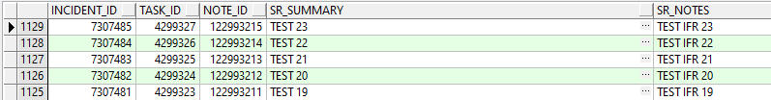
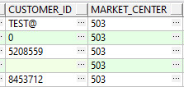
- Run Oracle Teleservices Import process:
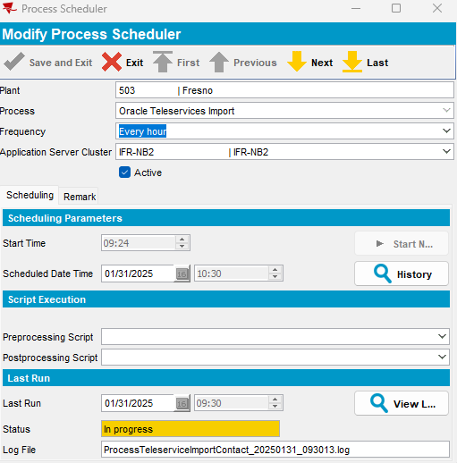
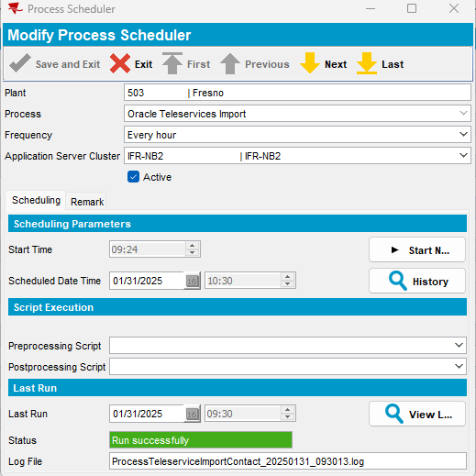

Check contacts in ABS table:
- select * from teleservicesimport order by timestamp desc;
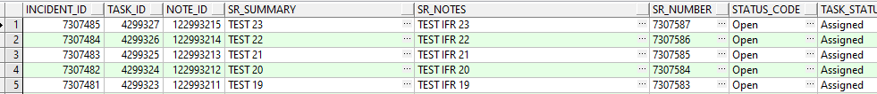
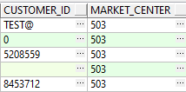
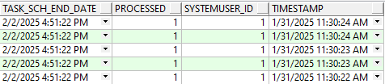
All contacts are processed.

01/31/2025 11:30:13 AM Process started on 01/31/2025 11:30:13 AM 01/31/2025 11:30:13 AM
01/31/2025 11:30:14 AM Start teleservice import process
01/31/2025 11:30:21 AM End teleservice import process
01/31/2025 11:30:21 AM Start data cleaning process
01/31/2025 11:30:21 AM End data cleaning process
01/31/2025 11:30:21 AM Start Processing Teleservices Data into ABSSolute
01/31/2025 11:30:22 AM A new contact for taskID 4299323 and srNumber 7307583 has been created!
01/31/2025 11:30:23 AM Error parsing customer number as null!
Cannot parse null string
01/31/2025 11:30:23 AM Customer number null for taskID 4299324and srNumber 7307584 does not exists in the database!
01/31/2025 11:30:23 AM A new contact for taskID 4299325 and srNumber 7307585 has been created!
01/31/2025 11:30:24 AM Customer number 0 for taskID 4299326and srNumber 7307586 does not exists in the database!
01/31/2025 11:30:24 AM Error parsing customer number as TEST@!
For input string: "TEST@"
01/31/2025 11:30:24 AM Customer number TEST@ for taskID 4299327and srNumber 7307587 does not exists in the database!
01/31/2025 11:30:24 AM End Processing Teleservices Data into ABSSolute
01/31/2025 11:30:24 AM Start creating RA Syncronisation Request for contacts
01/31/2025 11:30:24 AM End creating RA Syncronisation Request for contacts
01/31/2025 11:30:24 AM
01/31/2025 11:30:24 AM Process finished on 01/31/2025 11:30:24 AM
For Contacts with customer number null or string or not existing in the database, errors are logged in the process log.
- Check contacts in Contact dlg:
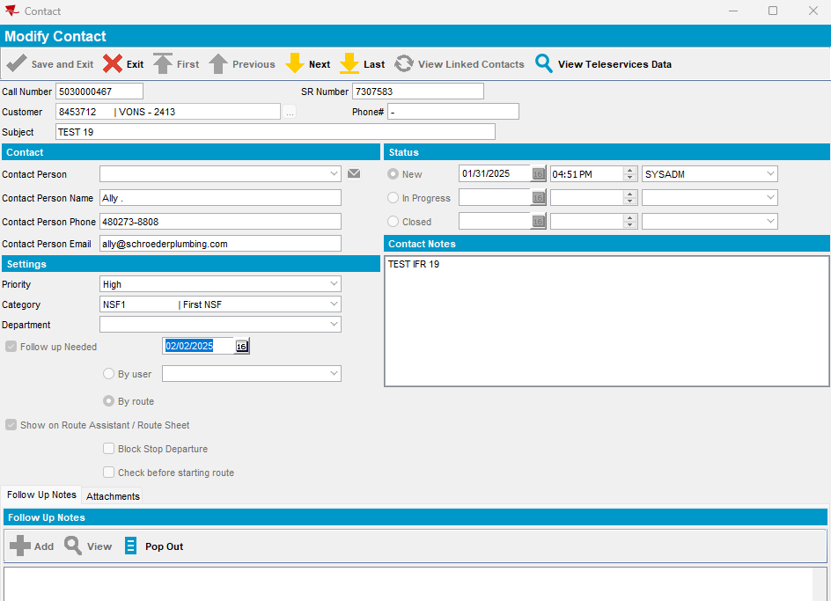
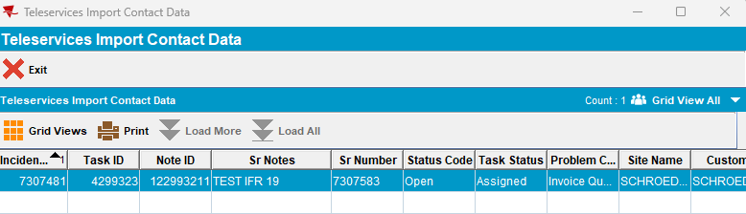
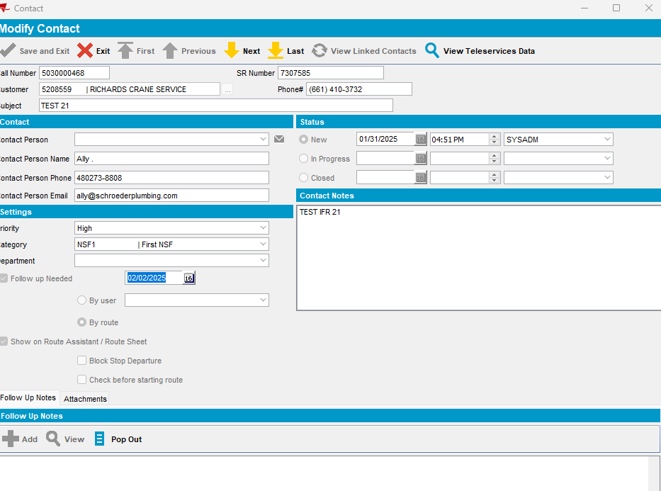
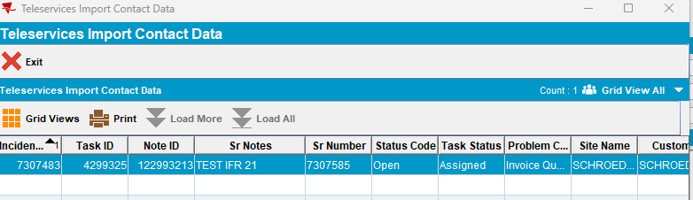
For the existing customers new contacts are ok added.
- Add next delivery route for these customers
- Generate PNs and invoice
- Mark route ready for transfer
- Downloading route
- Start route
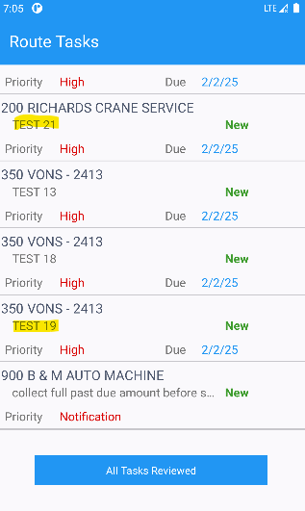
- Open Message screen:
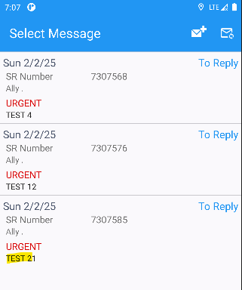
- Reply to this message:
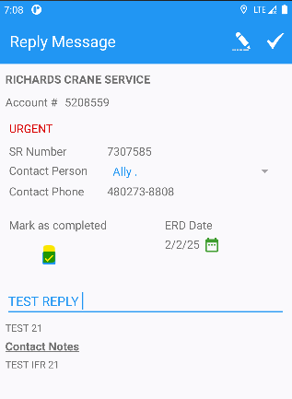
- Press sync button:
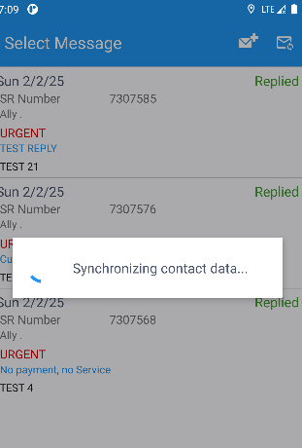

- Check on Contact dlg:
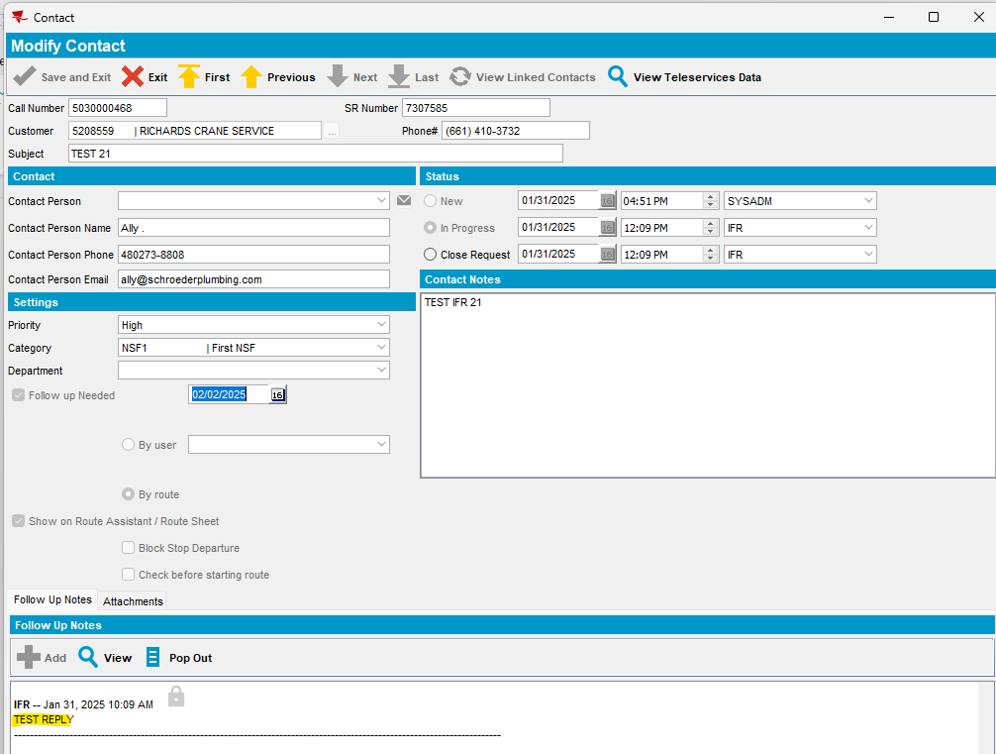
- Process Scheduler dialog: run Oracle Teleservices Export process
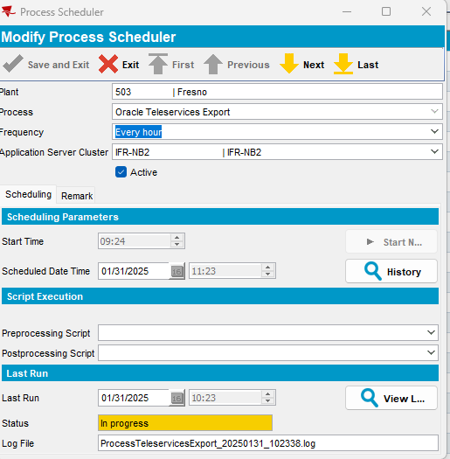

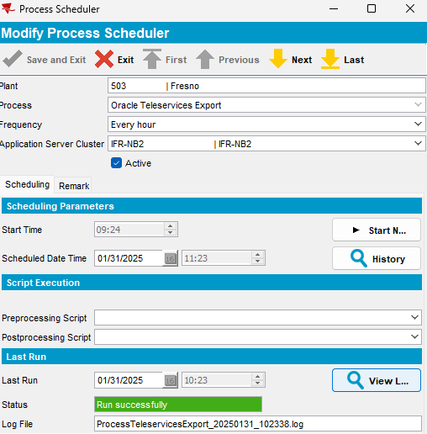

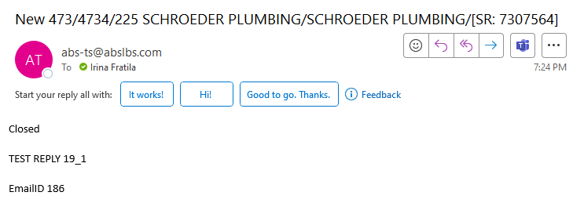
Email is sent.

- Repeat the flow:
- Run import process:
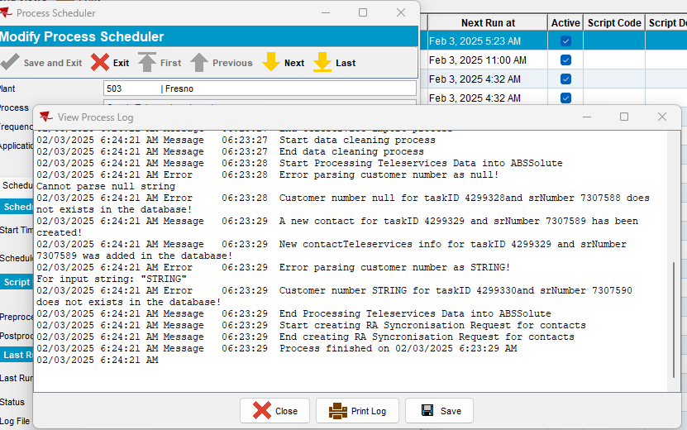
View process log is correct displayed.

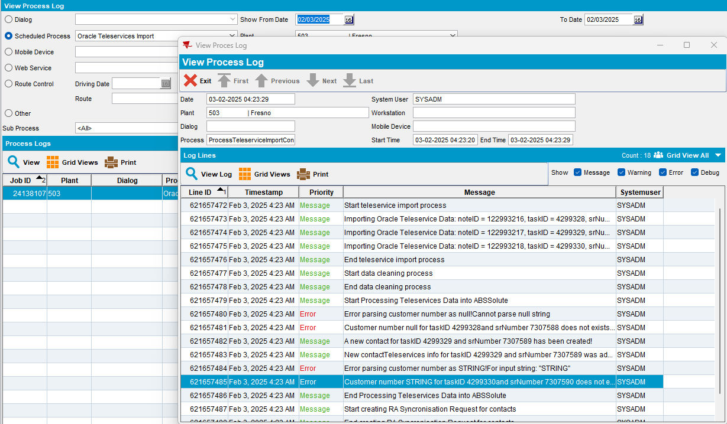
- A new contact is added:
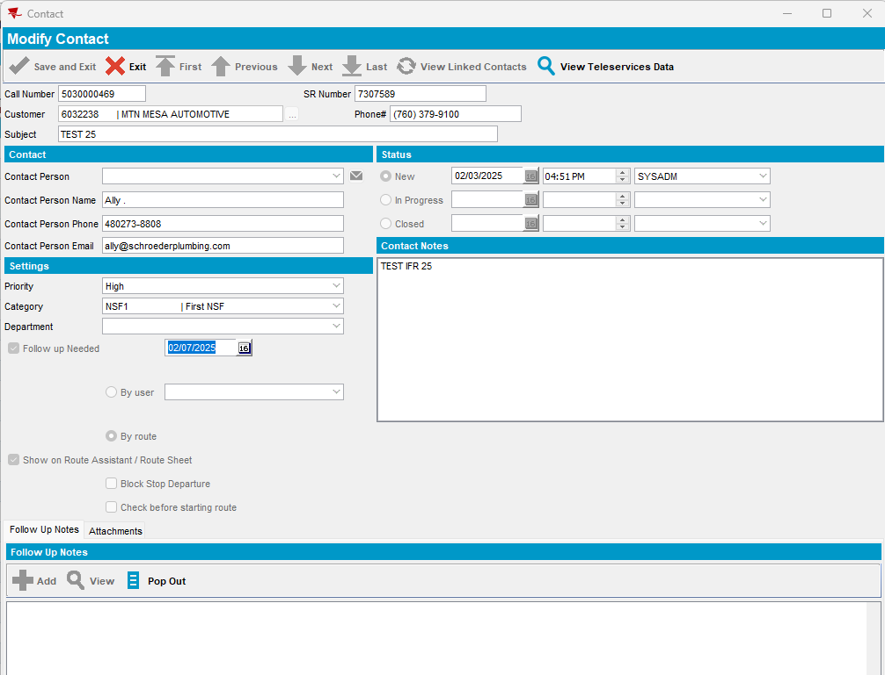

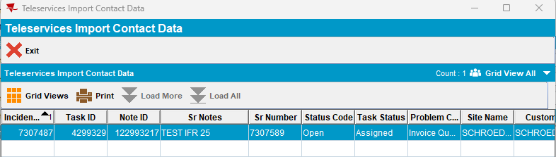
- Start route:
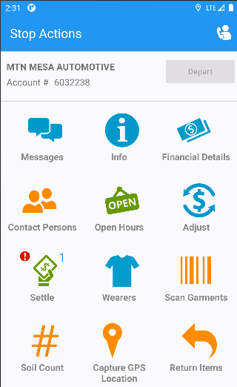

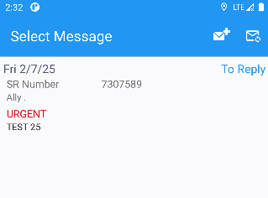
- Reply to the message:
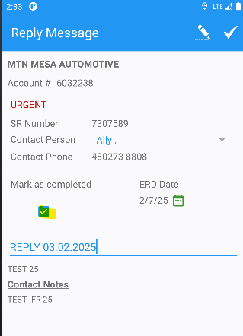

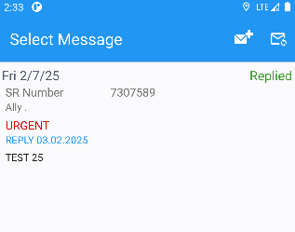

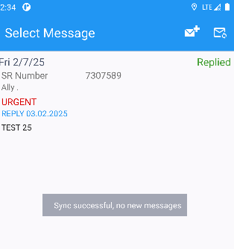
- Check on teleservicesexport table:
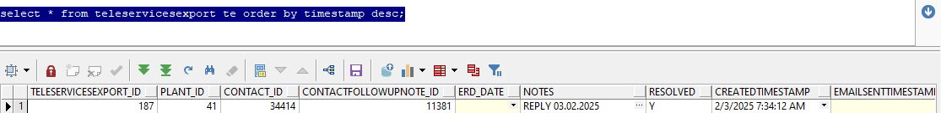

Status 0 -> pending send

After sync messages on PDA the note is sent to the client and the status becomes: In Progress:
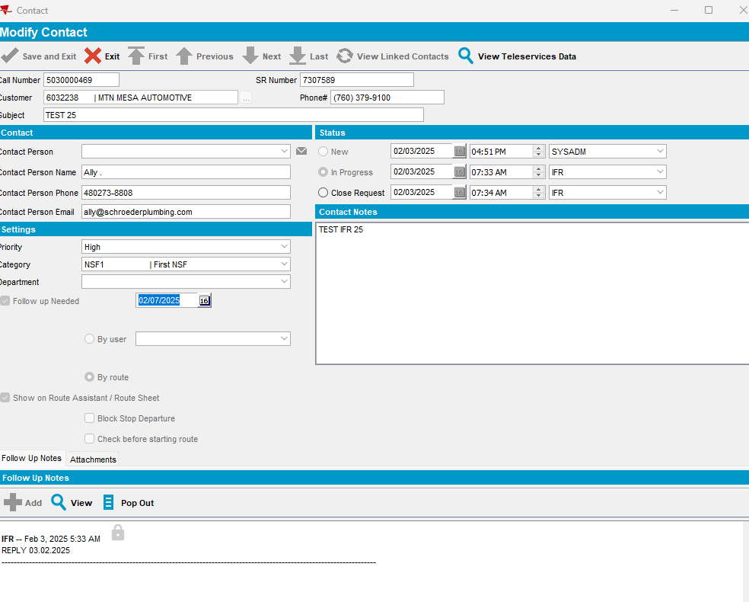
- Run export process:
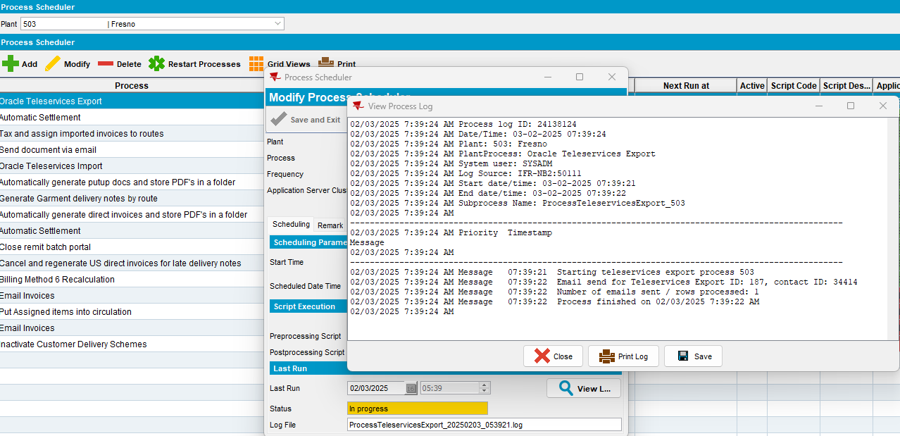
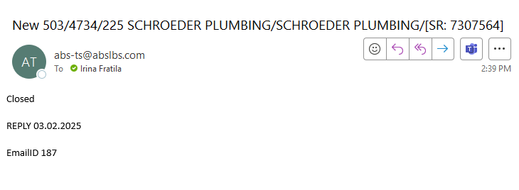
Email is sent and status becomes = 1
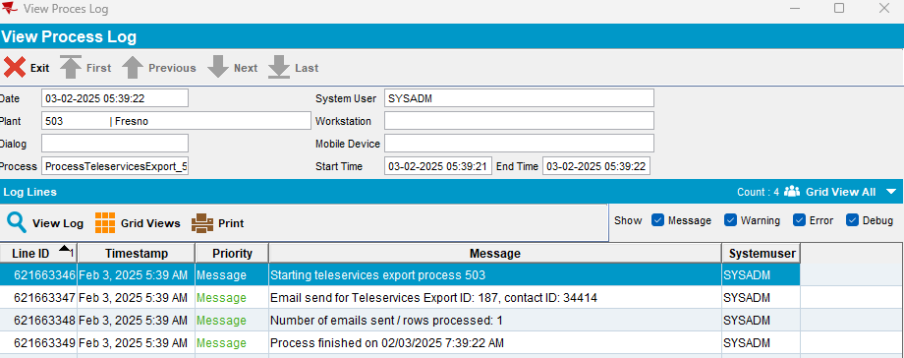
Tested ok.

