ABSN-1929 Downgrade to 9.08.00.release.p18_AUS

Environment | Prerequisites
Version: 9.08.00.RELEASE.p17  DBServerName=abs-srv16.internal.abslbs.com  DBSID=CUST21  DBUser=AUS_ND90502  DBPassword=  Environment=Production  Hash: a0b96e3 | - Module: AUSCUSTOM  - System setting: -  - Others… BU:258 Fresno

Contents
Retest after fix 1
ADD Mode 4
#1 Create new manual invoice for customer with no future route control record available (no routes in RSC that have this customer’s stop)- Test OK 4
#2. Test if manual invoice will be linked to route control – Test OK 4
#3. Test for a non delivery day – Test OK 5
#4. Test when pocketPCStatus = POCKETPC_COMPLETED (2) (PDA Status = Completed) and AUSCUSTOM -> display "No invoice can be added to the selected route control because the route is completed." – Test OK 6
#5. Test when pocketPCStatus = POCKETPC_EXPORTED (1) (PDA Status = “Transferred to PDA”) and AUSCUSTOM, display "No invoice can be added to the selected route control because the route is exported to PDA." – Test OK 6
#6. Modify manual invoices when (pocketPCStatus != POCKETPC_EXPORTED(1) - Not exported) && (pocketPCStatus != POCKETPC_COMPLETED/IMPORTED(2) – Test OK 6
#7. AUSCUSTOM not in the license 6

Retest after fix

Hash:
Step 1) …
Step 2) …
Step 3) …

RETEST OK
- Have module AUSCUSTOM in the license file
- In Maintain Invoices dlg, Customer tab, load a customer
- Unsettled tab, press ADD

- Open a customer to see its delivery scheme
- In Maintain Invoices, Customer tab, load the customer and add a manual invoice on non delivery day
- Save the manual invoice
- AUSCUSTOM in the license
- In RSC select a route control with PDA Status = “Completed” and select a customer
- In Maintain Invoices dlg, Customer tab, load a customer
- Unsettled tab, press ADD. Select the route date from the picture above.
- Save invoice
- Press “OK” and try to add an invoice line and then save
- Press X and “Yes”
- Press “cancel” and “yes”
- Modify an existing manual invoice

- Add
- Modify an existing manual invoice for this rc
- Select date
- Enter customer
- Press Enter
- Save
- Cancel and yes
- Close window and yes
- Modify an existing manual invoice for this route control
- AUSCUSTOM in the license
- In RSC select a route control with PDA Status = “Transferred to PDA” and select a customer
- In Maintain Invoices dlg, Customer tab, load a customer (890044954)
- Unsettled tab, press ADD. Select the route date from the picture above.
- Save invoice
- Add an invoice line and save invoice
- Try to close the window and “Yes”
- Press “cancel” and “yes”
- Modify an existing manual invoice for this route control

- Add button is not enabled in ADD mode
- In Modify mode, error occurs
- Modify an existing manual invoice for this route control
- Select date
- Enter customer
- Press Enter and save
- Click Cancel and yes
- Close window and press yes
- Modify an existing manual invoice for this route control
- In RSC select a route control with PDA Status = “Not exported” and select a customer
- In Maintain Invoices dlg, Customer tab, load a customer (792539525)
- Unsettled tab, press MODIFY. Select the route date from the picture above.
- Add a new invoice line and save
- In RSC select a route control with PDA Status = “Ready for transfer” and select a customer
- In Maintain Invoices dlg, Customer tab, load a customer (8717048)
- Unsettled tab, select an invoice and press MODIFY.
- Add an invoice lines
- Save and reopen
- On route tab, press ADD button
- Enter the customer
- Press enter button
- Save
- Modify
- On All tab, press ADD button
- Enter the customer
- Press enter button
- Save
- Modify invoice and add a new invoice line
- Reopen
- AUSCUSTOM NOT in the license
- In RSC select a route control with PDA Status = “completed” and select a customer
- In Maintain Invoices dlg, Customer tab, load a customer (160003366)
- Unsettled tab, press ADD to add a new manual invoice.
- Save invoice
- Modify
- Add a manual invoice
- Modify an existing invoice
- Add a manual invoice
- Modify an existing invoice
- Unsettled tab, press ADD to add a new manual invoice on the same date as the one from route control.
- Modify
- Add a manual invoice
- Modify an existing invoice

#1 Create new manual invoice for customer with no future route control record available (no routes in RSC that have this customer’s stop)- Test OK
- Open Route Status Control dlg and see when last route was added
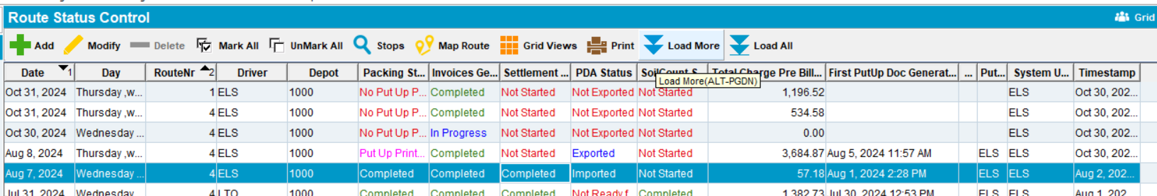
- In Maintain Invoices dlg, Customer tab, load a customer
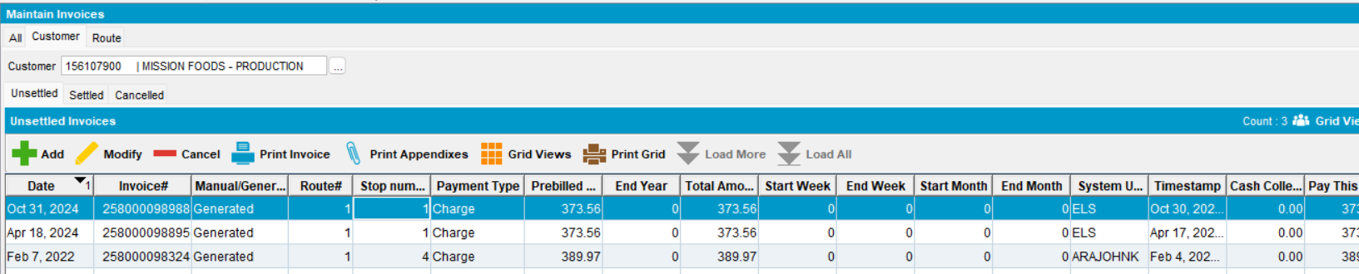
- Unsettled tab, press ADD. Select a date that on which there is no route added in RSC.
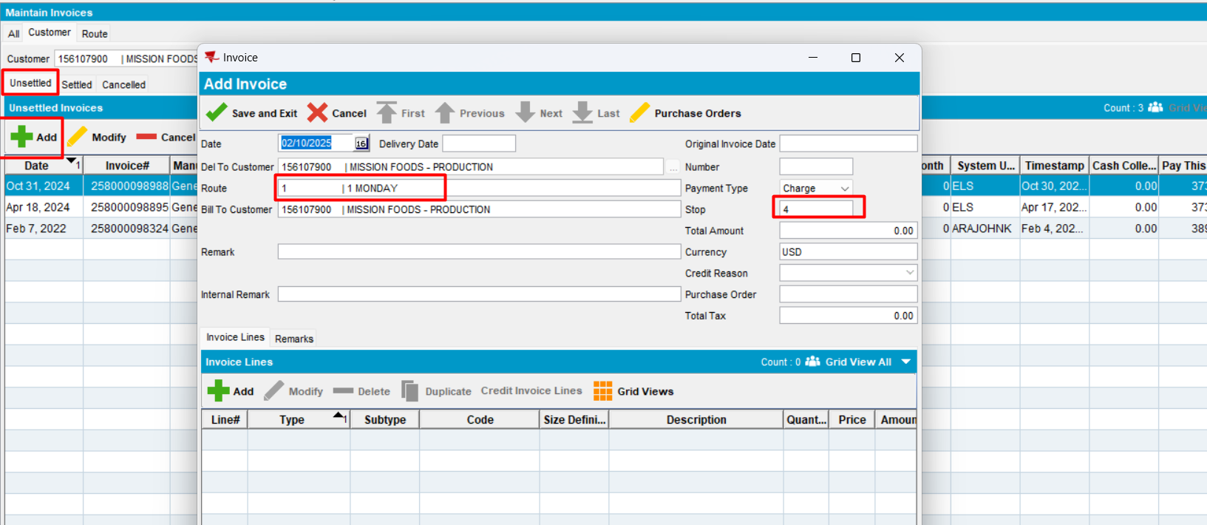
Expected behavior: when a customer is selected, in ADD mode, the route should populate and be automatically assigned to a new manually created invoice
Actual behavior: as expected.
Tested ok
- Save
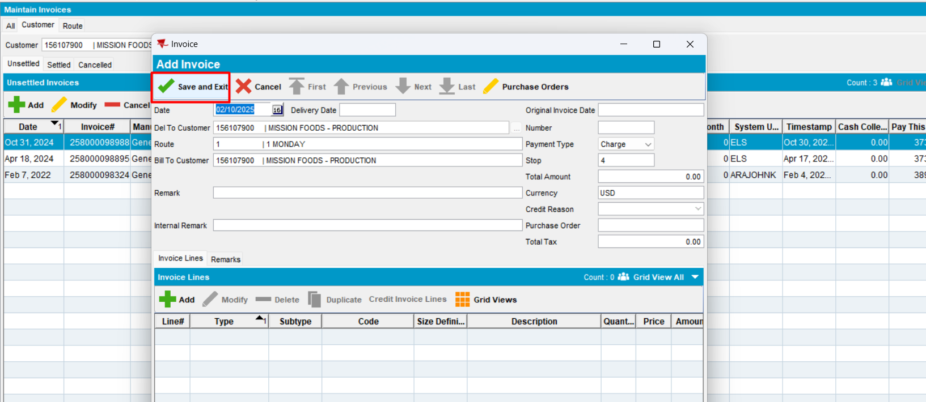
New manual invoice was saved. It can later be linked to a route control.
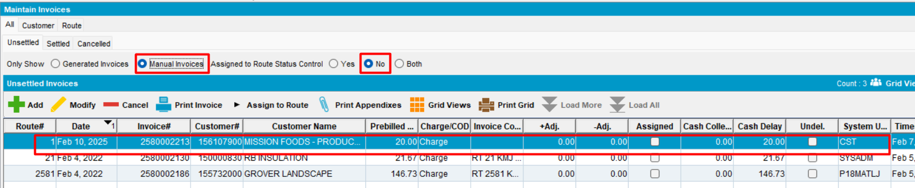
- Reopen
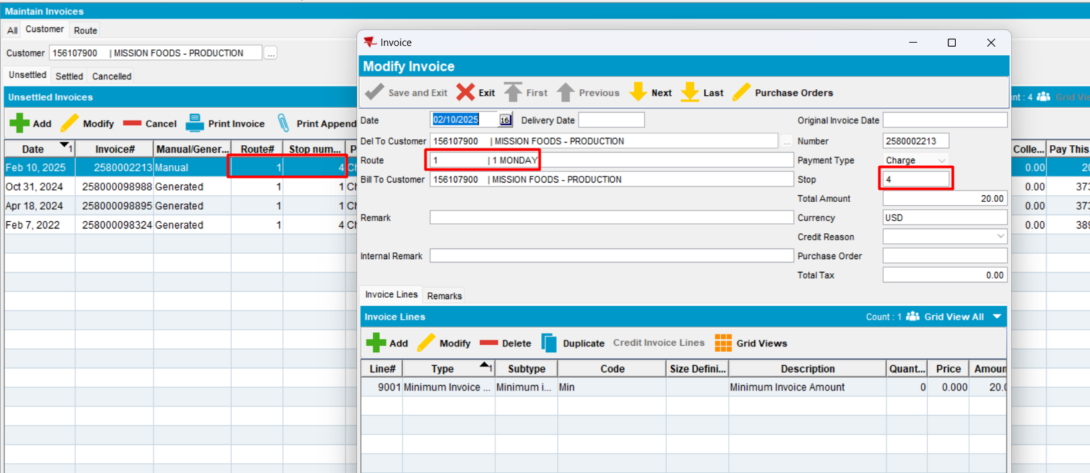
Fields “Route” and “Stop” are correctly populated.
Tested OK

#2. Test if manual invoice will be linked to route control – Test OK
- In Route Status Control add a route control and save. Do not generate Put Up Docs, do not generate Invoice. (route 1 from Feb 7, 2025)
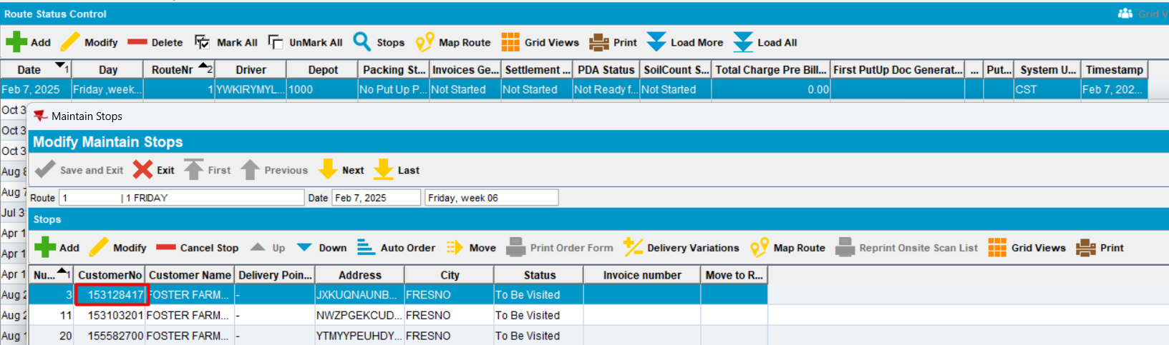
- In Maintain Invoices, add a manual invoice
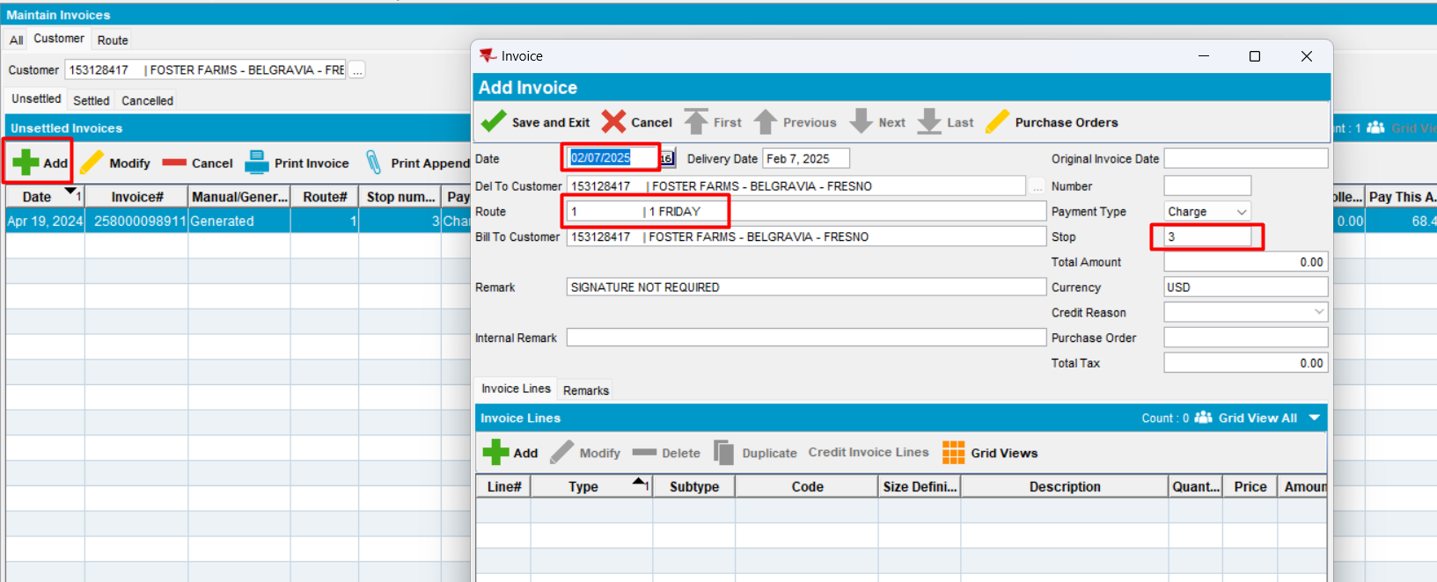
Expected behavior: when a customer is selected, in ADD mode, the route should populate and be automatically assigned to a new manually created invoice
Actual behavior: as expected.
Tested ok
- Add an invoice line and save the manual invoice
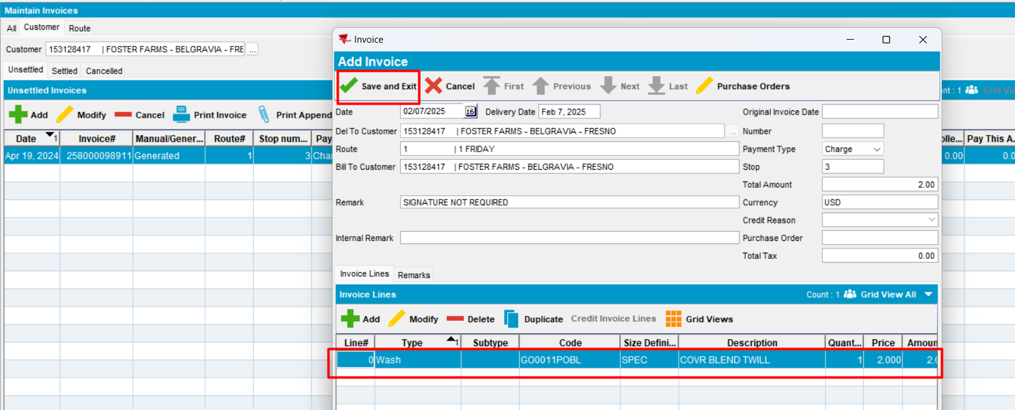
The invoice is saved
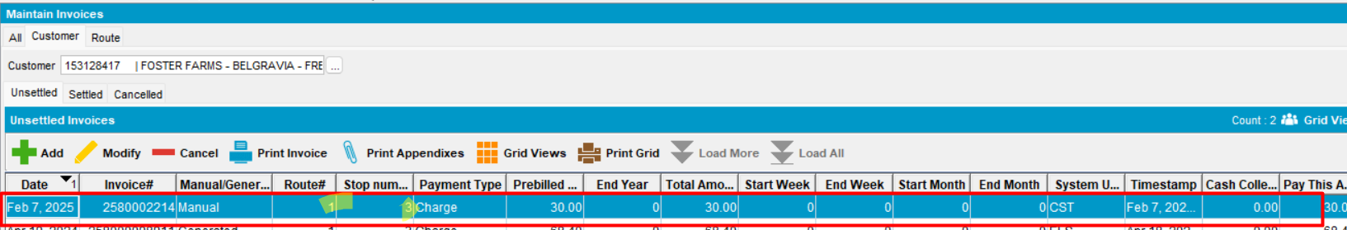
- Verify if in Route Status Control the manual invoice is linked to route control
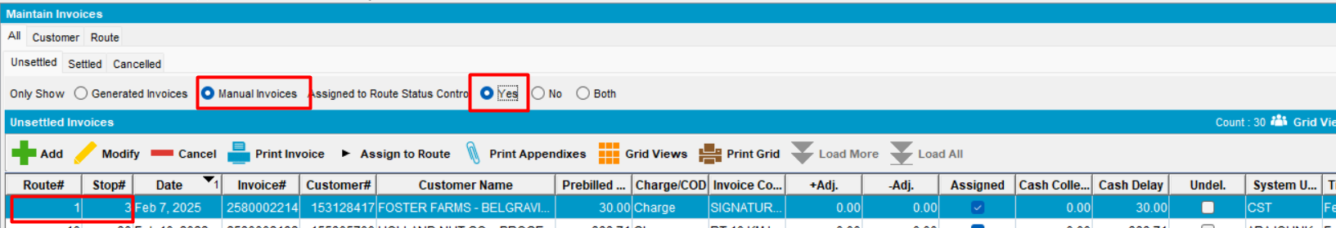
The manual invoice is linked to route control.
Tested OK

#3. Test for a non delivery day – Test OK
- Open a customer to see its delivery scheme
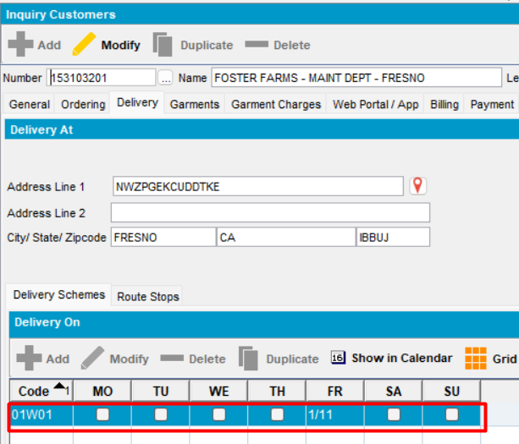
- In Maintain Invoices, Customer tab, load the customer and add a manual invoice on non-delivery day
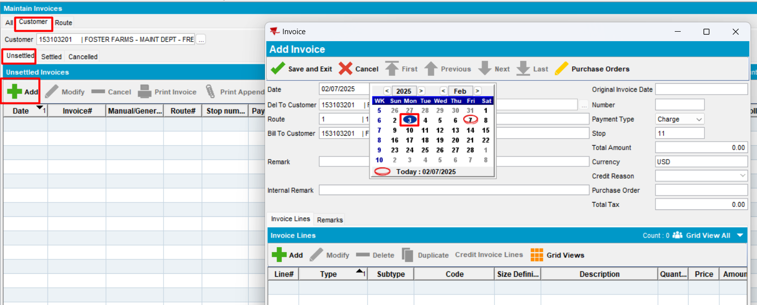
Select the non-delivery day
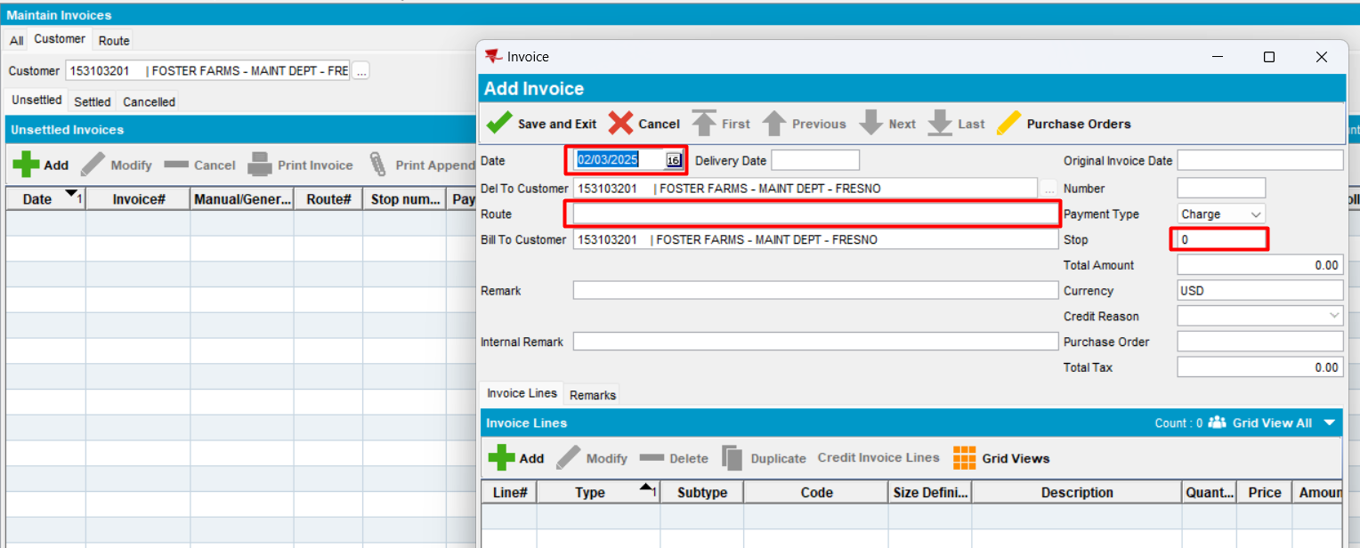
Expected behavior: when a customer is selected, in ADD mode, the route should populate and be automatically assigned to a new manually created invoice. Because is not a delivery day, the Route field is not filled. Stop field = 0.
Actual behavior: as expected.
Tested ok
- Save the manual invoice
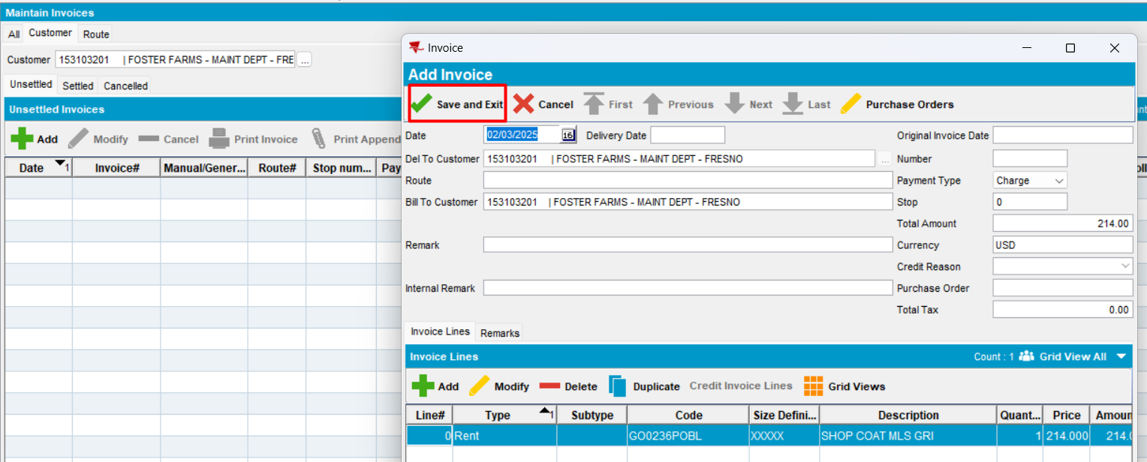
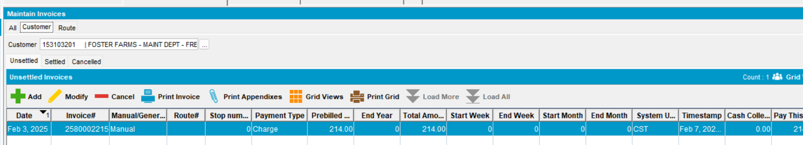
Tested ok

#4. Test when pocketPCStatus = POCKETPC_COMPLETED (2) (PDA Status = Completed) and AUSCUSTOM -> display "No invoice can be added to the selected route control because the route is completed." – Test OK
- AUSCUSTOM in the license
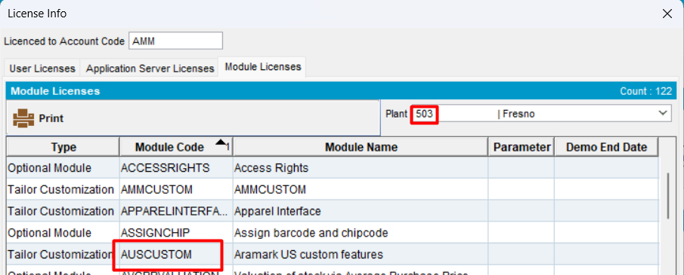
- In RSC select a route control with PDA Status = “Completed” and select a customer
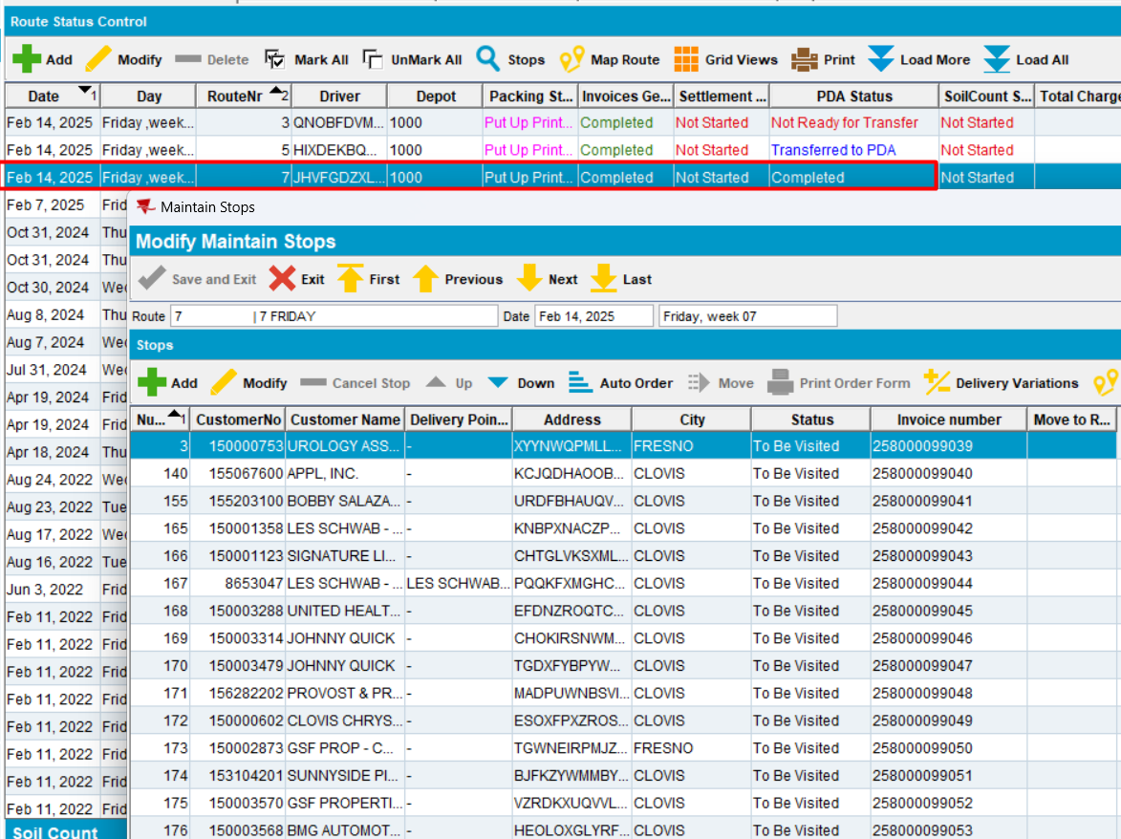
pocketPCStatus = POCKETPC_COMPLETED (2)
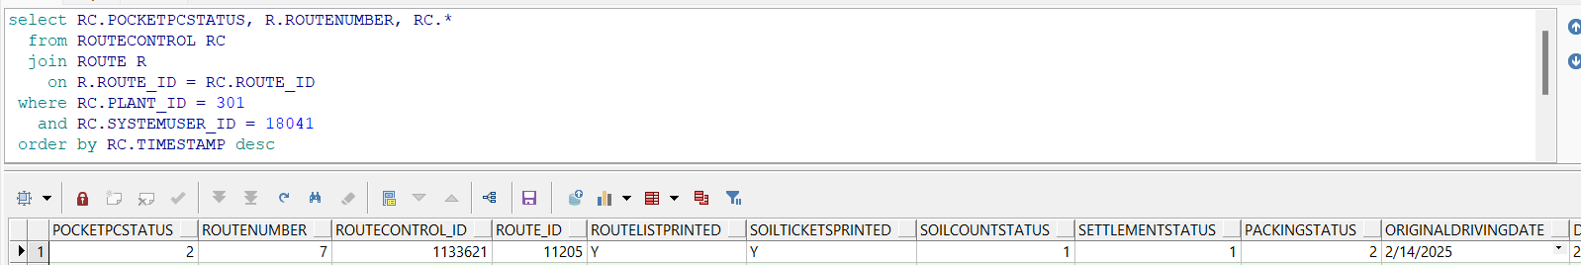
- In Maintain Invoices dlg, Customer tab, load a customer
- Unsettled tab, press ADD. Select the route date from the picture above.

Customer tab
Customer: 150000753
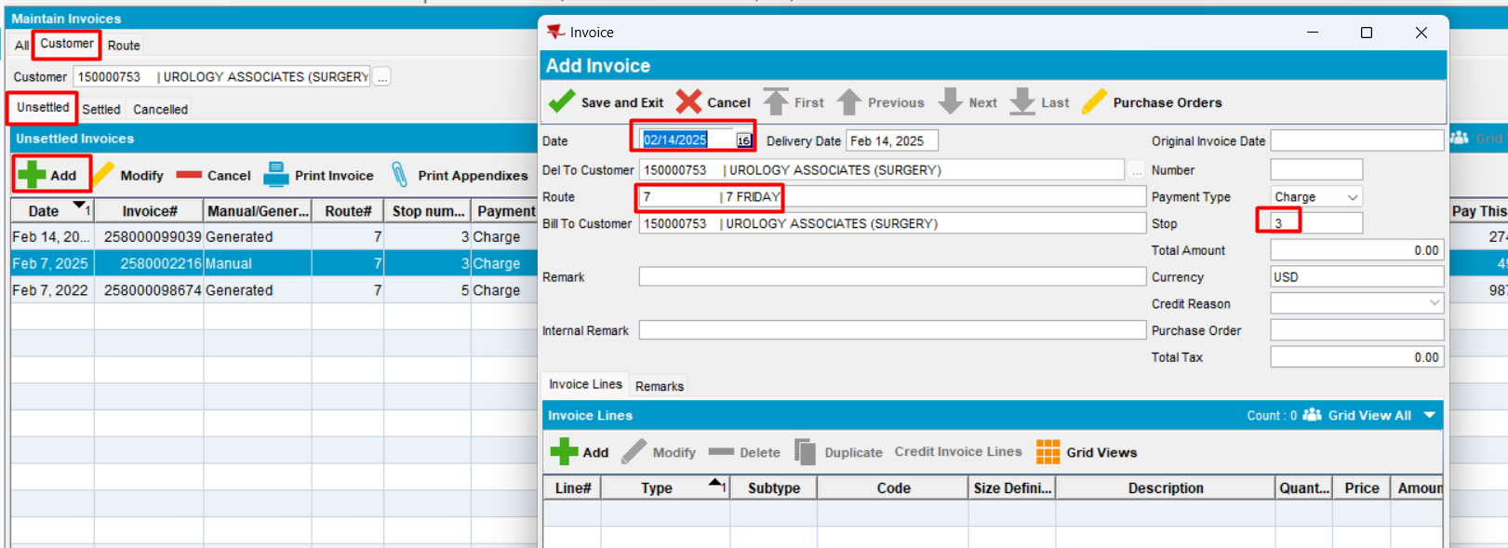
Expected behavior: when a customer is selected, in ADD mode, the route should populate and be automatically assigned to a new manually created invoice
Actual behavior: as expected.
Tested ok
- Save invoice
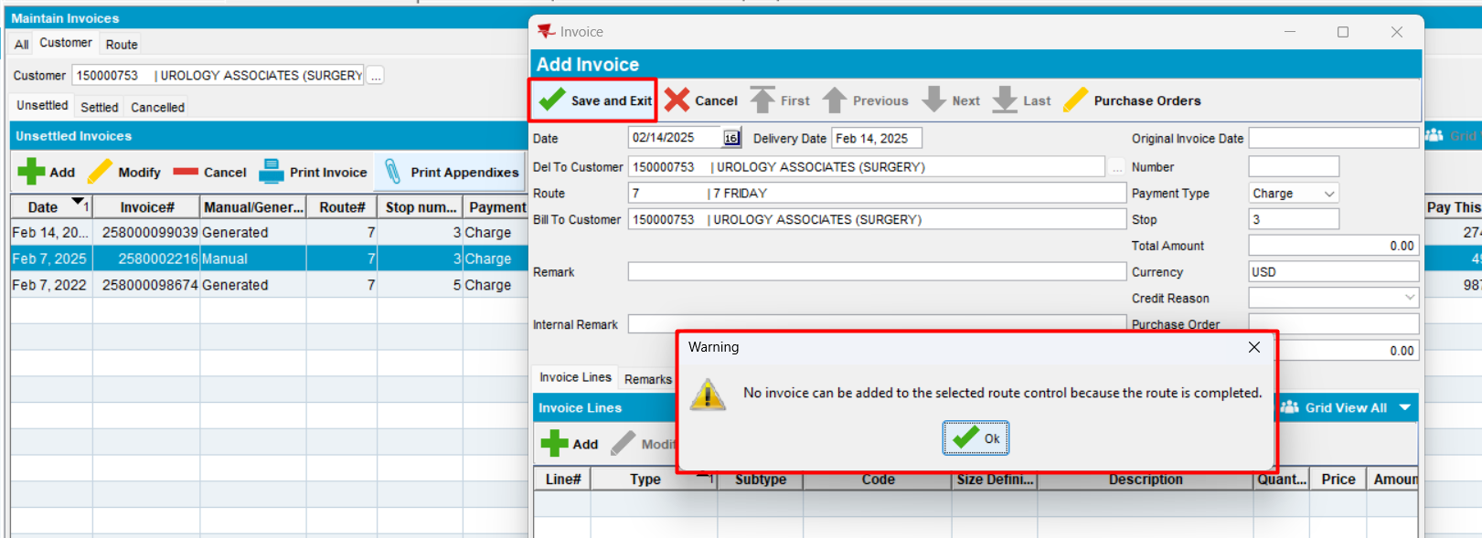
Expected behavior: - if pocketPCStatus = POCKETPC_COMPLETED (2)(PDA Status = Completed) and AUSCUSTOM ->when save, display message: "No invoice can be added to the selected route control because the route is completed."
Actual behavior: as expected.
Tested ok
- Press “OK” and try to add an invoice line and then save
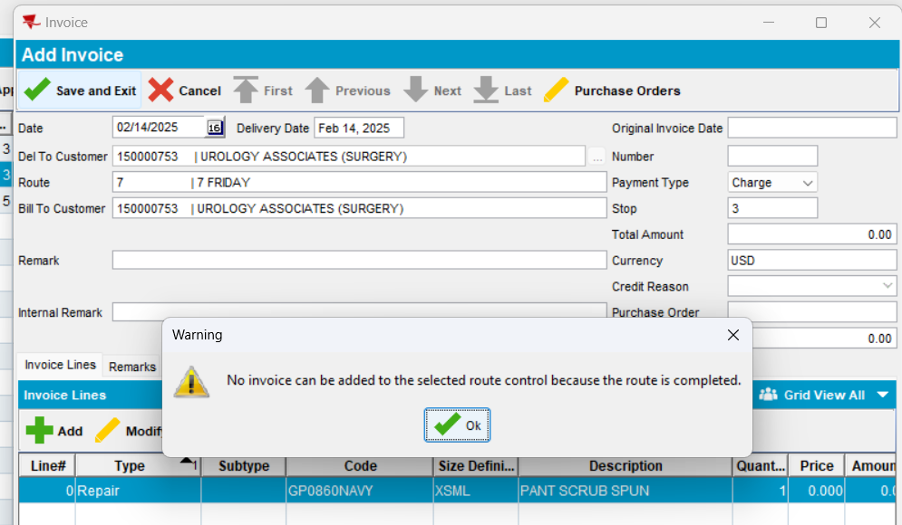
Expected behavior: - if pocketPCStatus = POCKETPC_COMPLETED (2)(PDA Status = Completed) and AUSCUSTOM ->when save, display message: "No invoice can be added to the selected route control because the route is completed."
Actual behavior: as expected.
Tested ok
- Press close(X) and “Yes”
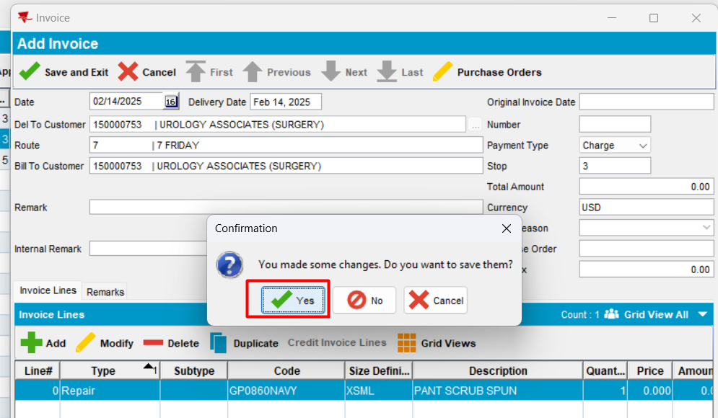
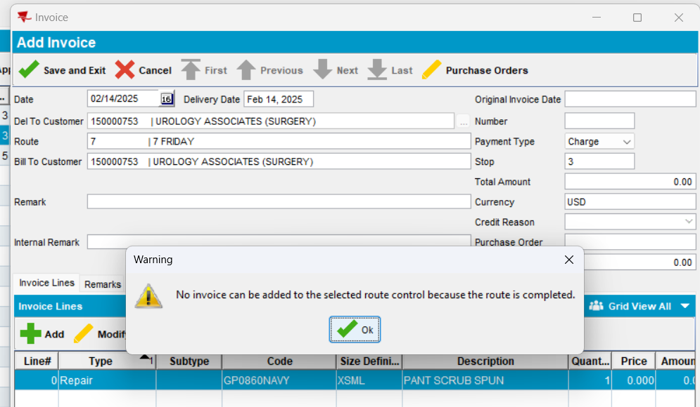
Expected behavior: - if pocketPCStatus = POCKETPC_COMPLETED (2)(PDA Status = Completed) and AUSCUSTOM -> display message: "No invoice can be added to the selected route control because the route is completed."
Actual behavior: as expected.
Tested ok
- Press “cancel” and “yes”
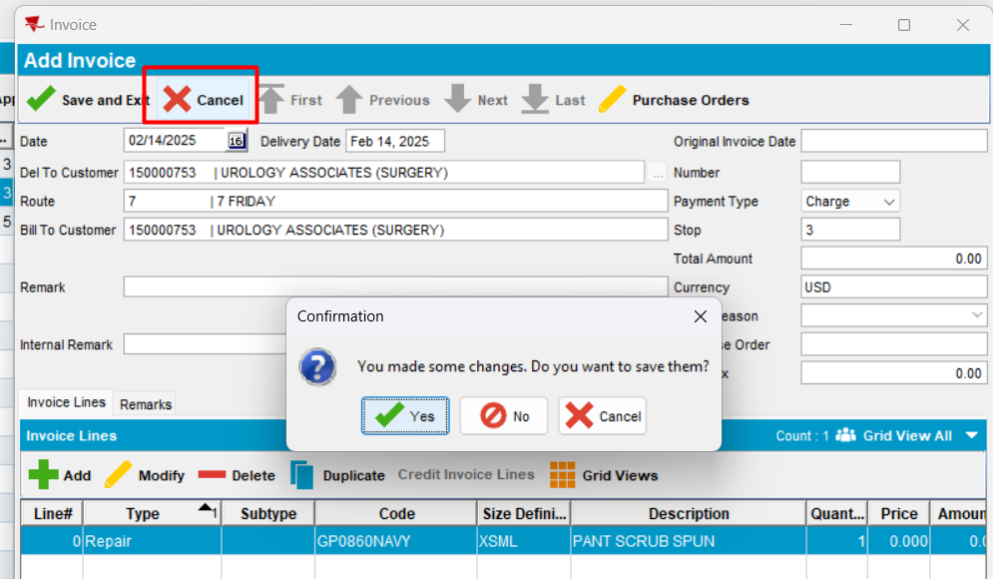
Expected behavior: - if pocketPCStatus = POCKETPC_COMPLETED (2)(PDA Status = Completed) and AUSCUSTOM -> display message: "No invoice can be added to the selected route control because the route is completed."
Actual behavior: as expected.
Tested ok
- Modify an existing manual invoice
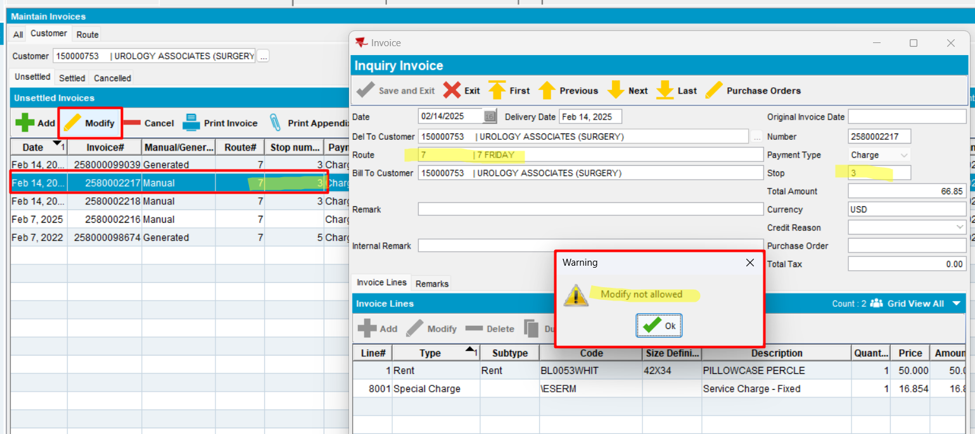
Expected behavior: - if pocketPCStatus = POCKETPC_COMPLETED (2)(PDA Status = Completed) and AUSCUSTOM -> display message: "No invoice can be added to the selected route control because the route is completed."
Actual behavior: as expected.
Tested ok

Route tab
- Add
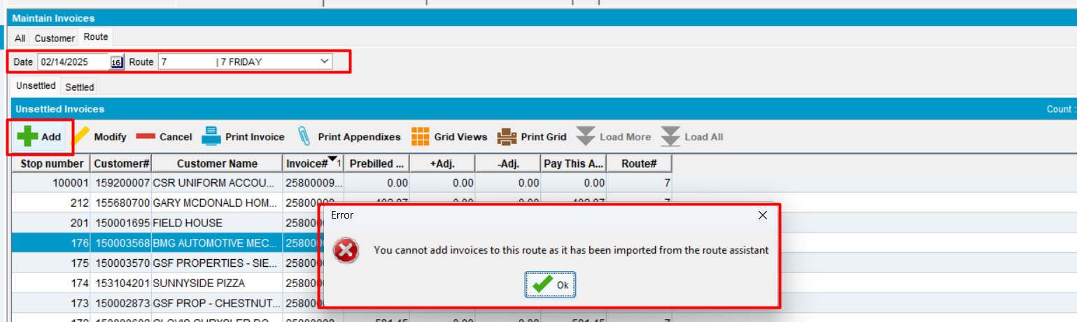
Tested OK
- Modify an existing manual invoice for this rc
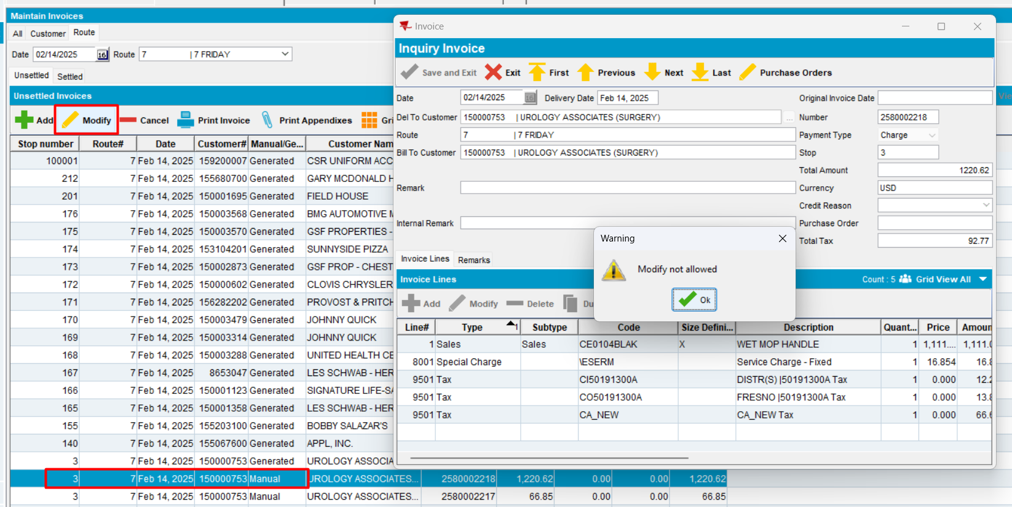
Expected behavior: if AUSCUSTOM and PDA Status=Completed -> it is not allowed to modify an existing manual invoice
Actual behavior: as expected
Tested OK

All tab
- Select date
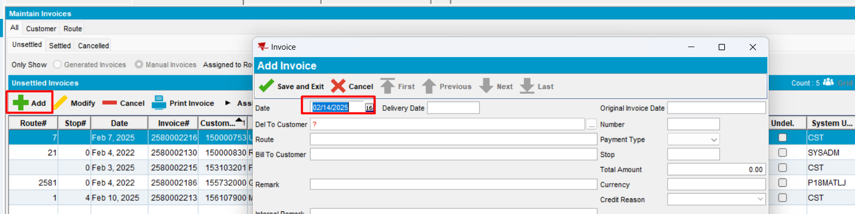
- Enter customer
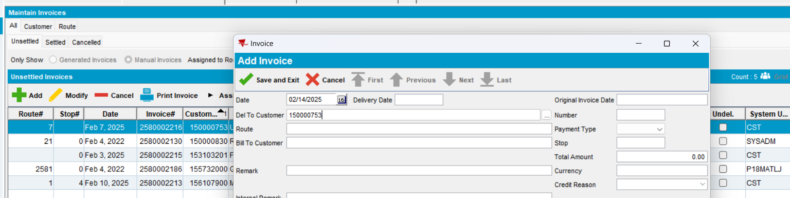
- Press Enter
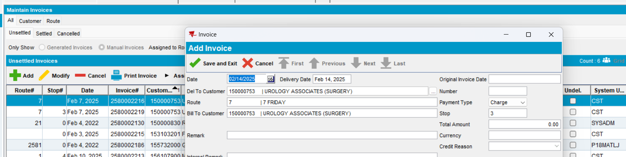
- Save
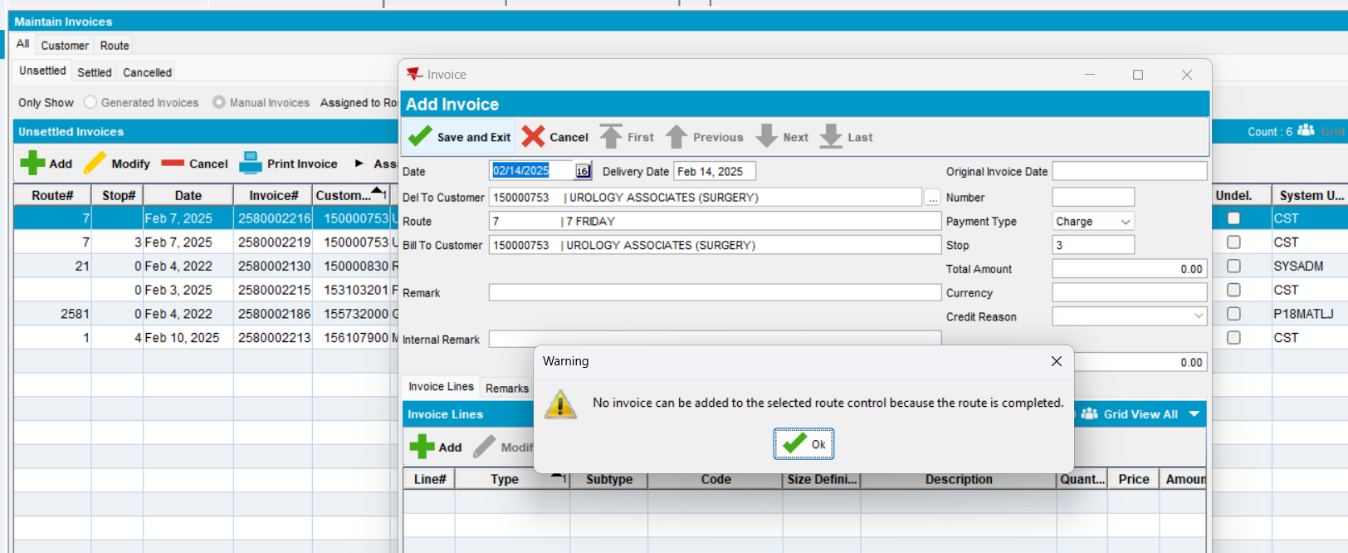
Expected behavior: - if pocketPCStatus = POCKETPC_COMPLETED (2)(PDA Status = Completed) and AUSCUSTOM -> display message: "No invoice can be added to the selected route control because the route is completed."
Actual behavior: as expected.
Tested ok
- Cancel and yes
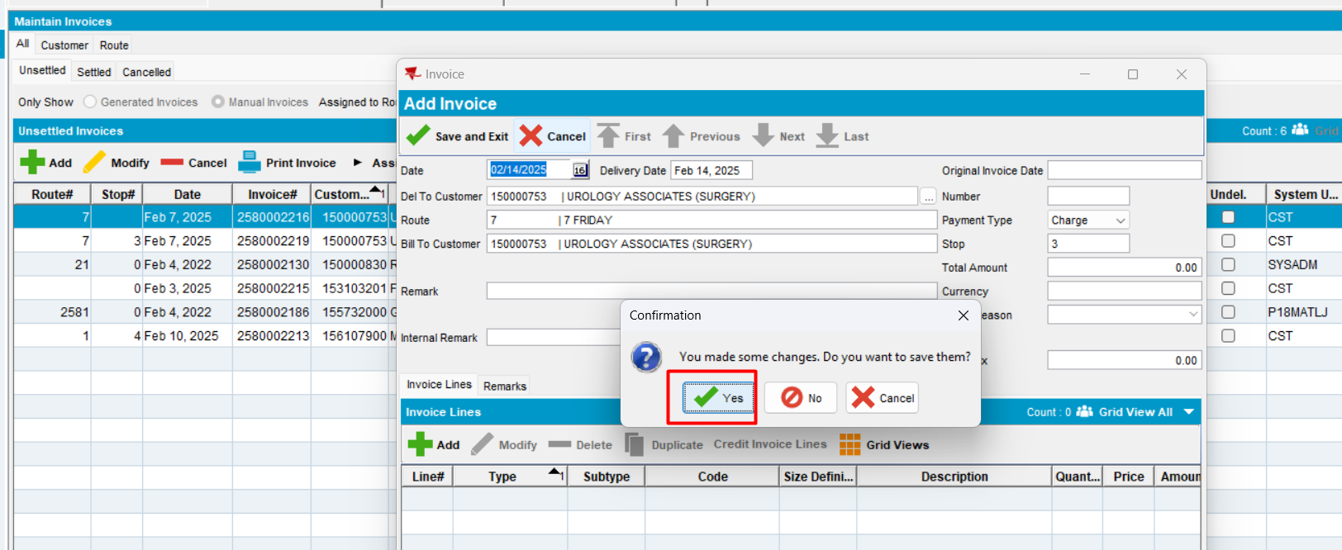
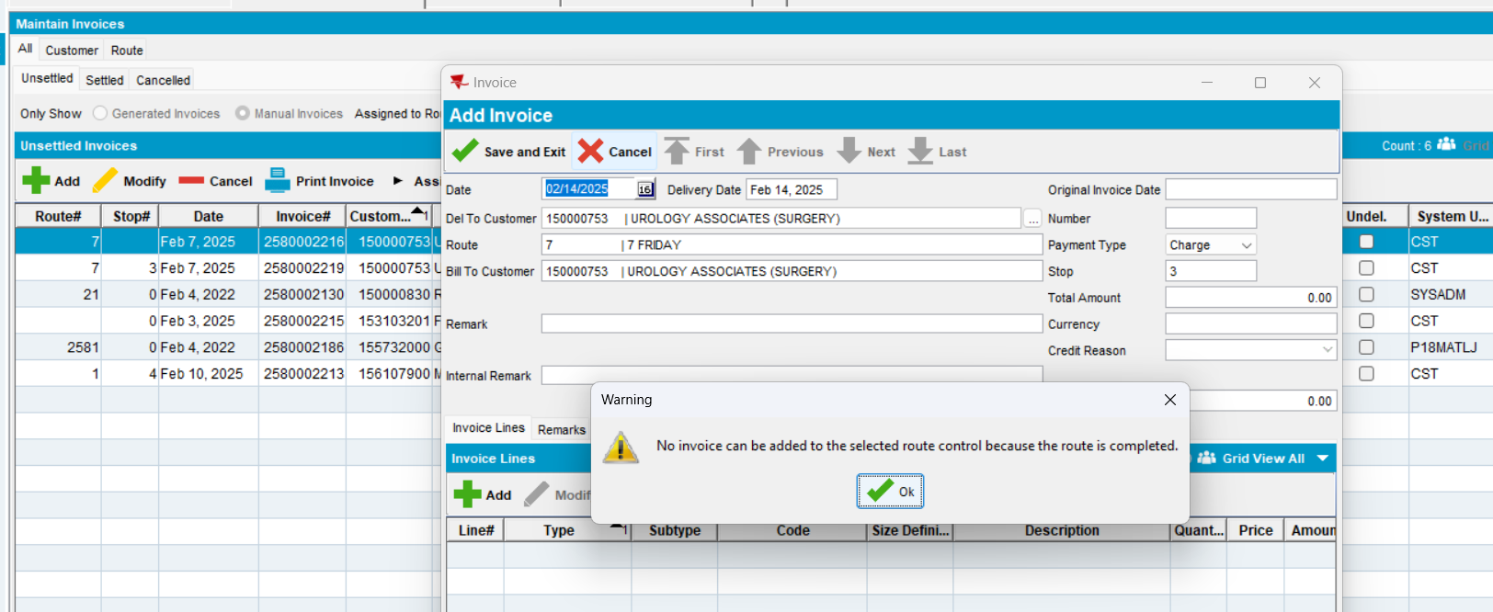
Expected behavior: - if pocketPCStatus = POCKETPC_COMPLETED (2)(PDA Status = Completed) and AUSCUSTOM -> display message: "No invoice can be added to the selected route control because the route is completed."
Actual behavior: as expected.
Tested ok
- Close window and yes
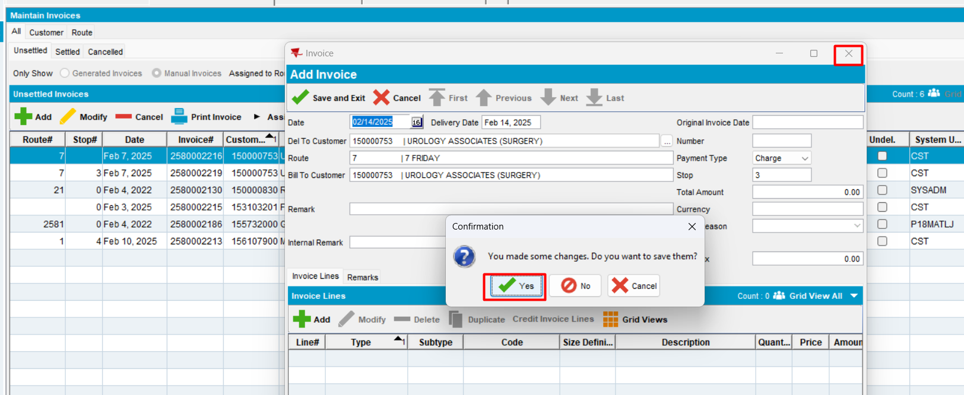
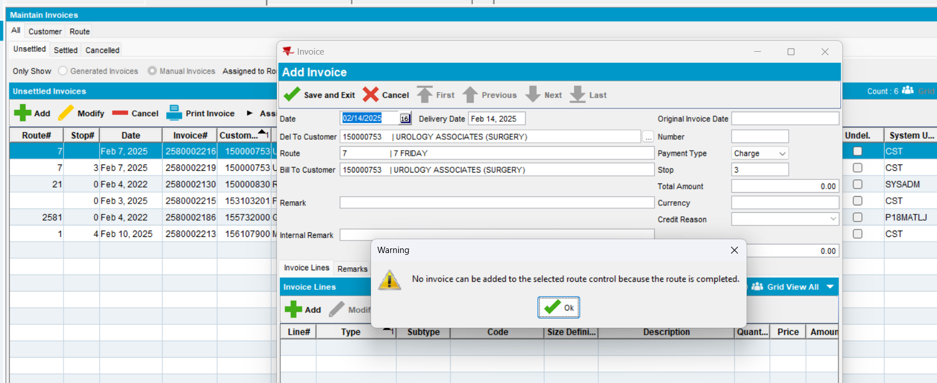
Expected behavior: - if pocketPCStatus = POCKETPC_COMPLETED (2)(PDA Status = Completed) and
AUSCUSTOM -> when save display message: "No invoice can be added to the selected route control because the route is completed."
Actual behavior: as expected.
Tested ok
- Modify an existing manual invoice for this route control
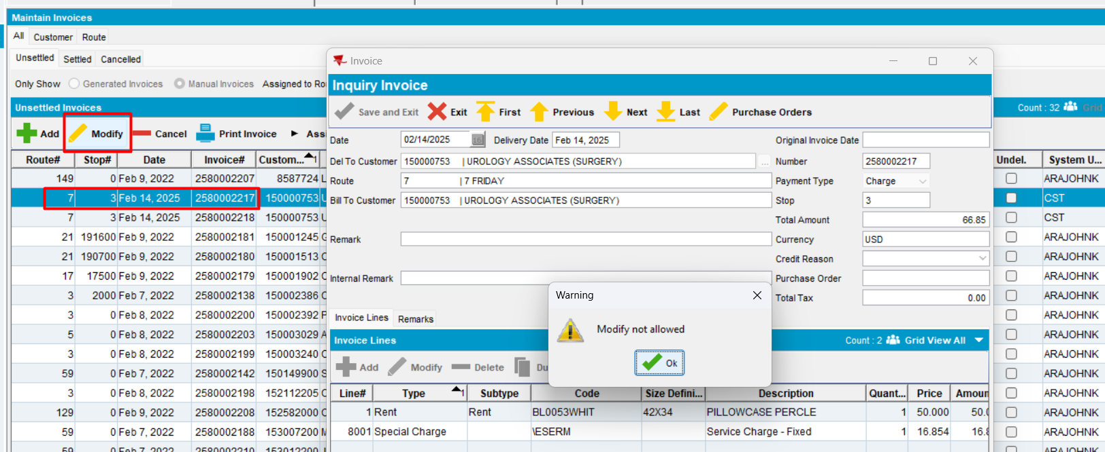
Expected behavior: if AUSCUSTOM and PDA Status=Completed -> it is not allowed to modify an existing manual invoice
Actual behavior: as expected
Tested OK

#5. Test when pocketPCStatus = POCKETPC_EXPORTED (1) (PDA Status = “Transferred to PDA”) and AUSCUSTOM, display "No invoice can be added to the selected route control because the route is exported to PDA." – Test OK
- AUSCUSTOM in the license
- In RSC select a route control with PDA Status = “Transferred to PDA” and select a customer
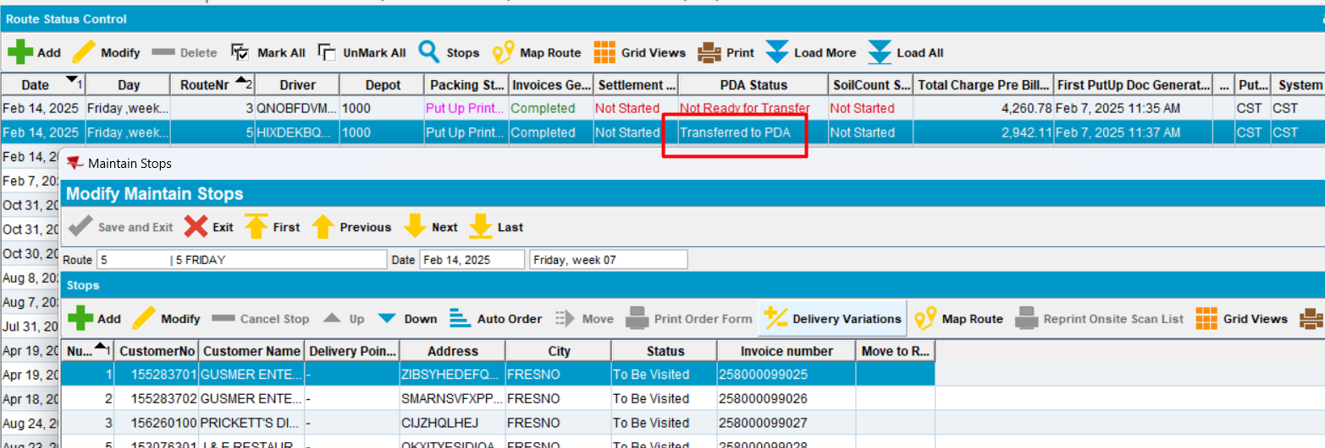
PDA Status = “Transferred to PDA”
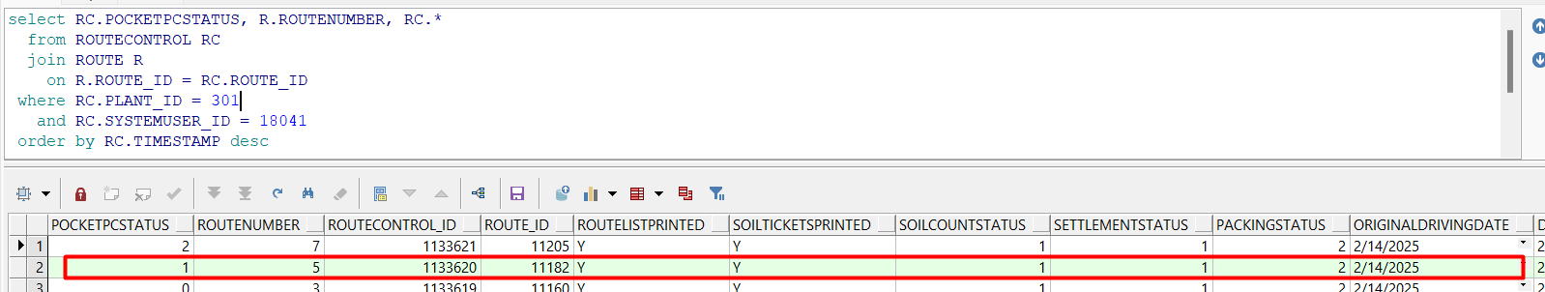

Customer tab
Customer: 155283701
- In maintain invoices dlg, add a new manual invoice on the route control date. Save it
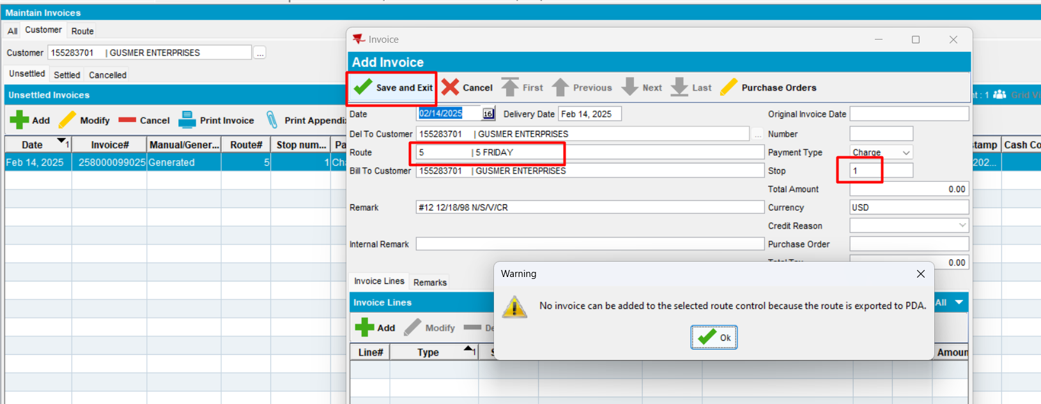
Expected behavior: when a customer is selected, in ADD mode, the route should populate and be automatically assigned to a new manually created invoice. If pocketPCStatus = POCKETPC_COMPLETED (2)(PDA Status = Completed) and AUSCUSTOM -> display message: "No invoice can be added to the selected route control because the route is completed."
Actual behavior: as expected.
Tested ok
- Press X(close) and “Yes”
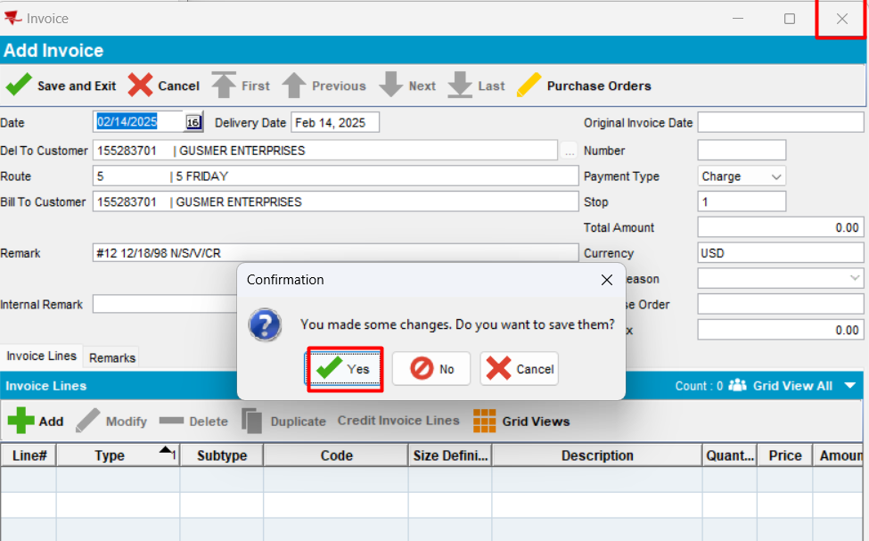
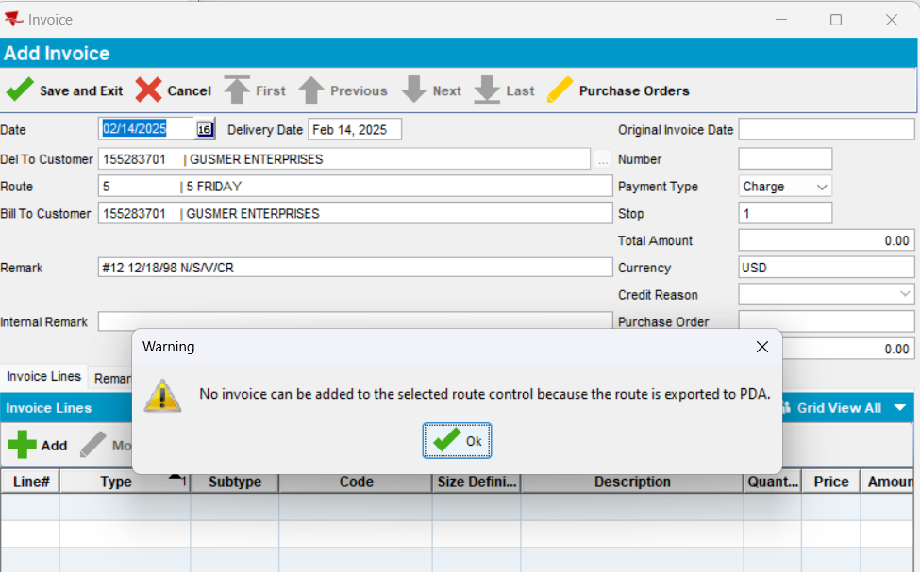
Expected behavior: - if pocketPCStatus = POCKETPC_COMPLETED (2)(PDA Status = Completed) and AUSCUSTOM -> display message: "No invoice can be added to the selected route control because the route is completed."
Actual behavior: as expected.
Tested ok
- Press “cancel” and “yes”
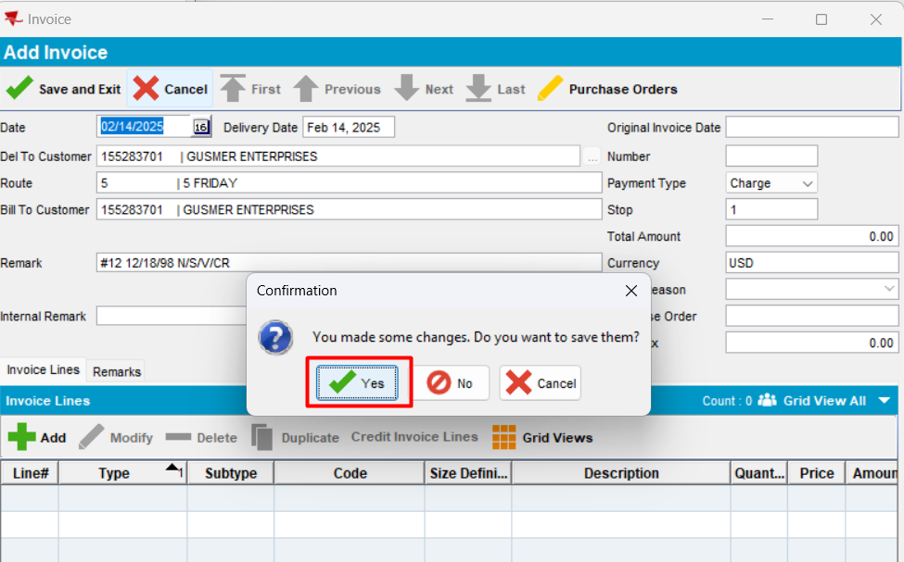
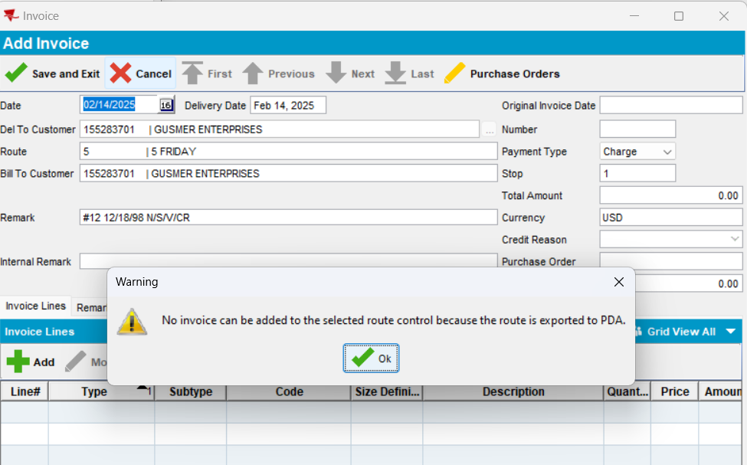
Expected behavior: - if pocketPCStatus = POCKETPC_COMPLETED (2)(PDA Status = Completed) and AUSCUSTOM -> display message: "No invoice can be added to the selected route control because the route is completed."
Actual behavior: as expected.
Tested ok
- Modify an existing manual invoice
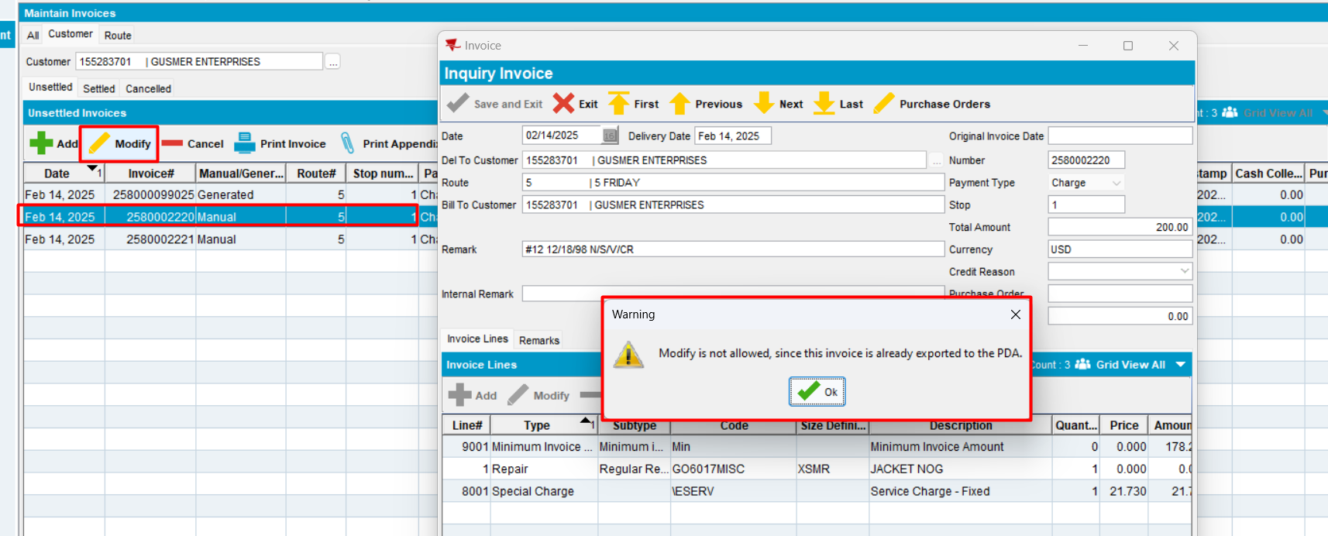
Expected behavior: - if pocketPCStatus = POCKETPC_COMPLETED (2)(PDA Status = Completed) and AUSCUSTOM -> display message: "No invoice can be added to the selected route control because the route is completed."
Actual behavior: as expected.
Tested ok

Route tab
- Add
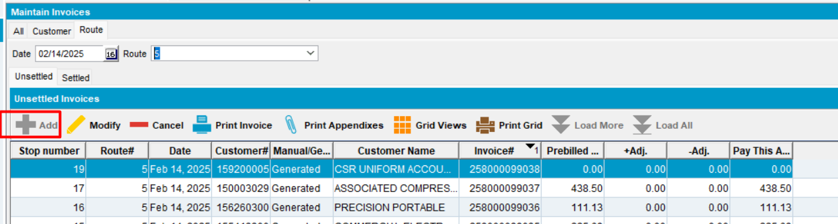
Add not available.
Tested OK
- Modify an existing manual invoice for this rc
Expected behavior: if AUSCUSTOM and PDA Status=Completed -> it is not allowed to modify an existing manual invoice
Actual behavior: as expected
Tested OK

All tab
- Select date
- Enter customer
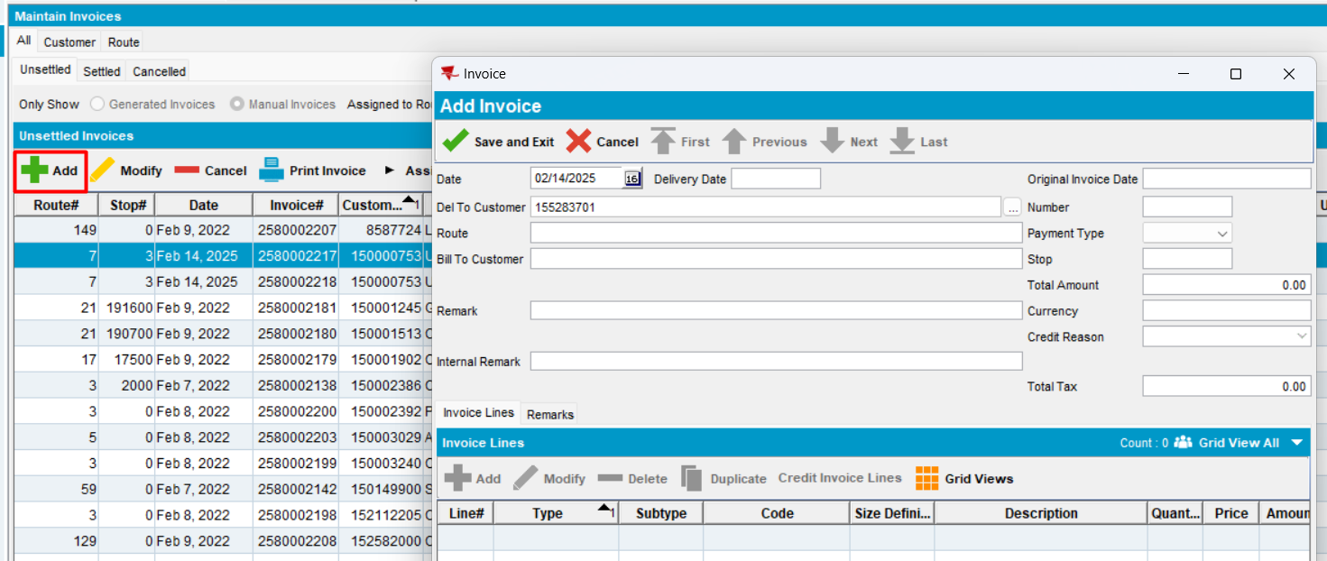
- Press Enter
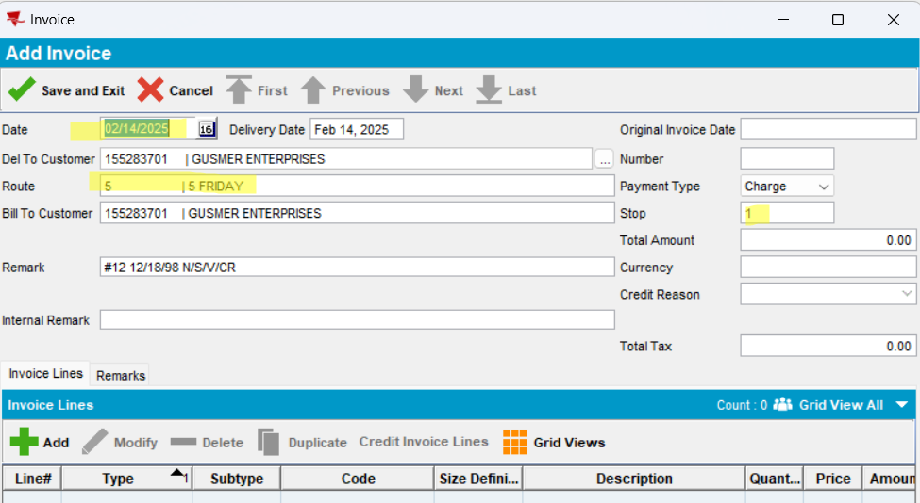
- Save
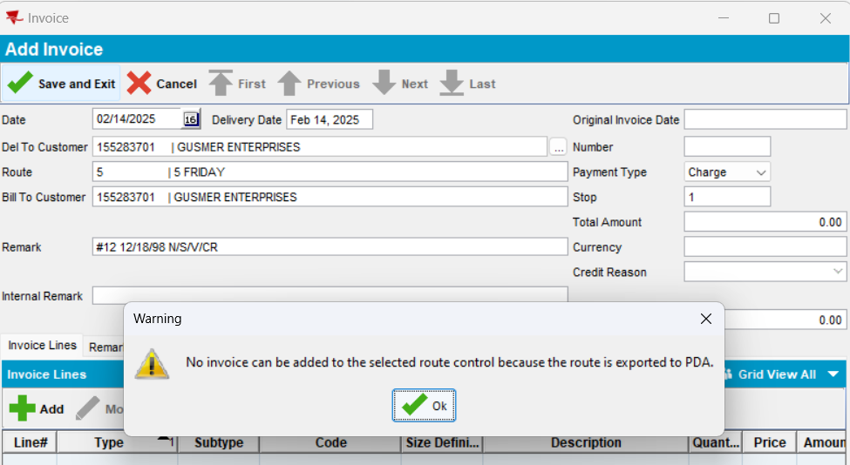
Expected behavior: - if pocketPCStatus = POCKETPC_COMPLETED (2)(PDA Status = Completed) and AUSCUSTOM -> display message: "No invoice can be added to the selected route control because the route is completed."
Actual behavior: as expected.
Tested ok
- Cancel and yes
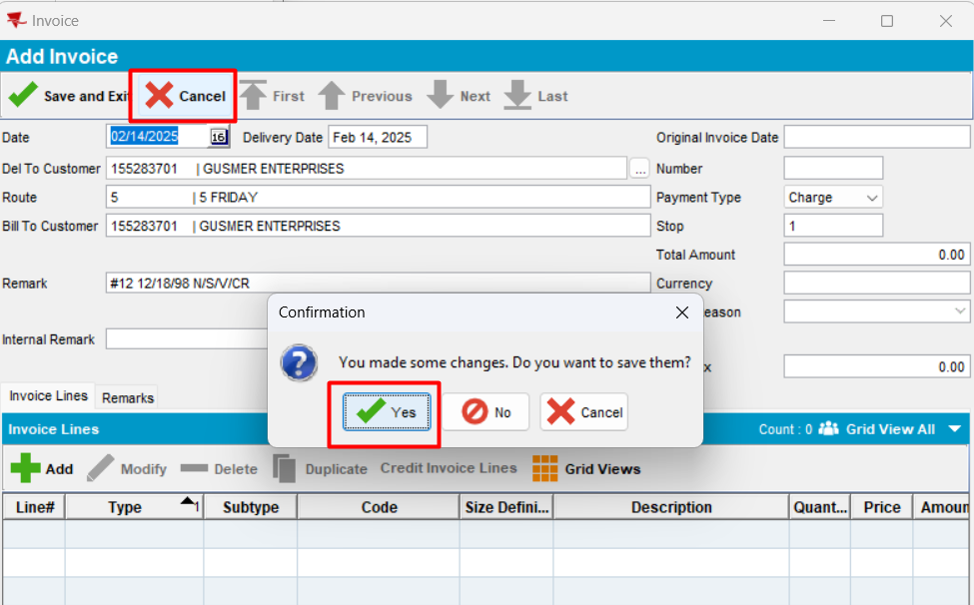
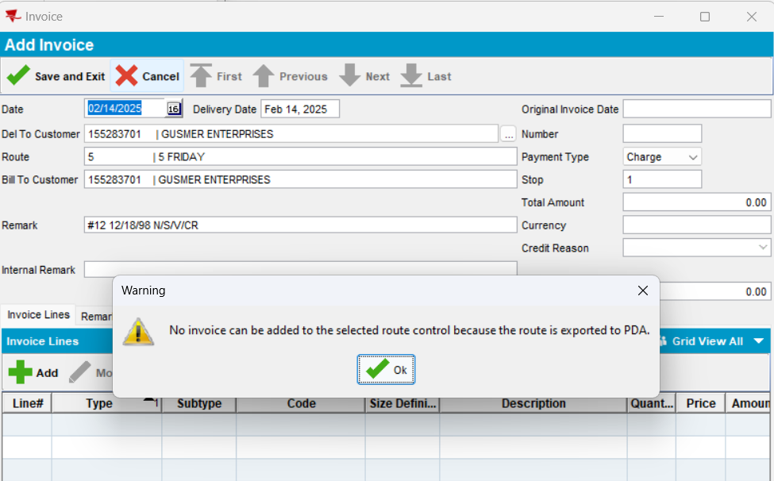
Expected behavior: - if pocketPCStatus = POCKETPC_COMPLETED (2)(PDA Status = Completed) and AUSCUSTOM -> display message: "No invoice can be added to the selected route control because the route is completed."
Actual behavior: as expected.
Tested ok
- Close window and yes
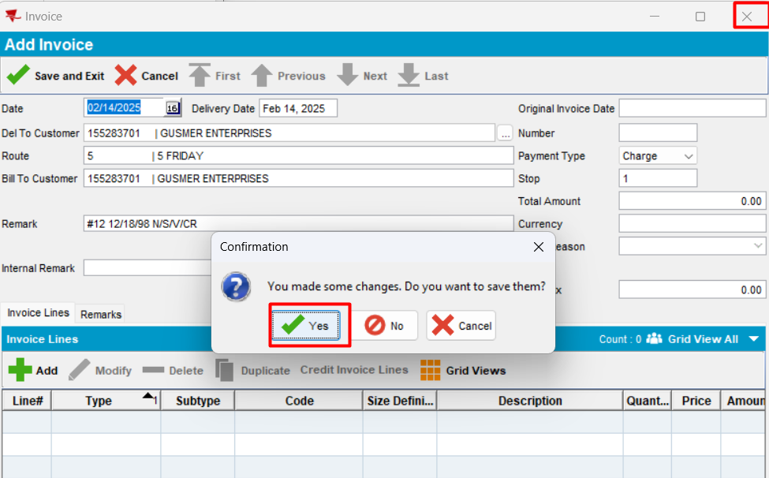
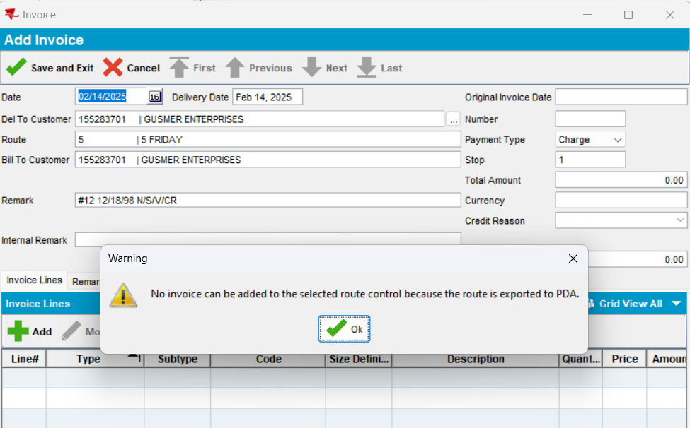
Expected behavior: - if pocketPCStatus = POCKETPC_COMPLETED (2)(PDA Status = Completed) and
AUSCUSTOM -> display message: "No invoice can be added to the selected route control because the route is completed."
Actual behavior: as expected.
Tested ok
- Modify an existing manual invoice for this route control
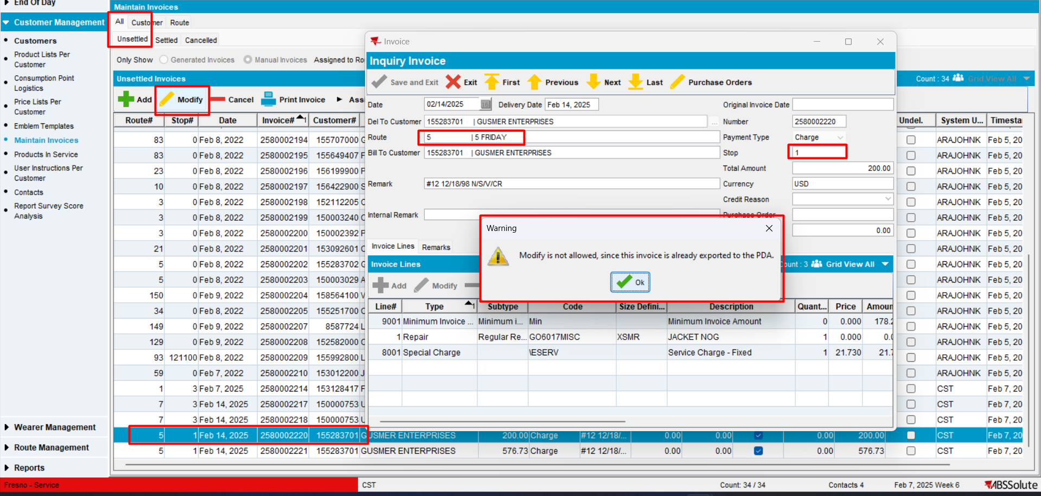
Expected behavior: if AUSCUSTOM and PDA Status=Completed -> it is not allowed to modify an existing manual invoice
Actual behavior: as expected
Tested OK

#6. Modify manual invoices when (pocketPCStatus != POCKETPC_EXPORTED(1) - Not exported) && (pocketPCStatus != POCKETPC_COMPLETED/IMPORTED(2) – Test OK
- In RSC select a route control with PDA Status = “Not exported” and select a customer
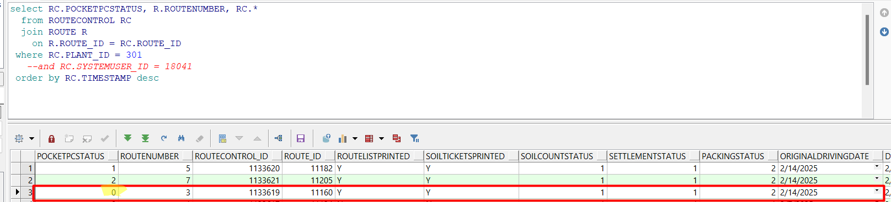
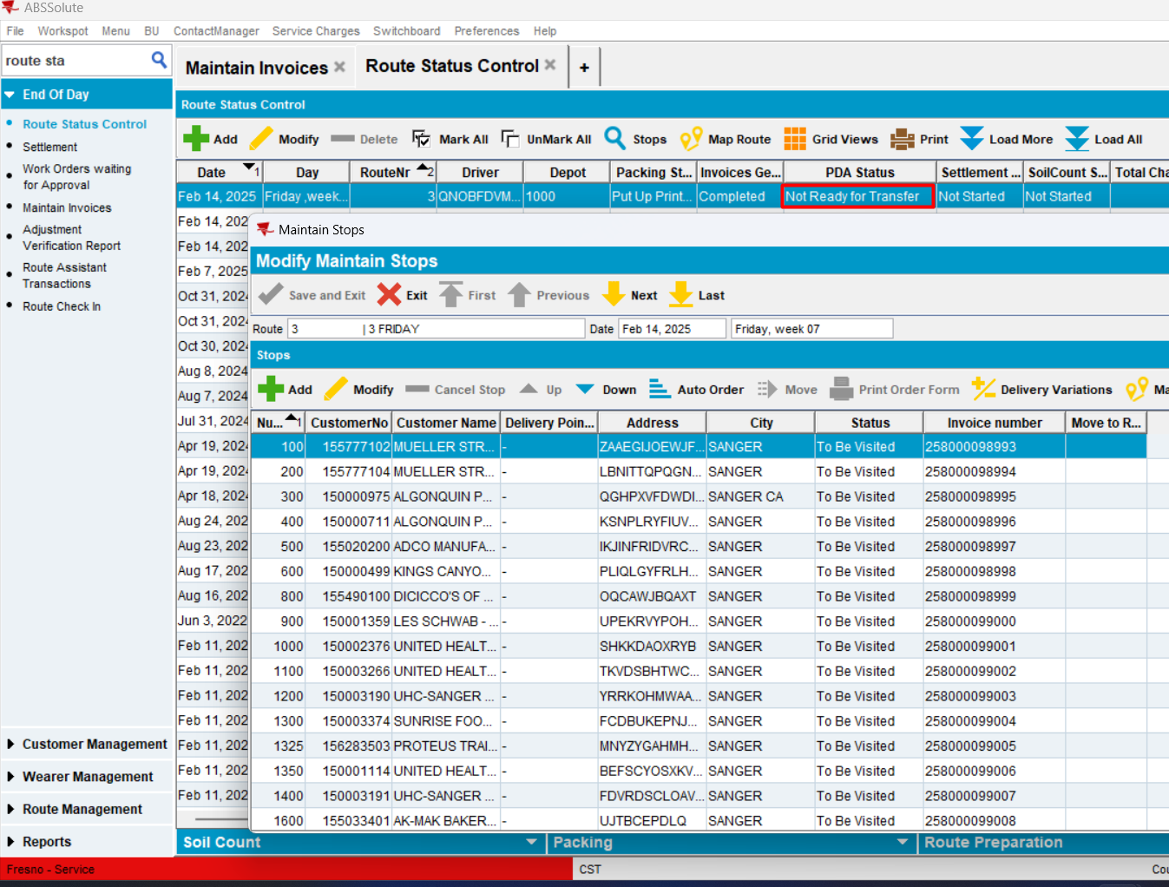

PDA Status = “Not exported” (PocketPCStatus=0)
- In Maintain Invoices dlg, Customer tab, load a customer (155777102 – stop 100)
- Unsettled tab, press MODIFY. Select the route date from the picture above.

Customer tab
- Add a new invoice line and save
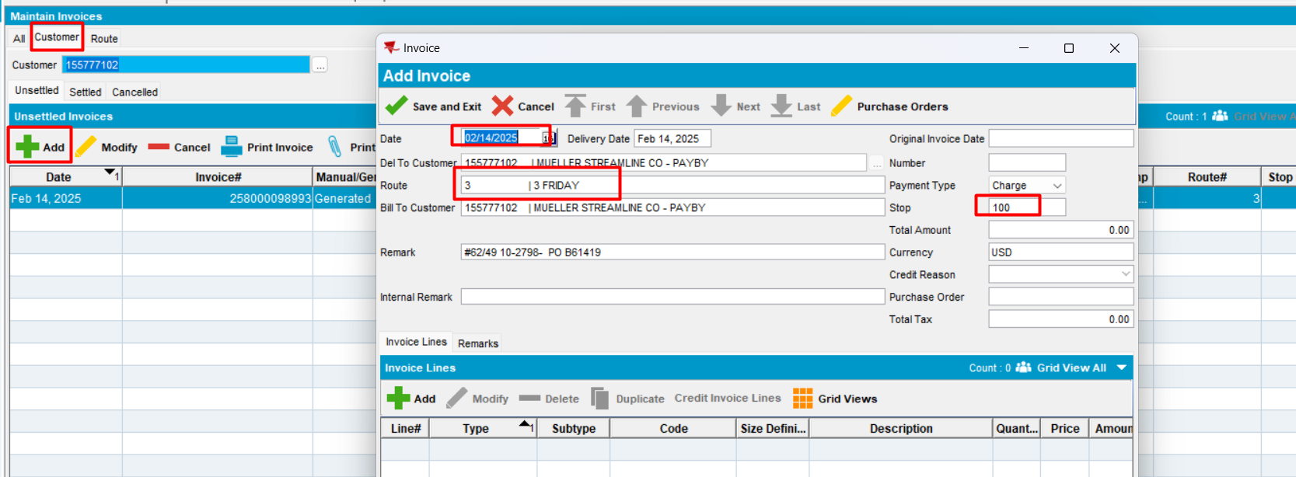
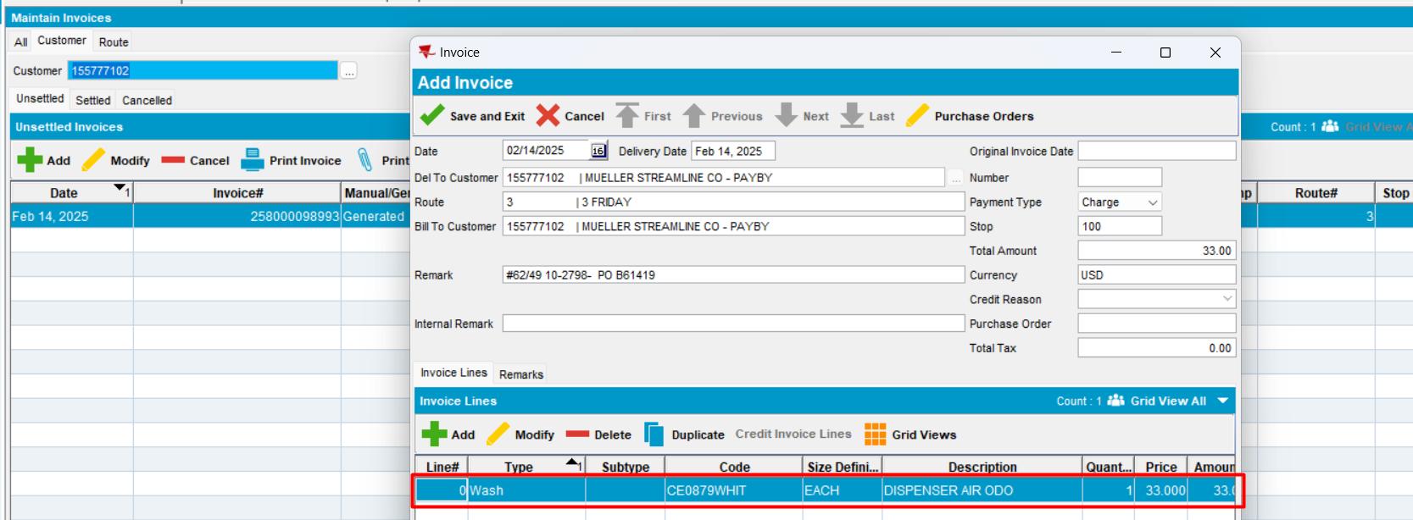
Invoice is saved
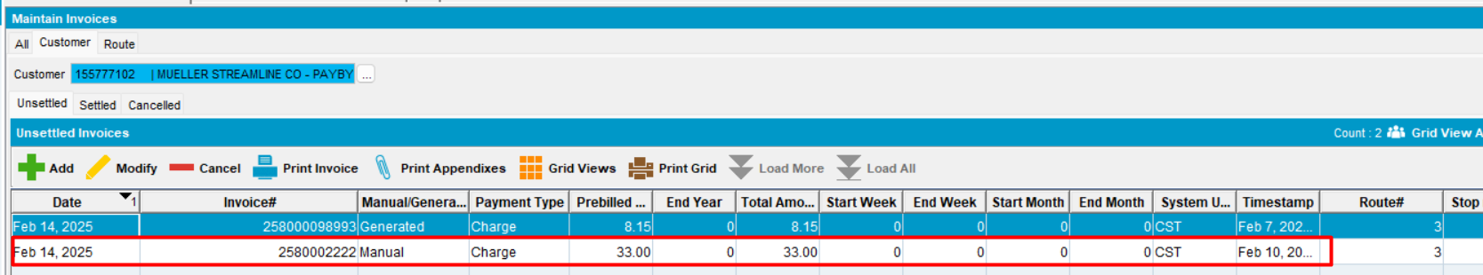
Reopen
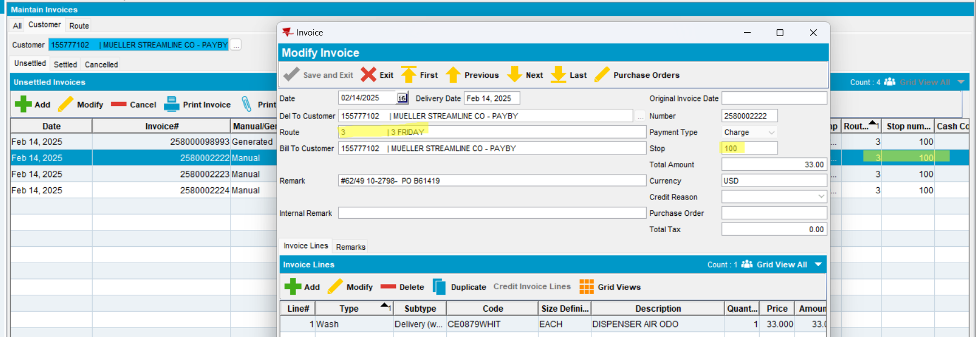
Expected behavior: when a customer is selected, in MODIFY mode, the route should populate and be automatically assigned to a new manually created invoice. No warning is shown.
Actual behavior: as expected.
Tested ok

Route tab
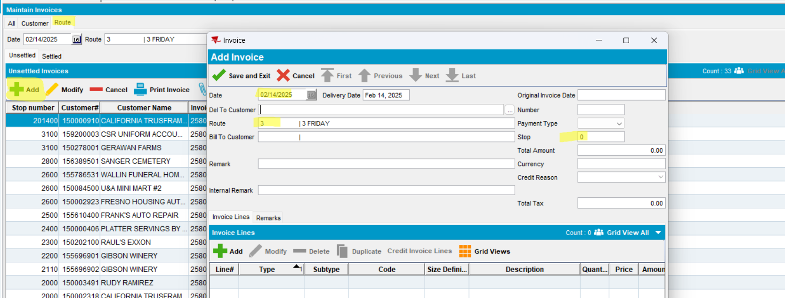
Expected behavior: when a customer is selected, in MODIFY mode, the route should populate and be automatically assigned to a new manually created invoice. No warning is shown.
Actual behavior: as expected.
Enter the customer number
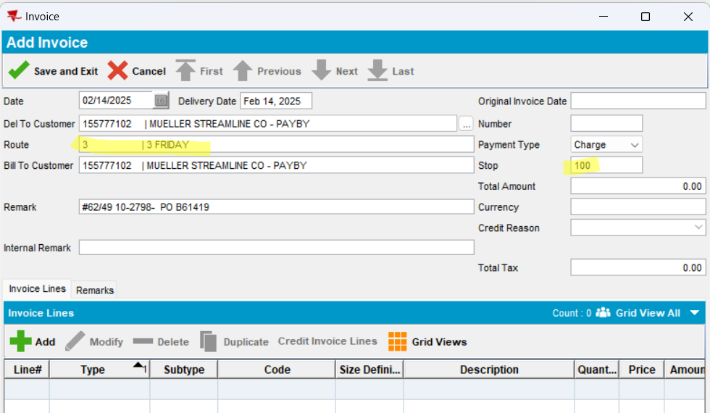
Save
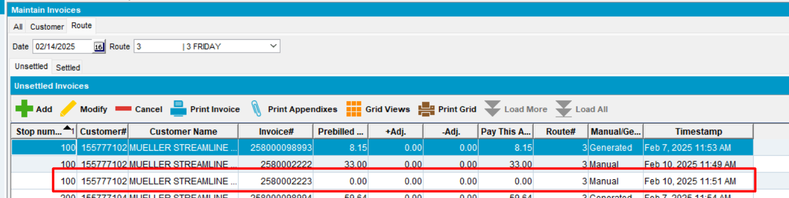
Reopen invoice
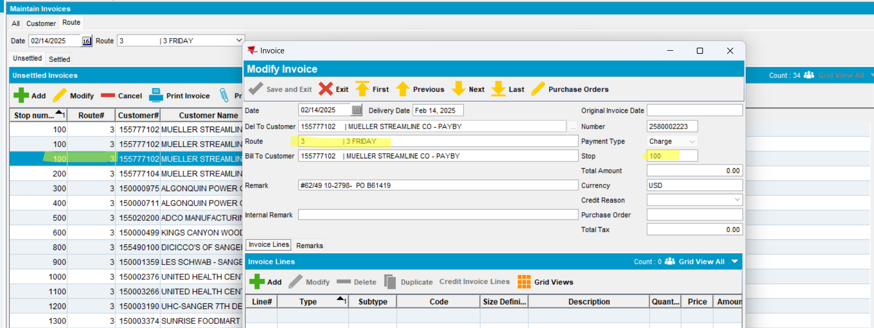
Tested ok

All tab
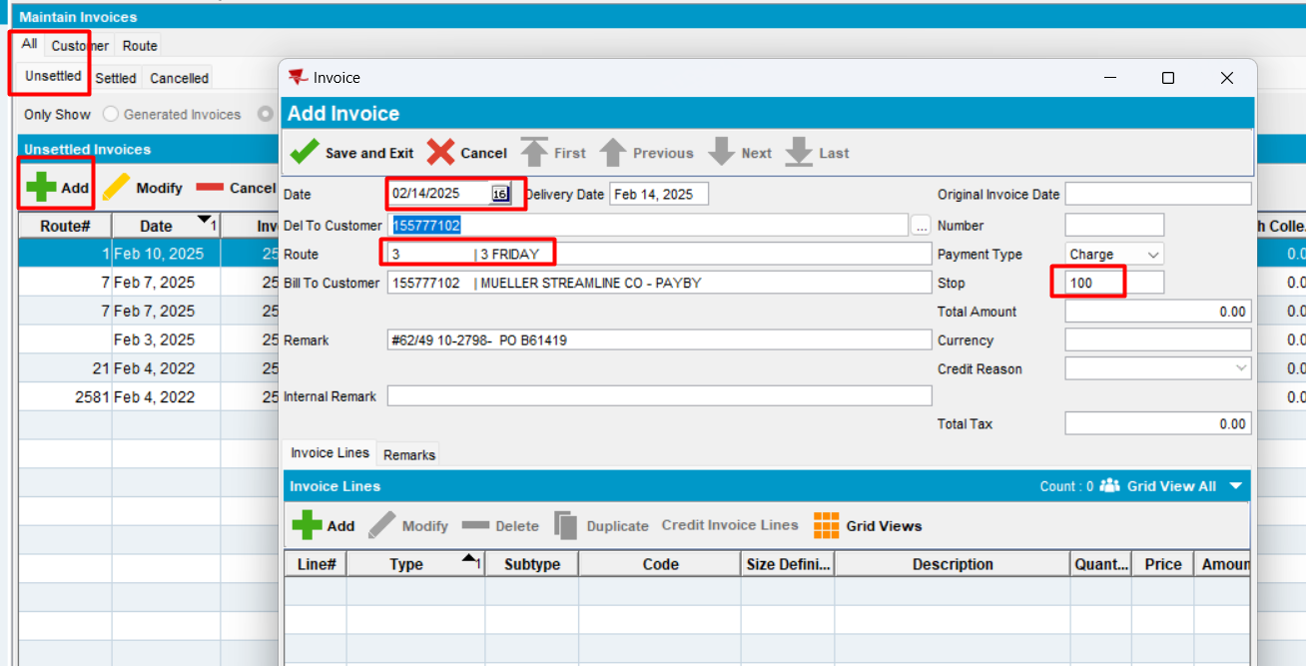
Add invoice line
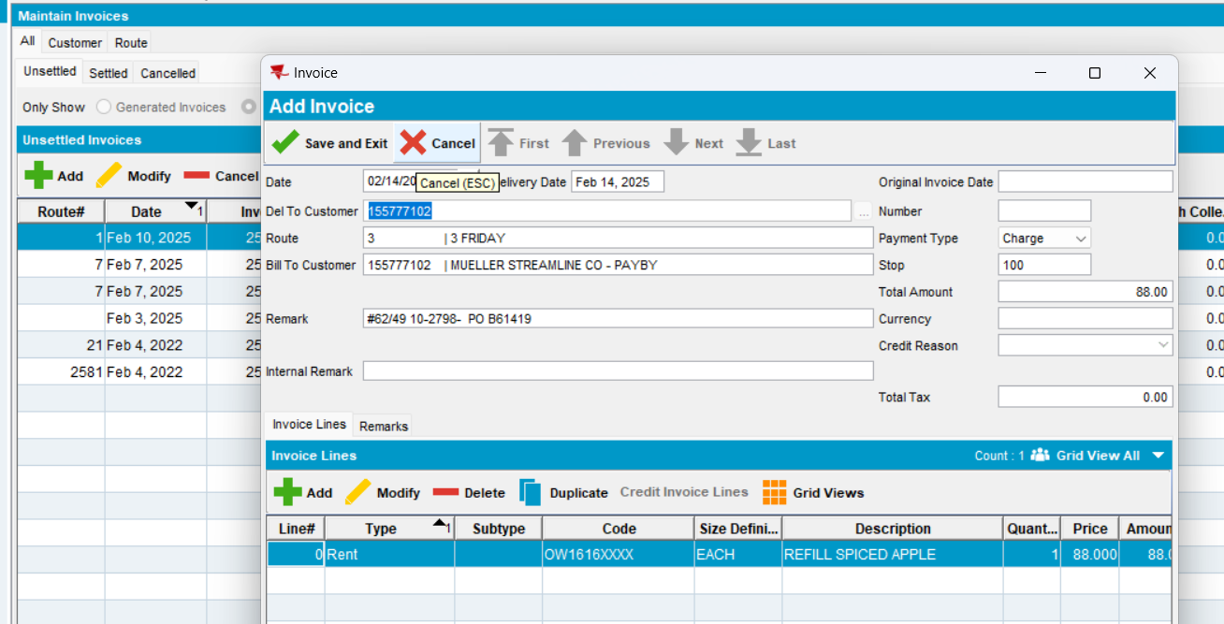
Reopen
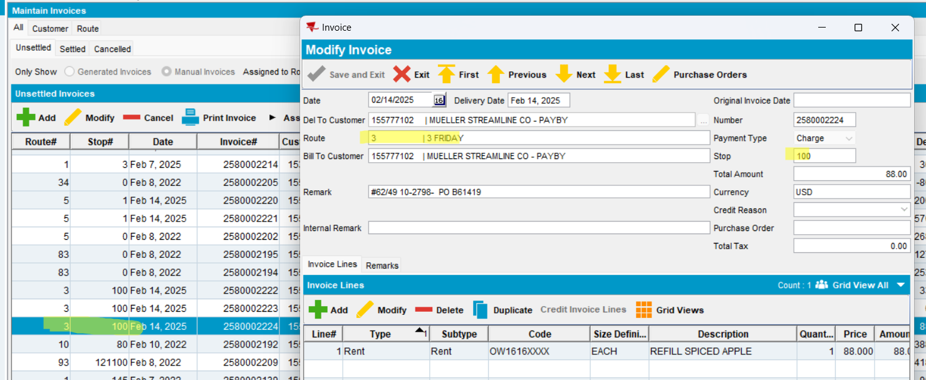
Expected behavior: when a customer is selected, in MODIFY mode, the route should populate and be automatically assigned to a new manually created invoice. No warning is shown.
Actual behavior: as expected.
Tested ok

PDA Status = “Ready for transfer” (PocketPCStatus=3)
- In RSC select a route control with PDA Status = “Ready for transfer” and select a customer
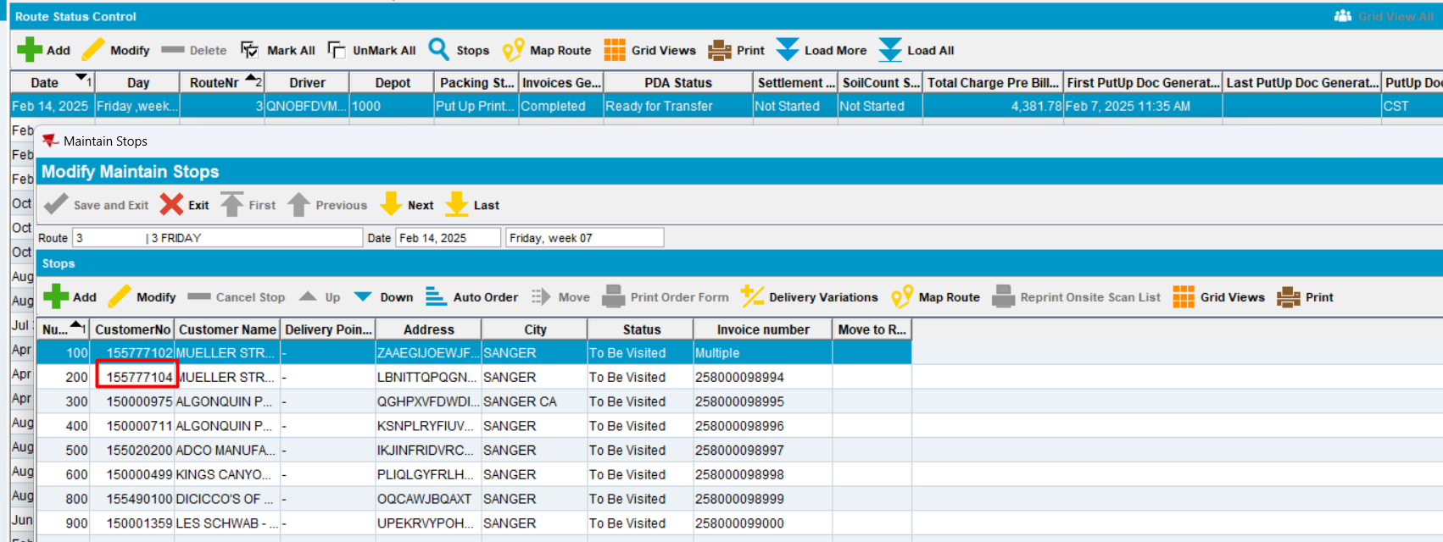

Customer tab
- In Maintain Invoices dlg, Customer tab, load a customer (155777104 - stop 200)
- Unsettled tab, select an invoice and press MODIFY.
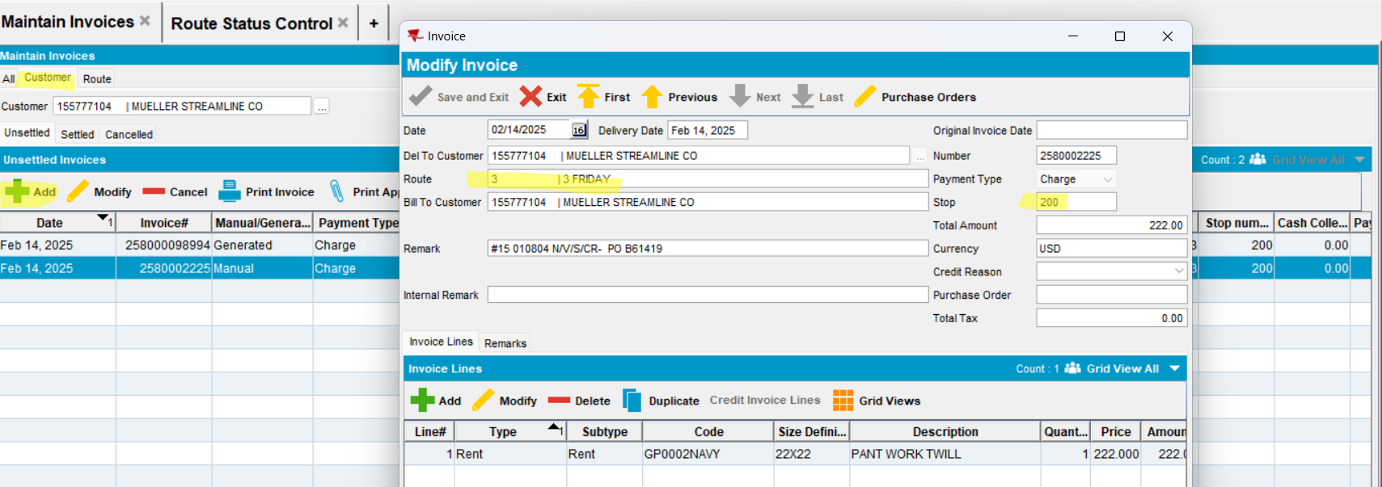
Expected behavior: when a customer is selected, in MODIFY mode, the route should populate and be automatically assigned to a new manually created invoice. No warning is shown.
Actual behavior: as expected.
- Add an invoice lines
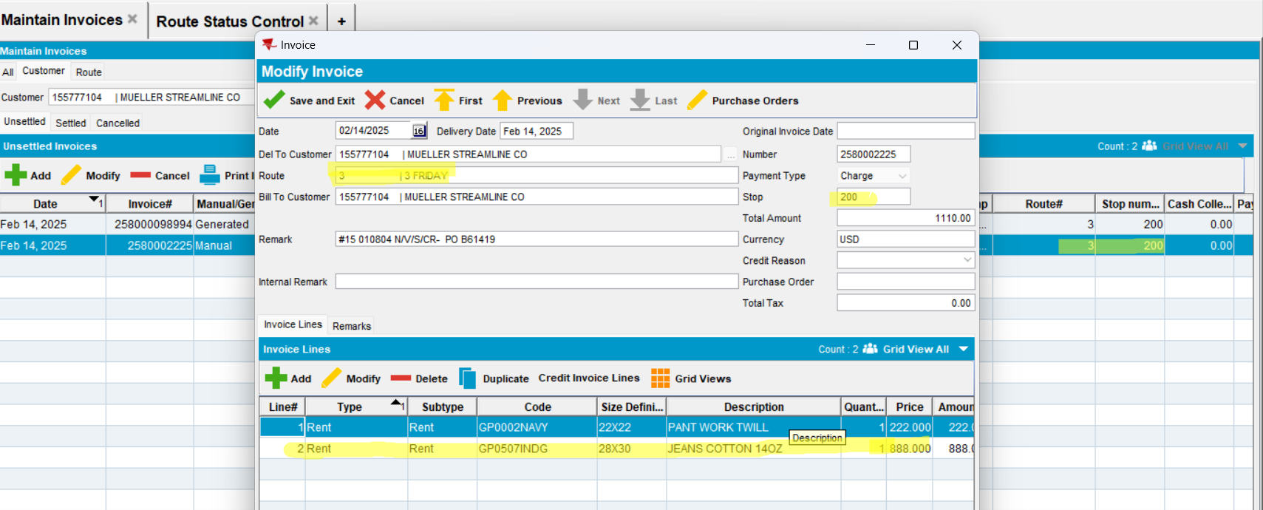
- Save and reopen
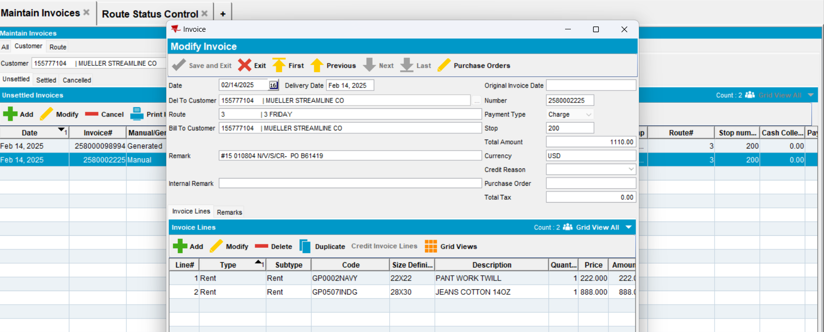
Modifications were saved.
Tested OK.

Route tab
- On route tab, press ADD button
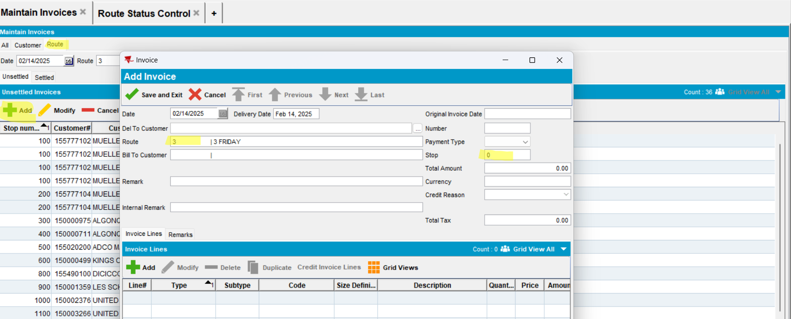
- Enter the customer
- Press enter button
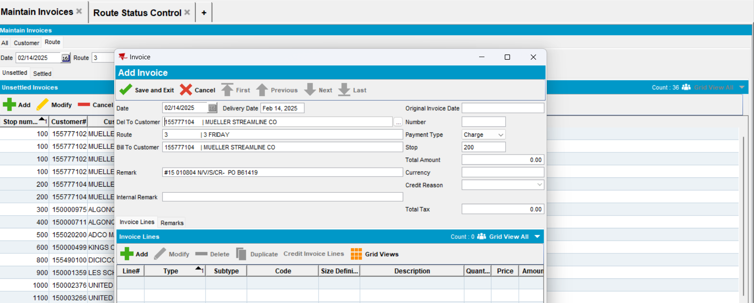
After pressing “enter” route and “stop” field are filled.
- Save
- Modify
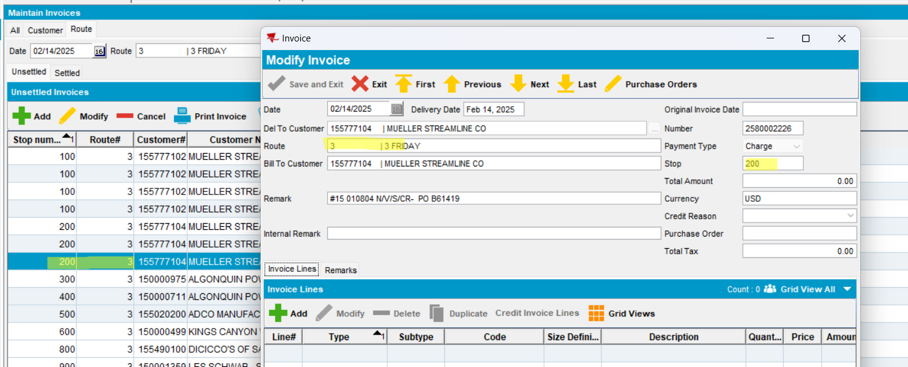
Expected behavior: when a customer is selected, in MODIFY mode, the route should populate and be automatically assigned to a new manually created invoice. No warning is shown.
Actual behavior: as expected.
Tested ok

All tab
- On All tab, press ADD button
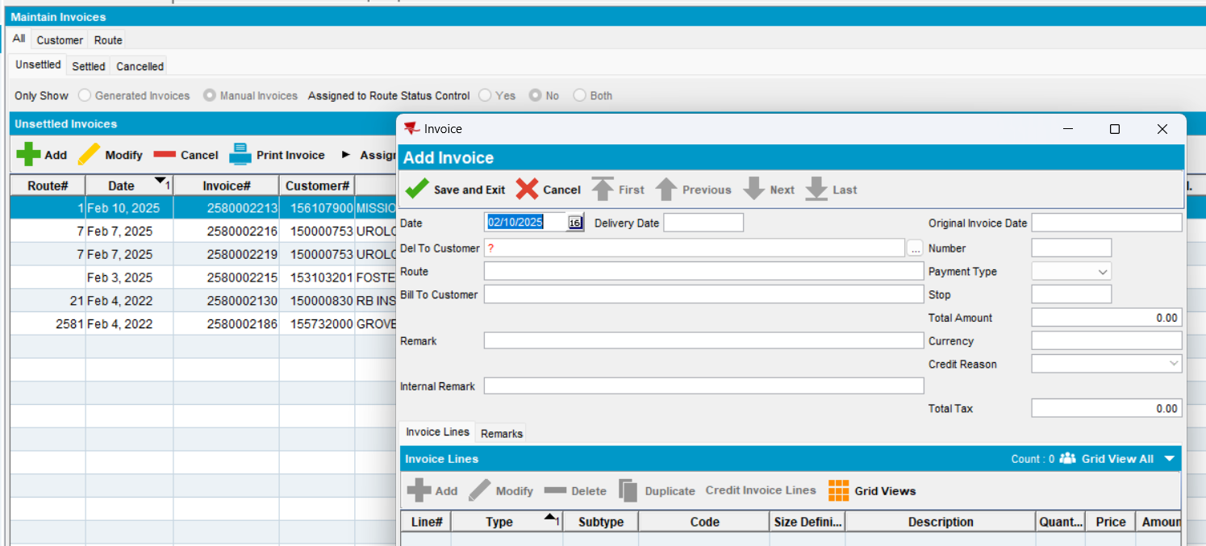
- Enter the customer
- Press enter button
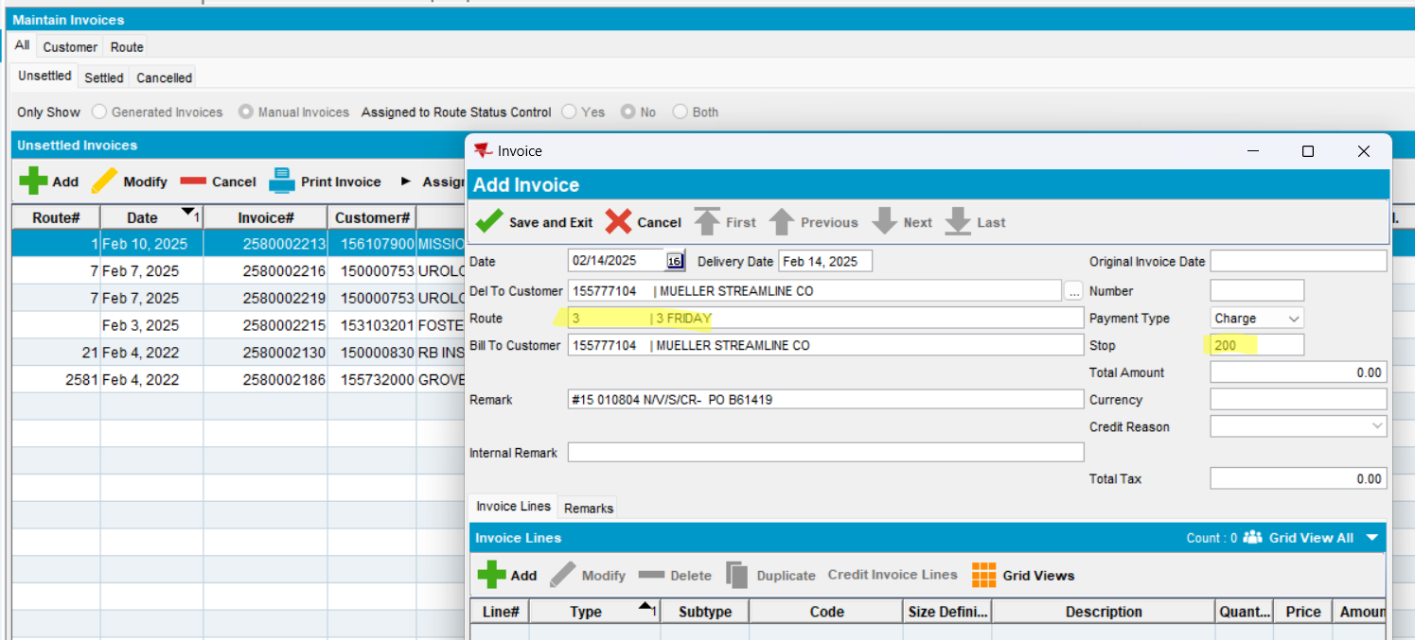
After pressing “enter” route and “stop” field are filled.
- Save
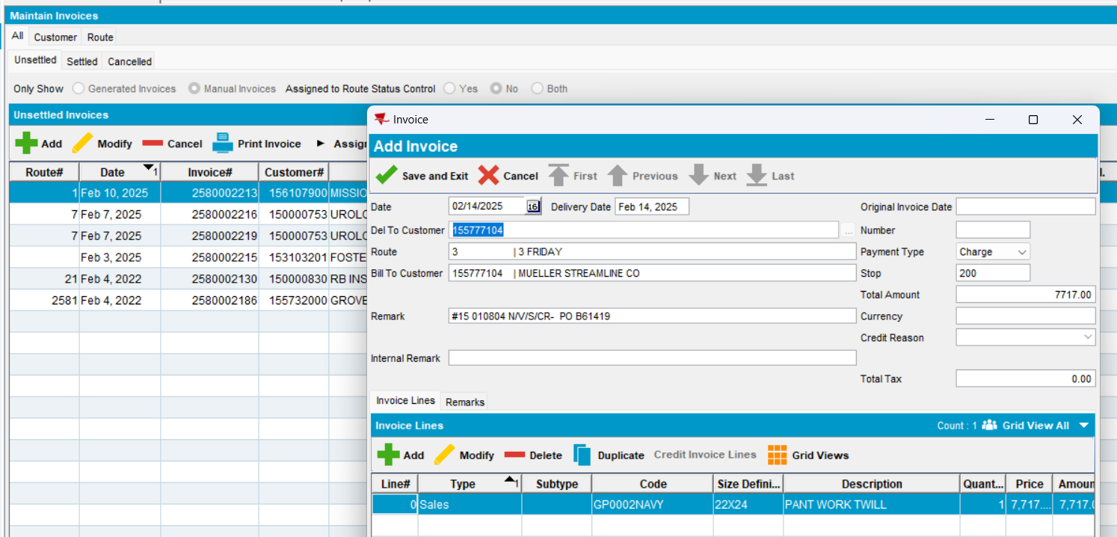
- Modify invoice and add a new invoice line
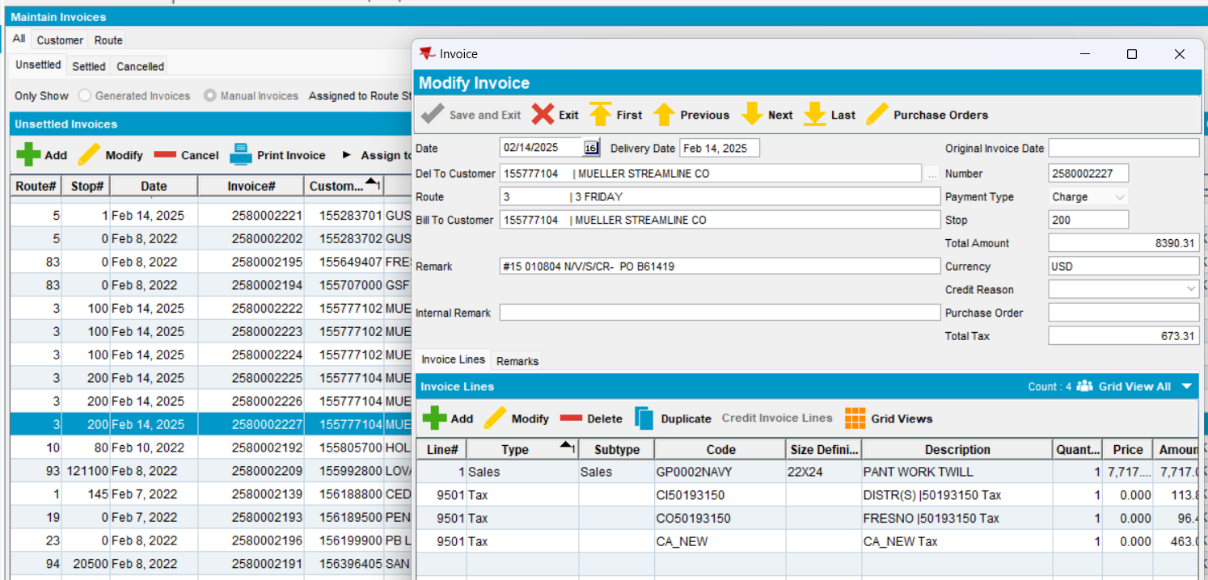
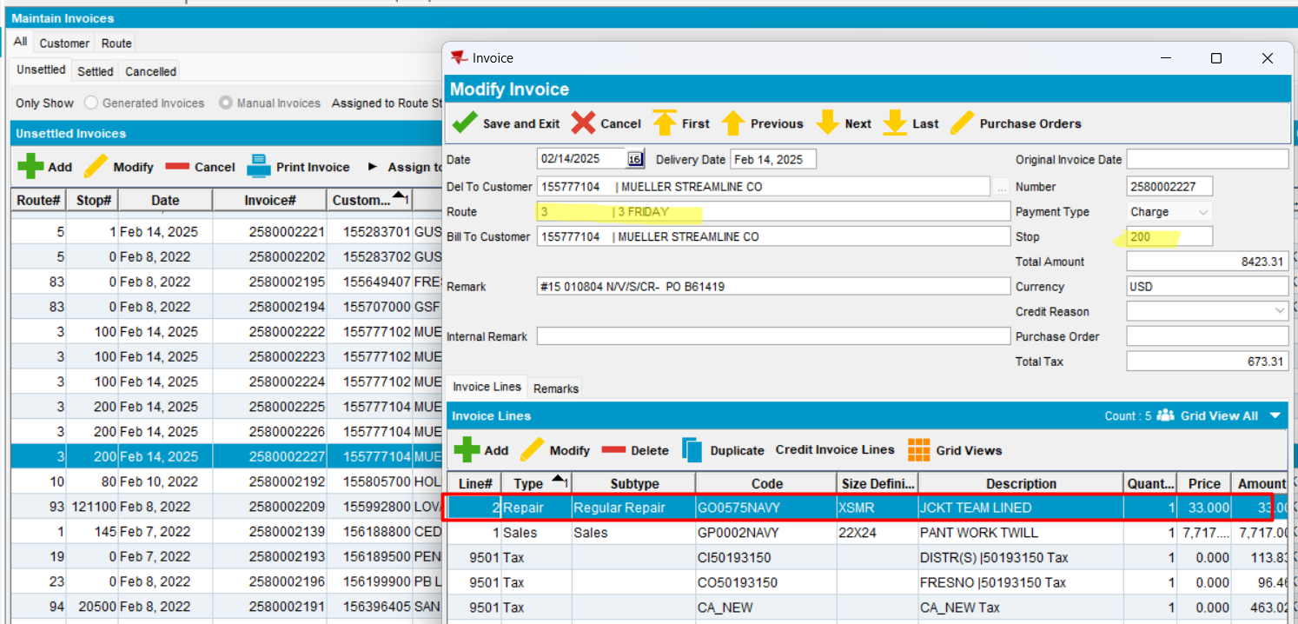
Expected behavior: when a customer is selected, in MODIFY mode, the route should populate and be automatically assigned to a new manually created invoice. No warning is shown.
Actual behavior: as expected.
Tested ok
- Reopen
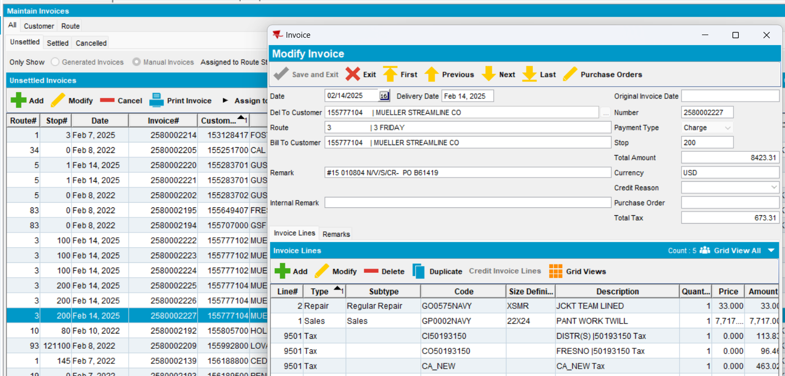
Modification is correctly saved.
Tested OK

#7. AUSCUSTOM not in the license
BU: 252 Fargo
- AUSCUSTOM NOT in the license

#7.1. Test when pocketPCStatus = POCKETPC_COMPLETED (2) (PDA Status = Completed) -> can add and can modify manual invoice – Test OK
Hash: a0b96e3
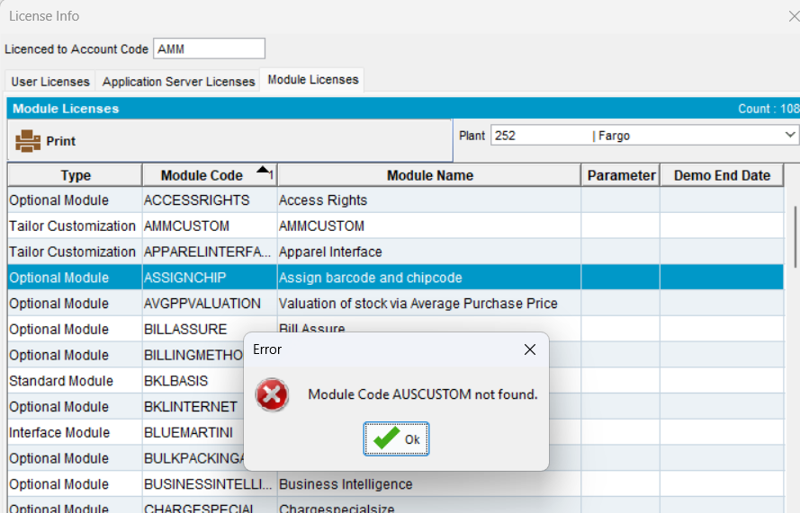
- In RSC select a route control with PDA Status = “completed” and select a customer
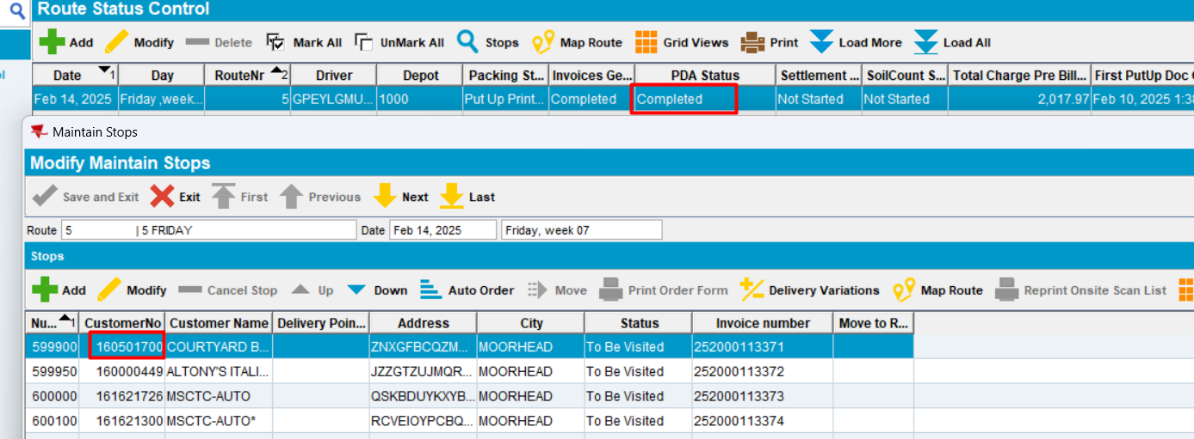
- In Maintain Invoices dlg, Customer tab, load a customer (160501700 - stop 599900)

Customer tab
- Unsettled tab, press ADD to add a new manual invoice.
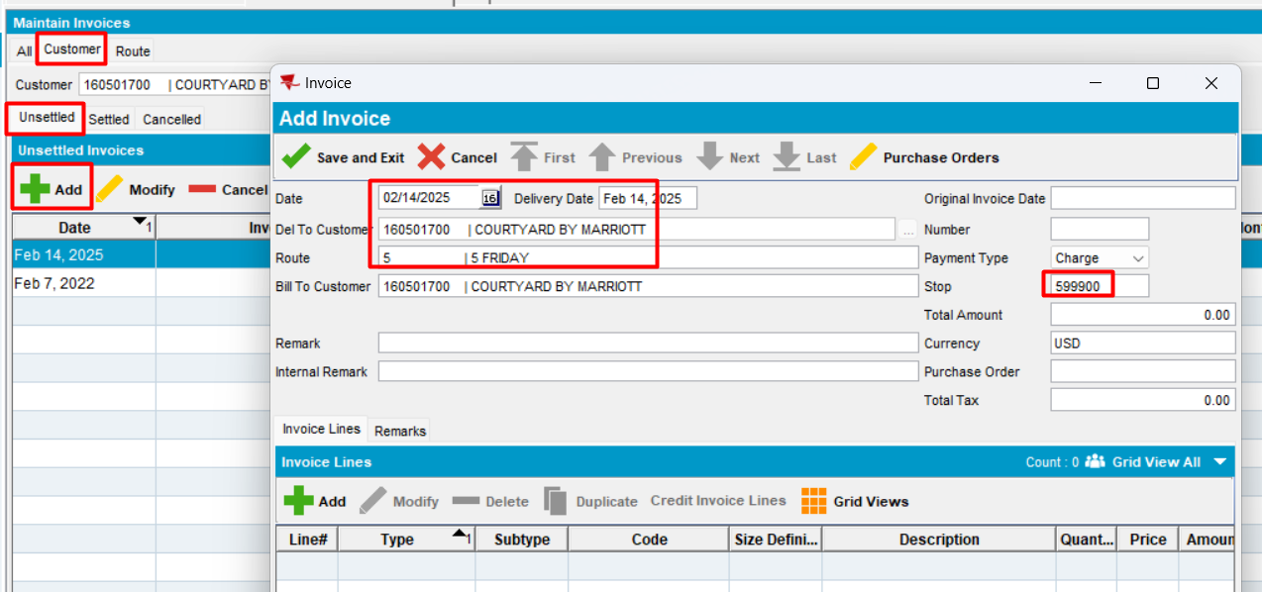
Expected behavior: when a customer is selected, ADD mode is allowed and the route should populate and be automatically assigned to a new manually created invoice
Actual behavior: as expected.
Tested ok
- Save invoice
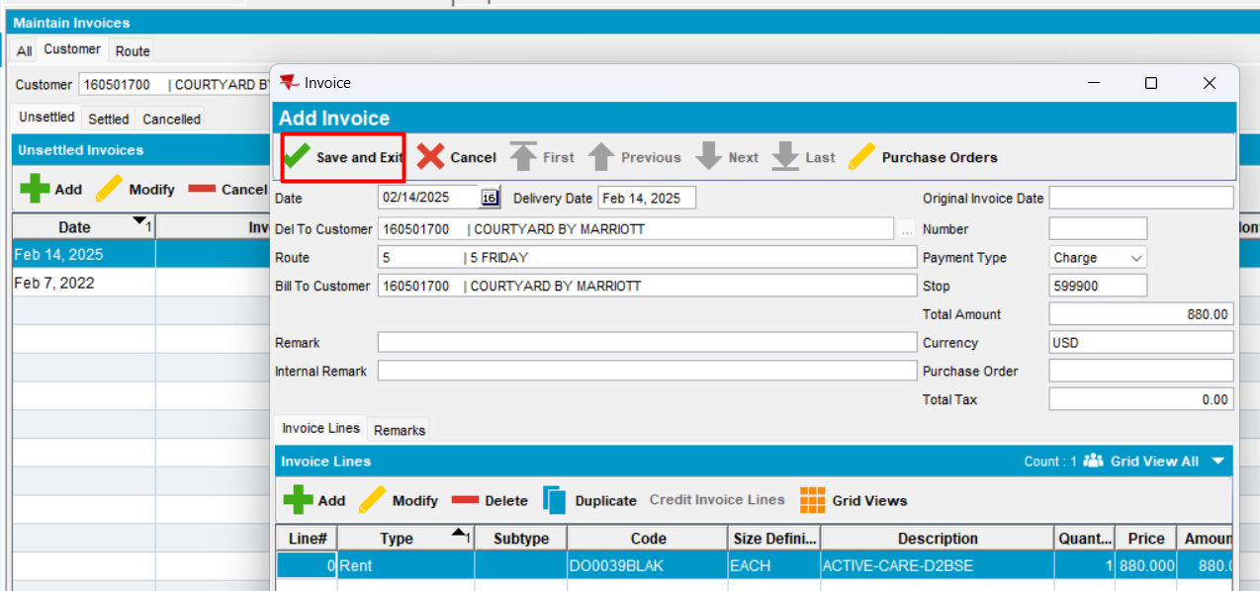
- Modify
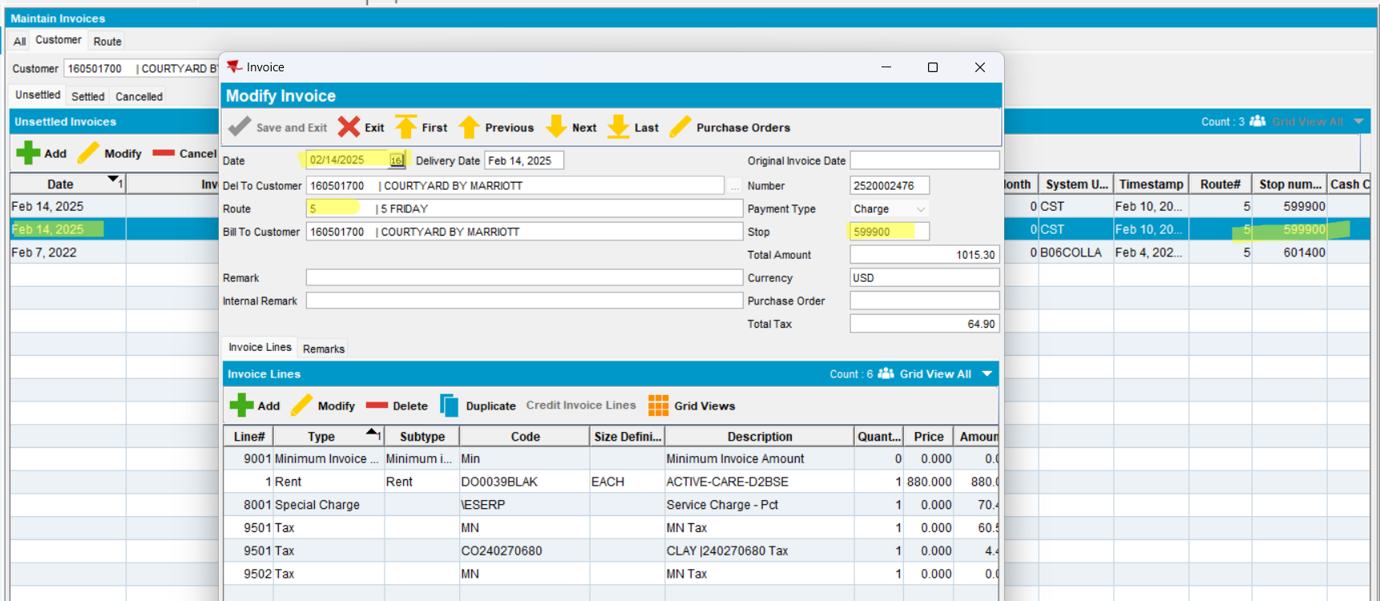
Invoice is saved
Expected behavior: - if pocketPCStatus = POCKETPC_COMPLETED (2)(PDA Status = Completed) and AUSCUSTOM not in license -> MODIFY is allowed
Actual behavior: as expected.
Tested ok

Route tab
- Add a manual invoice
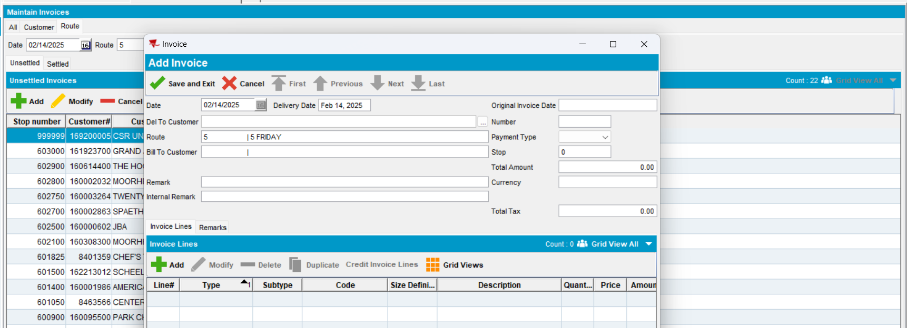
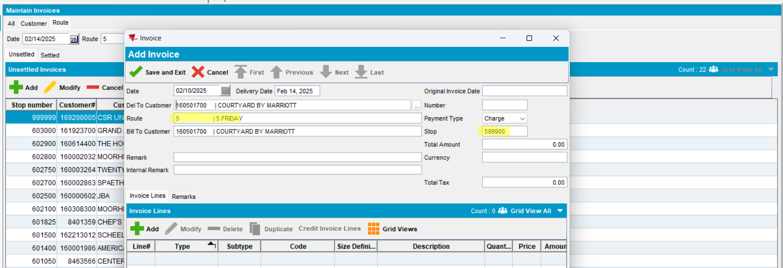
Invoice is saved
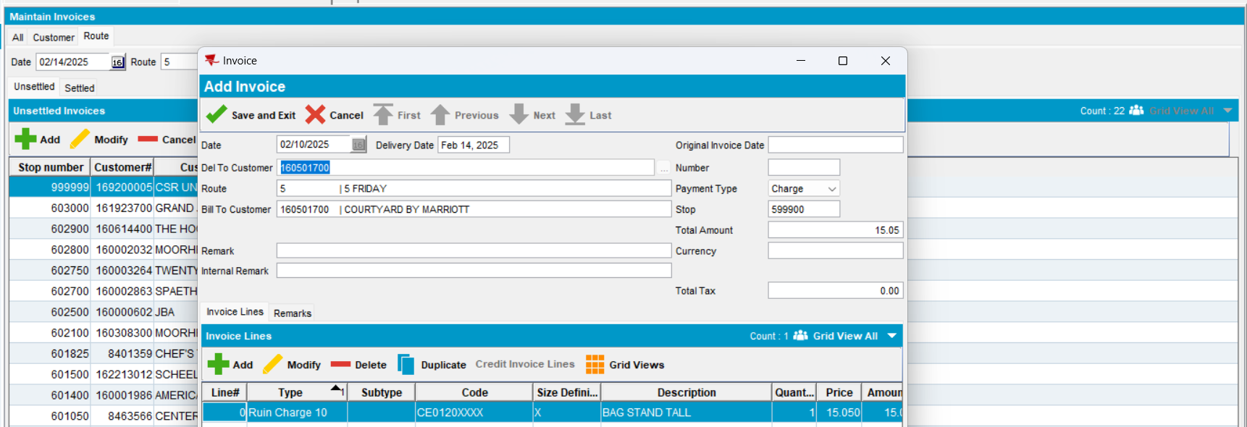
Expected behavior: when a customer is selected, ADD mode is allowed and the route should populate and be automatically assigned to a new manually created invoice
Actual behavior: as expected.
Tested ok
- Modify an existing invoice
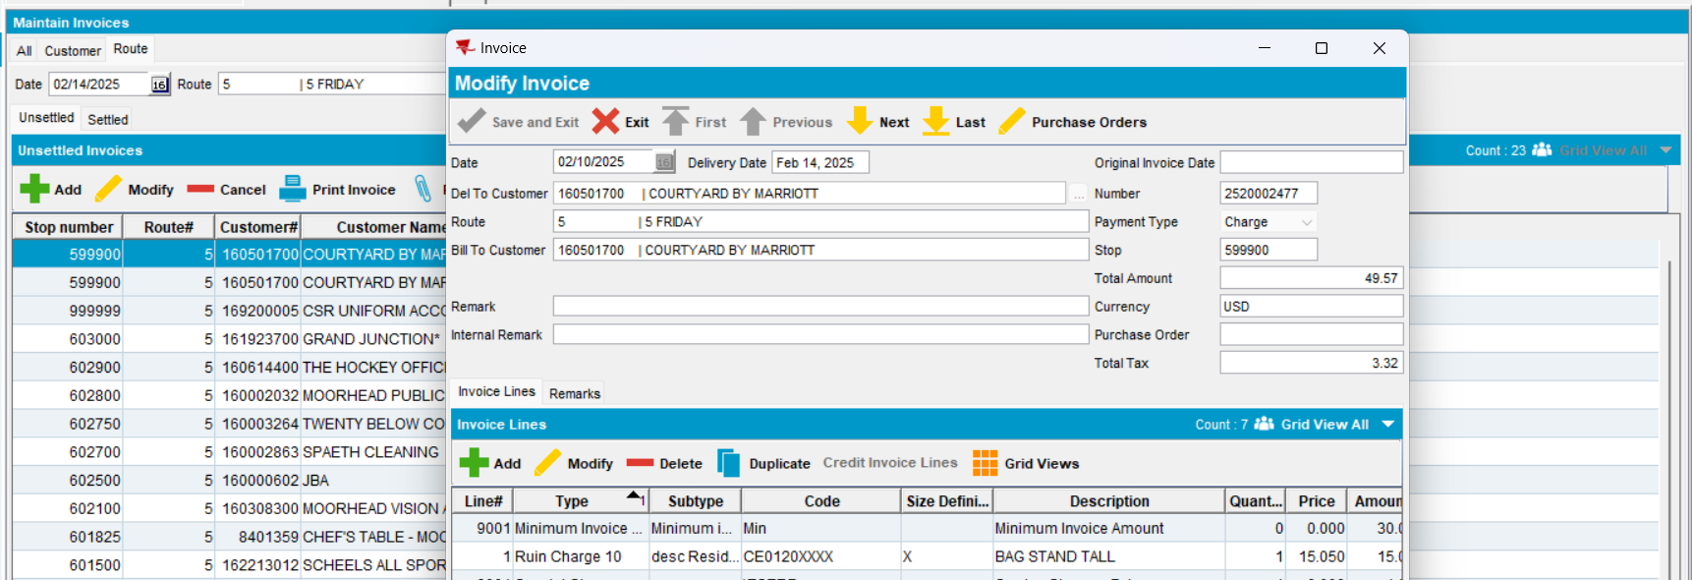
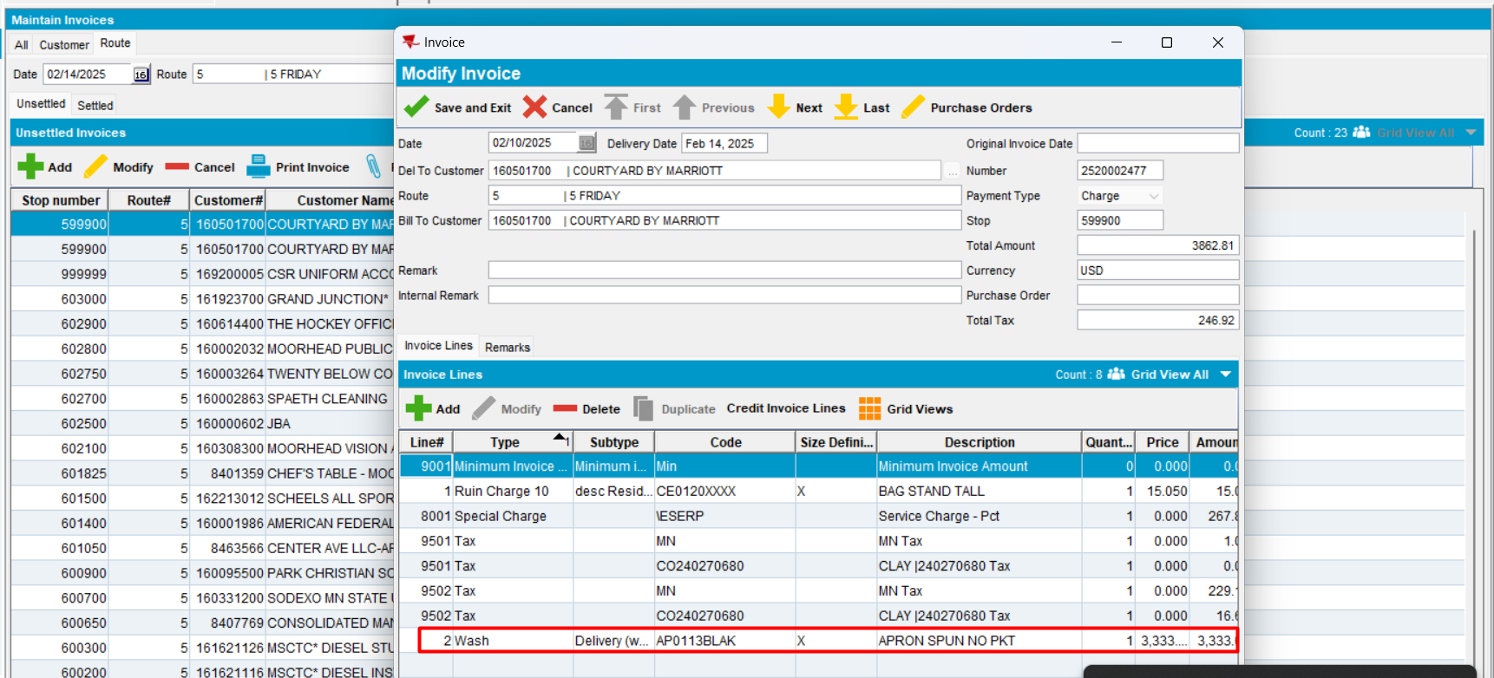
Expected behavior: - if pocketPCStatus = POCKETPC_COMPLETED (2)(PDA Status = Completed) and AUSCUSTOM not in license -> MODIFY is allowed
Actual behavior: as expected.
Tested ok

All tab
- Add a manual invoice
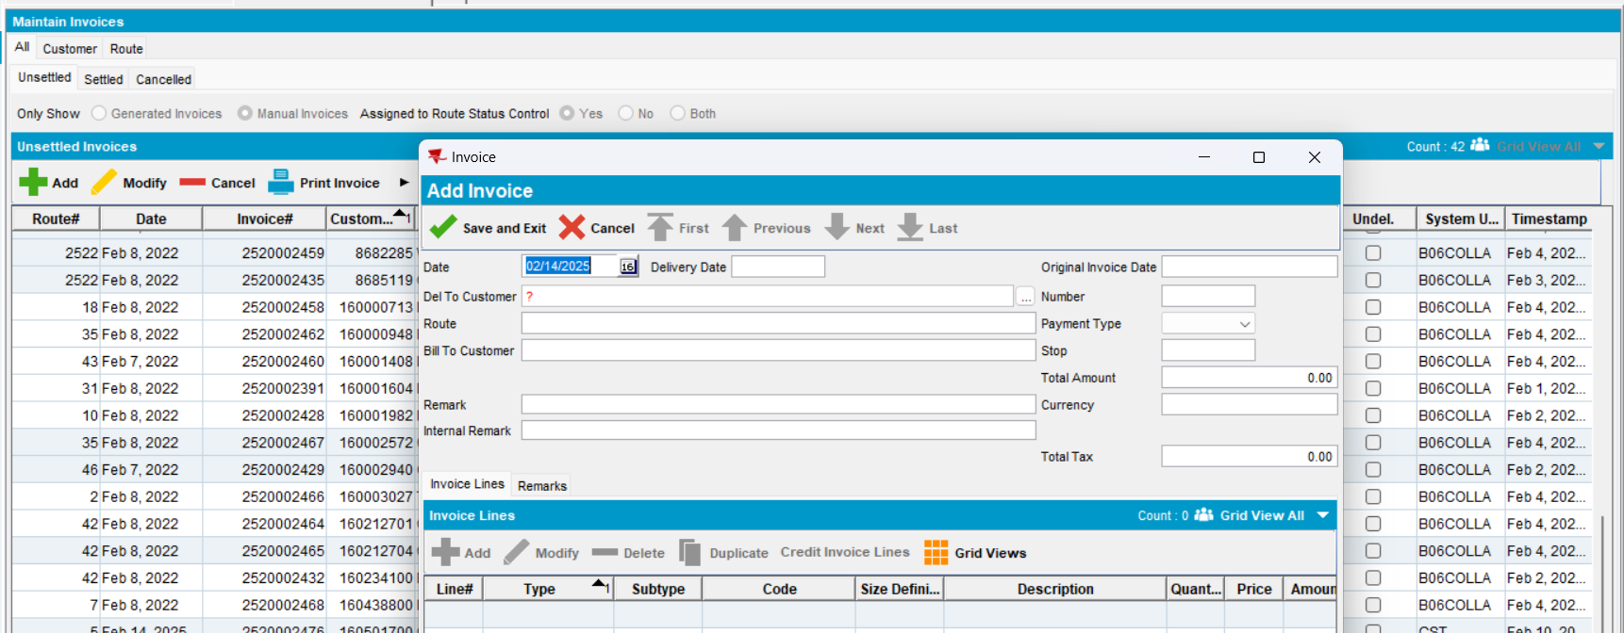
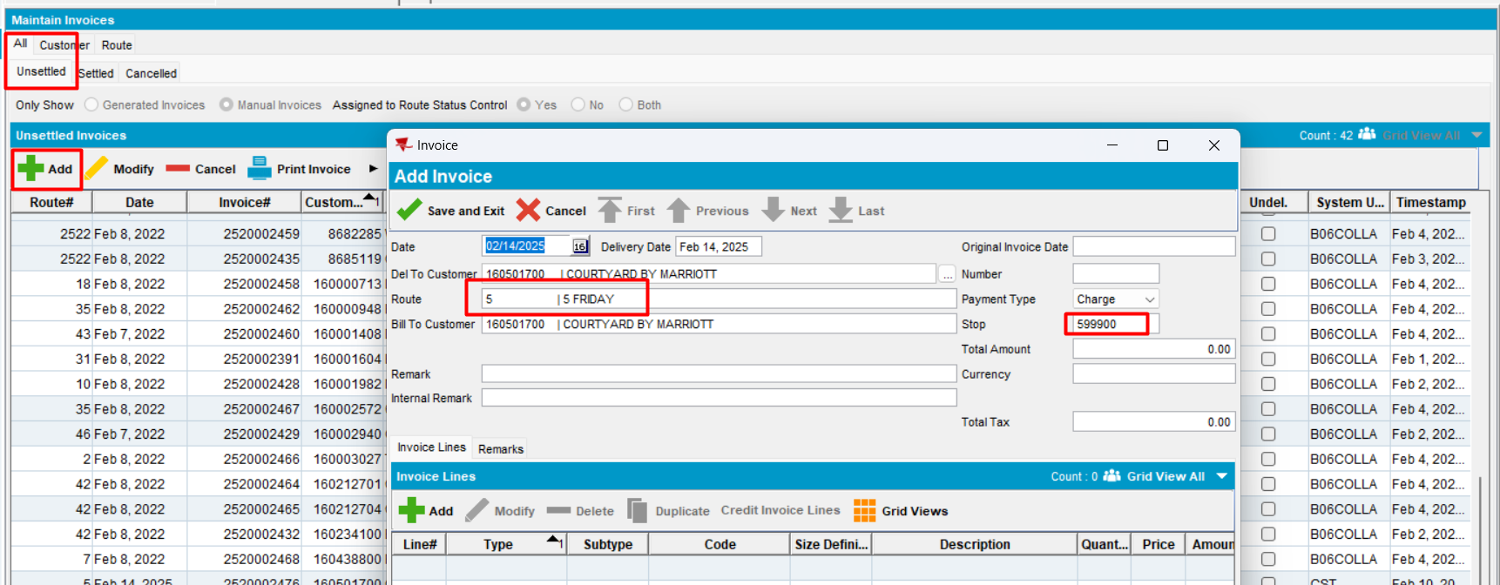
Invoice is saved
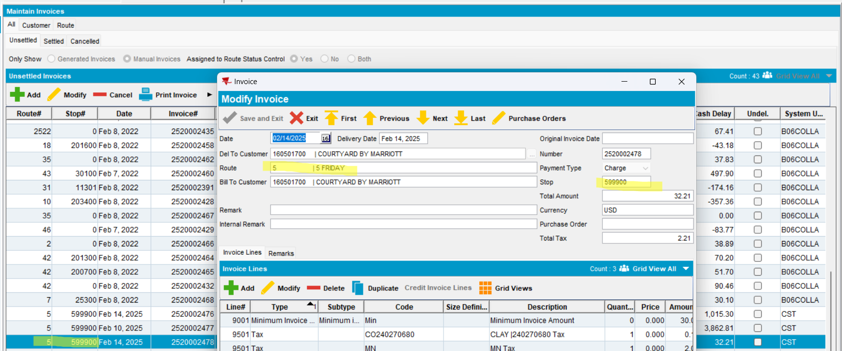
Expected behavior: when a customer is selected, ADD mode is allowed and the route should populate and be automatically assigned to a new manually created invoice
Actual behavior: as expected.
Tested ok
- Modify an existing invoice and add a new invoice line
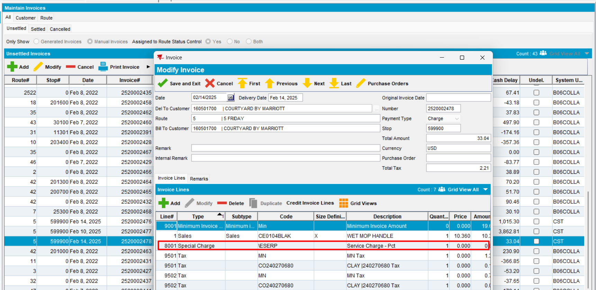
Modification was saved
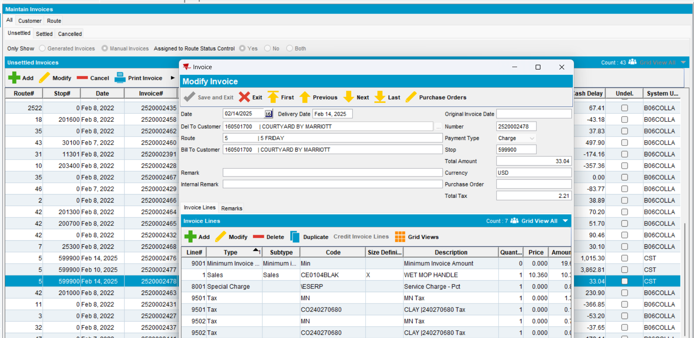
Expected behavior: - if pocketPCStatus = POCKETPC_COMPLETED (2)(PDA Status = Completed) and AUSCUSTOM not in license -> MODIFY is allowed
Actual behavior: as expected.
Tested ok

#7.2. Test when pocketPCStatus = POCKETPC_EXPORTED (1) (PDA Status = “Transferred to PDA”) -> can not add and can modify manual invoice – Test OK
BU: 252 Fargo
Hash: a0b96e3
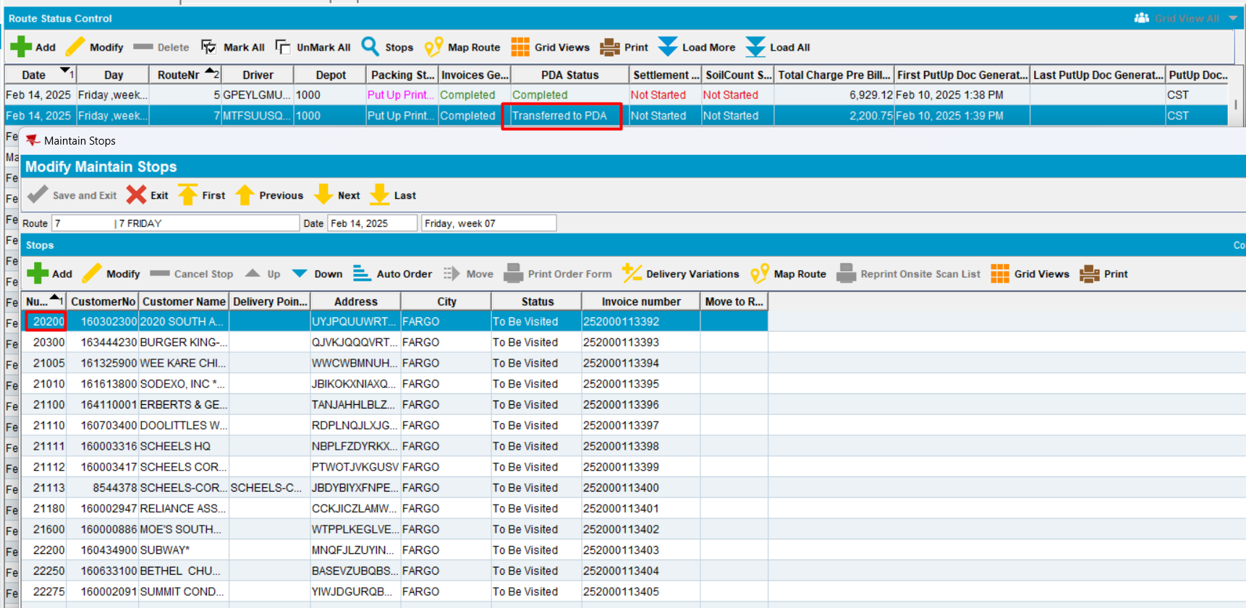

Customer tab
- Unsettled tab, press ADD to add a new manual invoice on the same date as the one from route control.
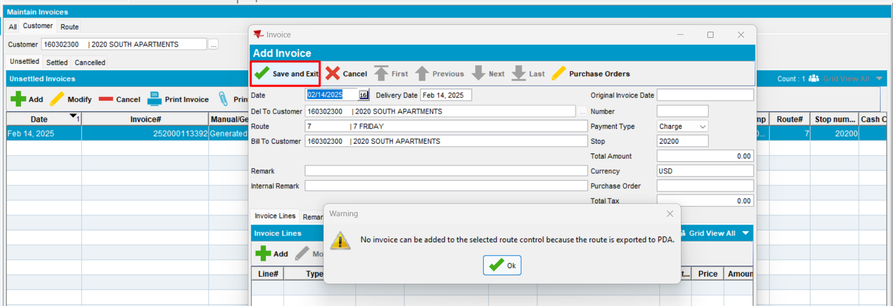
Expected behavior: when a customer is selected, in ADD mode the route should populate and be automatically assigned to a new manually created invoice. When saving, display message: "No invoice can be added to the selected route control because the route is exported to PDA."
Actual behavior: as expected.
Tested ok
- Try cancel + yes
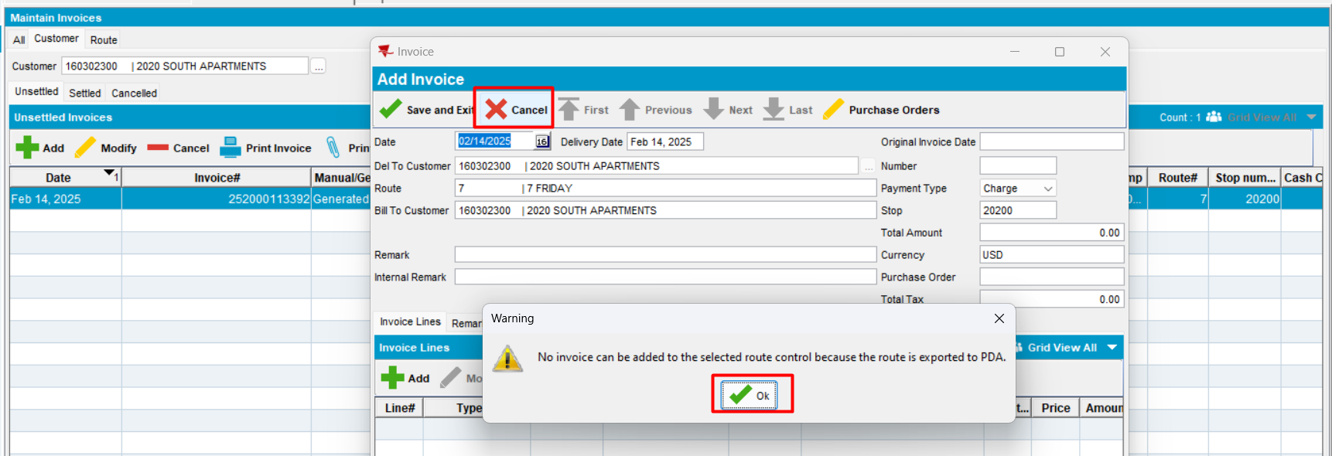
Expected behavior: when a customer is selected, in ADD mode the route should populate and be automatically assigned to a new manually created invoice. When saving, display message: "No invoice can be added to the selected route control because the route is exported to PDA."
Actual behavior: as expected.
Tested ok
- Try close and yes
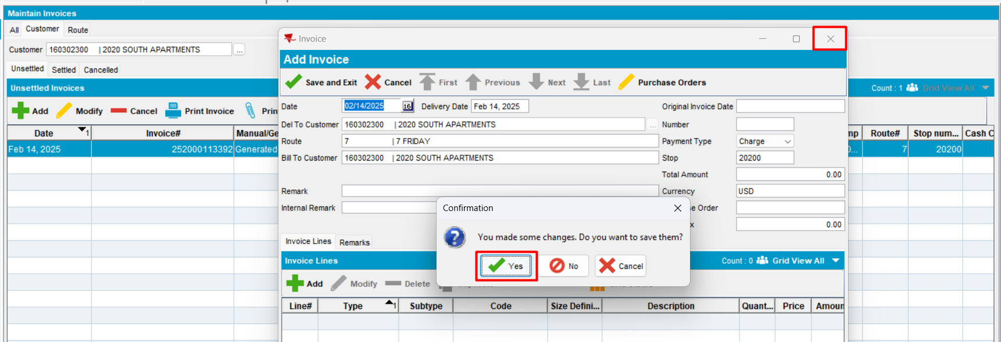
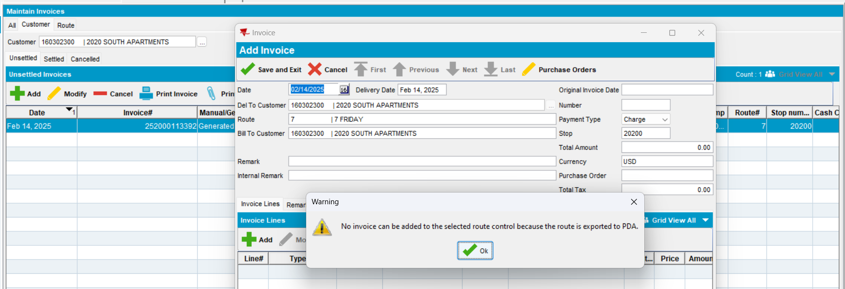
Expected behavior: when a customer is selected, in ADD mode the route should populate and be automatically assigned to a new manually created invoice. When saving, display message: "No invoice can be added to the selected route control because the route is exported to PDA."
Actual behavior: as expected.
Tested ok
- Modify
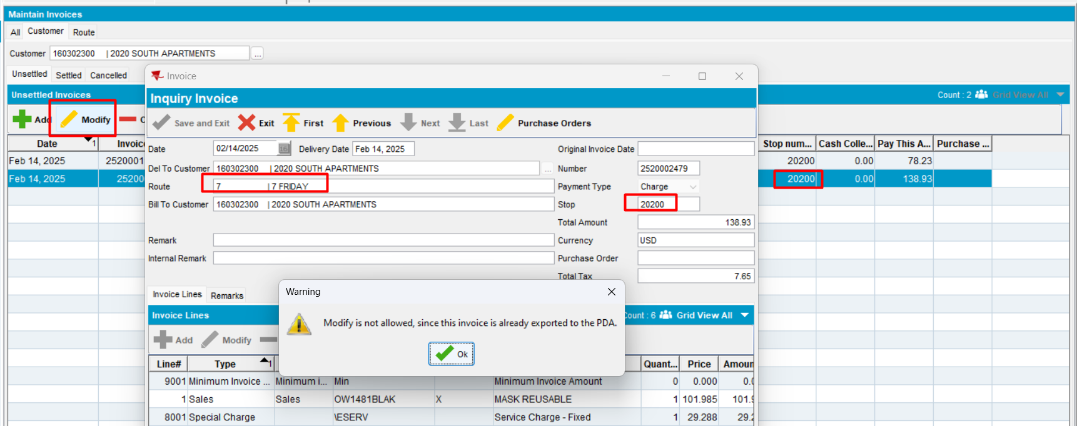
Modify is allowed for existing manual invoice.
Tested OK

Route tab
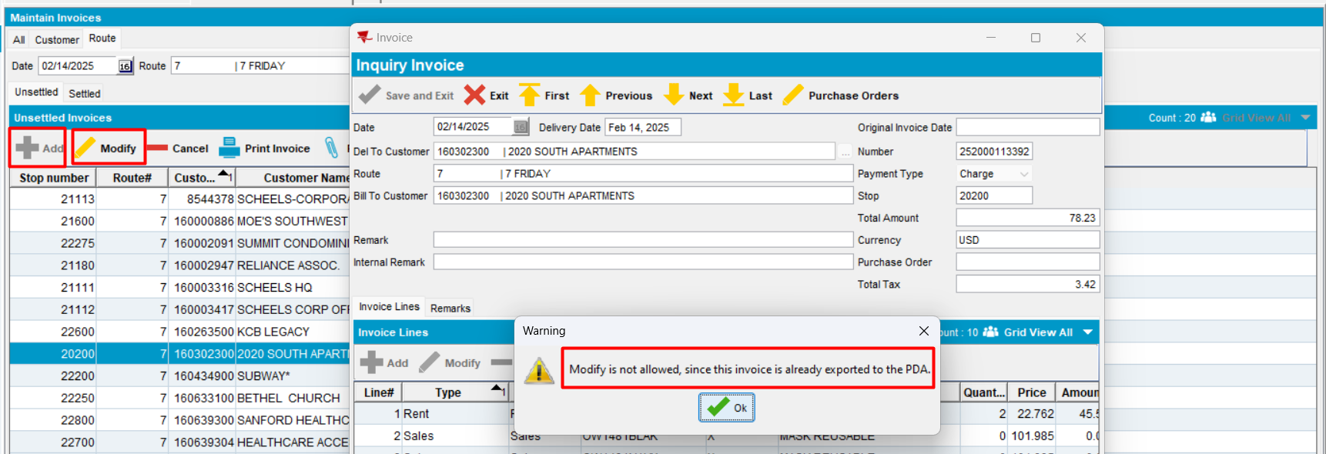
Add button is disabled and Modify is not allowed
Tested ok
Modify manual invoice
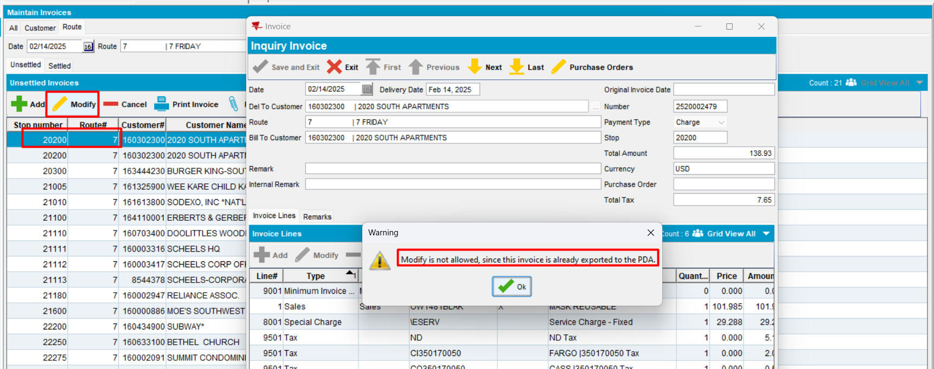
Modify is allowed for existing manual invoice.
Tested OK

All tab
- Add a manual invoice
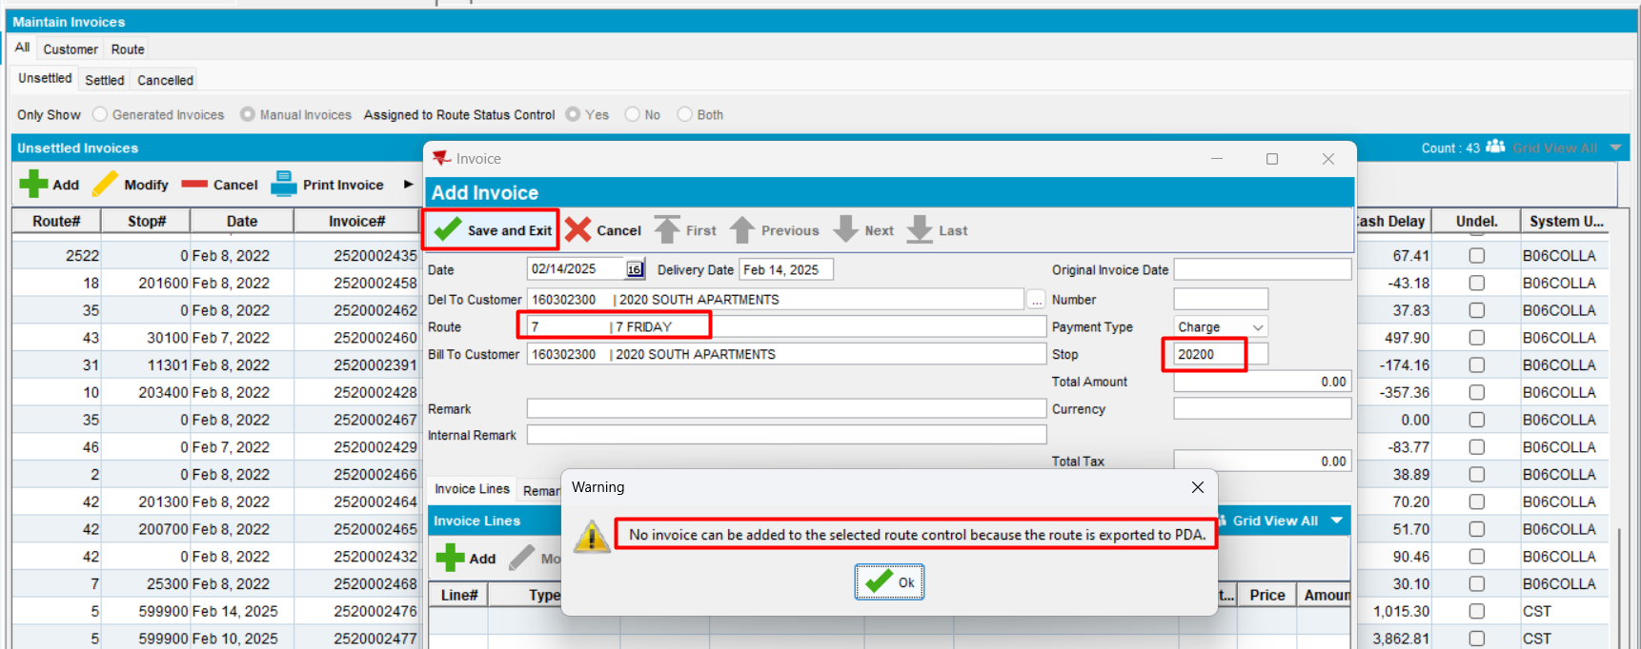
Expected behavior: when a customer is selected, in ADD mode the route should populate and be automatically assigned to a new manually created invoice. When saving, display message: "No invoice can be added to the selected route control because the route is exported to PDA."
Actual behavior: as expected.
Tested ok
- Try cancel + yes
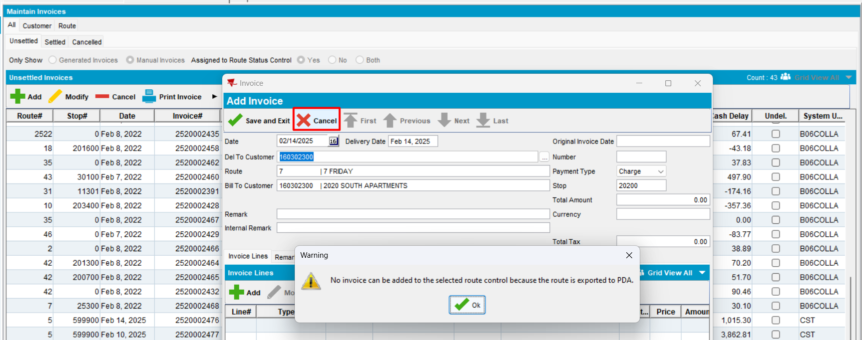
Expected behavior: when a customer is selected, in ADD mode the route should populate and be automatically assigned to a new manually created invoice. When saving, display message: "No invoice can be added to the selected route control because the route is exported to PDA."
Actual behavior: as expected.
Tested ok
- Try close and yes
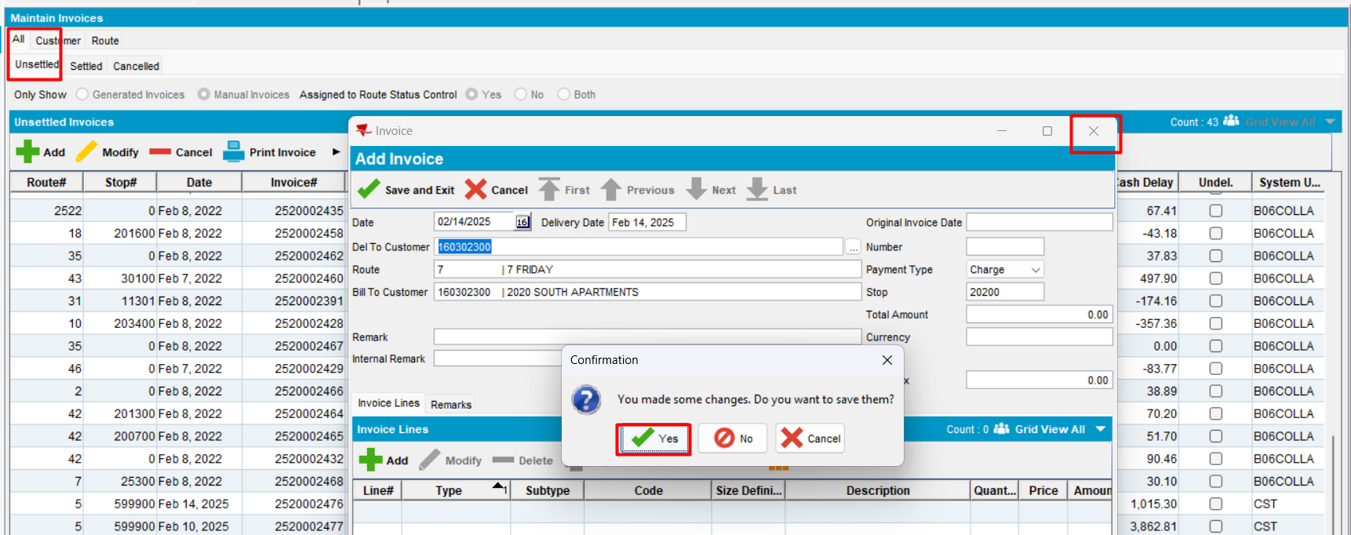
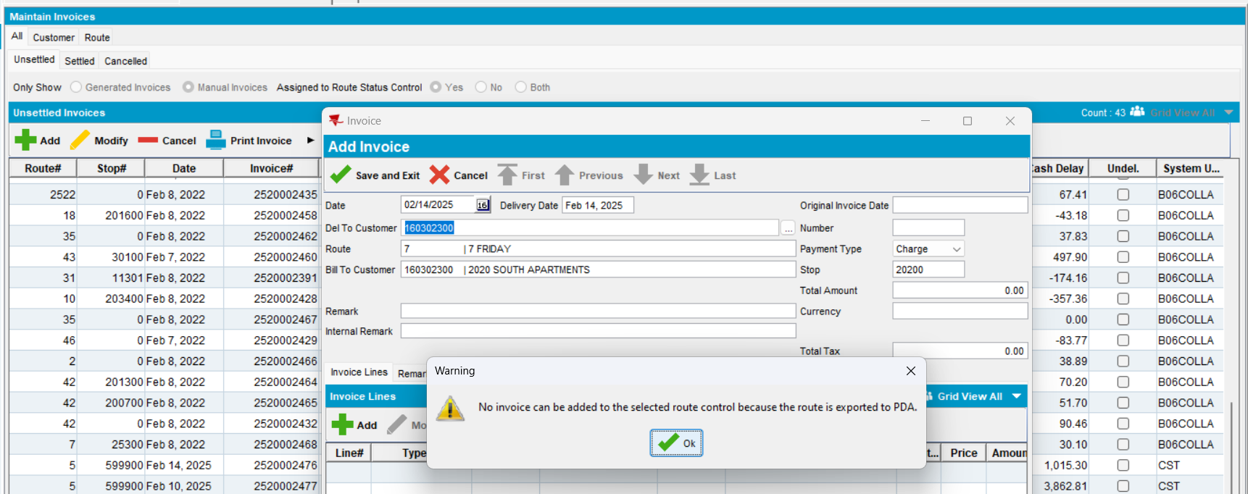
Expected behavior: when a customer is selected, in ADD mode the route should populate and be automatically assigned to a new manually created invoice. When saving, display message: "No invoice can be added to the selected route control because the route is exported to PDA."
Actual behavior: as expected.
Tested ok
- Modify an existing invoice
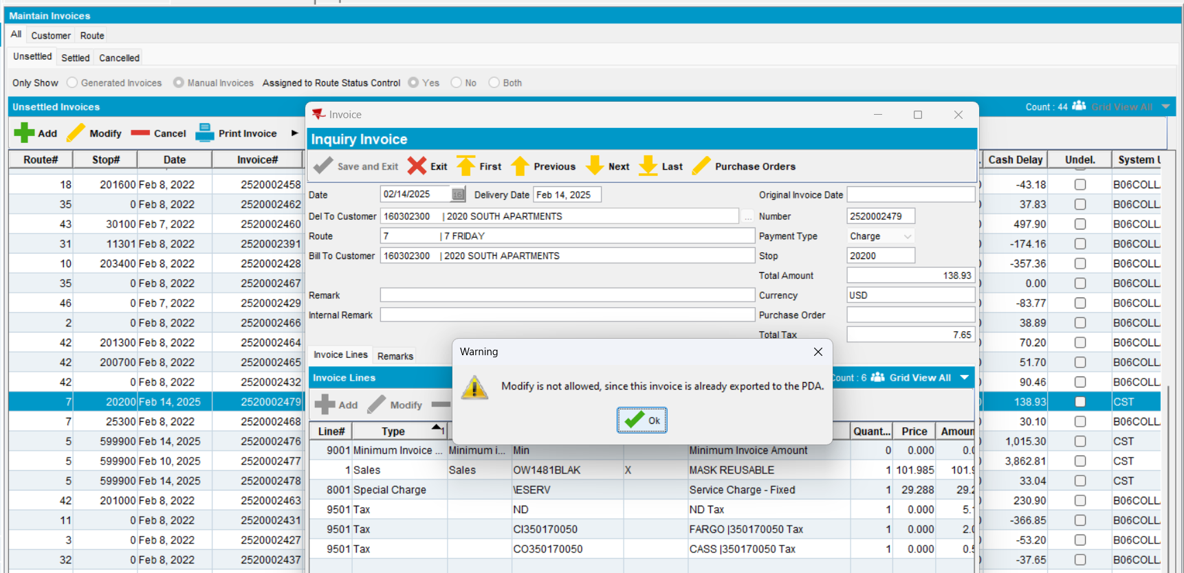
Expected behavior: - if pocketPCStatus = POCKETPC_COMPLETED (1)(PDA Status = Transferred to PDA) and AUSCUSTOM not in license -> MODIFY is not allowed
Actual behavior: as expected.
Tested ok

