ABSN-1172 Downgrade to 9.08.00.release.p18_AUS
Environment | Prerequisites
Version: 9.08.00.RELEASE.p17  DBServerName=abs-srv16.internal.abslbs.com  DBSID=CUST21  DBUser=AUS_ND90502  DBPassword= AUS_ND90502  Environment=Production  Hash: 0de56eb | - Module: -  - System setting: -  - Others: BU: Dallas

Contents
Retest after fix 1
Modify existing contact person 1
Add new contact person 4

Retest after fix
Hash: 0de56eb

Modify existing contact person
- Open Customers dlg, select a customer, change to Modify Mode and click button Contact Persons:
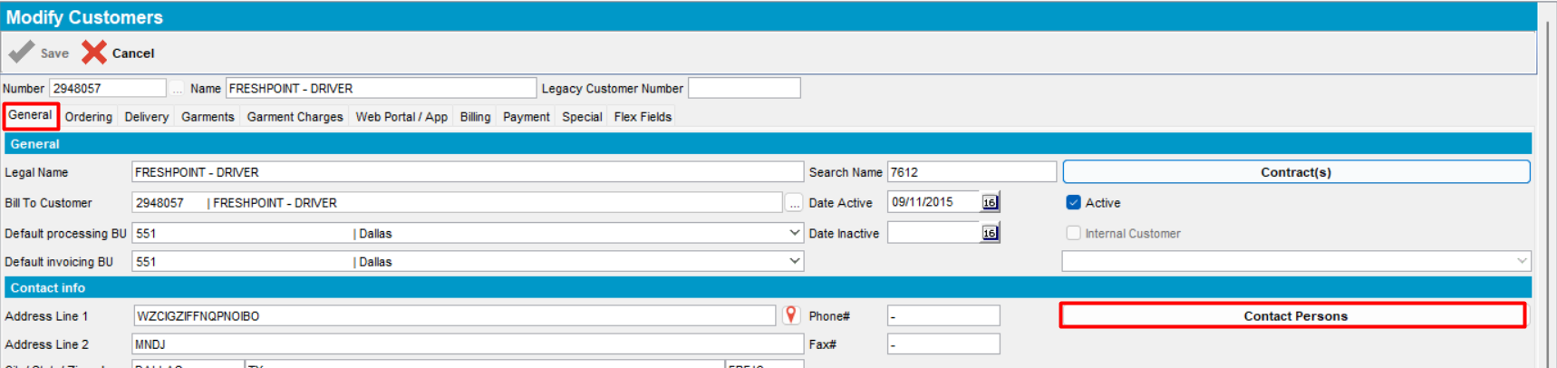
- Modify an existing contact person number
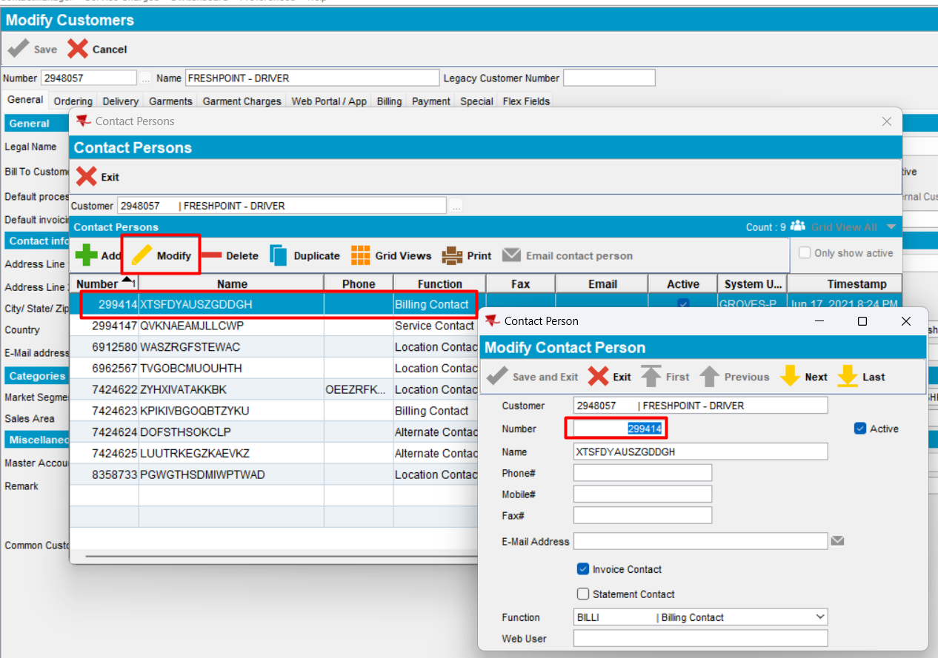
Modify a customer’s contact, change the Contact Person Number:
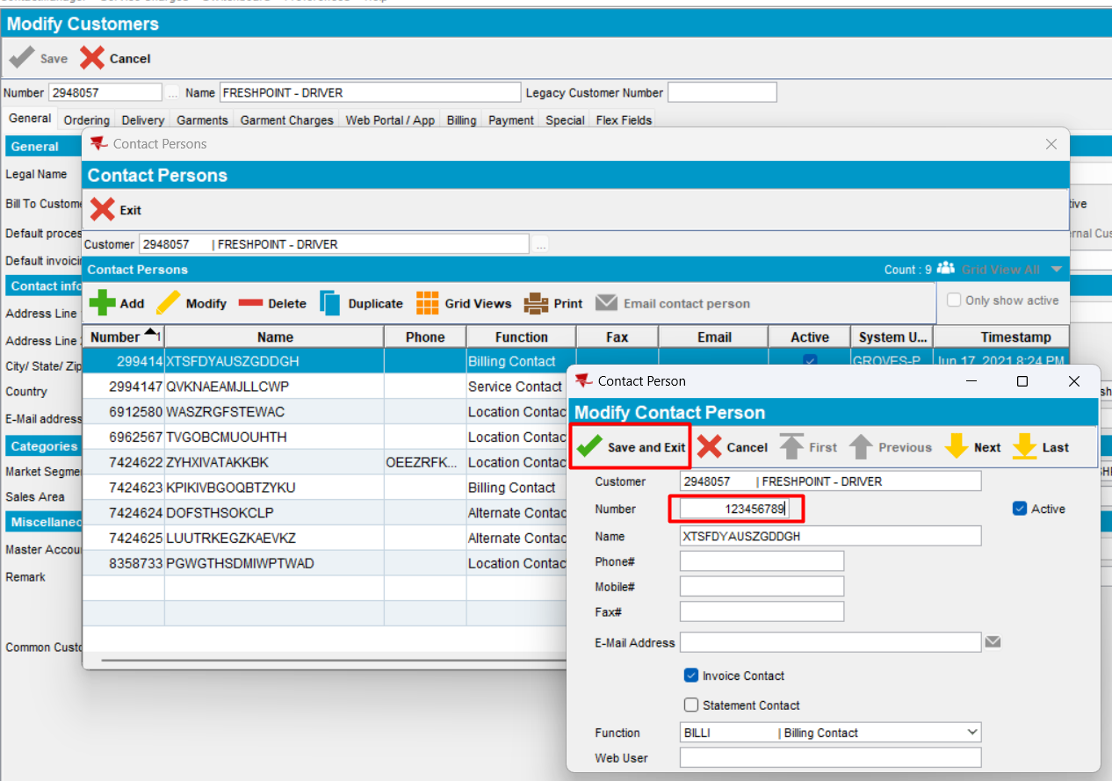
Expected behavior: Contact person number should fit in up to 9 digits.
Actual behavior: as expected.
- Save
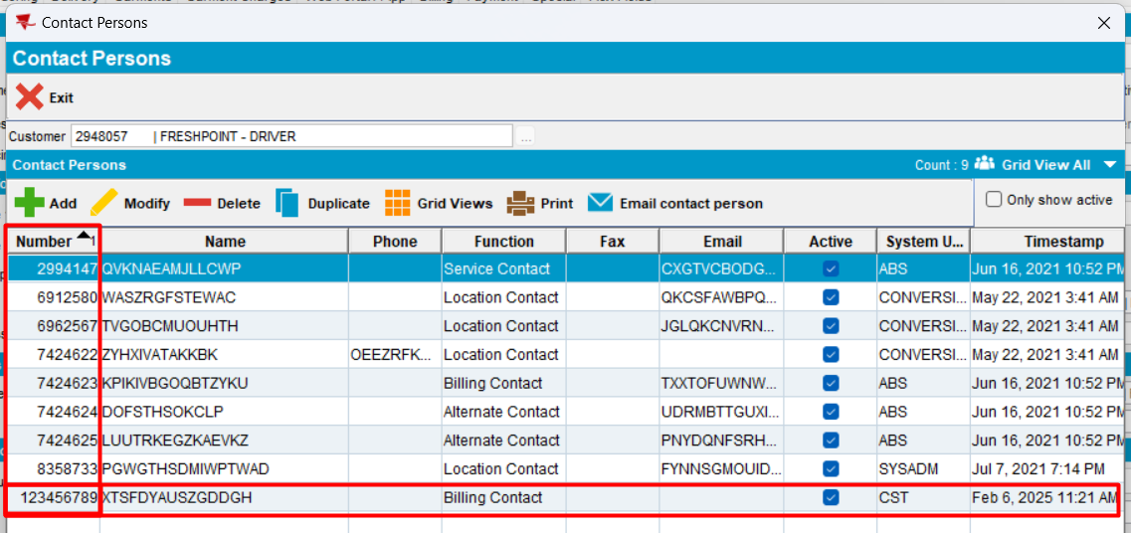
Modification is saved. 9 numbers could be fit in.
- Click exit and reopen Contact Persons dlg
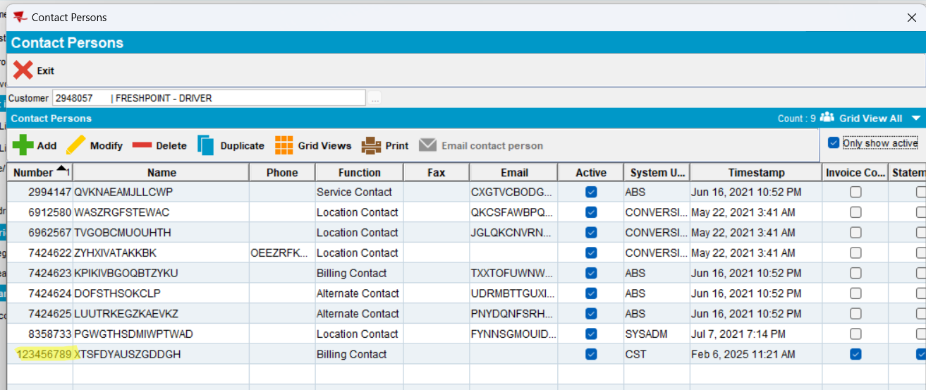
Modification was saved.
- Check the db table
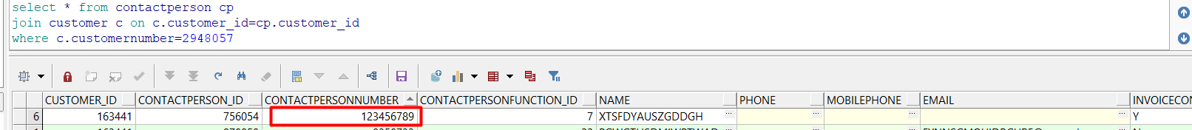
New value for contact person number is saved in db table.
Tested OK

Add new contact person
- Add a new contact:
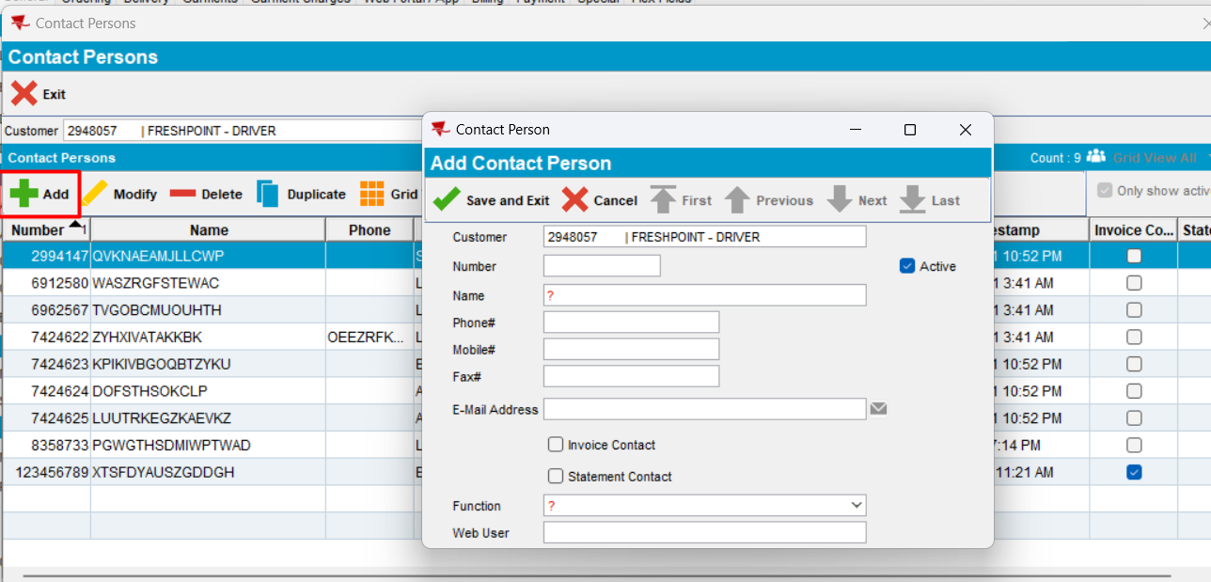
- Fill the information
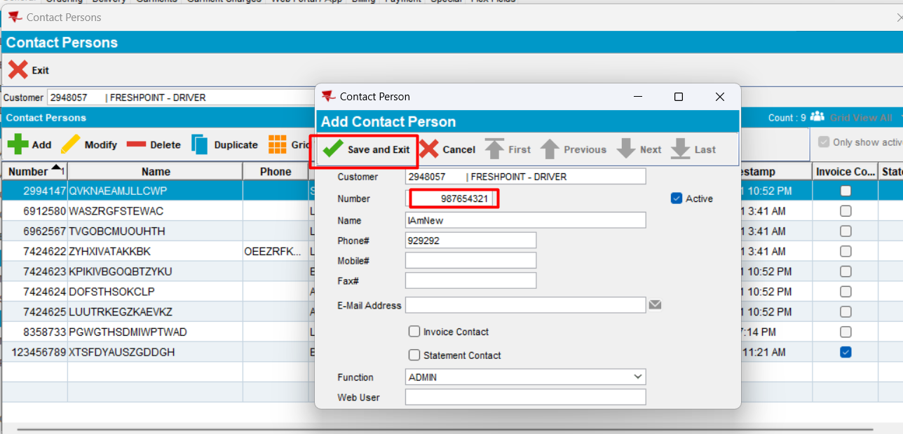
Contact Person Number field can contain 9 decimals.
- Save
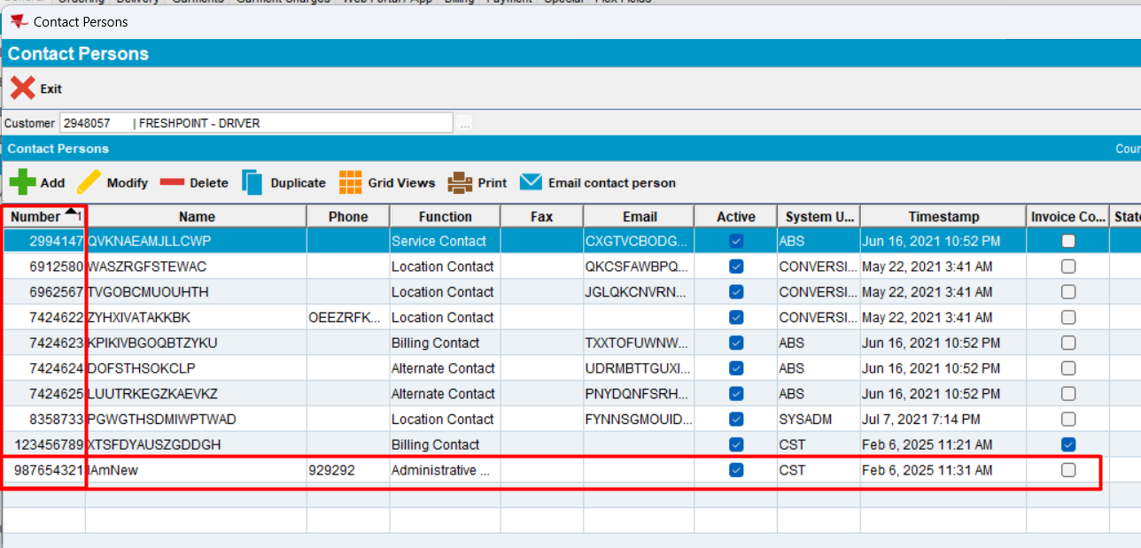
The new contact person is saved.
- Check the db table
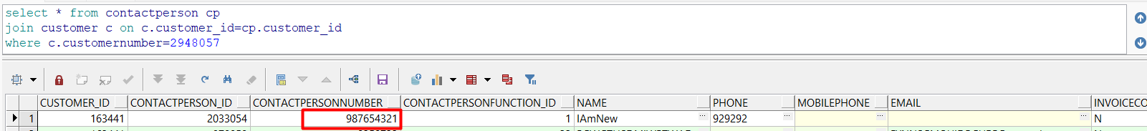
Value of 9 digits is saved in db table.
- Reload the customer in Customer dlg without modifying it
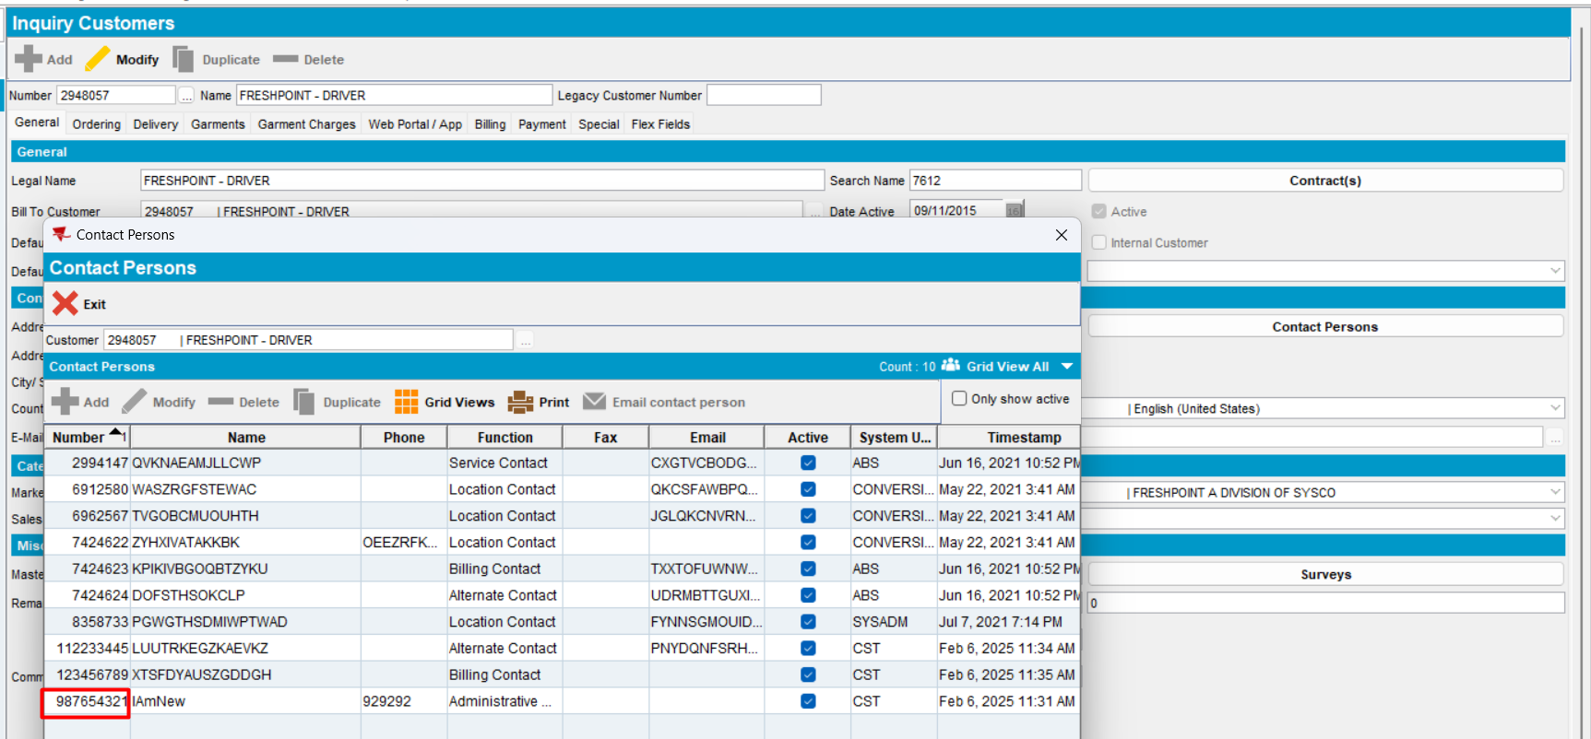
Expected behavior: Contact person number should fit in up to 9 digits.
Actual behavior: as expected.
Tested OK.

