ABSN-1664 Switchboard BM6 Weekly Usage Management - inquiry mode full access rights
Environment | Prerequisites
- Version: 9.08.00.RELEASE.p17  - DBServerName=abs-srv16.internal.abslbs.com  - DBSID=CUST21  - DBUser=AUS_ND90502  - DBPassword=AUS_ ND90502  - Environment=Production | - Module: BILLINGMETHOD6  - System setting: -  - Others: BU 503

Contents
Retesting after fix 1

Retesting after fix

- Read only user:

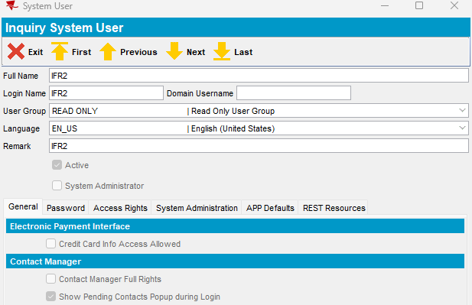

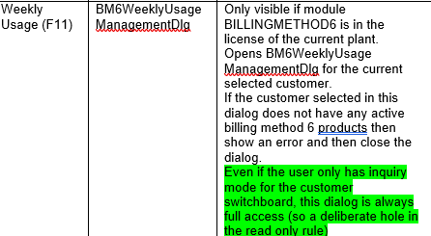

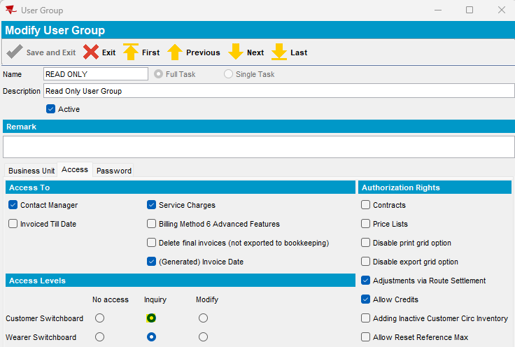

BM6 product in PLPC:
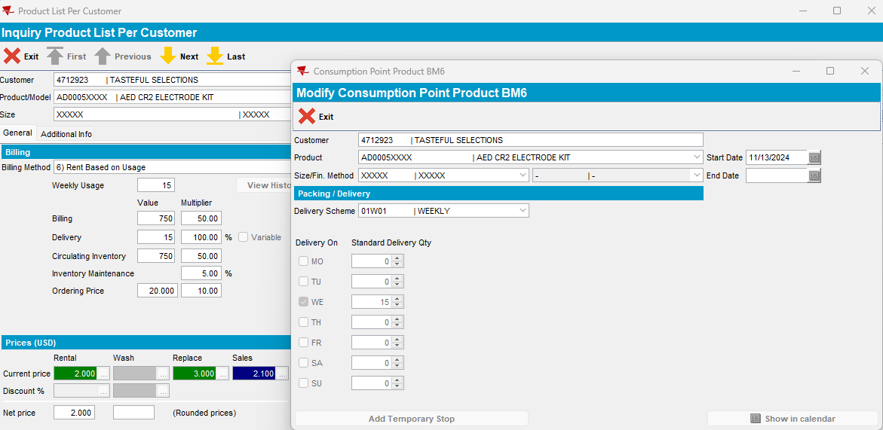

Switchboard access to BM6 form:
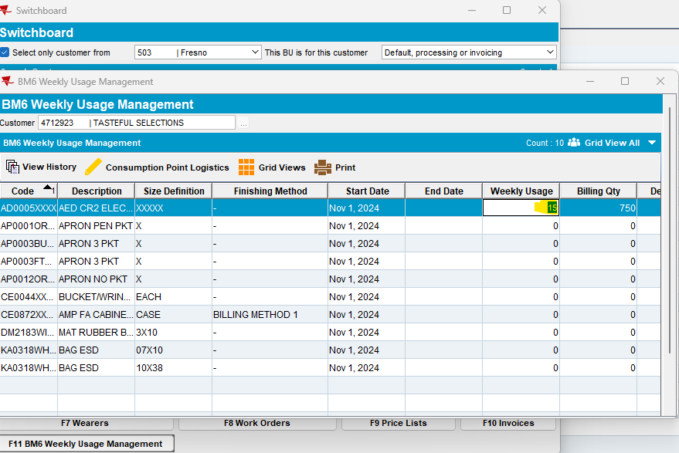

Change Weekly usage:
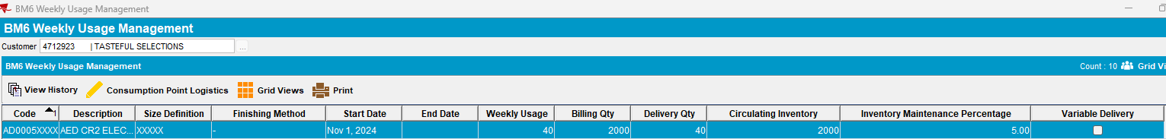
Switchboard BM6 Weekly Usage Management - inquiry mode has full access rights for Weekly Usage field.
All factors are recalculated.
Tested ok.

