ABSN-1618 Maintain Invoices - Read-only user access change problem
Environment | Prerequisites
- Version: 9.08.00.RELEASE.p17  - DBServerName=abs-srv16.internal.abslbs.com  - DBSID=CUST21  - DBUser=AUS_ND90502  - DBPassword=AUS_ND90502  - Environment=Production | - Module: AUSCUSTOM  - System setting: -  - Others: BUs 503, 250

Contents
Retesting after fix 1

Retesting after fix

- BU with module: AUSCUSTOM in the license
Read only user:
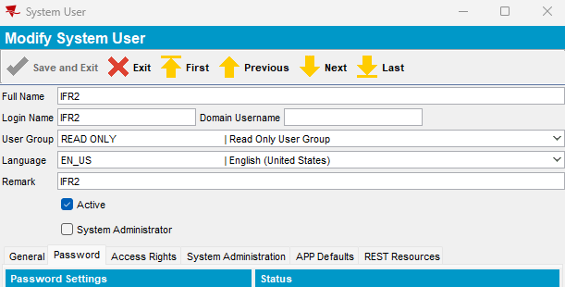

Open Maintain Invoices dlg
Assign to Route it is functional:
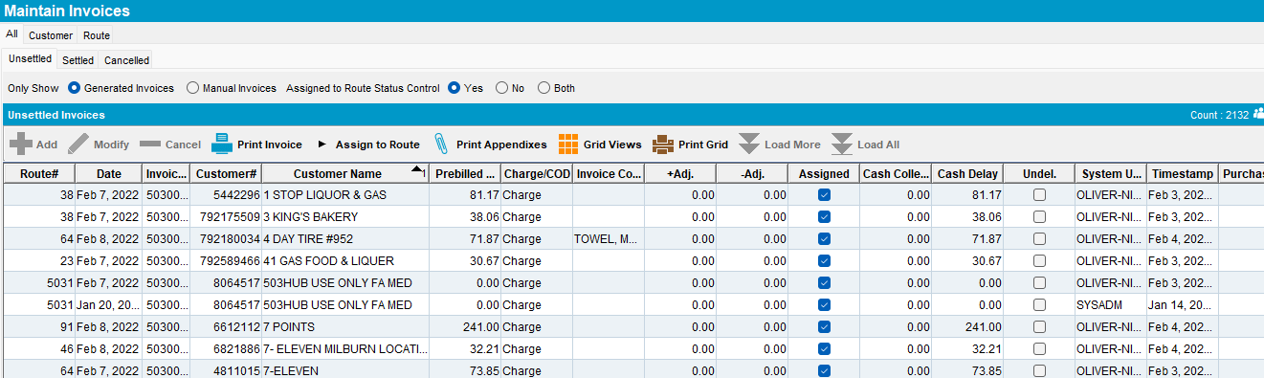

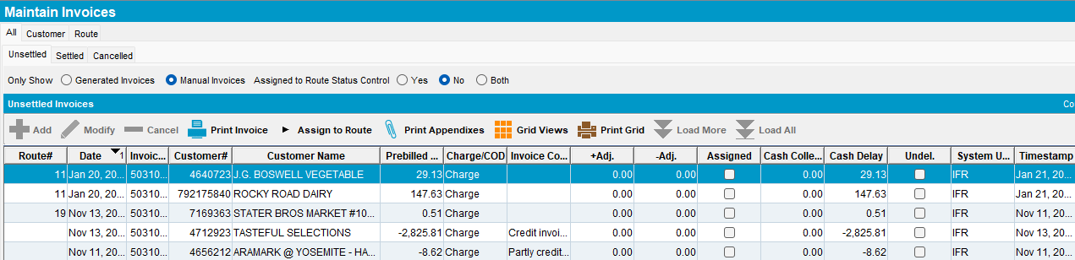

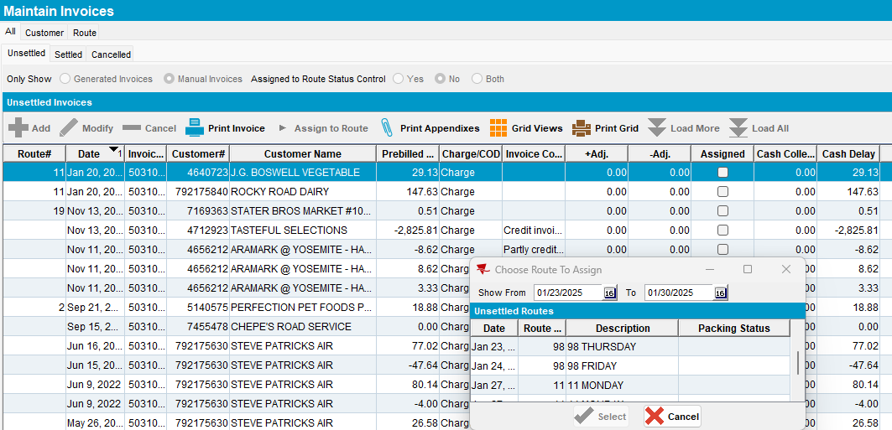

Invoice is assigned to route:

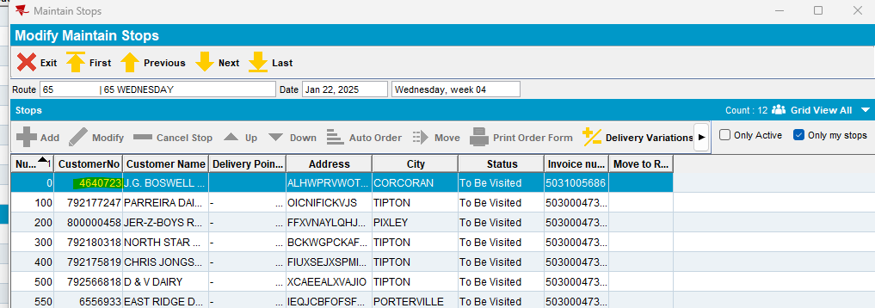

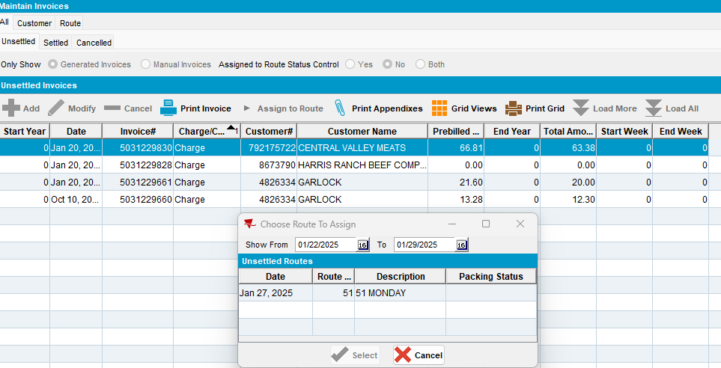

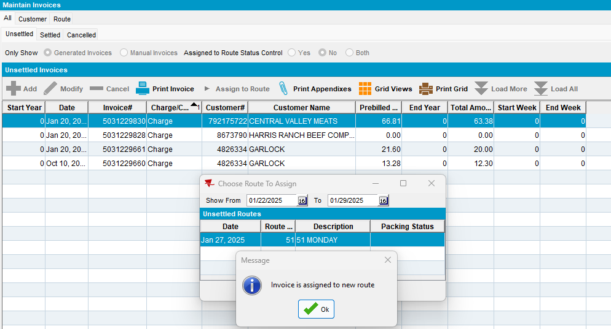

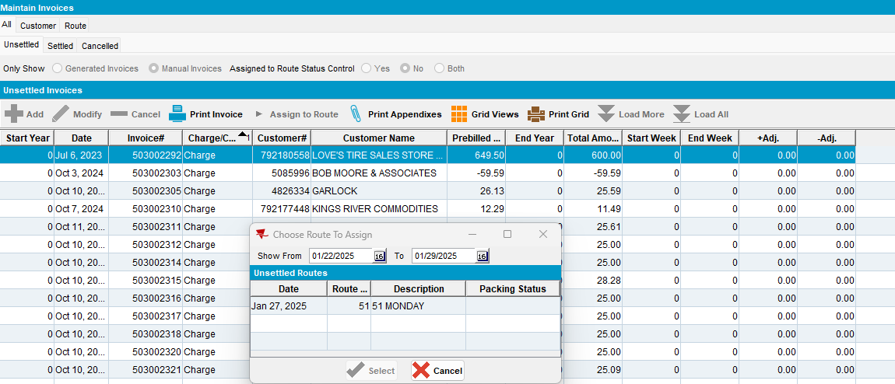

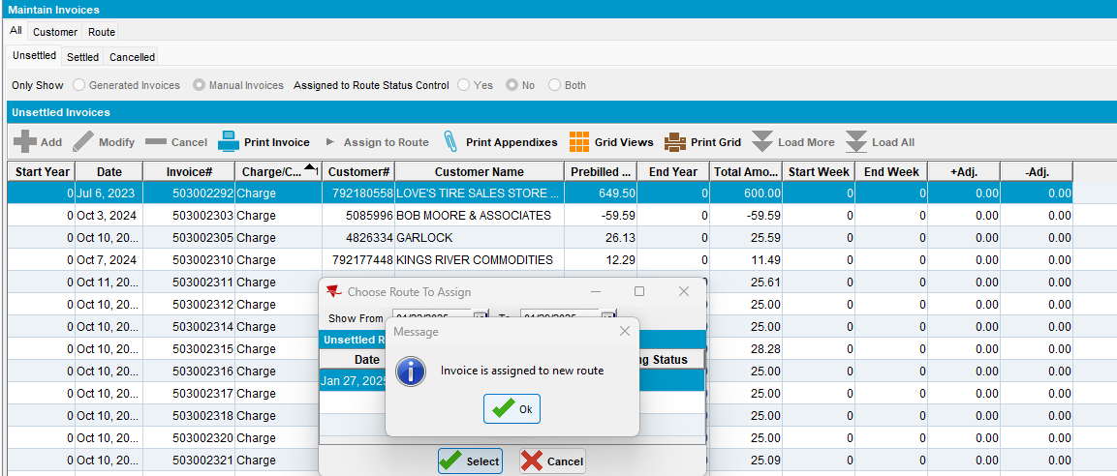

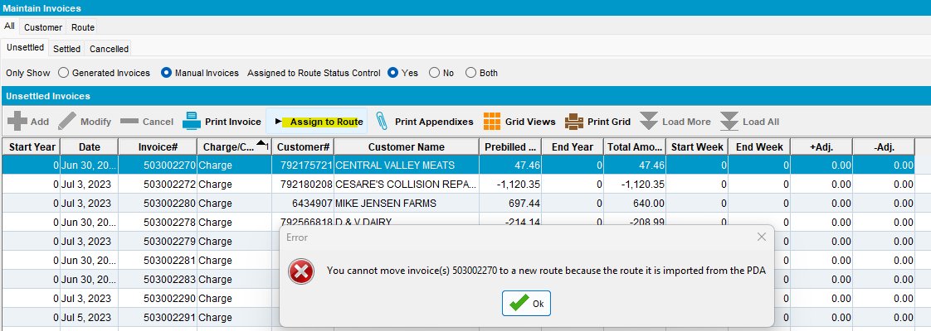

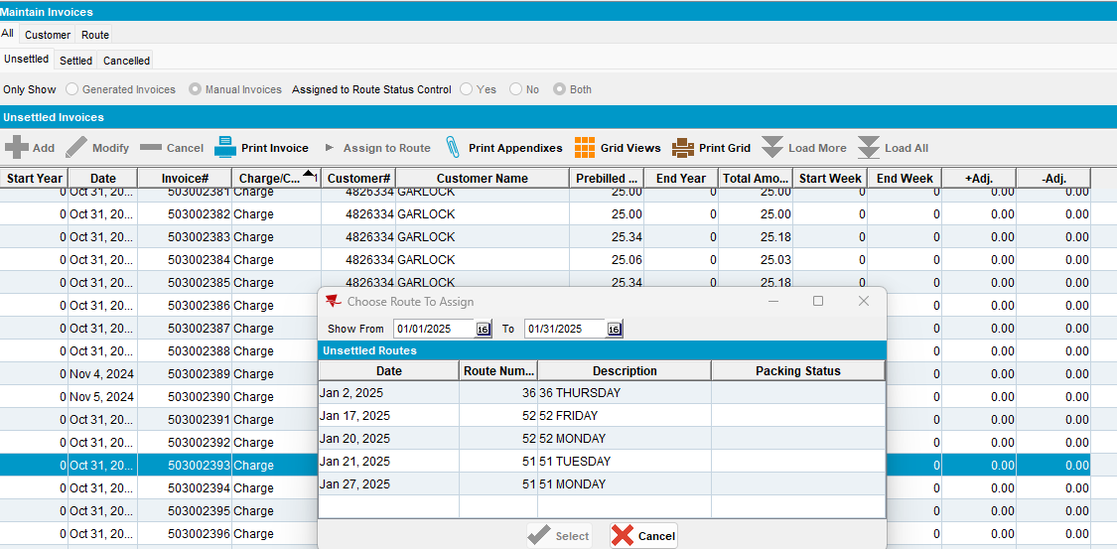

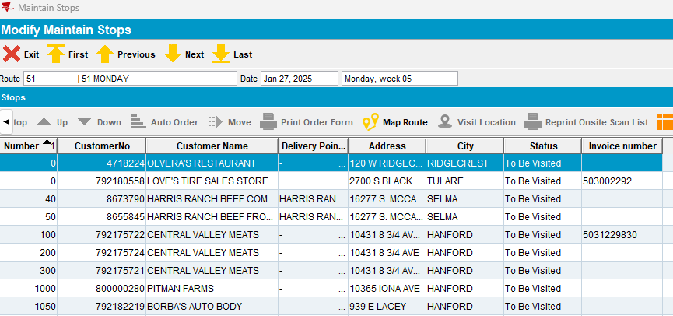

Tested ok.

- BU without module: AUSCUSTOM in the license

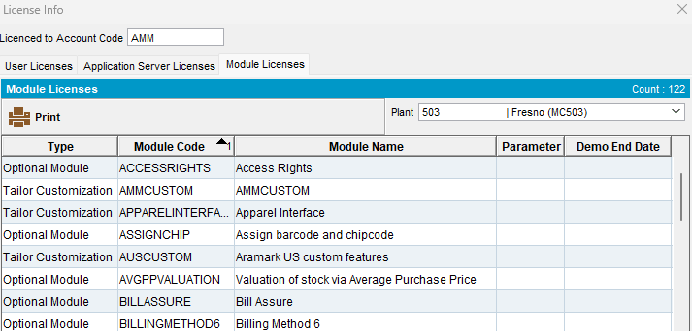

Assign to Route button for a read only user is not available:

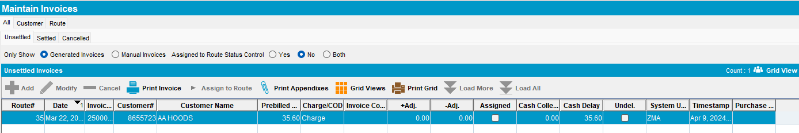

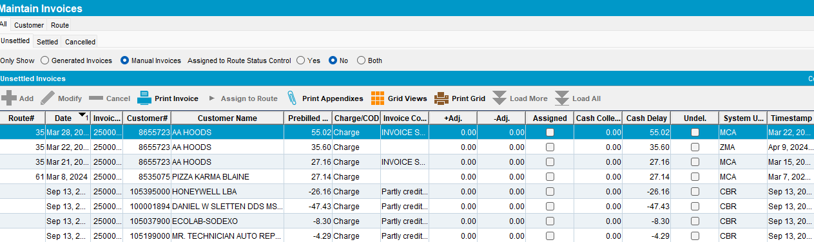

Tested ok.

