ABSN-1585 Unable to assign invoice to route in status Ready for Transfer
Environment | Prerequisites
- Version: 9.08.00.RELEASE.p17  - DBServerName=abs-srv16.internal.abslbs.com  - DBSID=CUST21  - DBUser=AUS_ND90502  - DBPassword=AUS_ ND90502  - Environment=Production | - Module: AUSCUSTOM  - System setting: -  - Others: BU 503

Contents
Reproducing before fix 1
Retesting after fix 5

Reproducing before fix

Version: 9.08.00.RELEASE.p16
Route 51 from 20.01.2025
Not assigned invoices:
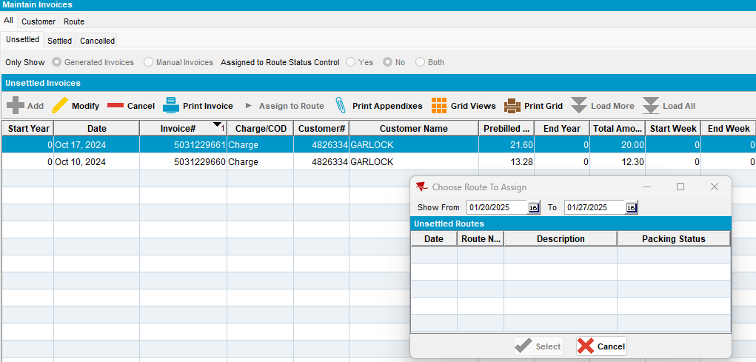

Not assigned manual invoice:
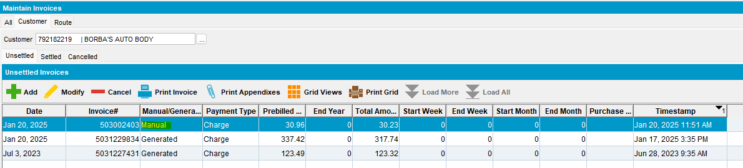
The same customer was added to this route:
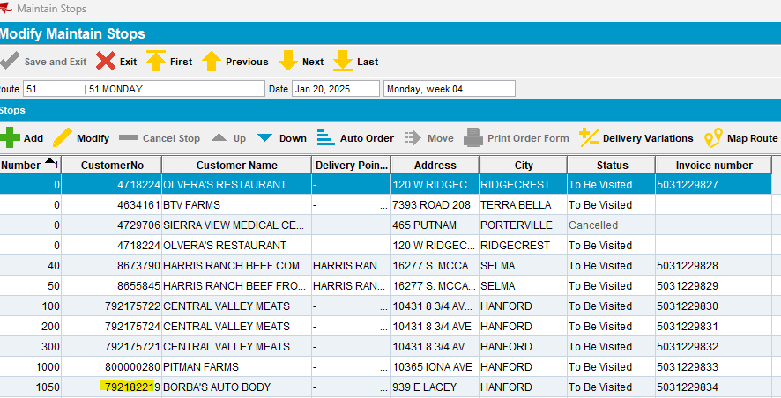
Route with PDA status = Ready for Transfer:
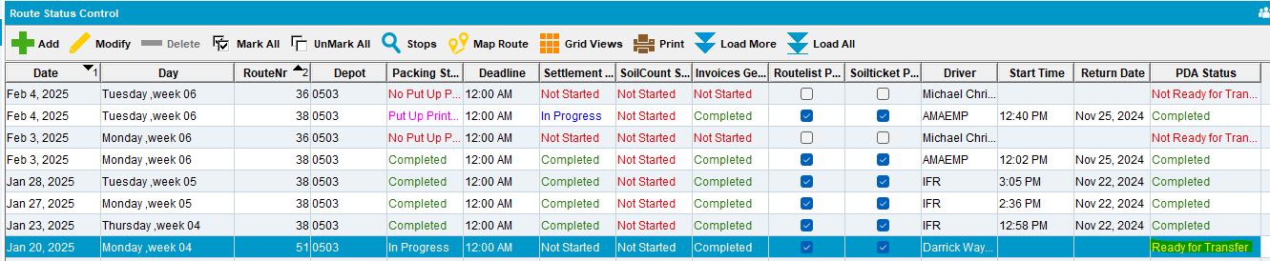

From Maintain Invoices dlg try to Assign to this route the manual invoice above:
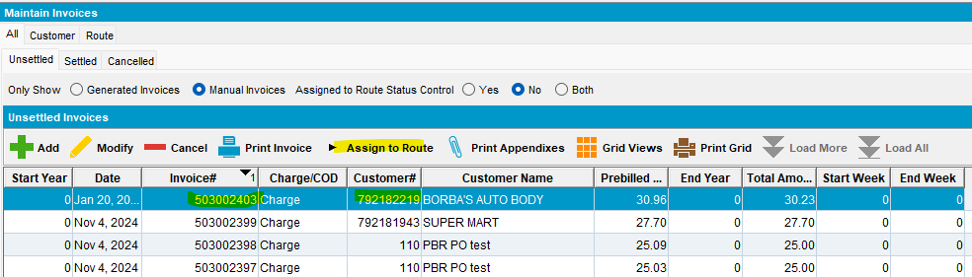
This route is not available to be selected:
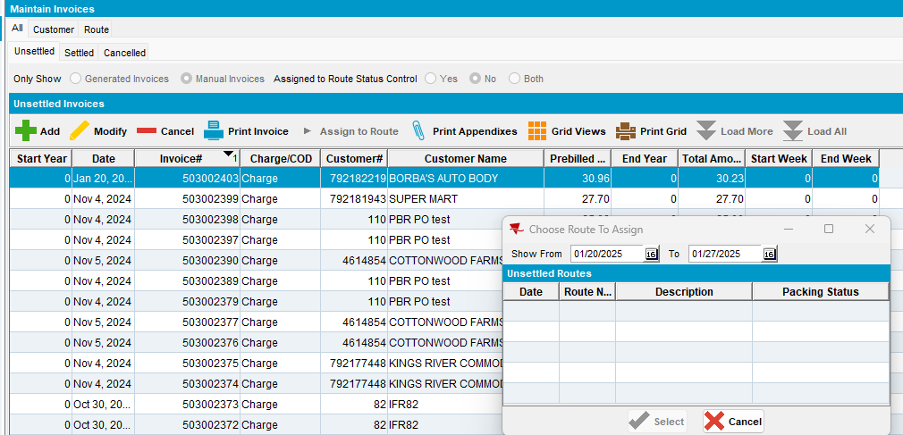
Remove ready for transfer mark for this route in RSC:
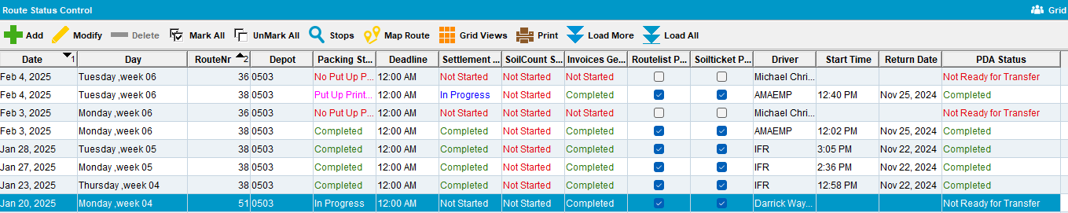

For both, not assigned generate or manual invoices, the route becomes available on Choose Route To Assing pop-up:
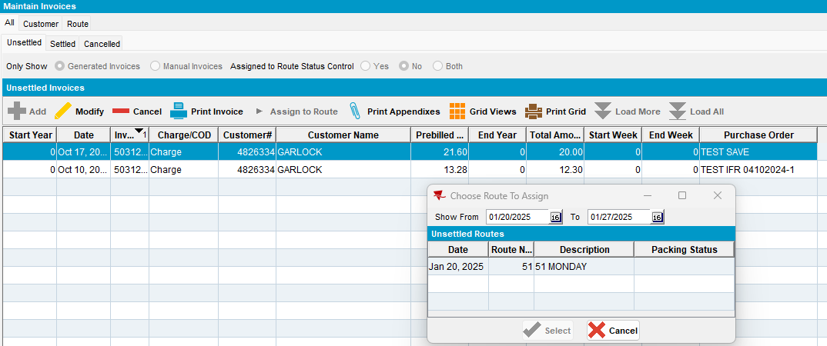
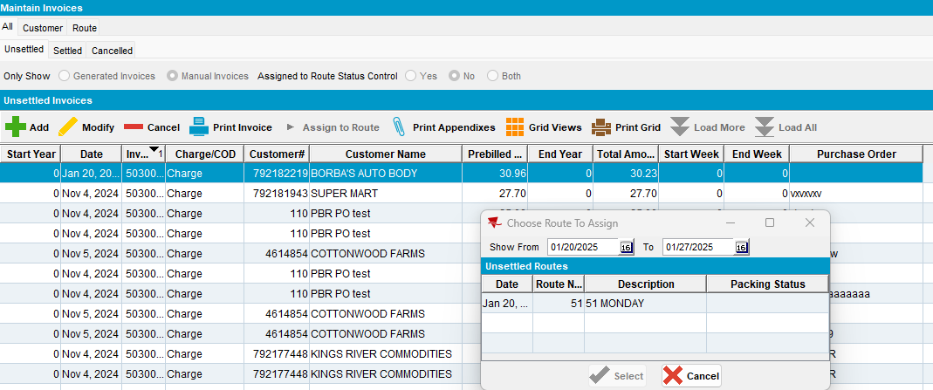
This route should be available even when status is “ready for transfer” when there’s a stop for the customer present on the route! (manual invoice requires this stop be present)
Reproduced on master.

Retesting after fix

- Route 95 from 21.01.2025: pocketpcstatus=3

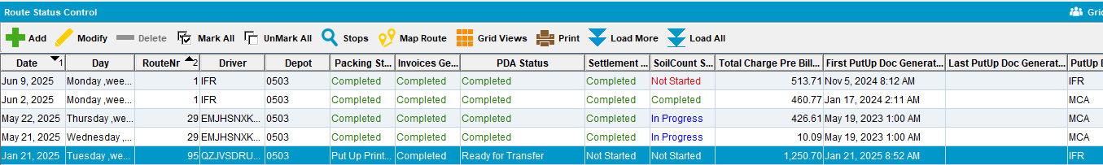

select rc.pocketpcstatus, rc.drivernumber,rc.* from routecontrol rc where rc.routecontrol_id=1133533;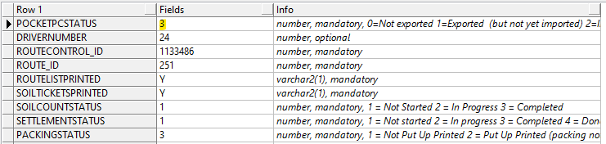

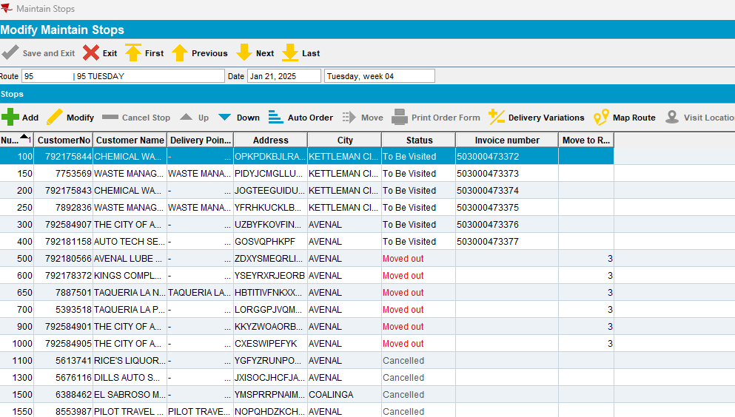

Not assigned invoices:

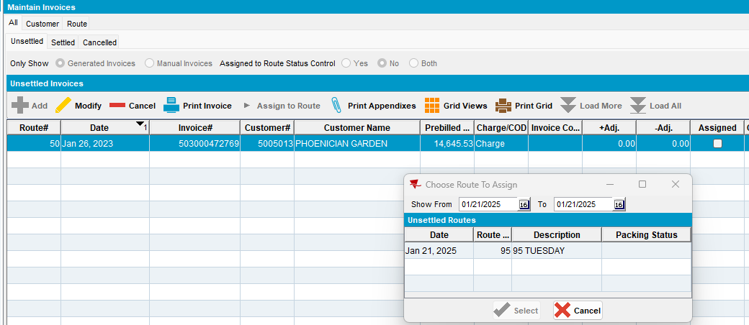
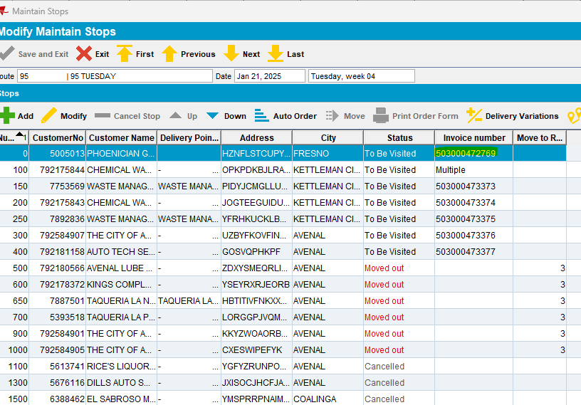

Not assigned manual invoices:
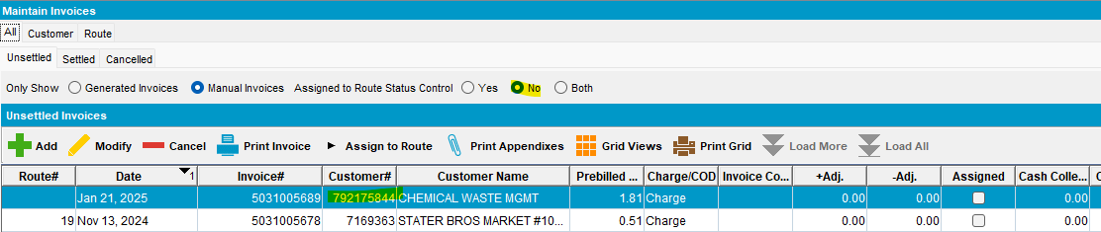
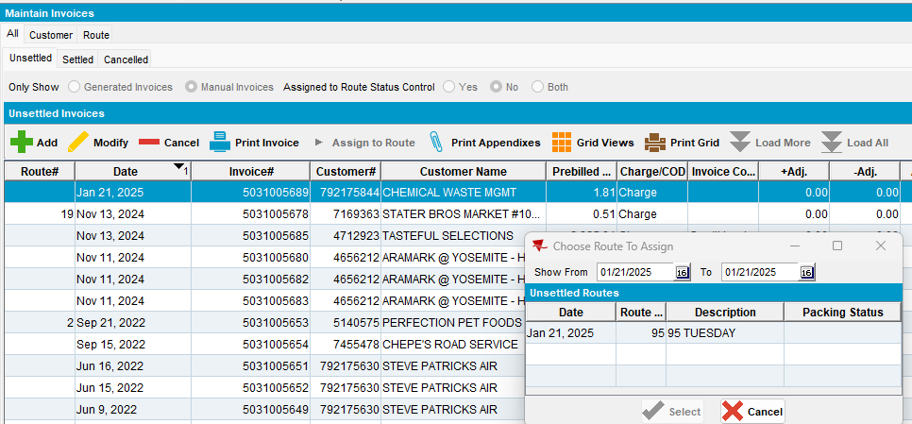
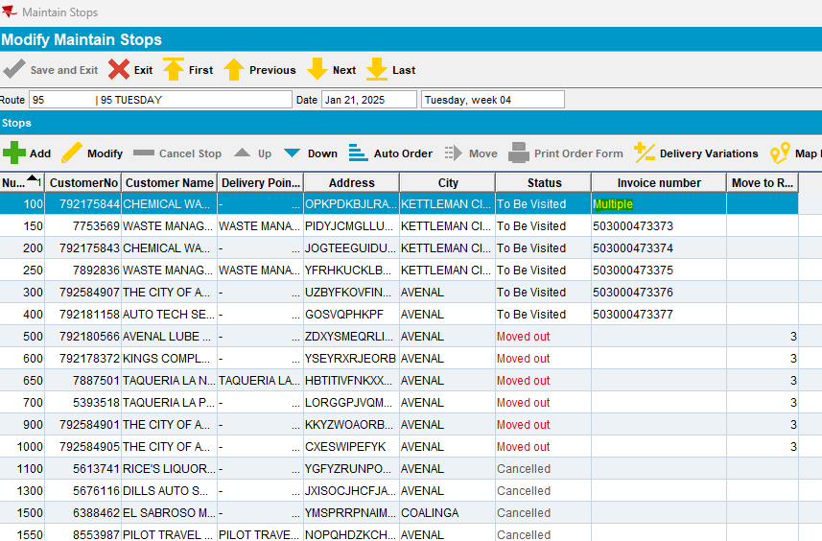
This route should be available even when status is “ready for transfer” when there’s a stop for the customer present on the route! (manual invoice requires this stop be present)
Tested ok.

- The same route: pocketpcstatus=0
Route 11 from 03.02.2025
select rc.pocketpcstatus, rc.drivernumber,rc.* from routecontrol rc where rc.routecontrol_id=1133535;
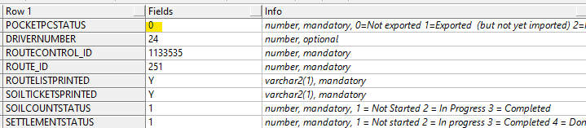
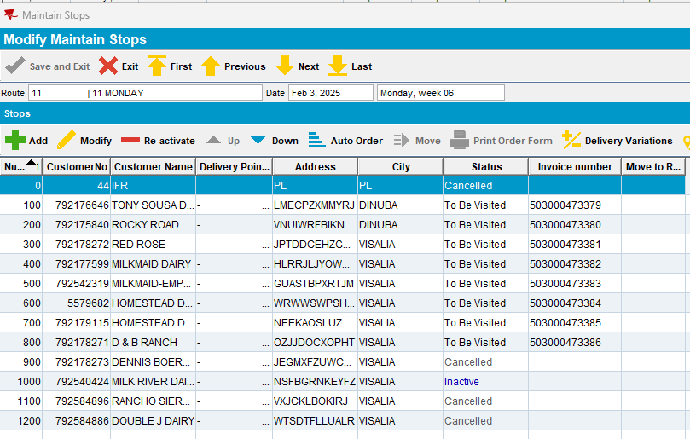
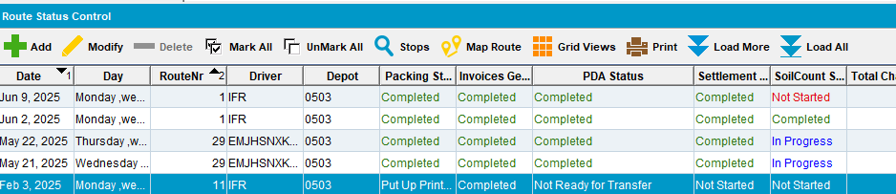

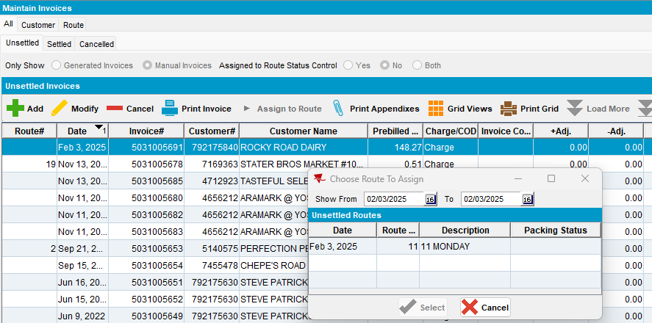

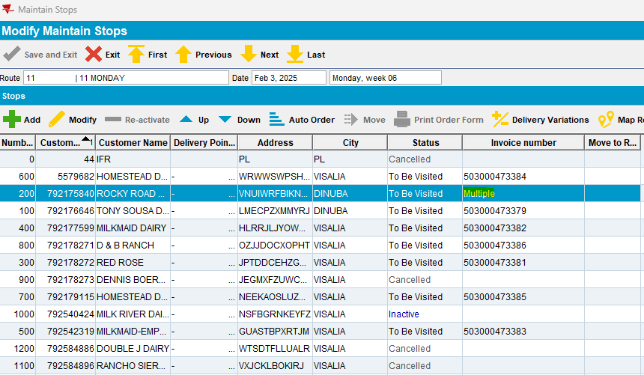
This route should be available even when status is “not ready for transfer” when there’s a stop for the customer present on the route! (manual invoice requires this stop be present)
Tested ok.

- Route 52 from 20.01.2025: pocketpcstatus=1

select rc.pocketpcstatus, rc.drivernumber,rc.* from routecontrol rc where rc.routecontrol_id=1133371;
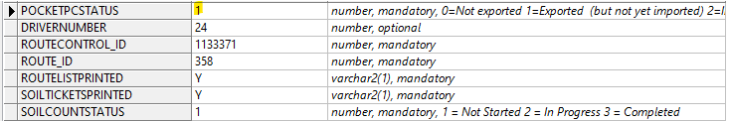

The route is not available in Choose Route To Assing for both manual or generated invoices:

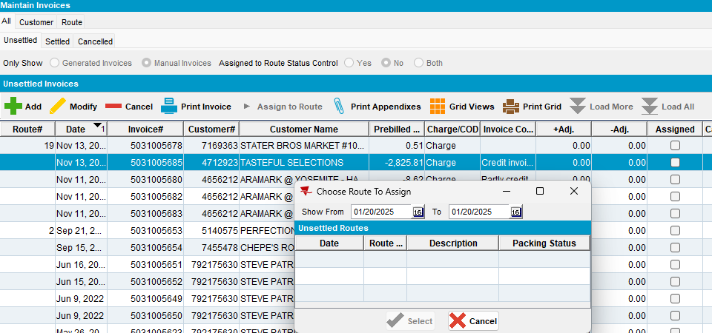

Tested ok.

- The route 11 from 20.01.2025: pocketpcstatus=2

select rc.pocketpcstatus, rc.drivernumber,rc.* from routecontrol rc where rc.routecontrol_id=1133486;

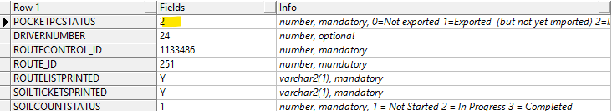

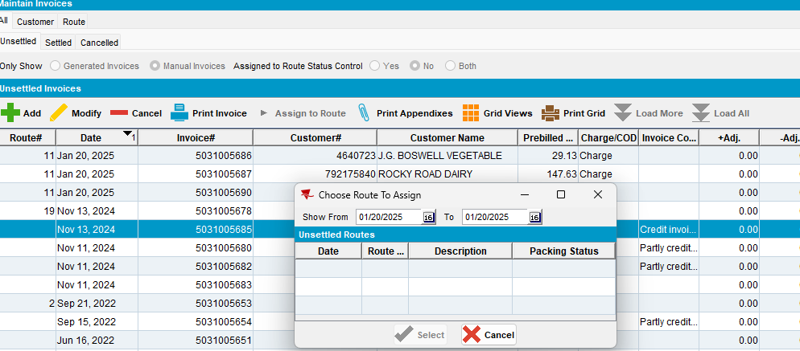

Tested ok.

- The same route, next delivery week: pocketpcstatus=3

Route 11 from 27.01.2025
select rc.pocketpcstatus, rc.drivernumber,rc.* from routecontrol rc where rc.routecontrol_id=1133534;
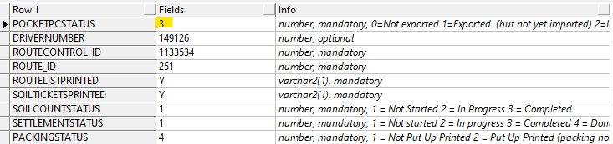

- Manual invoices are available to be assign to route:

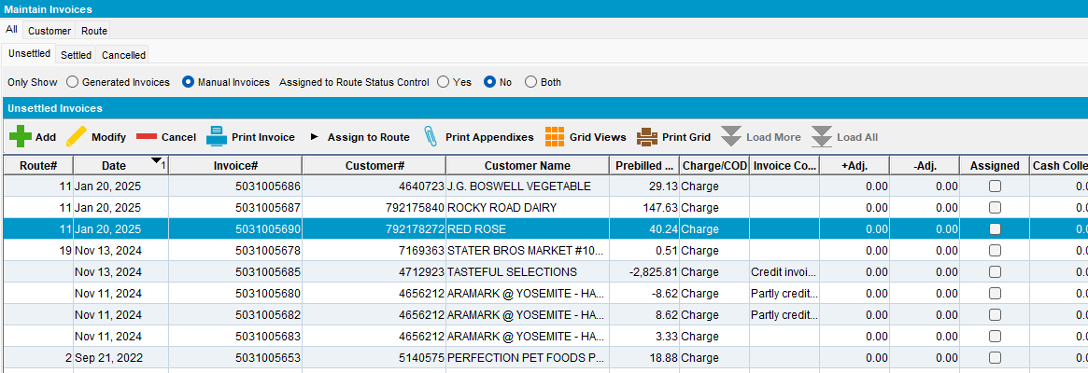

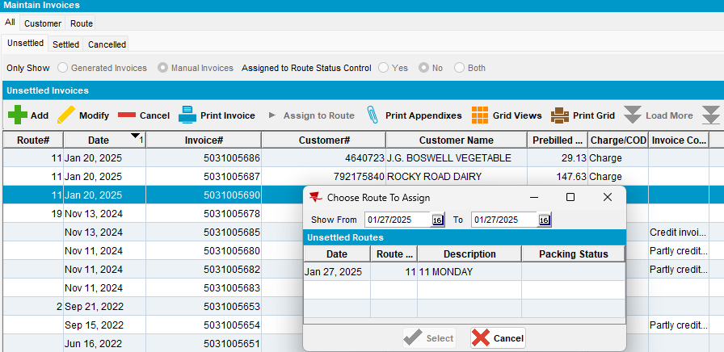

- For the previous route do some Undeliverable stops with the right reason code (on PDA):

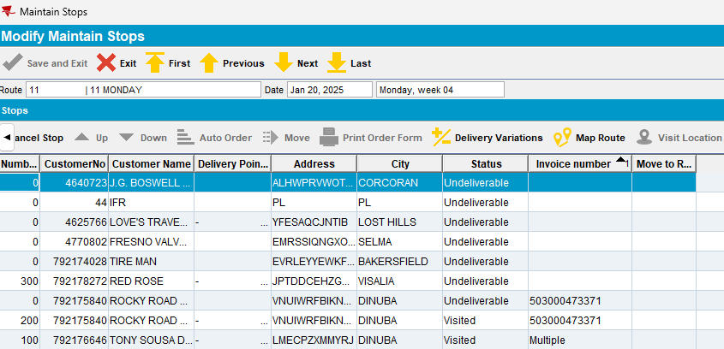

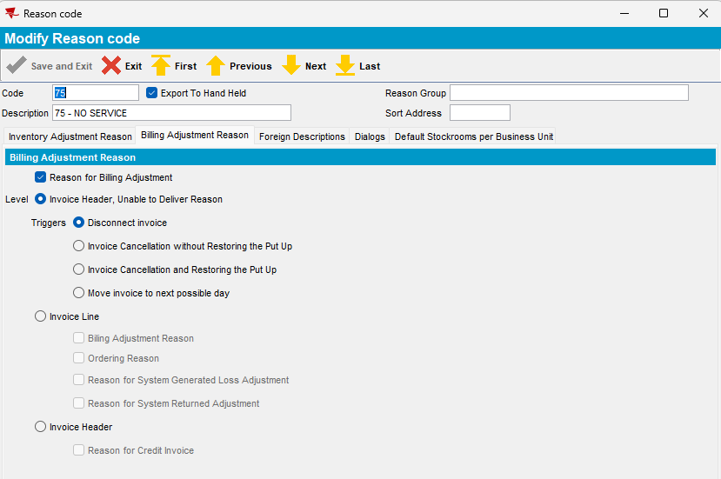

- Settle the previous route
- From Maintain Invoices dlg check if the previous invoices for previous route and Undeliverable stops are available
- Try to assign to the next delivery route (same route, next week):

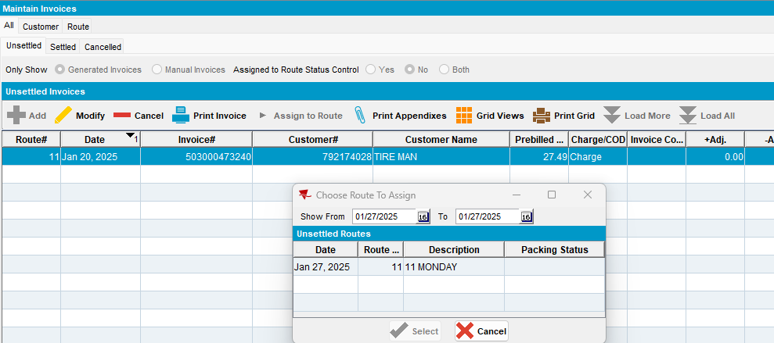
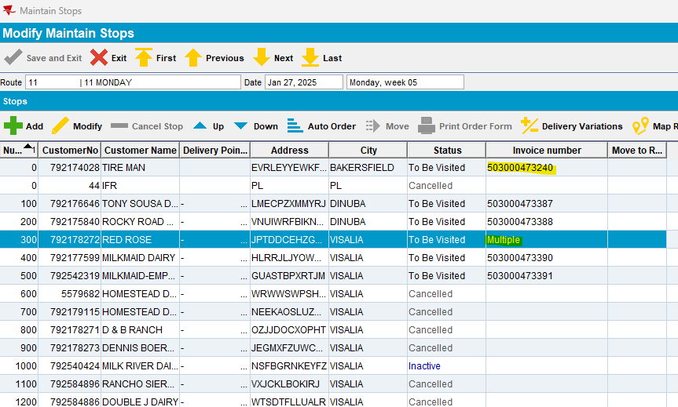
This is possible.
Tested ok.

