ABSN-1515 RSC - automatic mark ready for PDA transfer not happening in 2 scenarios
Environment | Prerequisites
- Version: 9.08.00.RELEASE.p17  - DBServerName=abs-srv16.internal.abslbs.com  - DBSID=CUST21  - DBUser=AUS_ND90502  - DBPassword=AUS_ND90502  - Environment=Production | - Module: AUSCUSTOM  - System setting: -  - Others: BU 503

Contents
Reproducing before fix 1
Retesting after fix 3

Reproducing before fix

- Version: 9.08.00.RELEASE.p16
Driver with mobile device:

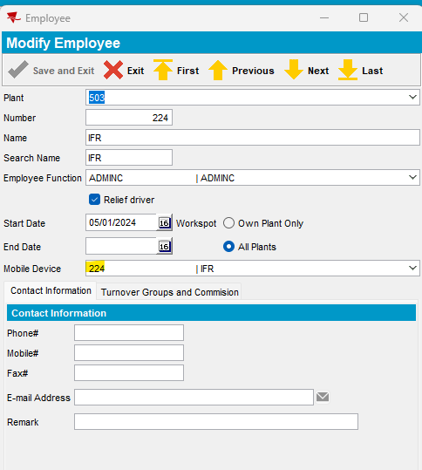

Generate invoice:

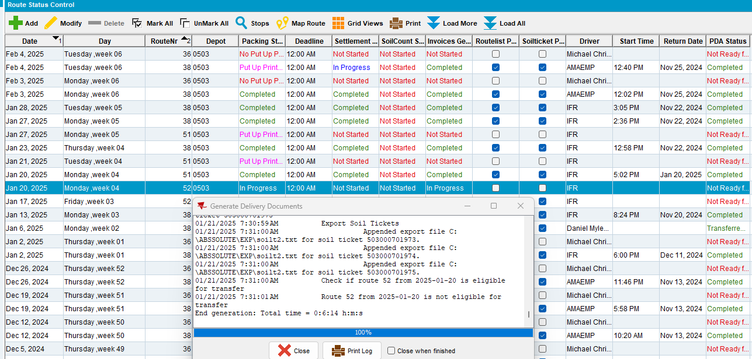

Route it is not automatically Mark ready for transfer to PDA:

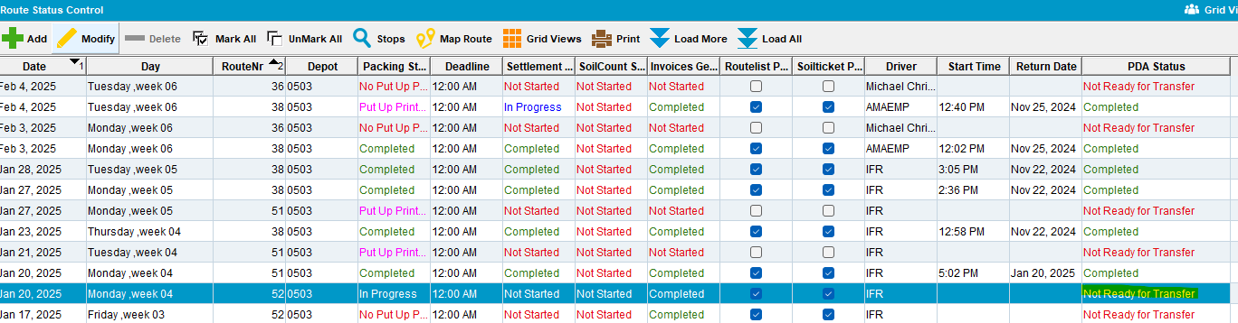

Reproduced.

Retesting after fix

Generate invoice:

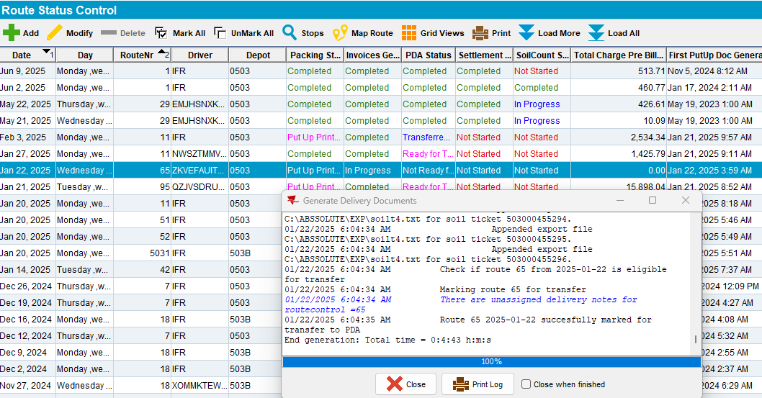

Route it is automatically Mark ready for transfer to PDA:

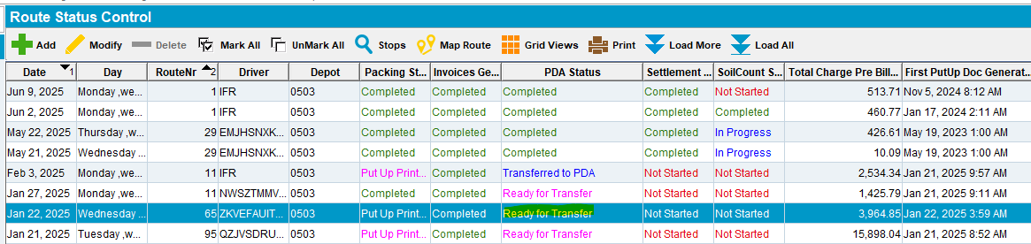

Tested ok.

Mark a route for automatically invoice generation:

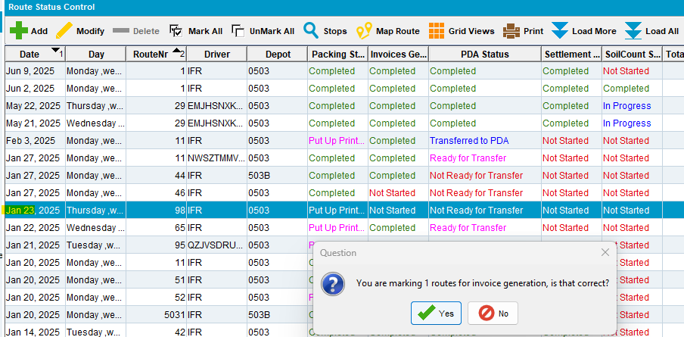

Run the process:

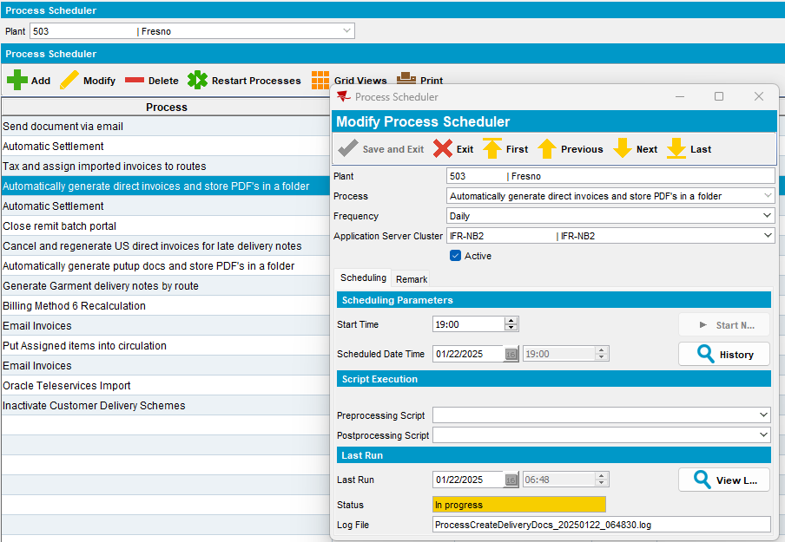

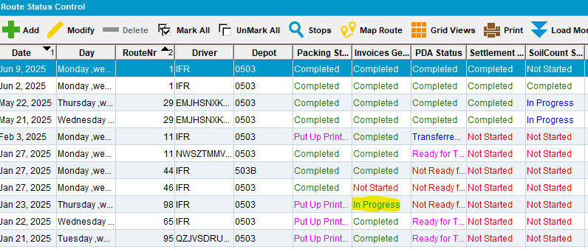

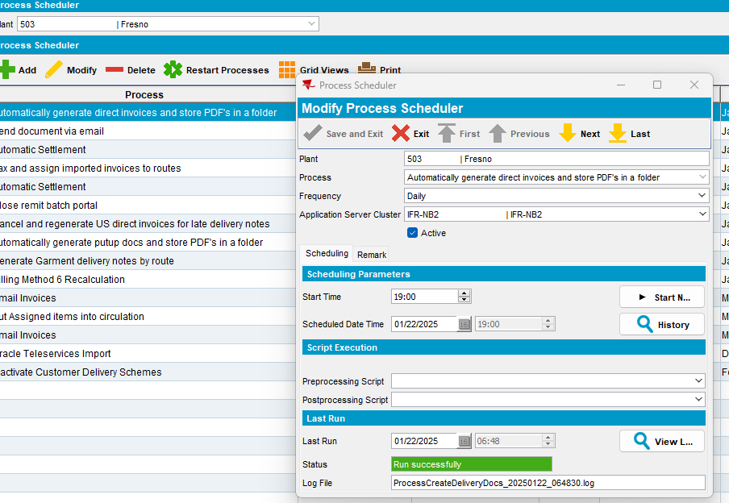

Route it is automatically Mark ready for transfer to PDA:

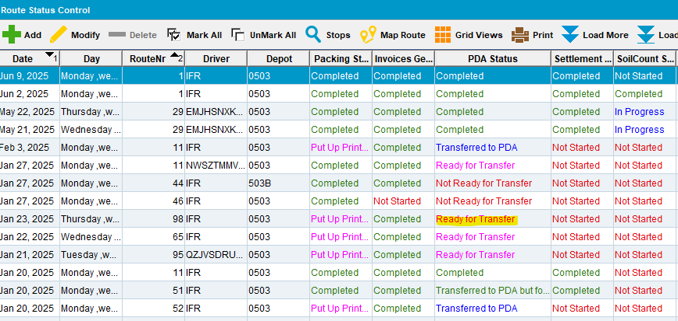

Tested ok.

Repeat the previous steps also with Automatically generate putup docs process:

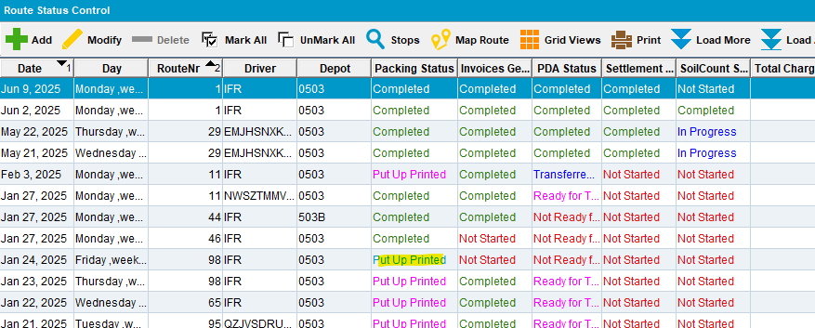

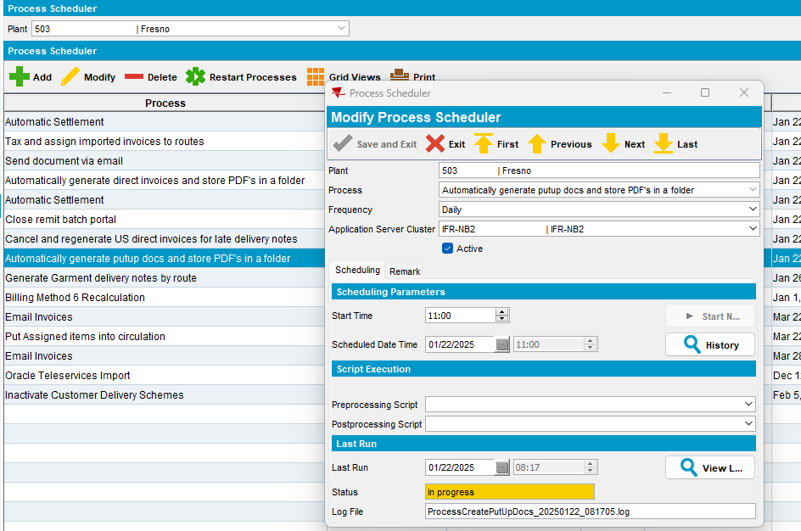

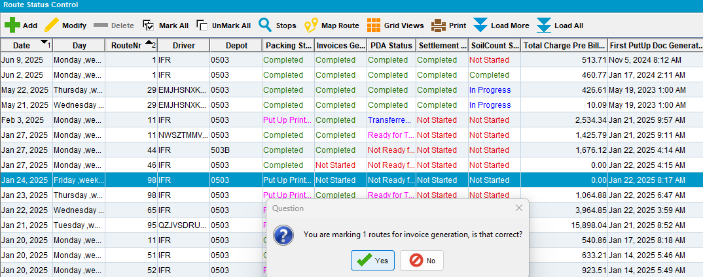

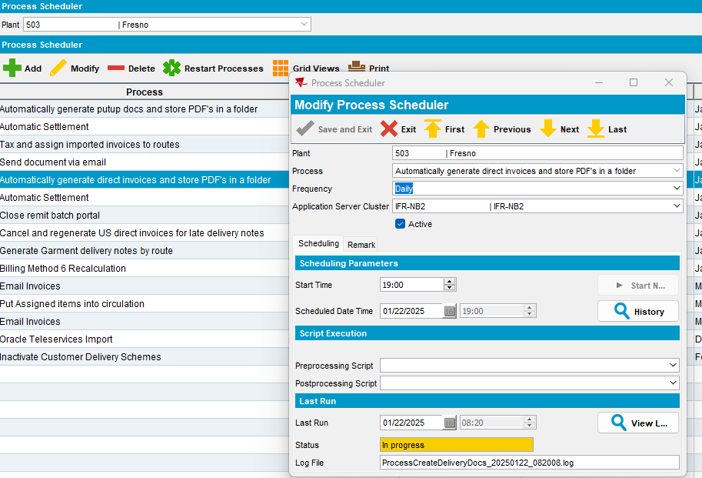

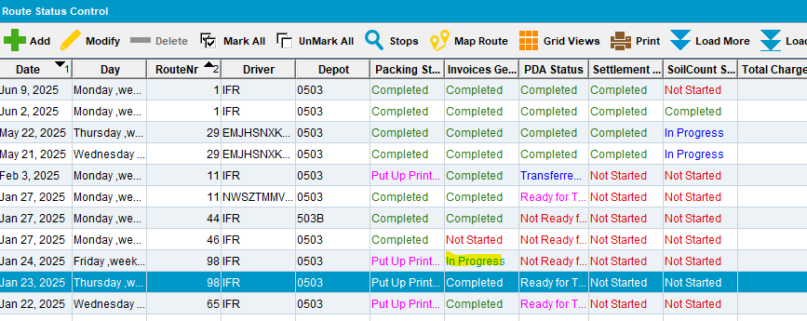

Route it is automatically Mark ready for transfer to PDA:

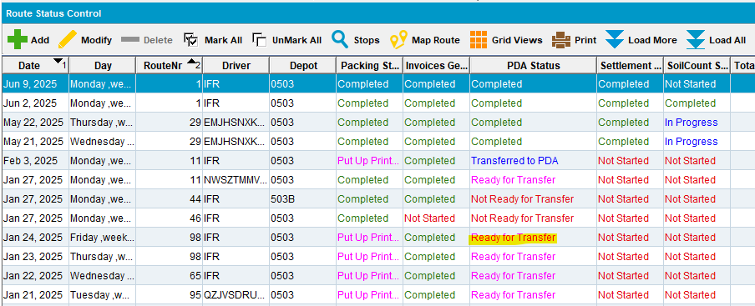

Tested ok.

