ABSN-1511 Downgrade to 9.08.00.RELEASE.p17_AUS
Environment | Prerequisites
Version: 9.08.00.RELEASE.p16  DBServerName=abs-srv16.internal.abslbs.com  DBSID=CUST21  DBUser=AUS_ND90502  DBPassword= AUS_ND90502  Environment=Production  Hash: 734ddcf  Branch: bugfix/ABSN-1511-rsc-read-only-user-unable-to-perform-actions-under-custom-module9.08 | - Module: AUSCUSTOM  - System setting: -  - Others: BU 602 , 252  - AllowCommitsInReadOnlyMode=N

Contents
Retest after fix 1
Module AUSCUSTOM in the license file 1
Module AUSCUSTOM is NOT in the license file 9

Retest after fix
Observation! In application.properties, AllowCommitsInReadOnlyMode=N. This property indicates whether commits should be allowed or rejected for system users that do not have necessary access level rights.

Module AUSCUSTOM in the license file
Expected behavior:
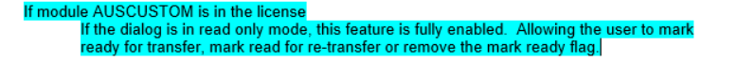
- Module AUSCUSTOM in the license file
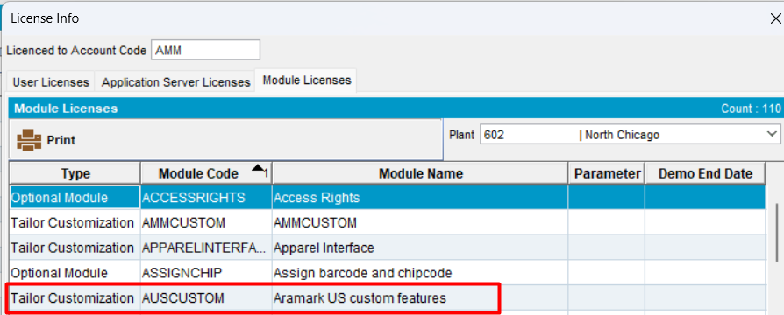
- System User with Read Only access rights
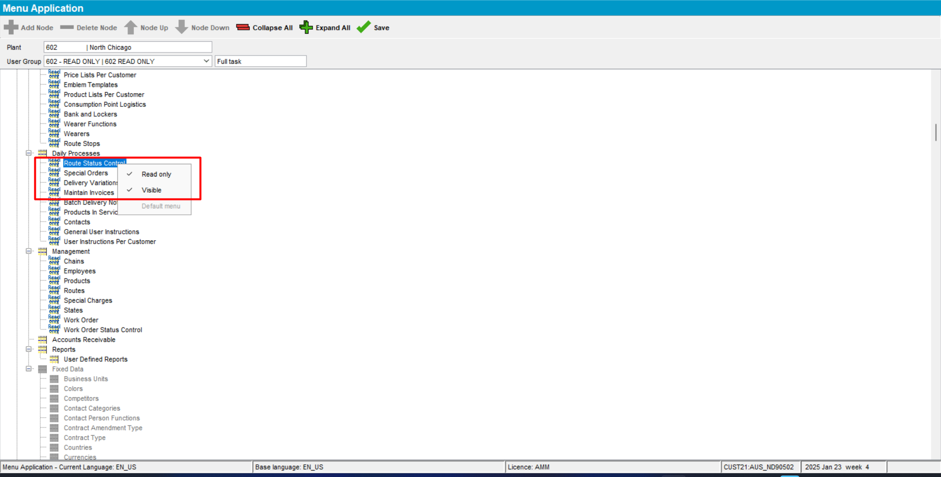
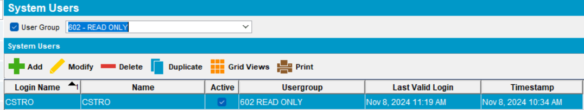
- Using a Read Only user, open Route Status Control dlg. Select a route control with invoice status = “Completed”. Depending on the PDA Status, go to Route Preparation tab and select the needed status and press “OK”.
Try the following cases:
- Ready for Transfer to PDA -> Ready for Transfer to PDA -> OK. No error
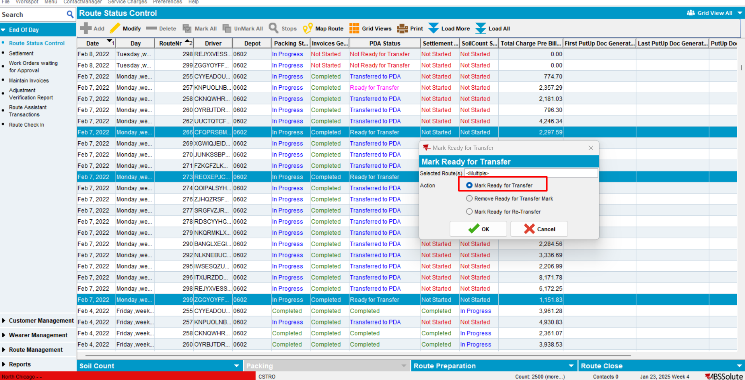
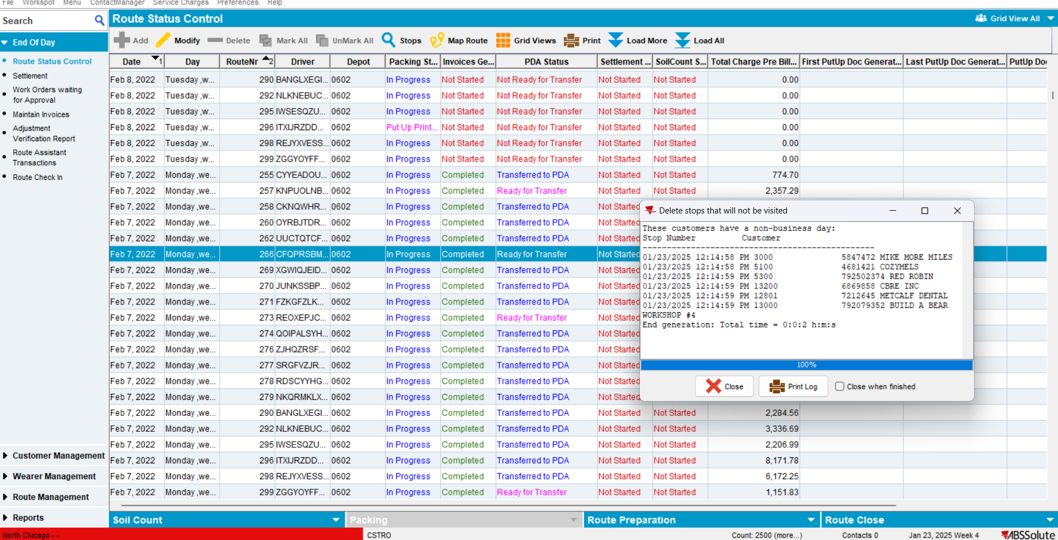
- Ready for Transfer to PDA -> Remove Ready for Transfer
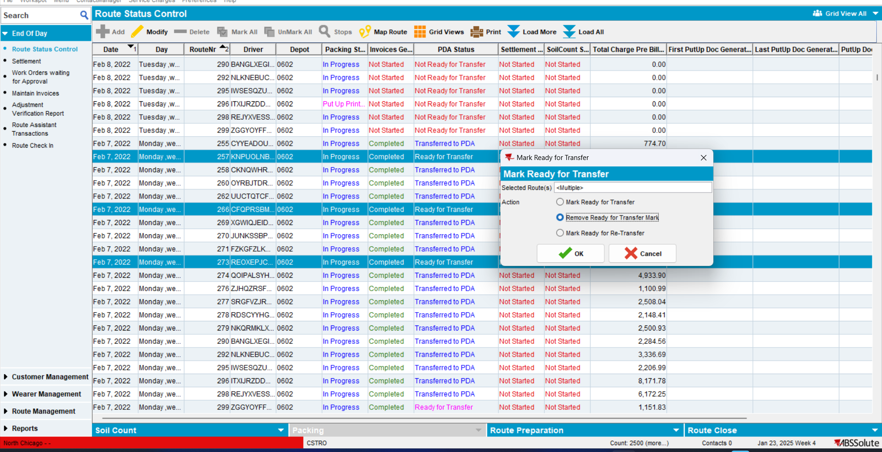
No error occurs. Status is changed to “Not Ready for Transfer”.
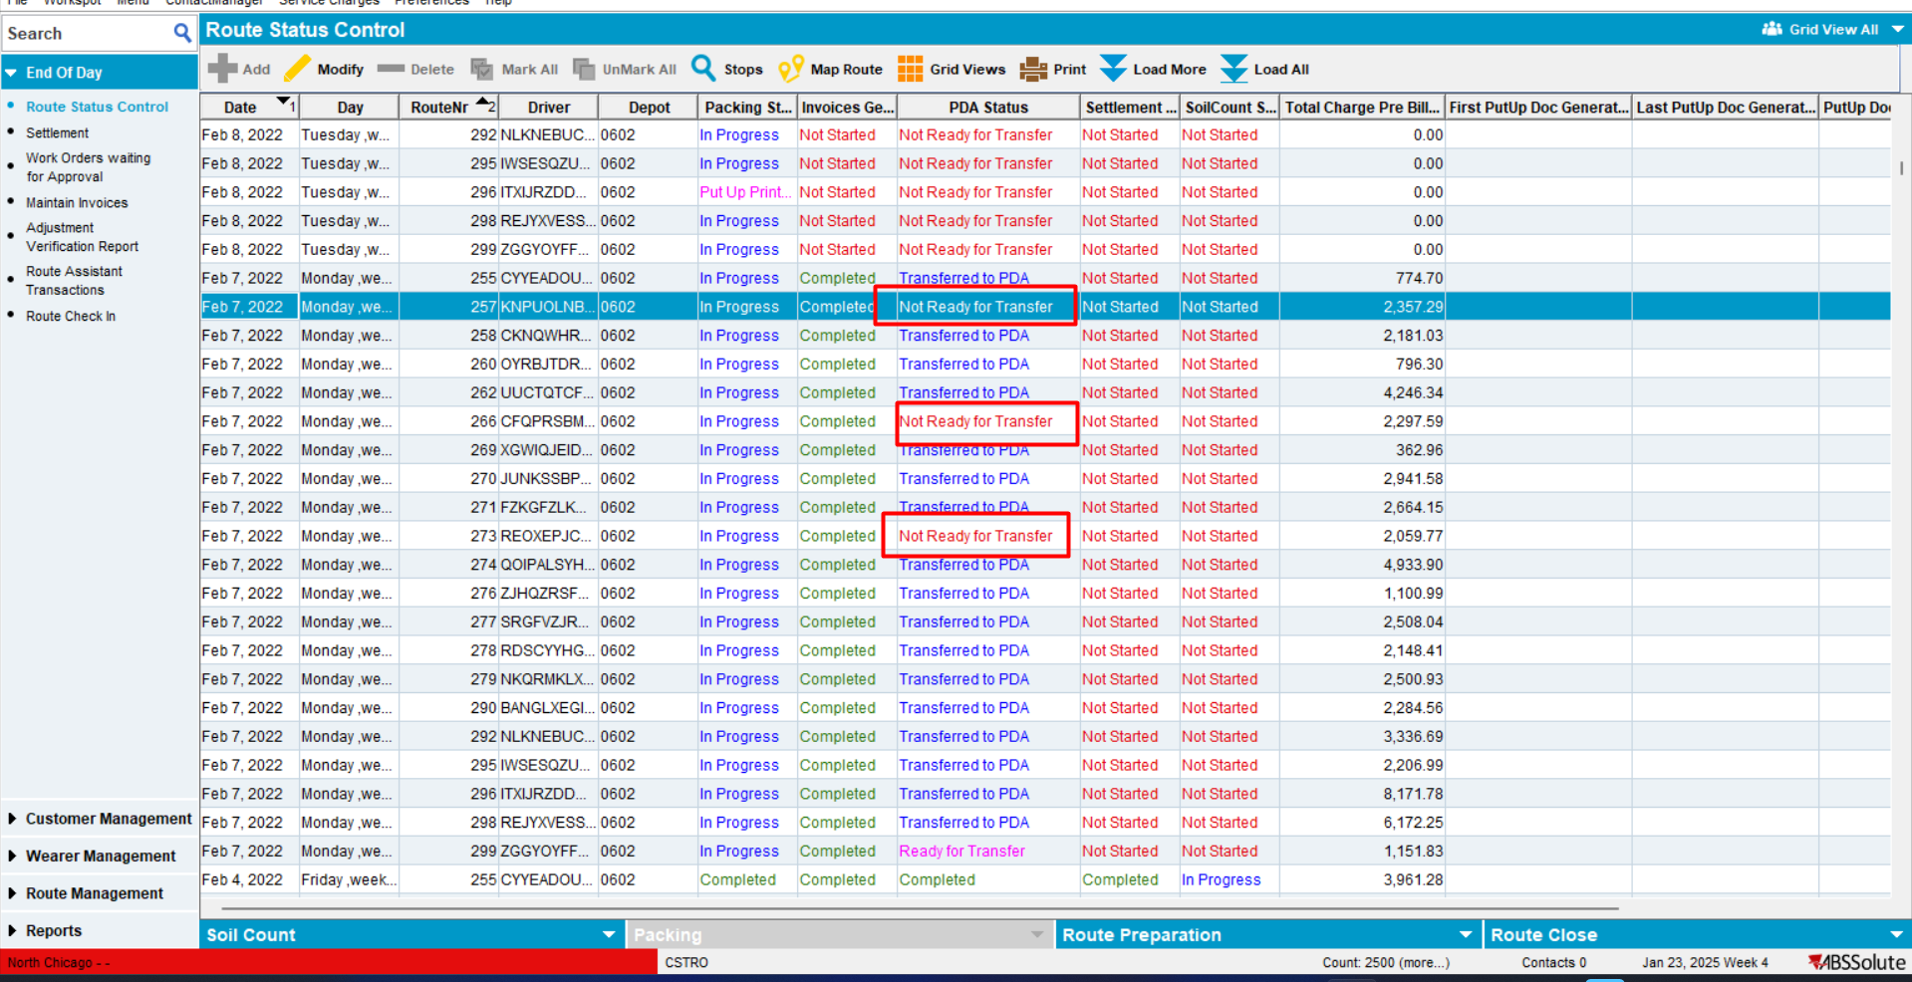
TESTED OK
- Ready for Transfer to PDA -> Mark Ready for Re-Transfer to PDA -> specific error occurs. OK
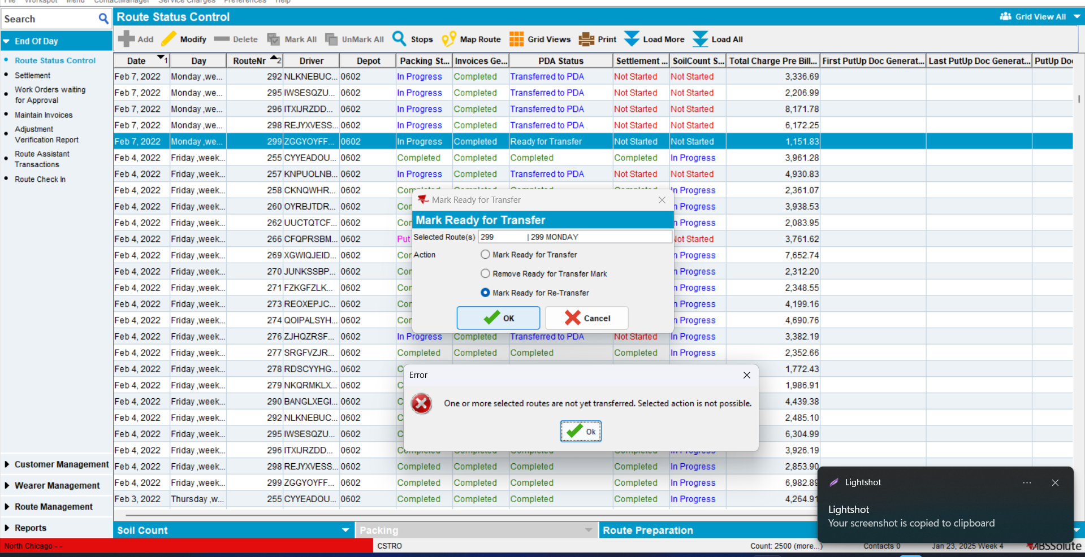
TESTED OK
- Transferred to PDA -> Mark Ready for Transfer -> Specific error occurred -> OK
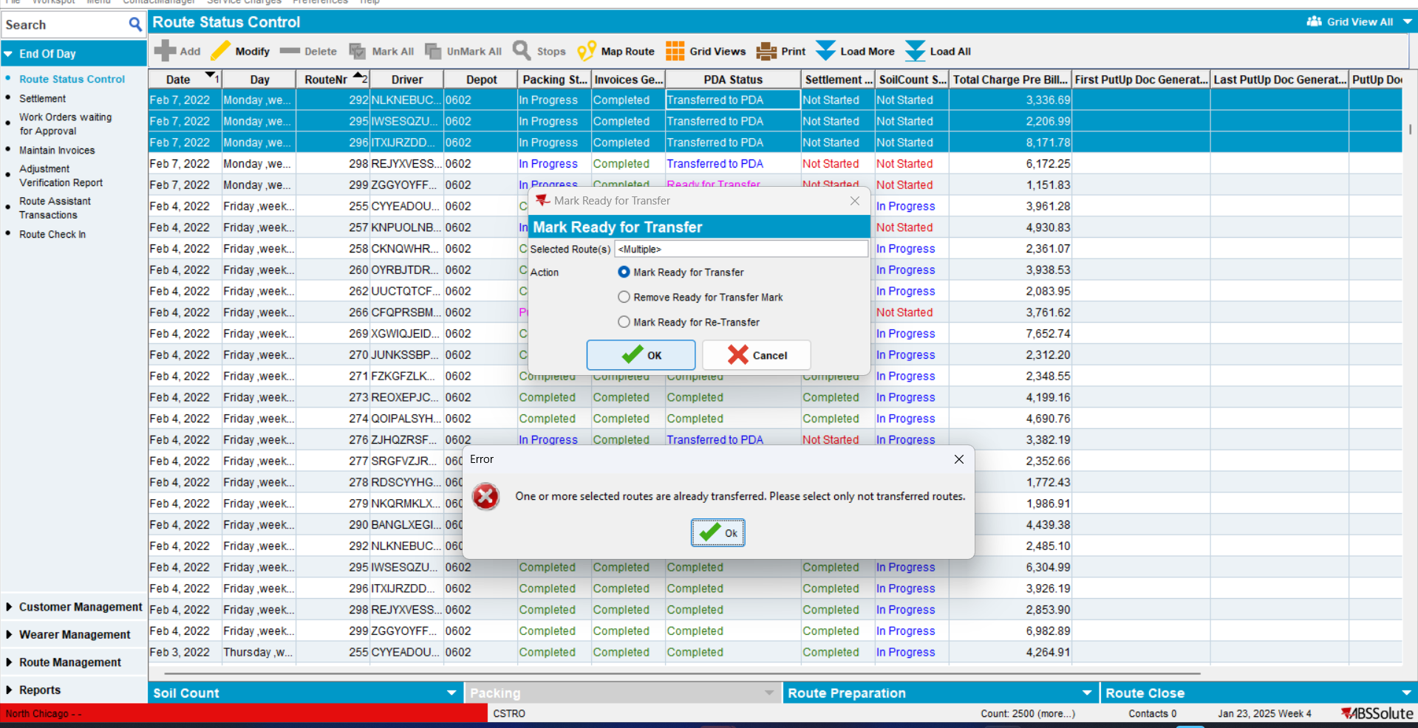
TESTED OK
- Transferred to PDA -> Remove Ready for Transfer Mark-> Specific error occurred -> OK
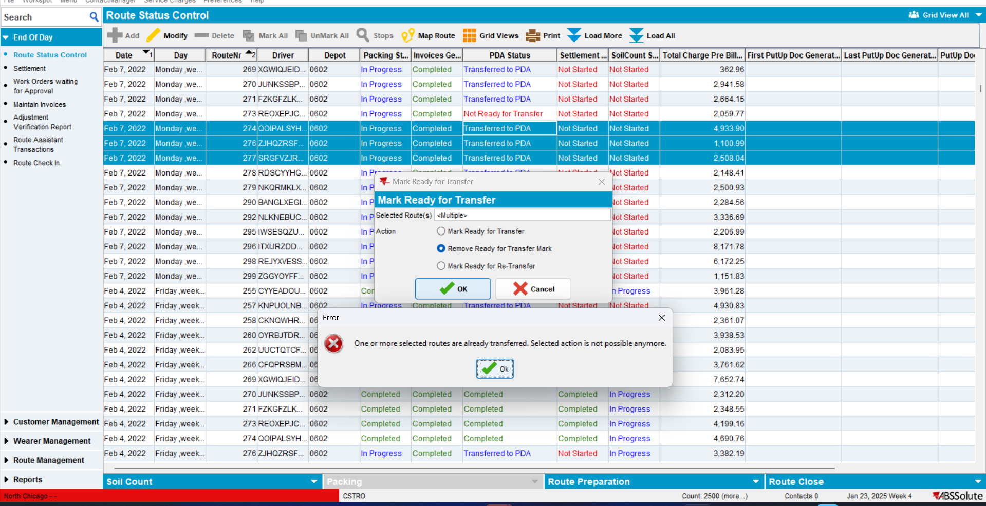
TESTED OK
- Transferred to PDA -> Mark Ready for Re-Transfer
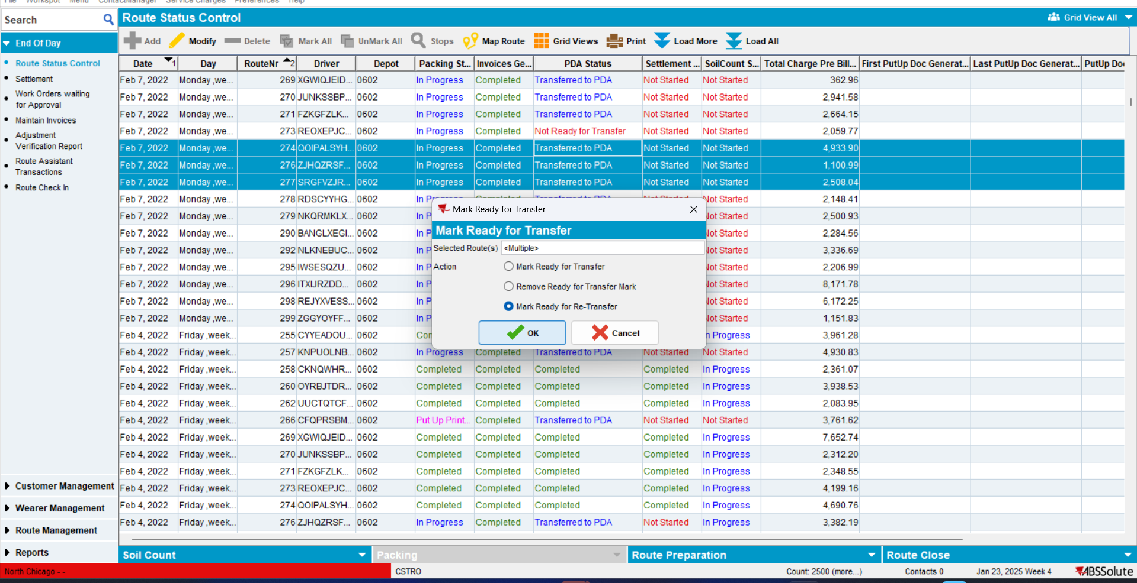
PDA Status changed to “Mark Ready for Transfer” -> OK.
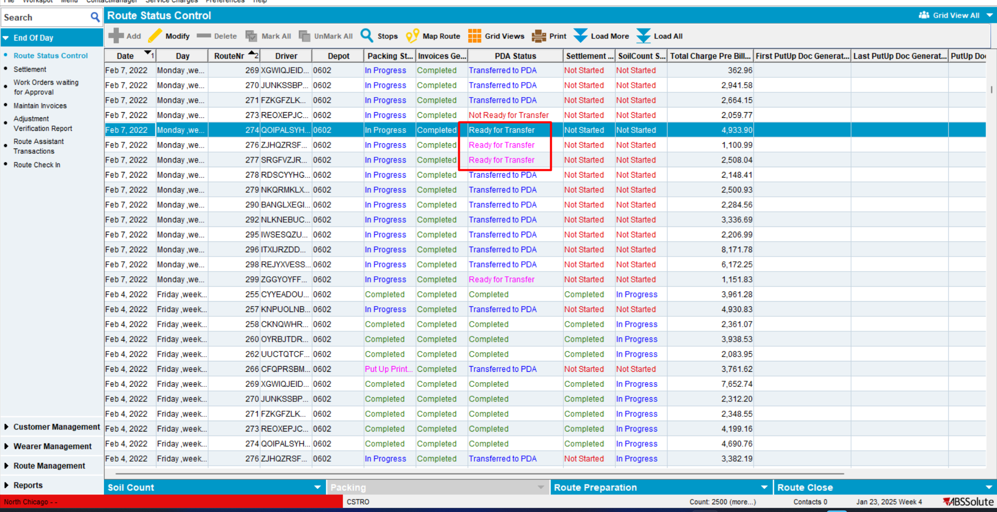
TESTED OK
- Not Ready For Transfer -> Mark Ready For Transfer
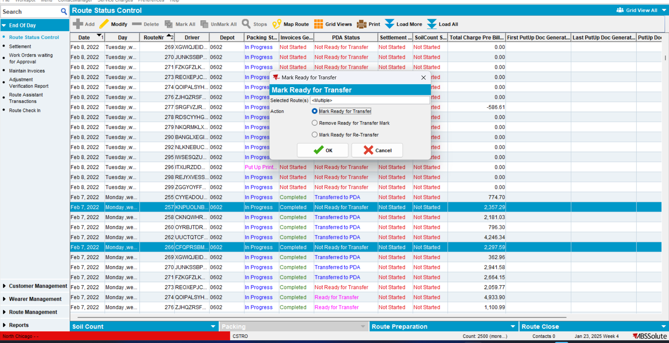
No error occurred. Status did change to “Ready For Transfer”
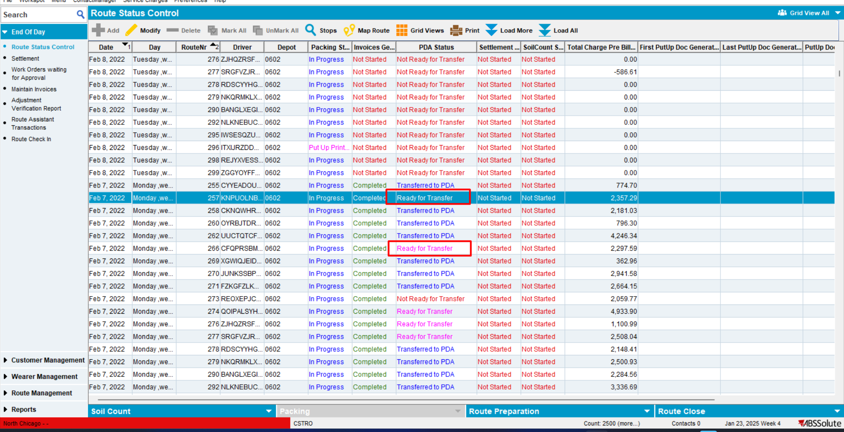
TESTED OK
- Not Ready For Transfer -> Remove Ready For Transfer
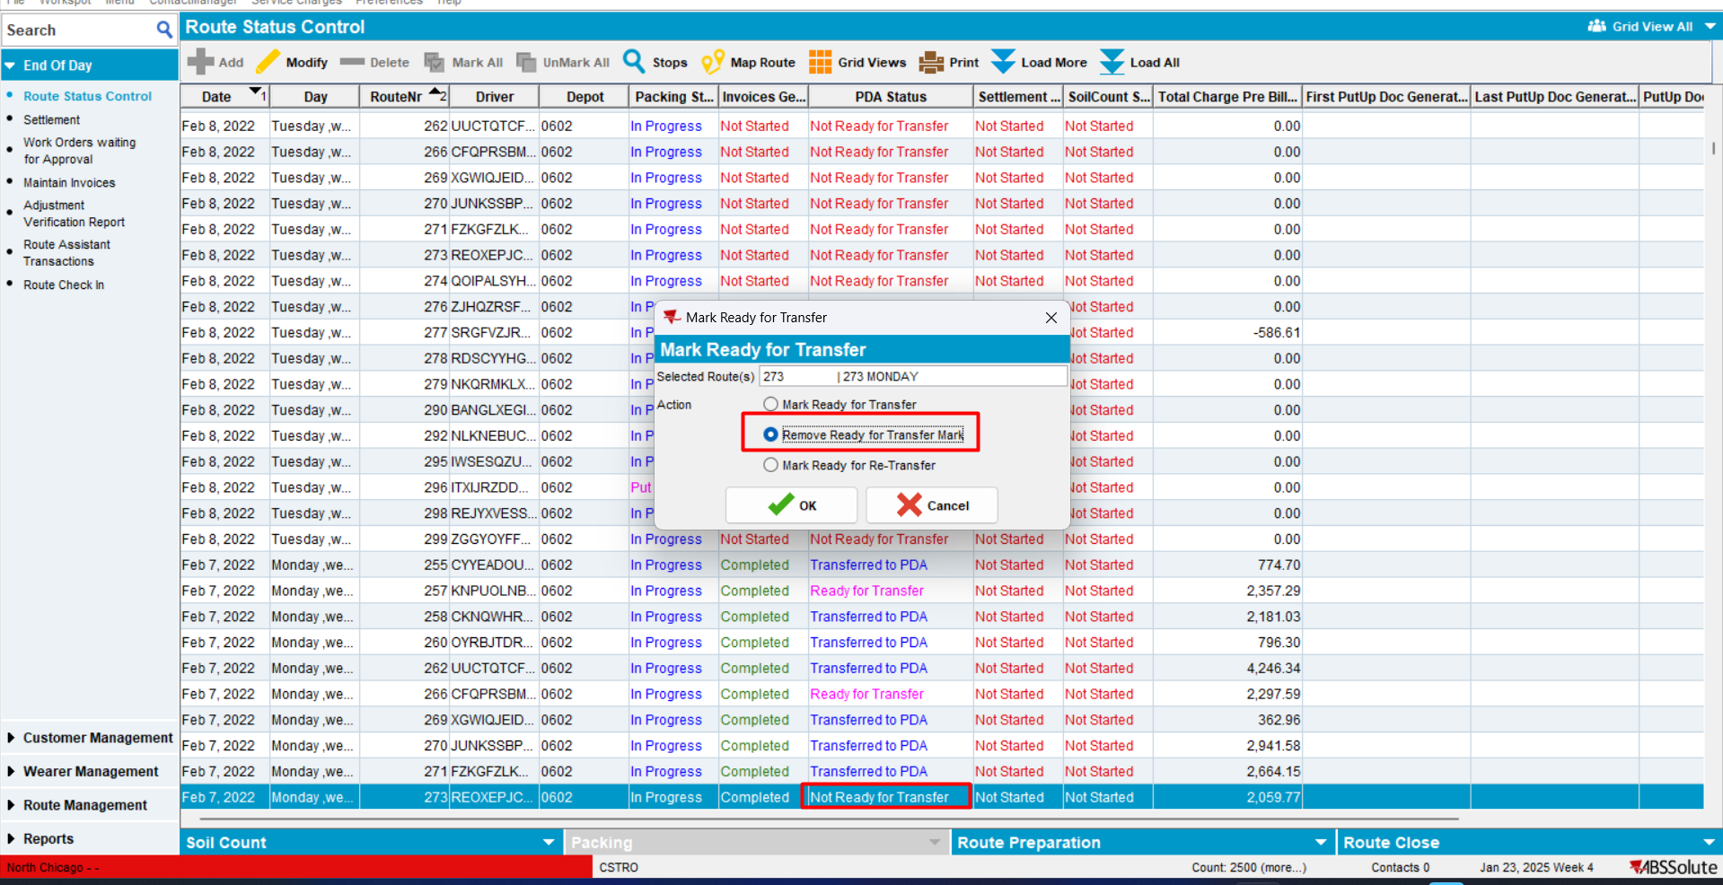
Nothing happened. Status did not change
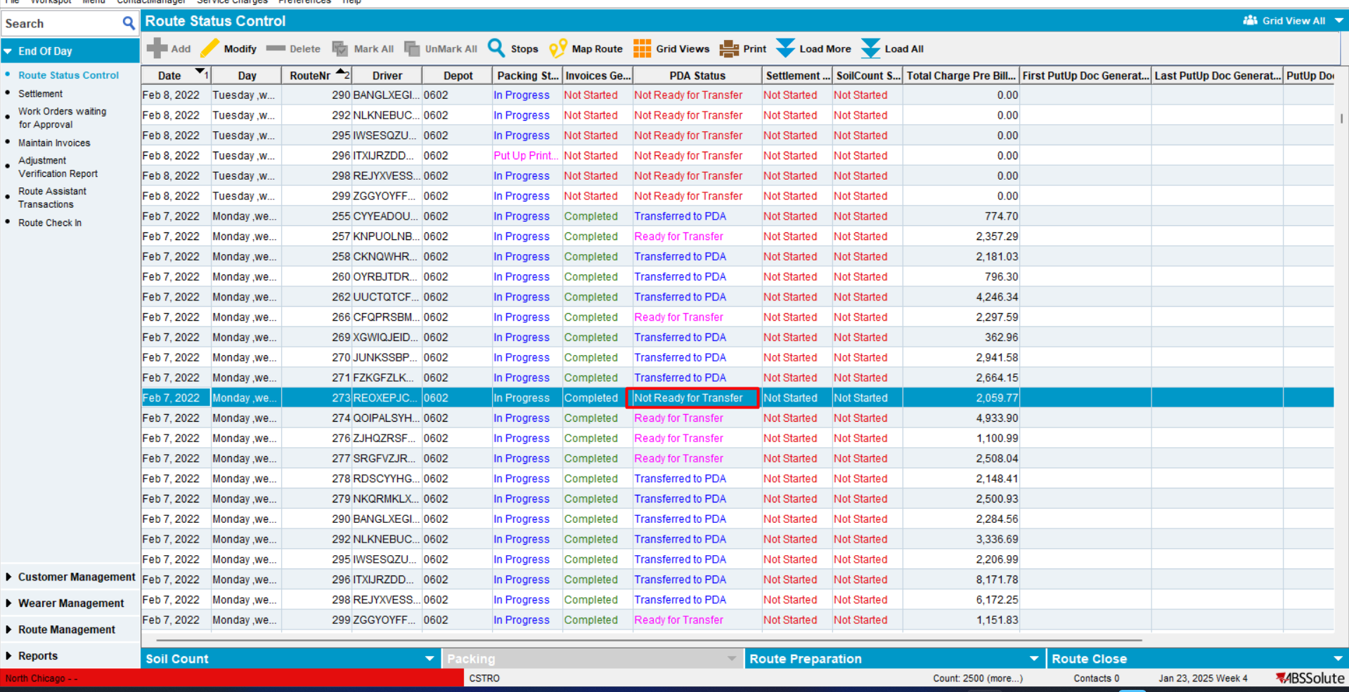
TESTED OK
- Not Ready For Transfer -> Mark Ready for Re-Transfer -> specific error occurred -> OK
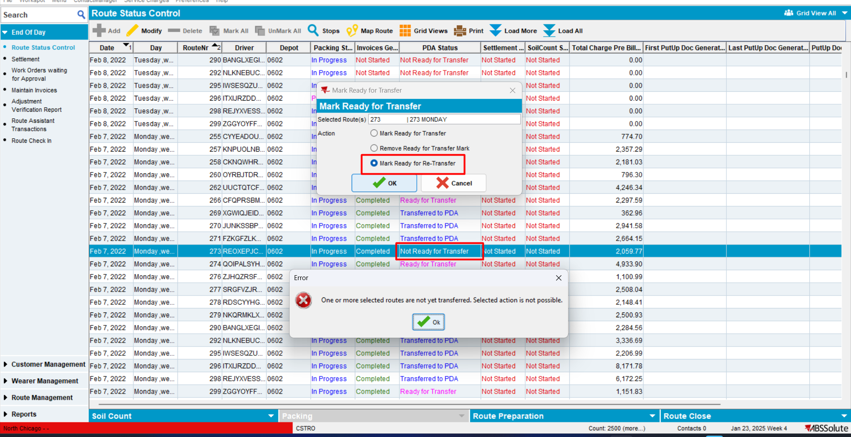
RETEST OK

Module AUSCUSTOM is NOT in the license file
Expected behavior:
When AUSCUSTOM is not in the license file and the dialog is in read only mode, this feature is fully disabled.
- Module AUSCUSTOM not in the license file
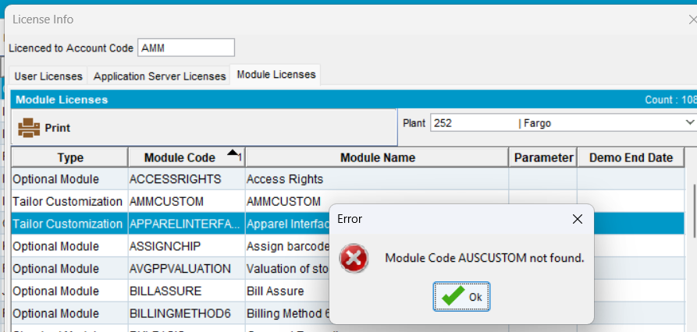
- System User with Read Only access rights
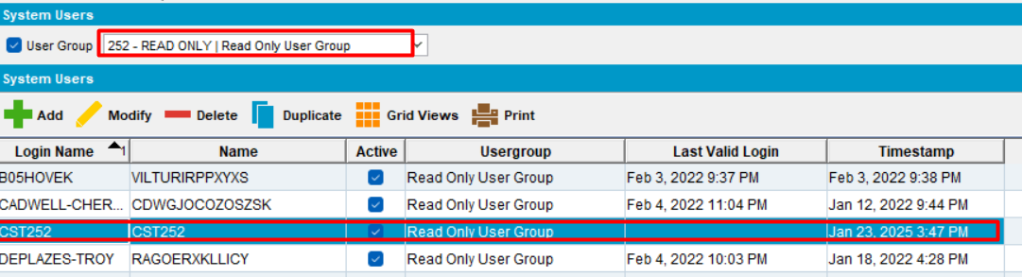
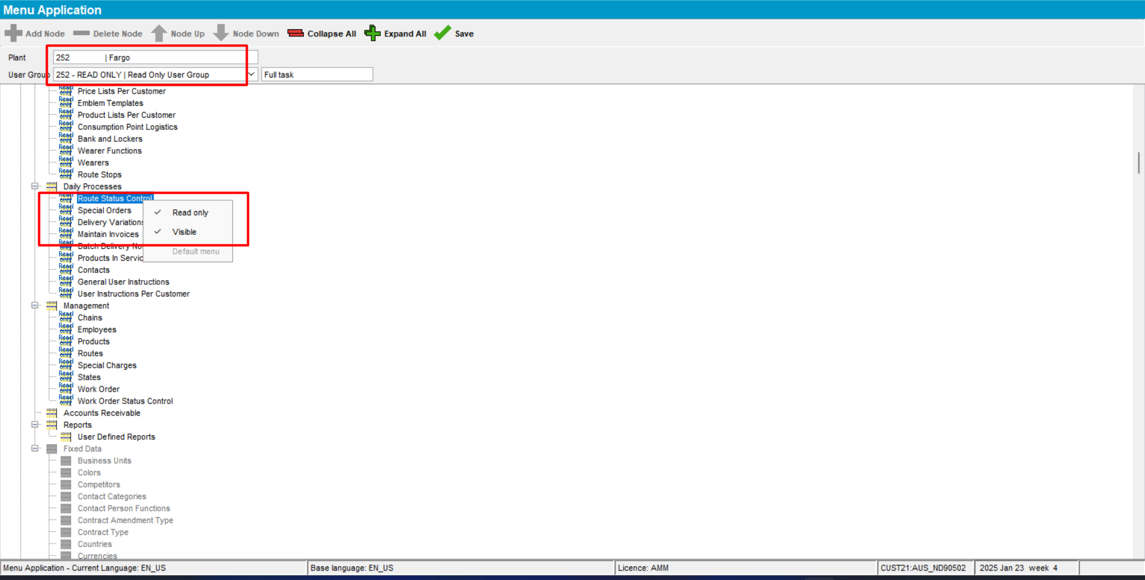
- Using a Read Only user, open Route Status Control dlg. Select a route control with invoice status = “Completed”. Depending on the PDA Status, go to Route Preparation tab and select the needed status and press “OK”.
Try the following cases:
- Ready for Transfer to PDA -> mark Ready for Transfer
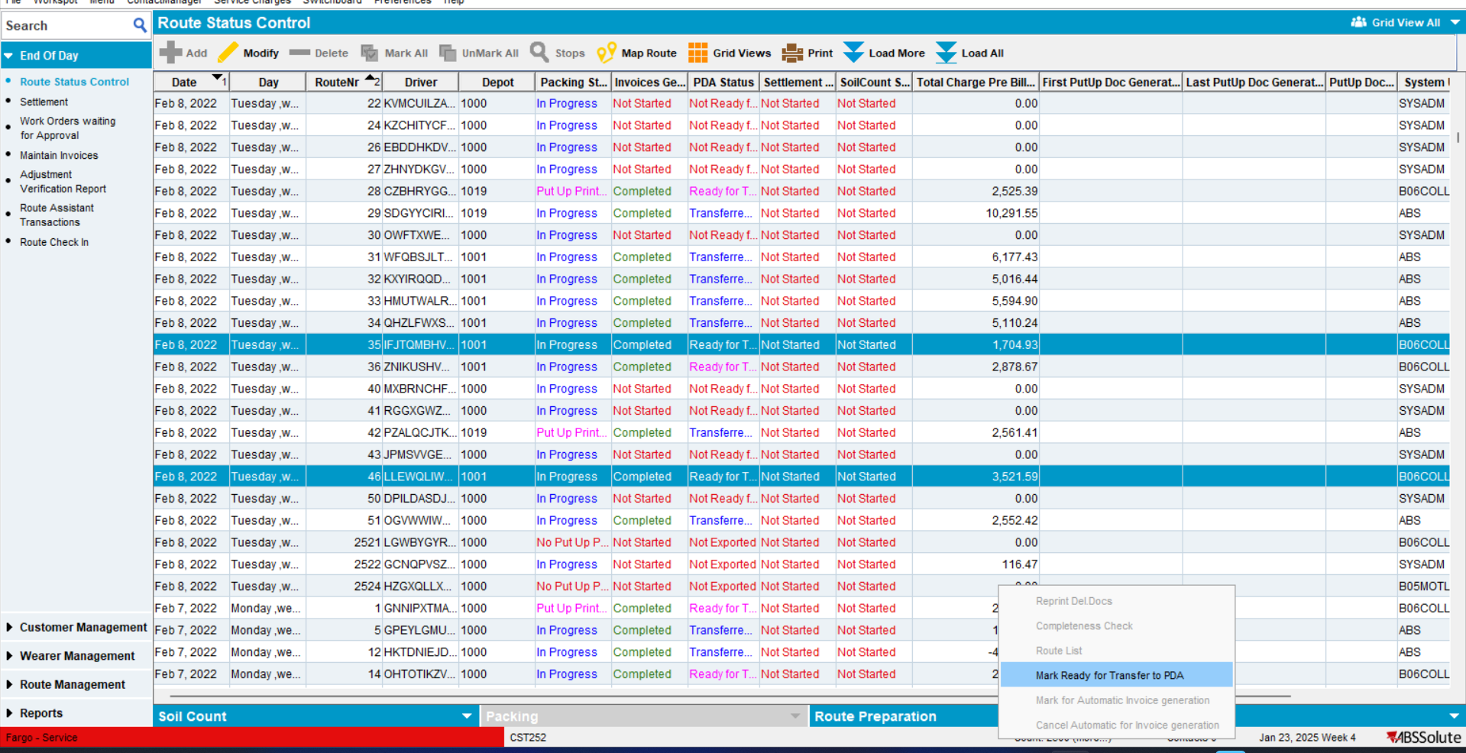
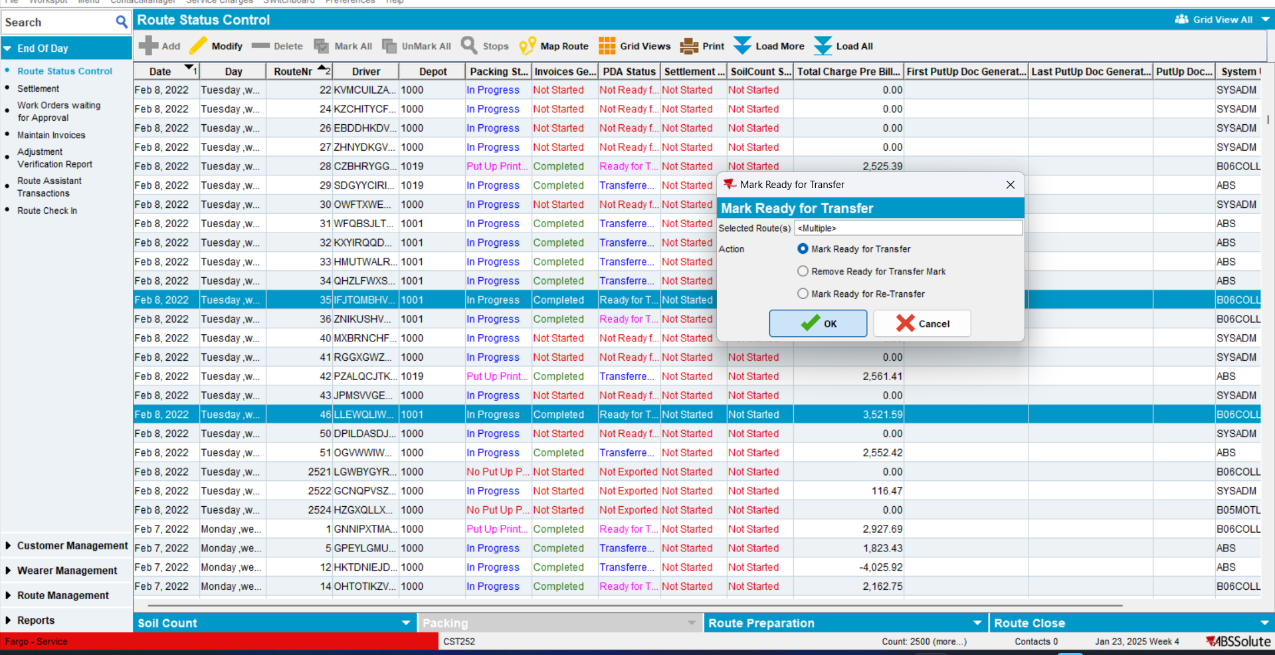
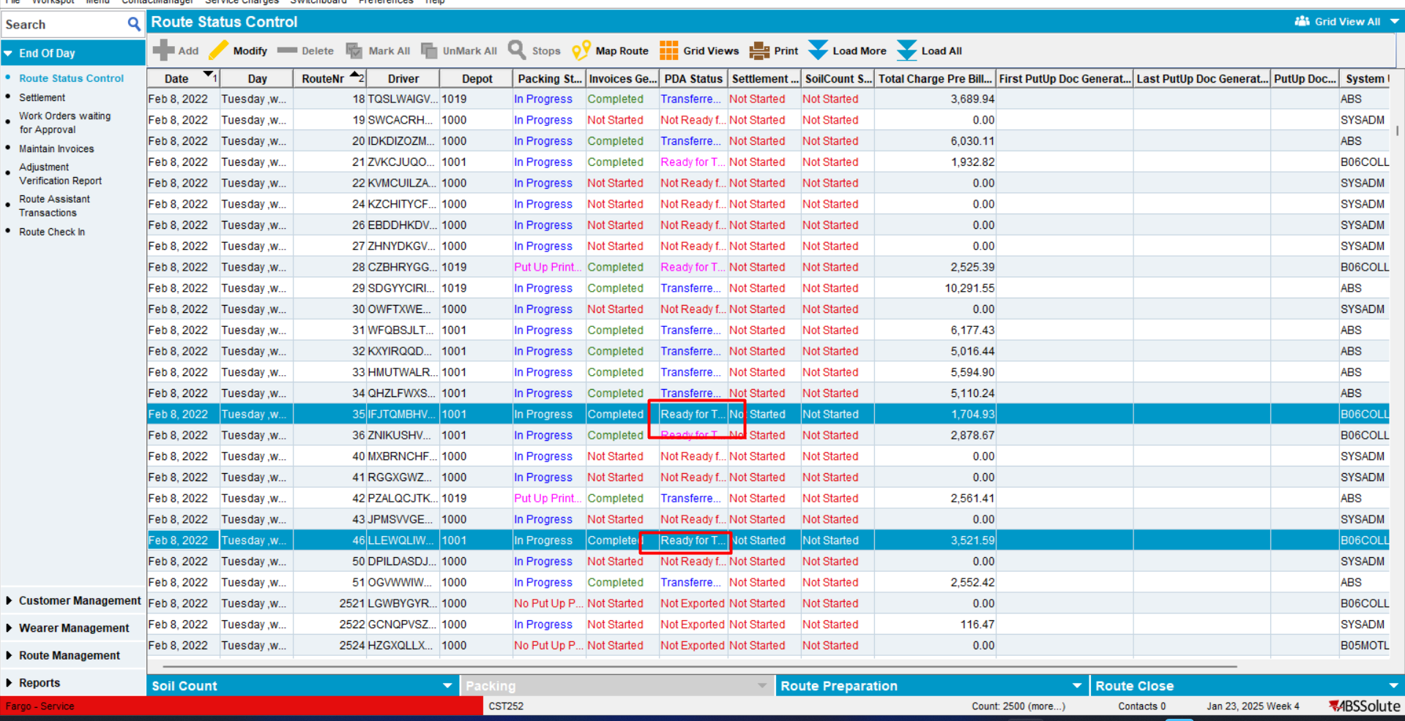
Nothing changed
- Ready for Transfer to PDA -> Remove Ready for Transfer
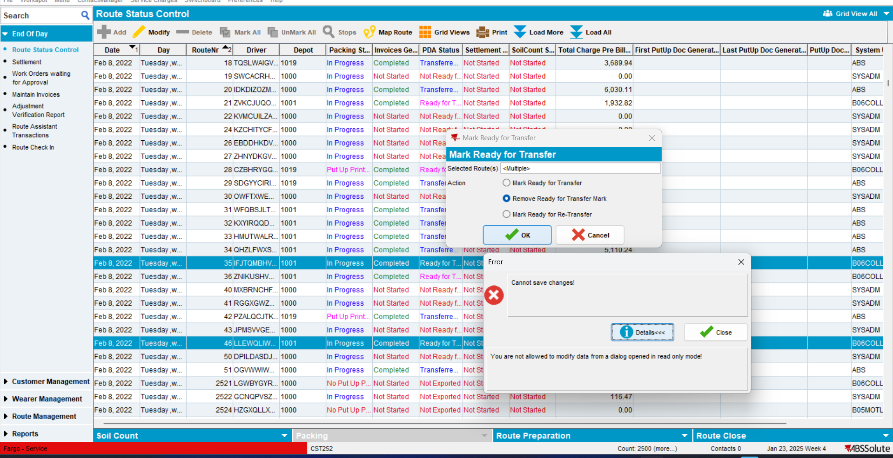
Error occurred due to Read Only functionality.
TESTED OK
- Ready for Transfer to PDA -> Mark Ready for Re-Transfer to PDA -> specific error occurs. OK
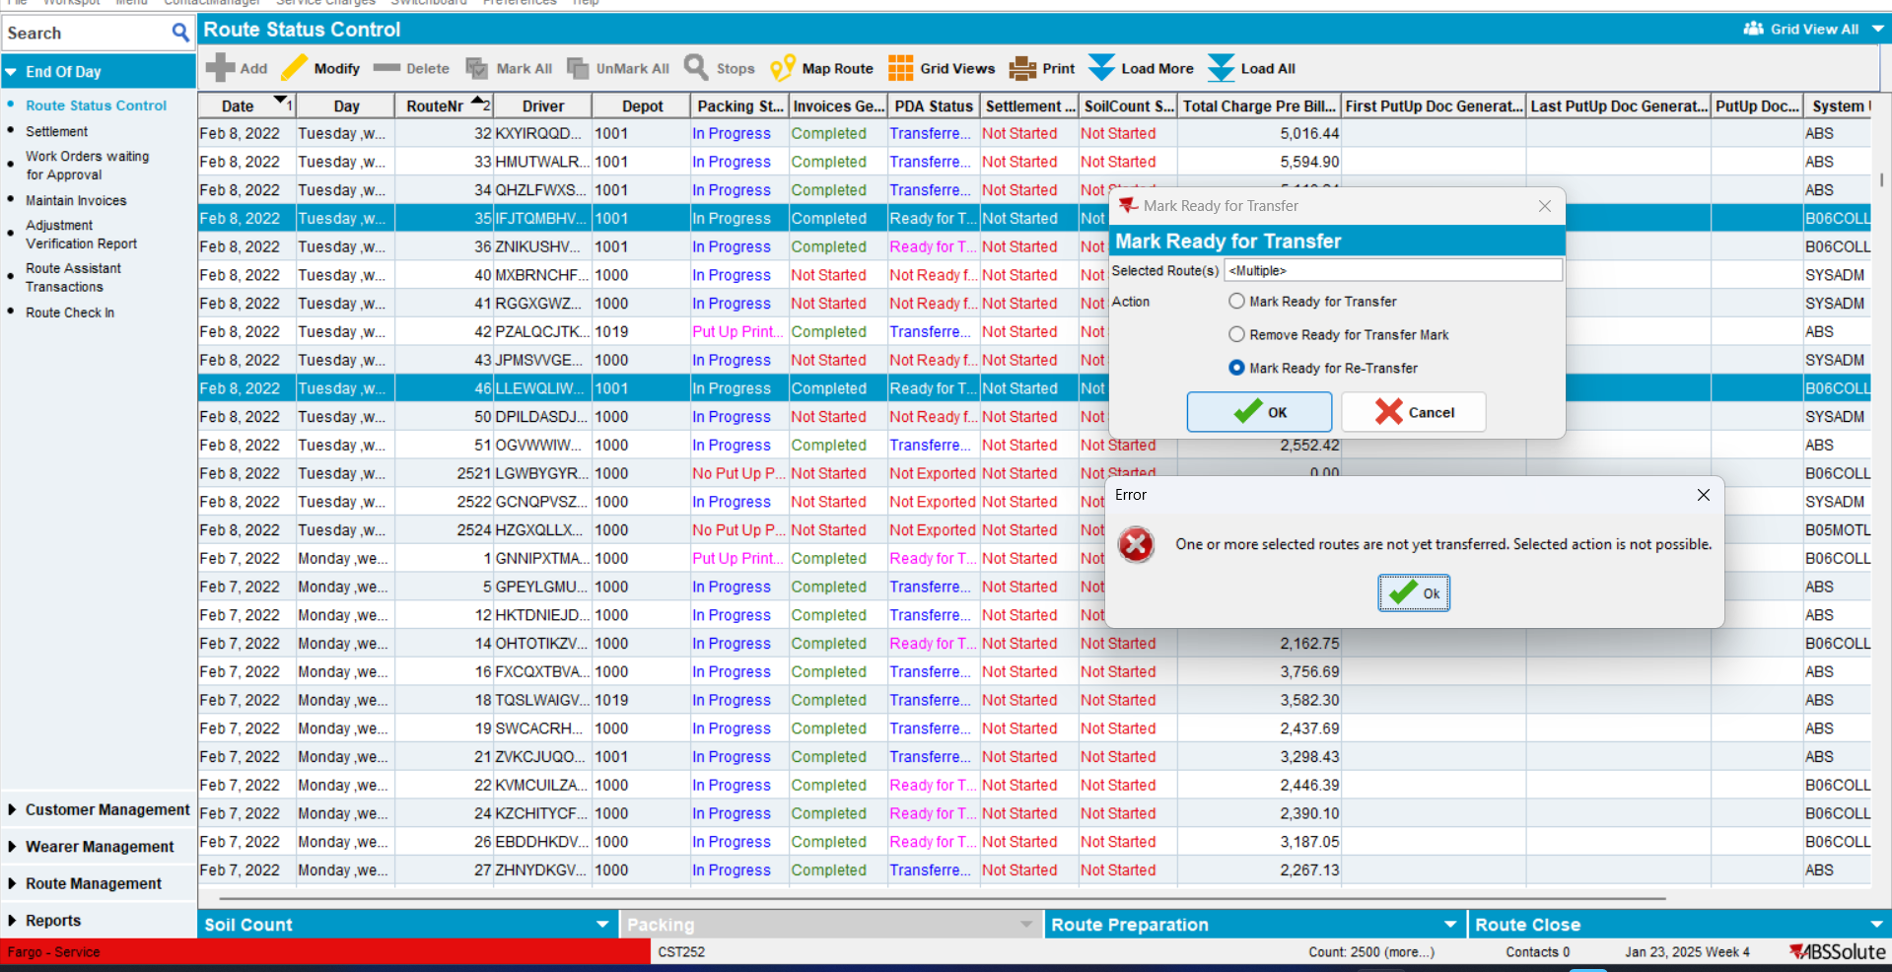
TESTED OK
- Transferred to PDA -> Mark Ready for Transfer -> Specific error occurred -> OK
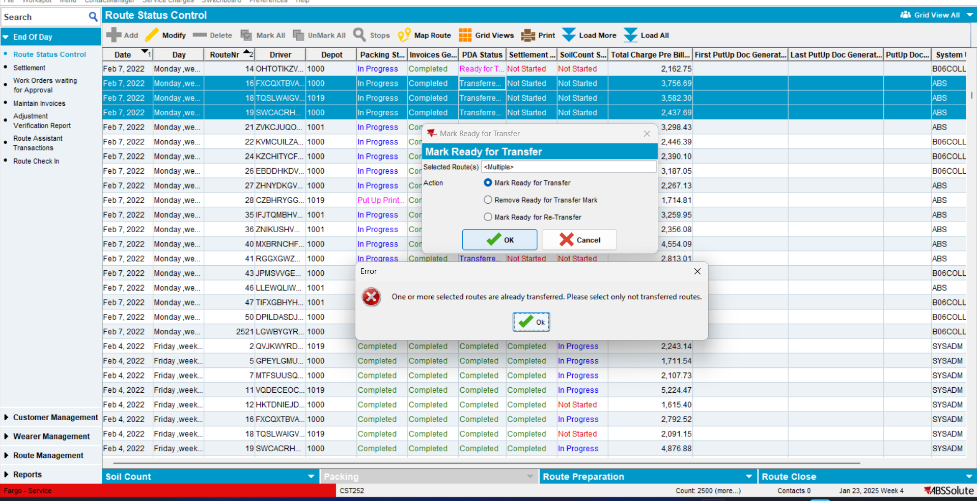
TESTED OK
- Transferred to PDA -> Remove Ready for Transfer Mark-> Specific error occurred -> OK
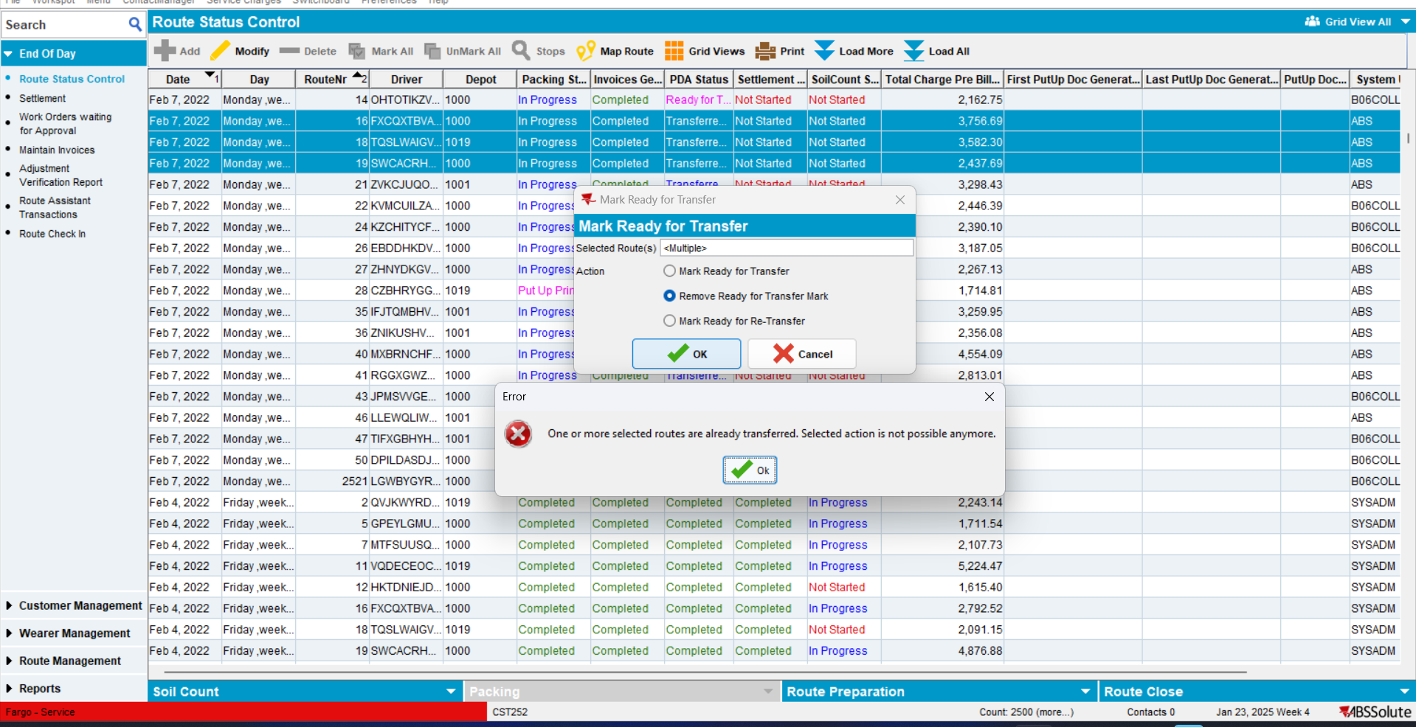
TESTED OK
- Transferred to PDA -> Mark Ready for Re-Transfer
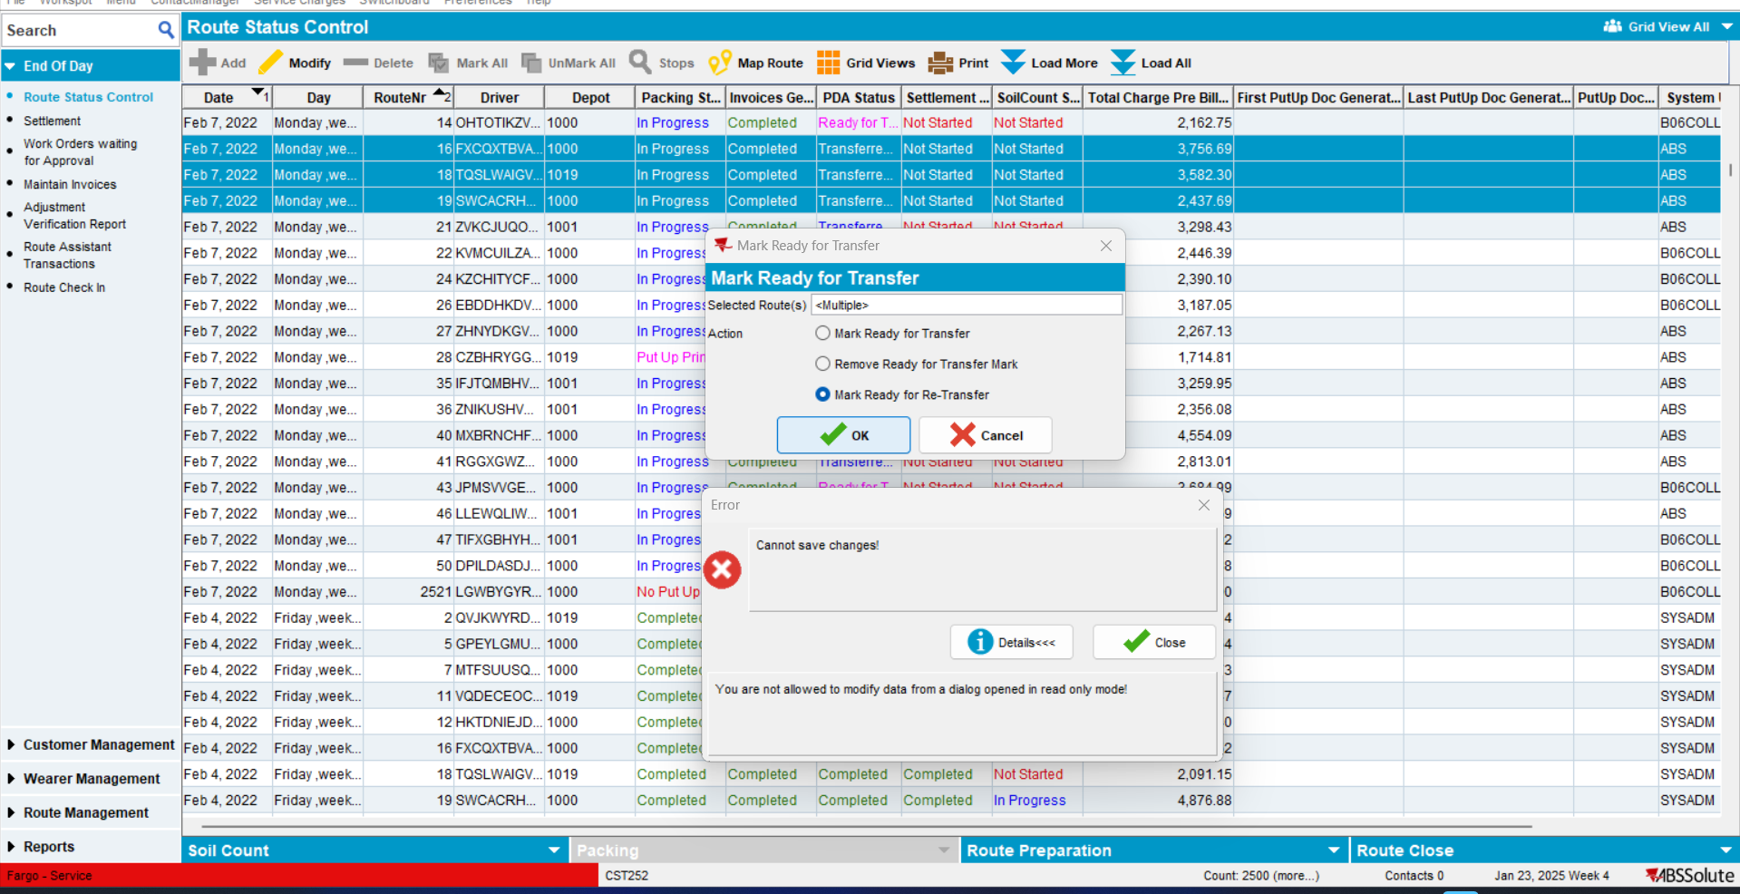
Error occurred due to Read Only functionality.
TESTED OK
- Not Ready For Transfer -> Remove Ready For Transfer
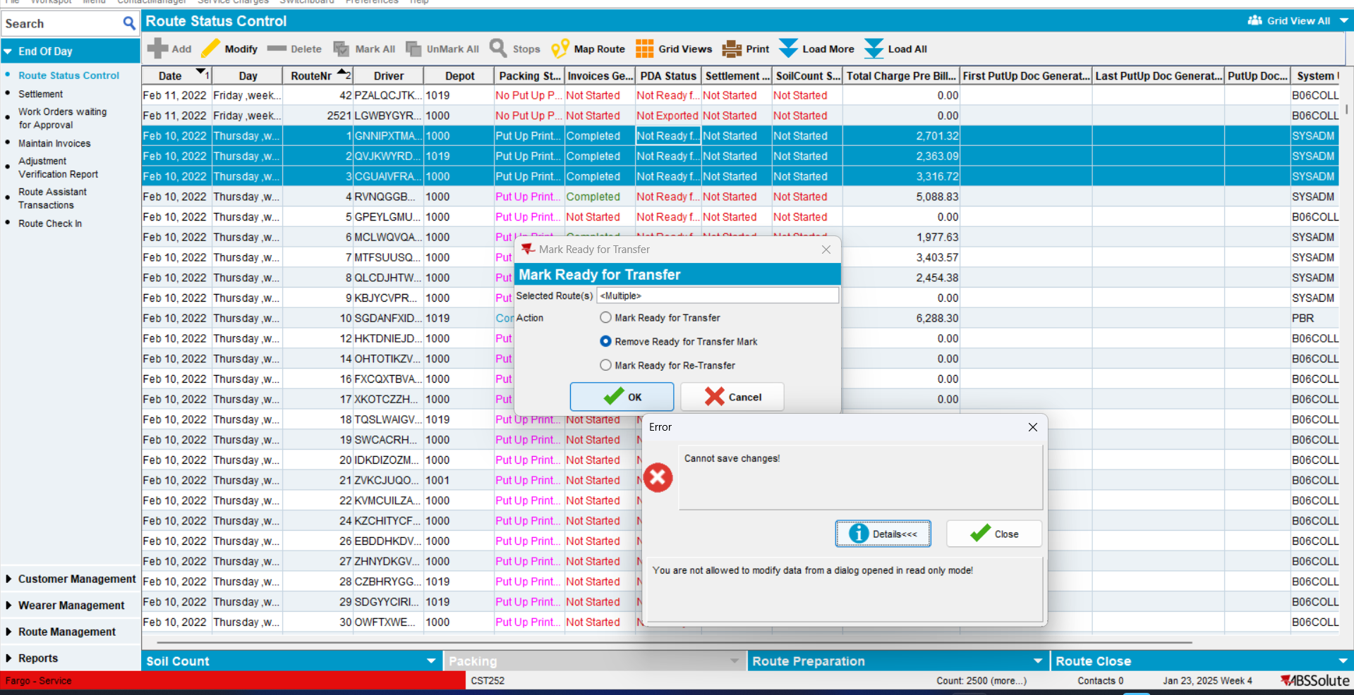
TESTED OK
- Not Ready For Transfer -> Mark Ready for Re-Transfer -> specific error occurred -> OK
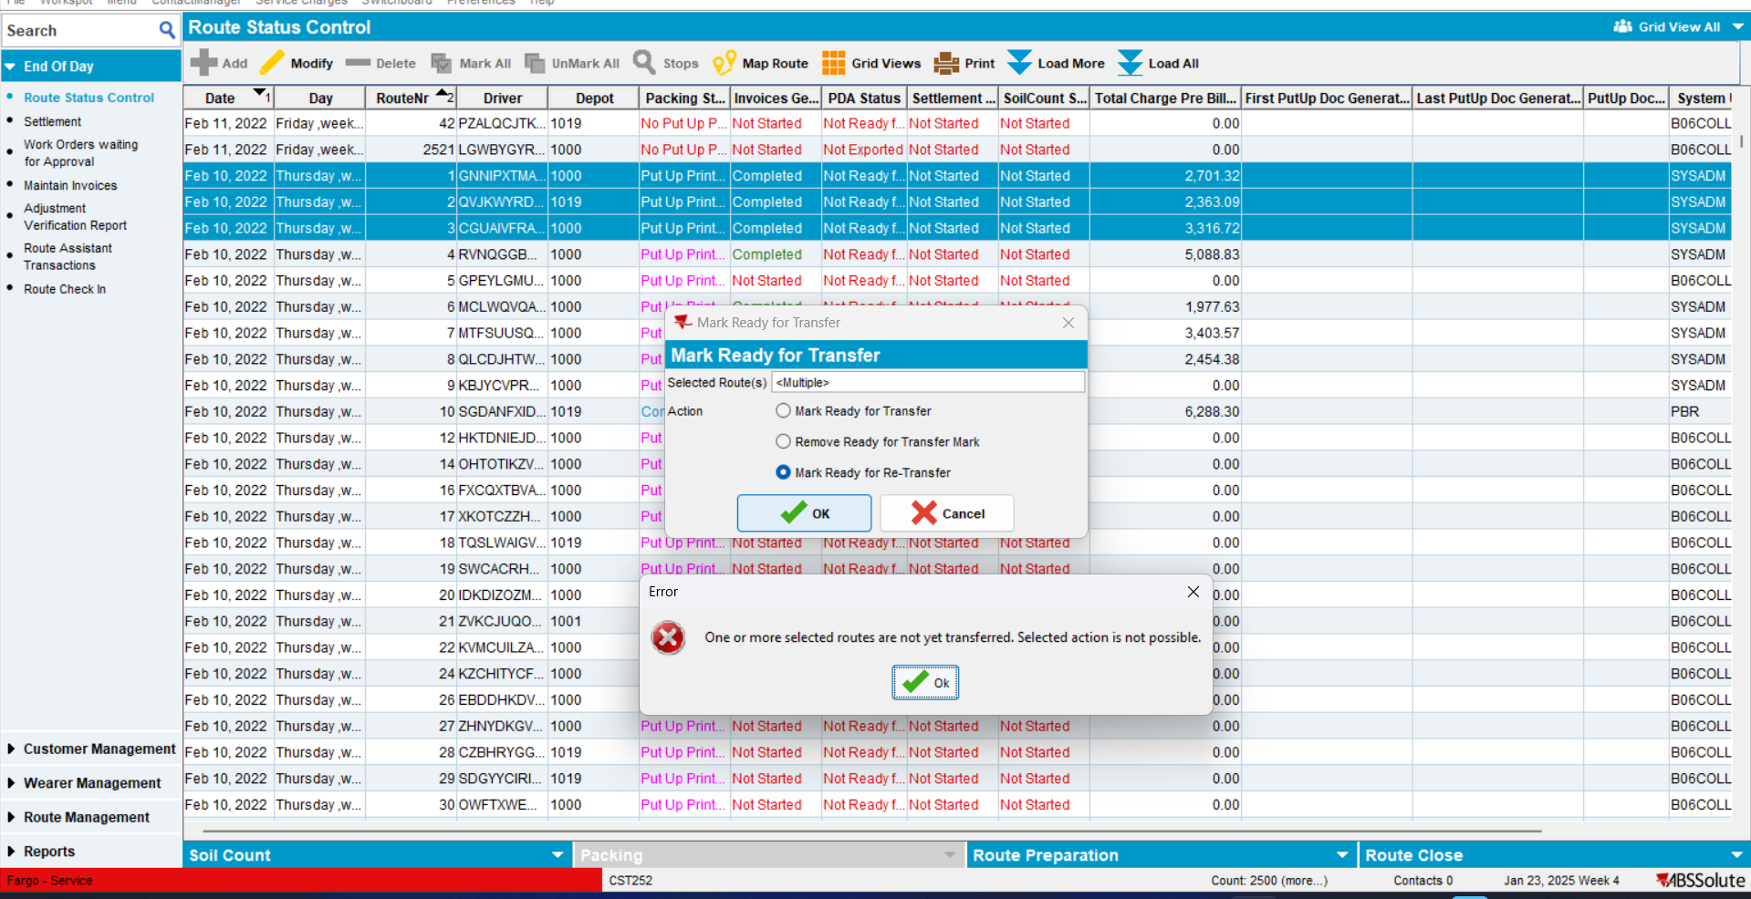
RETEST OK

