ABSN-1374 Performance issues/NULL error in scheduled process

Environment | Prerequisites
Version: 9.08.00.RELEASE.p16  DBServerName=abs-srv16.internal.abslbs.com  DBSID=CUST21  DBUser=AUS_ND90502  DBPassword= AUS_ND90502  Environment=Production  Branch: bugfix/ABSN-1374-performance-issues-null-error-in-scheduled-process90800 | - Module:-  - System stting: -  - Others: BU 307 Charlotte  - Ss: DELETENOTVISITEDSTOPS=3

Contents
Reproducing before fix 1
Retest after fix 6
Test when DELETENOTVISITEDSTOPS=3 using Automate Invoice Generation process – 1 route control marked 6
Test when DELETENOTVISITEDSTOPS=3 using Automate Invoice Generation process – 2 route controls marked 9

Reproducing before fix
Hash: 14749eb
- Set System Setting DELETENOTVISITEDSTOPS=3
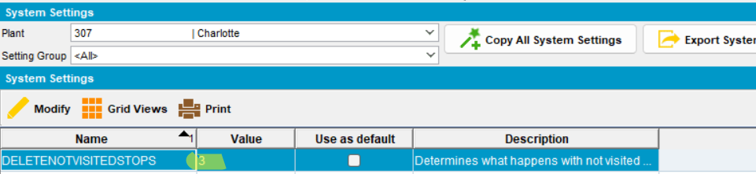
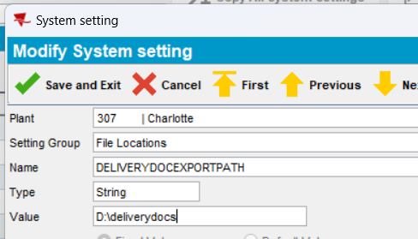
- Open Customers dlg, load customers and end date them. Keep “Active” checkbox checked.
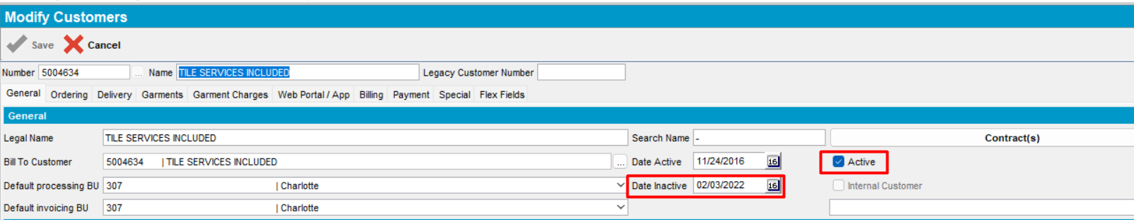
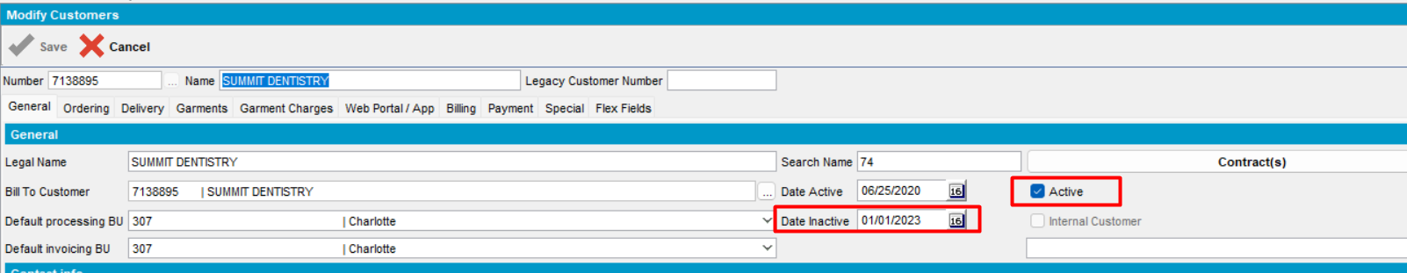
- Route Status Control dlg, add the route control containing the specific customers
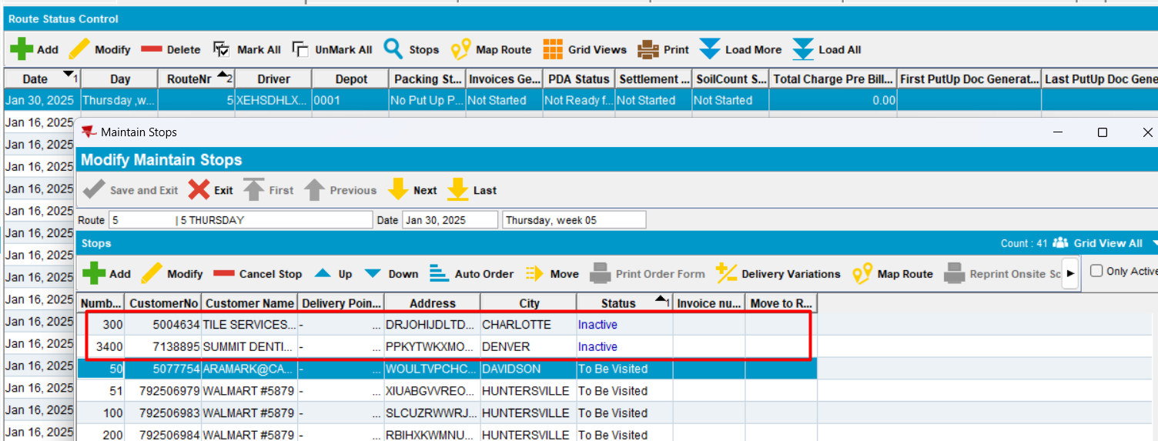
- Generate put up docs
- Mark route for Automatic Invoice Generation process
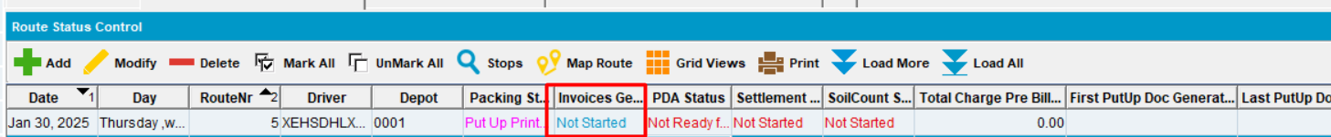
select RCT.INVOICESGENERATED, RT.ROUTENUMBER, Q.*
from ROUTEDOCUMENTGENERATIONQ Q
join ROUTE RT
on RT.ROUTE_ID = Q.ROUTE_ID
join ROUTECONTROL RCT
on RCT.ROUTECONTROL_ID = Q.ROUTECONTROL_ID
where Q.PLANT_ID = 342
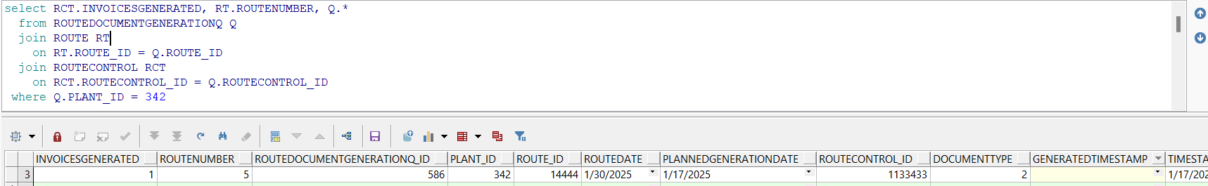
- In Process Scheduler dlg, start the Automatic Invoice Generation process
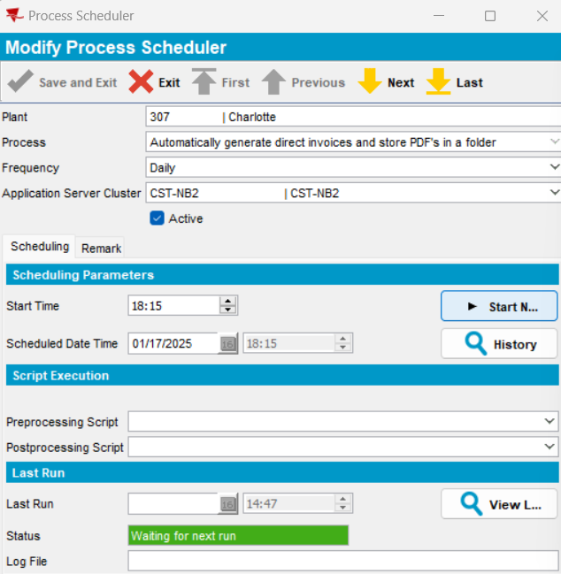
- The process started. The generation is in progress
During the process, invoices were generated for active stops. Inactive stops were left last to be deleted according to the system setting.
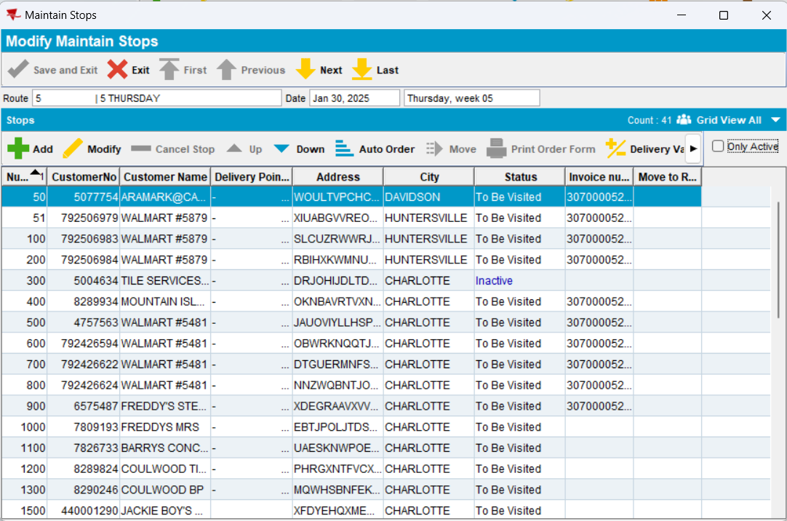
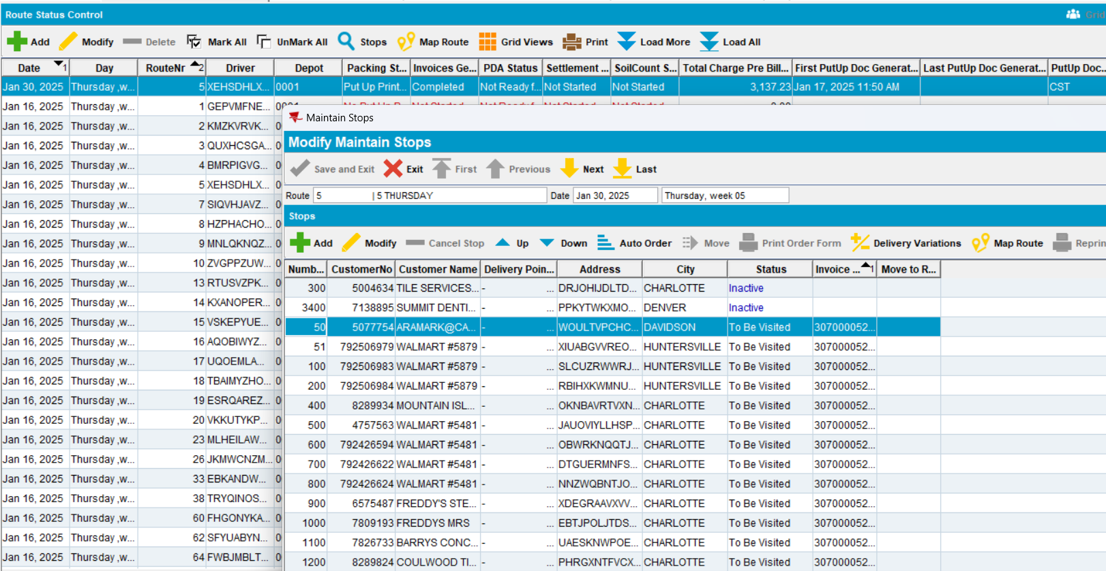
During the generation, waiting time was very long.
select
v.SID, v.inst_id,
v.PROGRAM,v.client_info,
to_char(v.LOGON_TIME, 'dd/mm/yyyy HH24:mi:ss') logintime,
v.SQL_ID,
v.PREV_SQL_ID,
v.PREV_EXEC_START,
round(v.SECONDS_IN_WAIT / 60) waitmin,
a.OBJECT_NAME,
l.*
from gv$locked_object l, all_objects a, gv$session v
where l.OBJECT_ID = a.object_id
and v.SID = l.SESSION_ID
and v.INST_ID = l.INST_ID
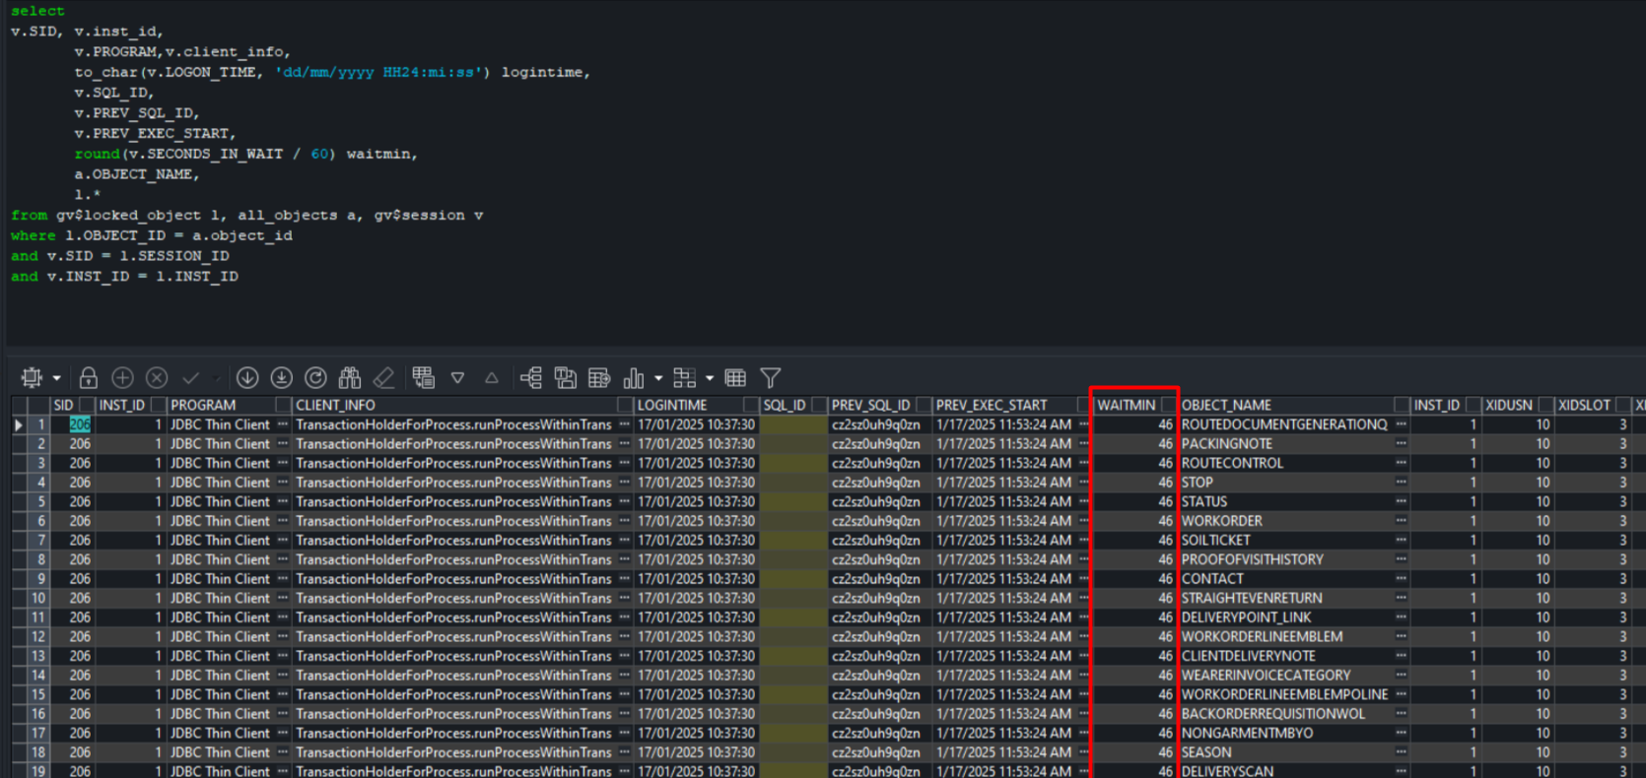
The process finished.
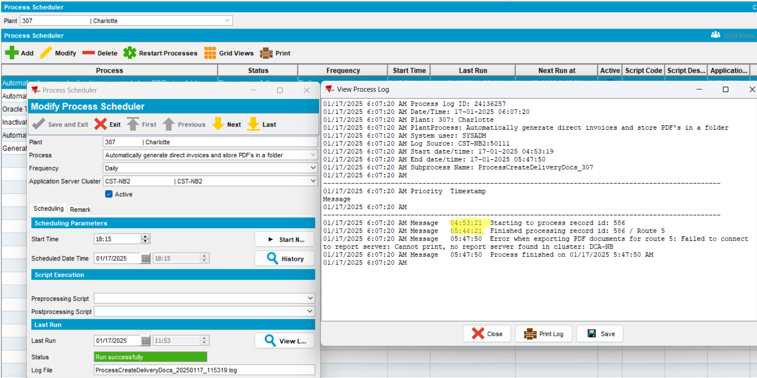
Actual behavior: the process of Automate Invoice Generation took a very long time and blocked records in database.
REPRODUCED OK.

Retest after fix
Hash: ffed09c
AUSCUSTOM in the license file
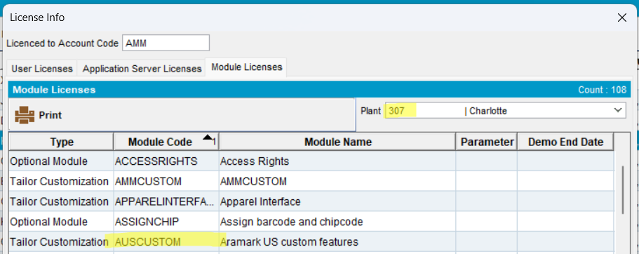

Test when DELETENOTVISITEDSTOPS=3 using Automate Invoice Generation process – 1 route control marked
- Set System Setting DELETENOTVISITEDSTOPS=3
- Open Customers dlg, load customers and end date them. Keep “Active” checkbox checked.
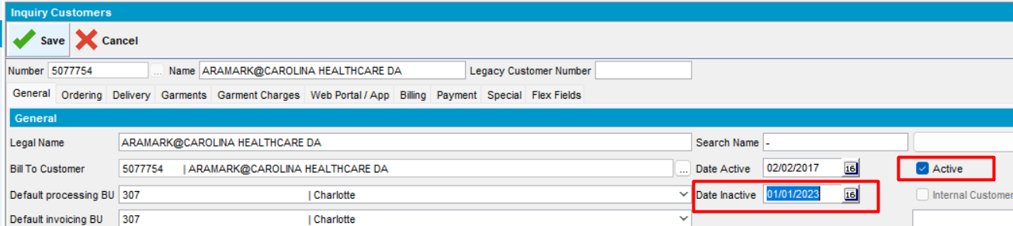
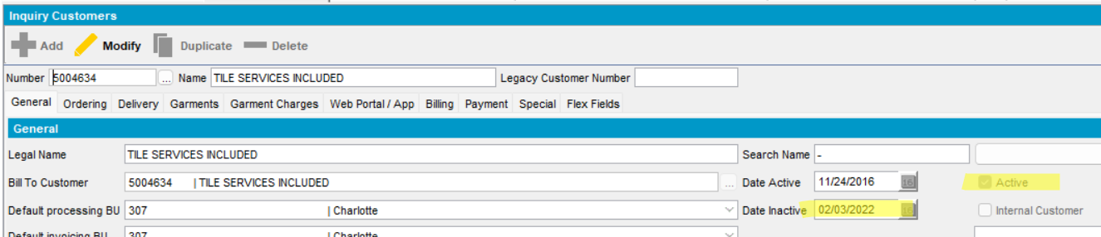
- Route Status Control dlg, add the route control containing the specific customers
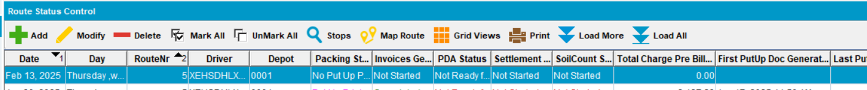
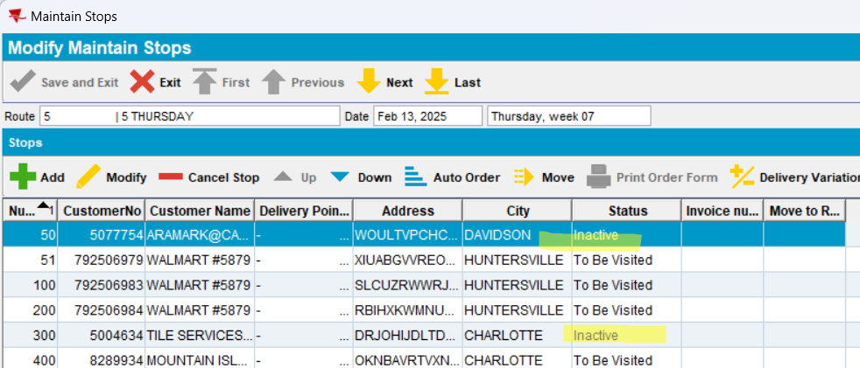
- Generate put up docs
- Mark route for Automatic Invoice Generation process
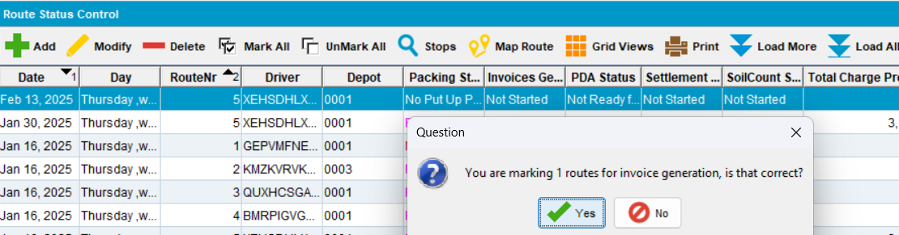
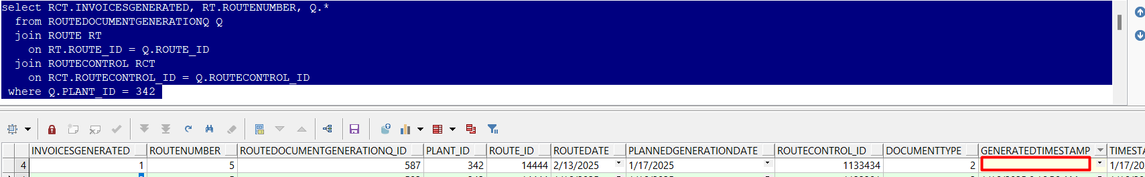
- In Process Scheduler dlg, start the Automatic Invoice Generation process
- Observe the behavior:
During Automatic Invoice Generation process is in progress with invoice generation, the inactive stops were firstly deleted.
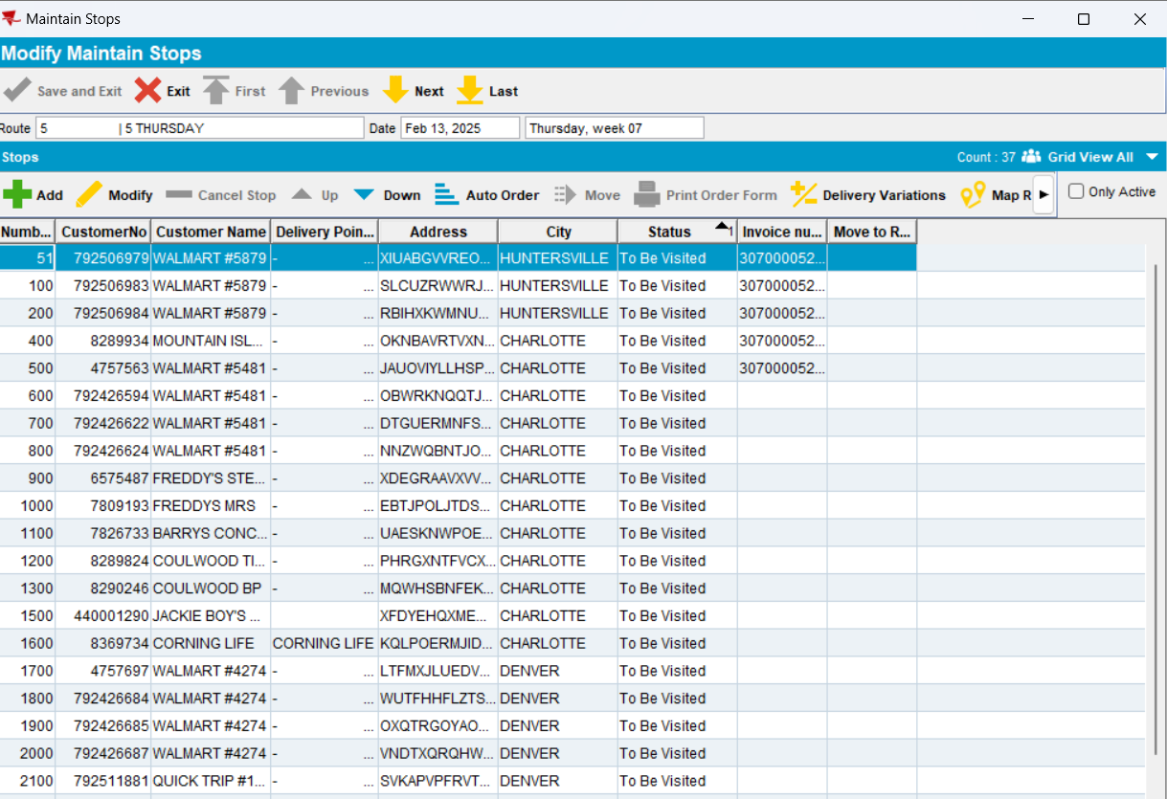
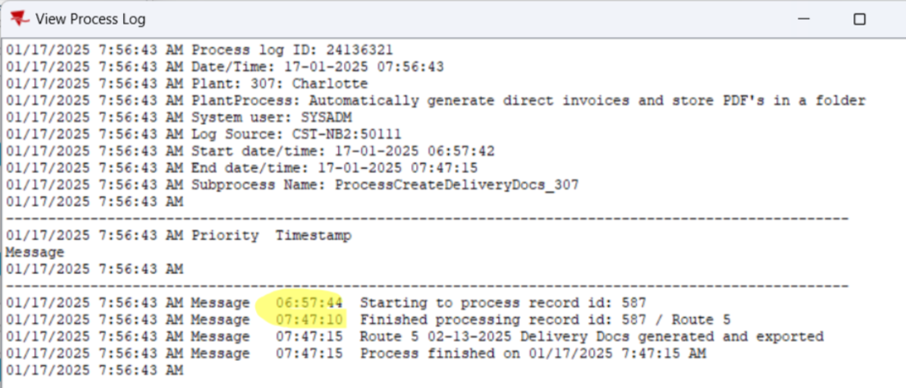
Actual behavior: when DELETENOTVISITEDSTOPS=3, the process Automatic Invoice Generation process finished successfully.
RETEST OK

Test when DELETENOTVISITEDSTOPS=3 using Automate Invoice Generation process – 2 route controls marked
- Set System Setting DELETENOTVISITEDSTOPS=3
- Route Status Control dlg, add 2 route controls(route 3 and route 7) containing inactive stops
For route 3, there is only 1 inactive customer
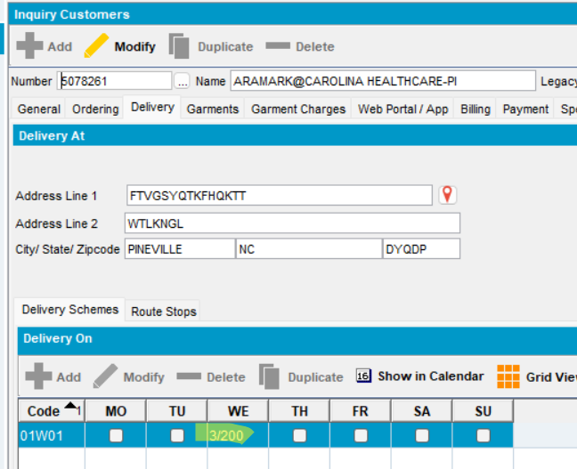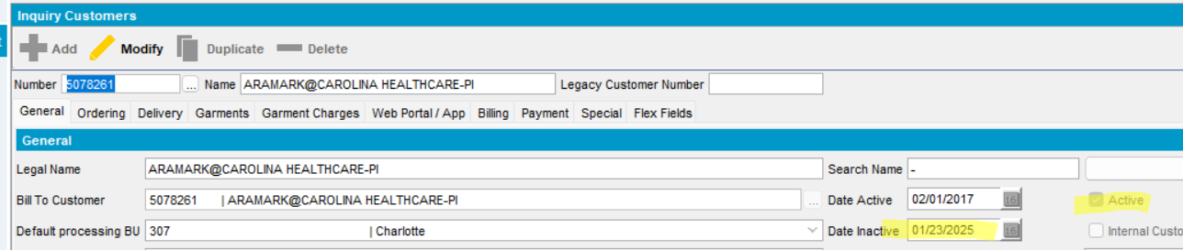
For route 7, there is only many inactive customers

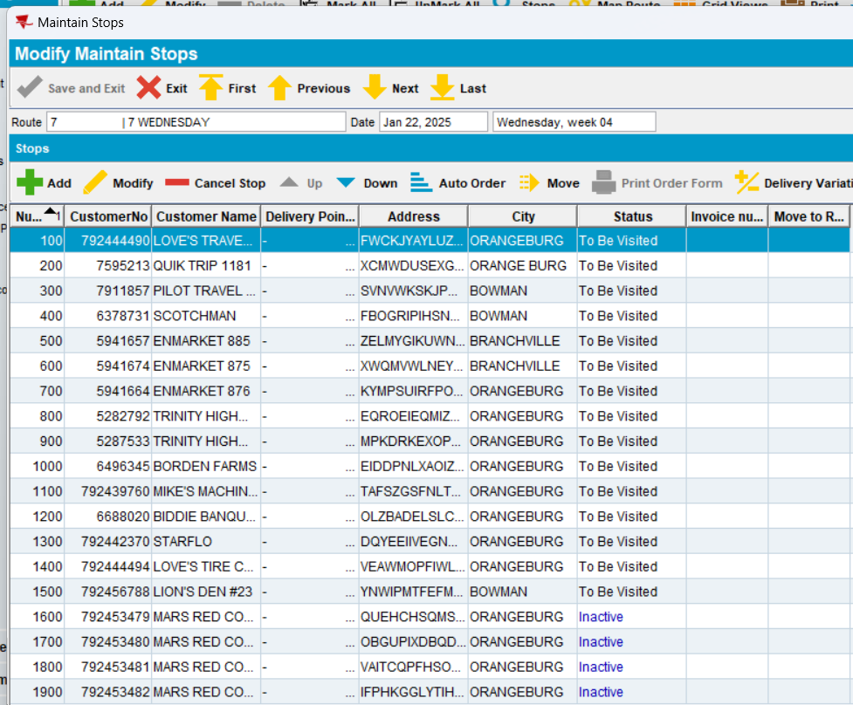
- Generate put up docs
- Mark route for Automatic Invoice Generation process
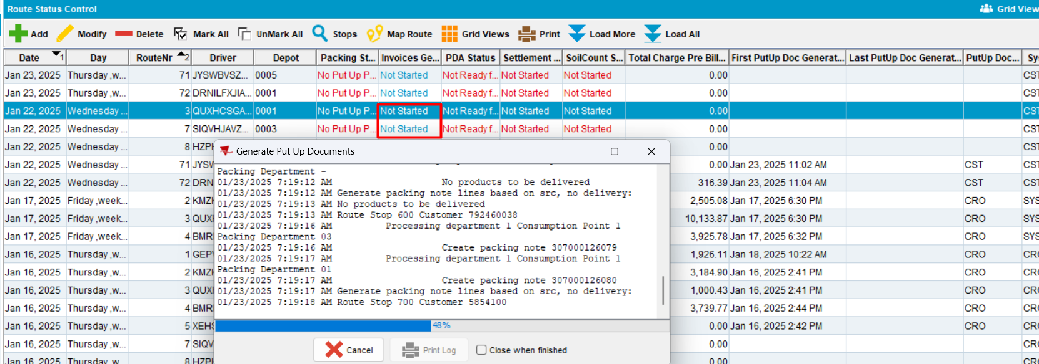
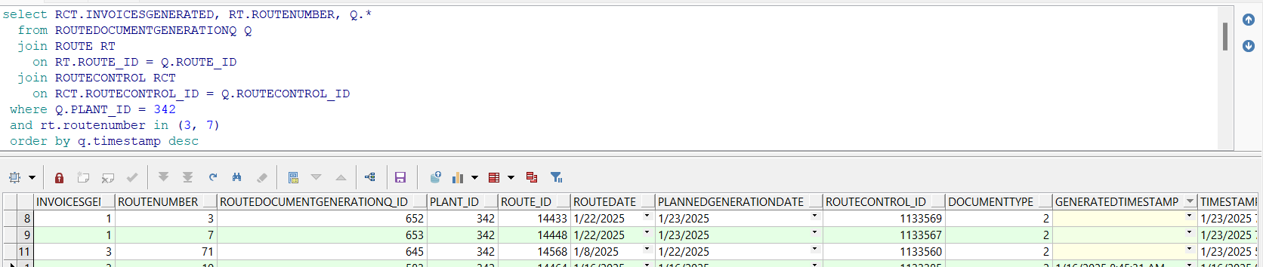
- In Process Scheduler dlg, start the Automatic Invoice Generation process
- Observe the behavior:
During Automatic Invoice Generation process is in progress with invoice generation, the inactive stops were firstly deleted.
- For route 3
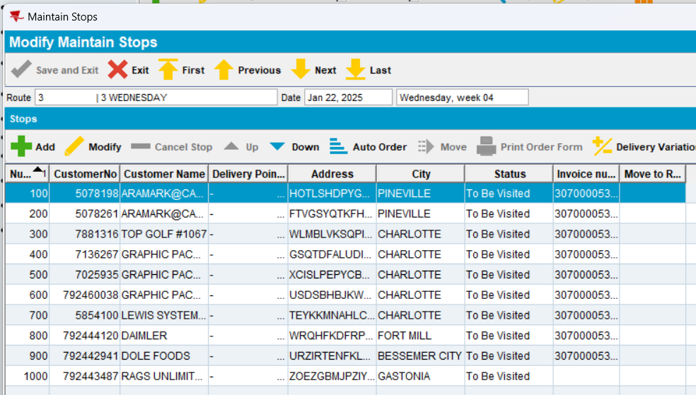
- For route 7
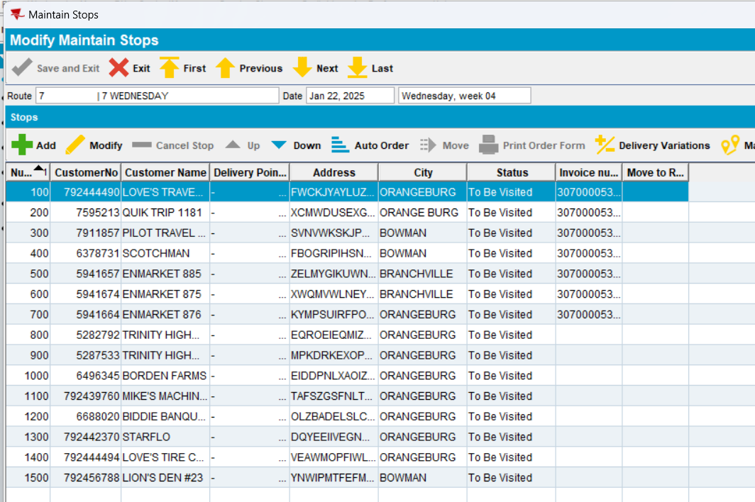
- Check the process
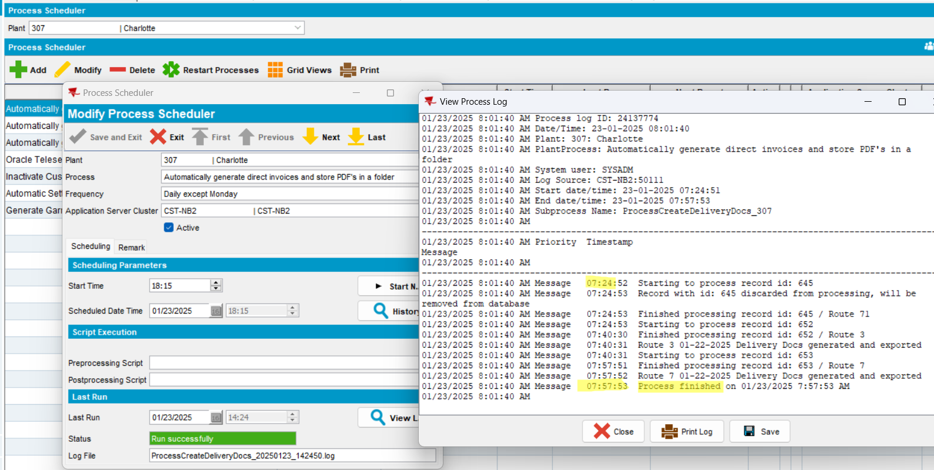
The process finished successfully.
In db table, the column was updated.
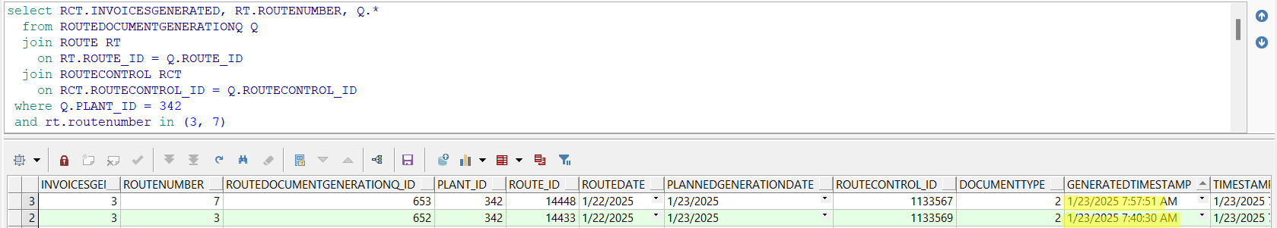
TESTED OK

