ABS-172053 WebX - negative invoice adjustments from RA causing issues in WebX
Environment | Prerequisites
Version: 9.08.00.RELEASE.p15  Environment=PRODUCTION  DBServerName=abs-srv16.internal.abslbs.com  DBSID=CUST21  DBUser=AUS_ND90502  DBPassword=AUS_ND90502 | - Module: AUSCUSTOM  - Systems setting: -  - Others: BU 503

Contents
Reproducing before fix 1
Retest after fix 3

Reproducing before fix

Pre-conditions:
USEROUTECHECKINSCREEN=Y
INVOICELINEADJADDRULE=1
INVOICELINEADJAPPROVERULE=1
INVOICELINEADJMODIFYRULE=1
INVOICELINEADJNORARULE=1
INVOICELINEADJVALUERULE=0

- Do a setup like this, on client side:
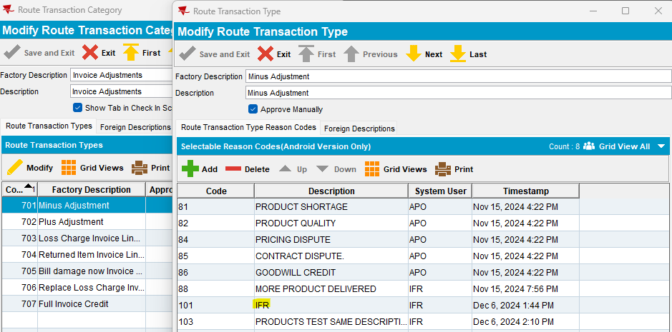
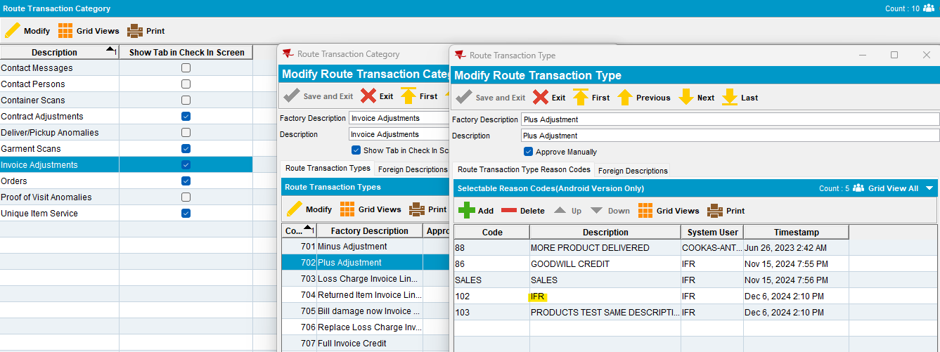
- Open route on Web Client X and do a minus adjustment (on Invoice Adjustments tab/ Modify option) and choose the above reason code;
- Save the changes
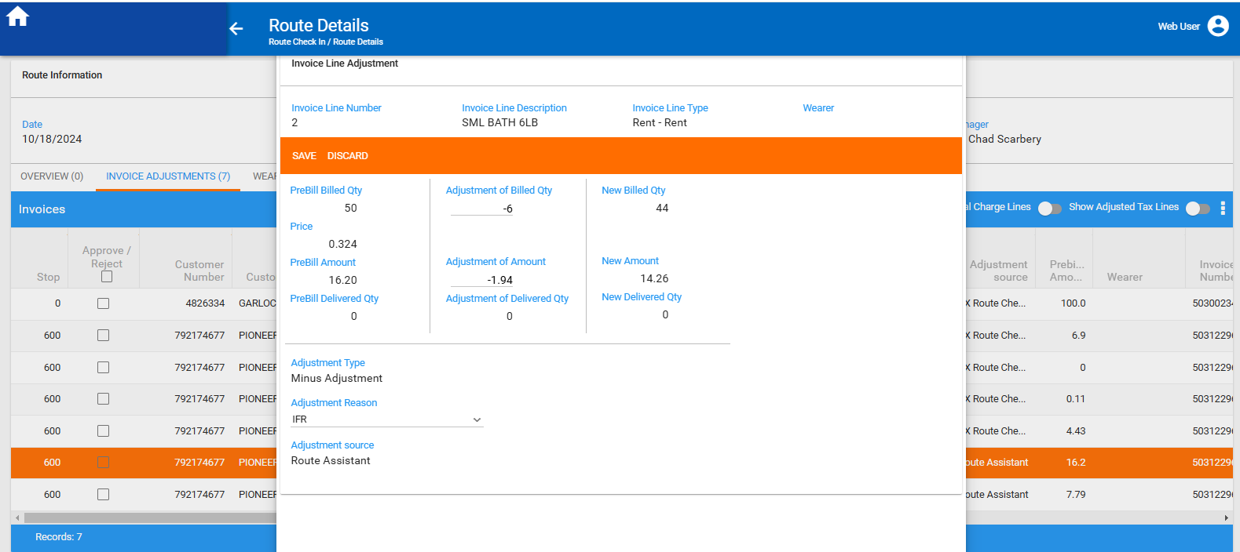
Actual result:
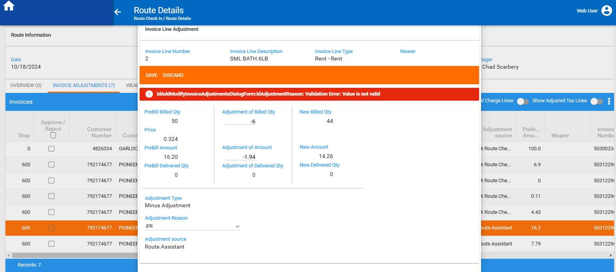
Reproduced.

Retest after fix

- Do a setup like this, on client side:
(it is necessary to have 2 different reason codes with the same description but, one on 701 transaction type and another on 702 transaction type);
(if these 2 reason codes are added both on 701 and 702 transactions types, meaning: 701 = 101 + 102, 702=101+102, it is not reproducible)
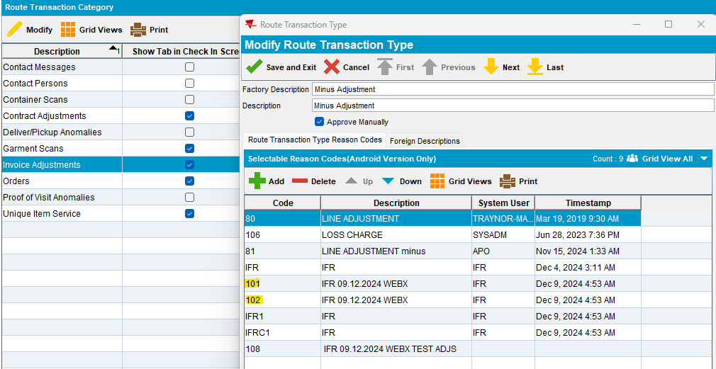
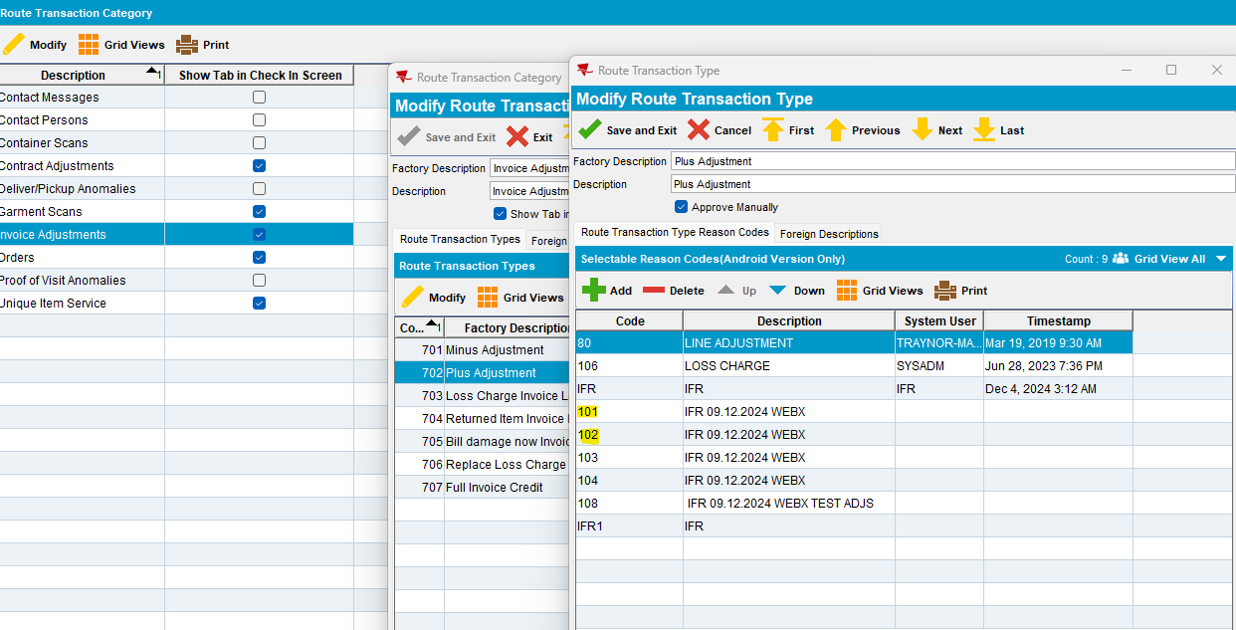

- also, for orders’ transactions do the same setup as above:
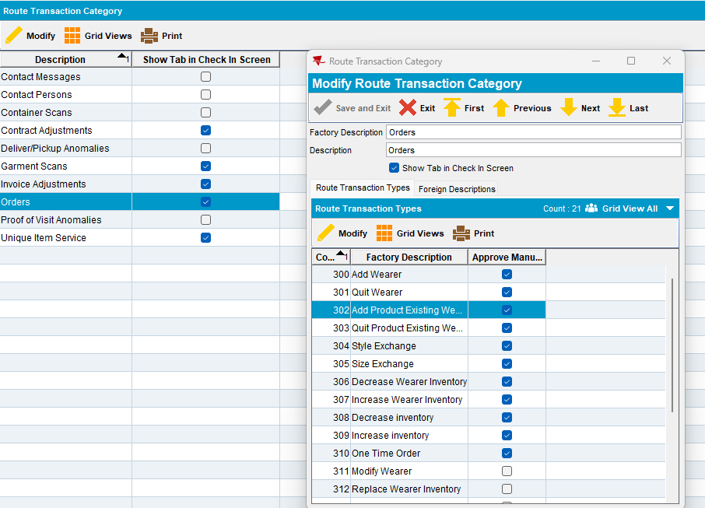
- examples:
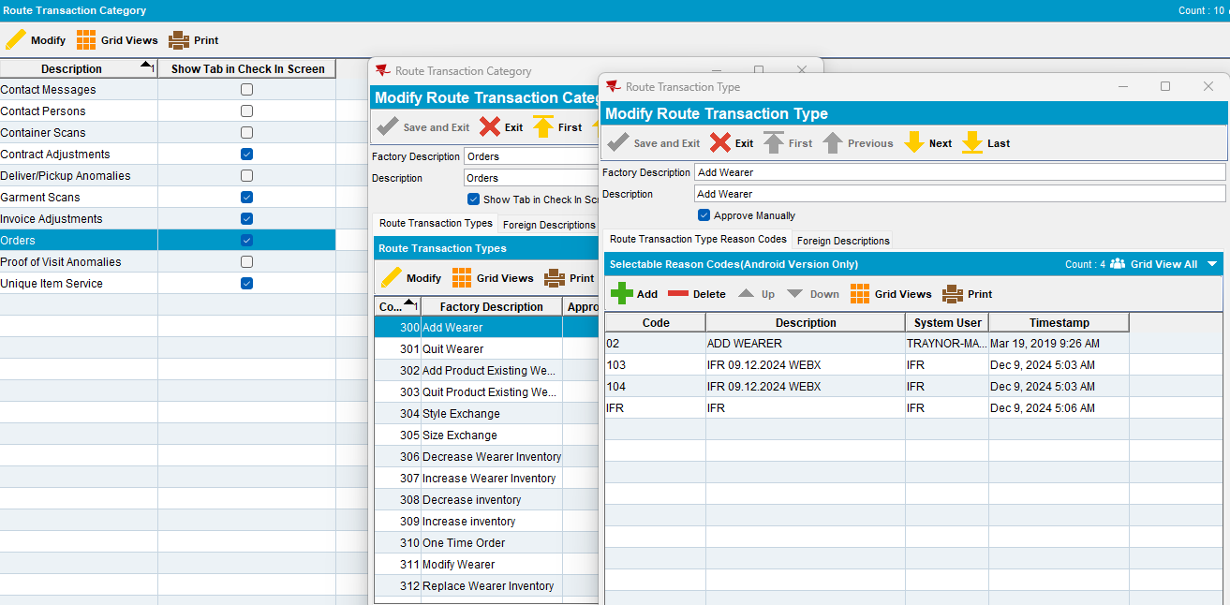

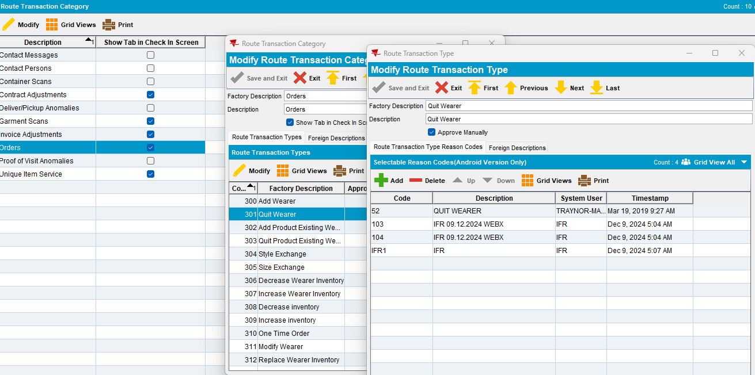

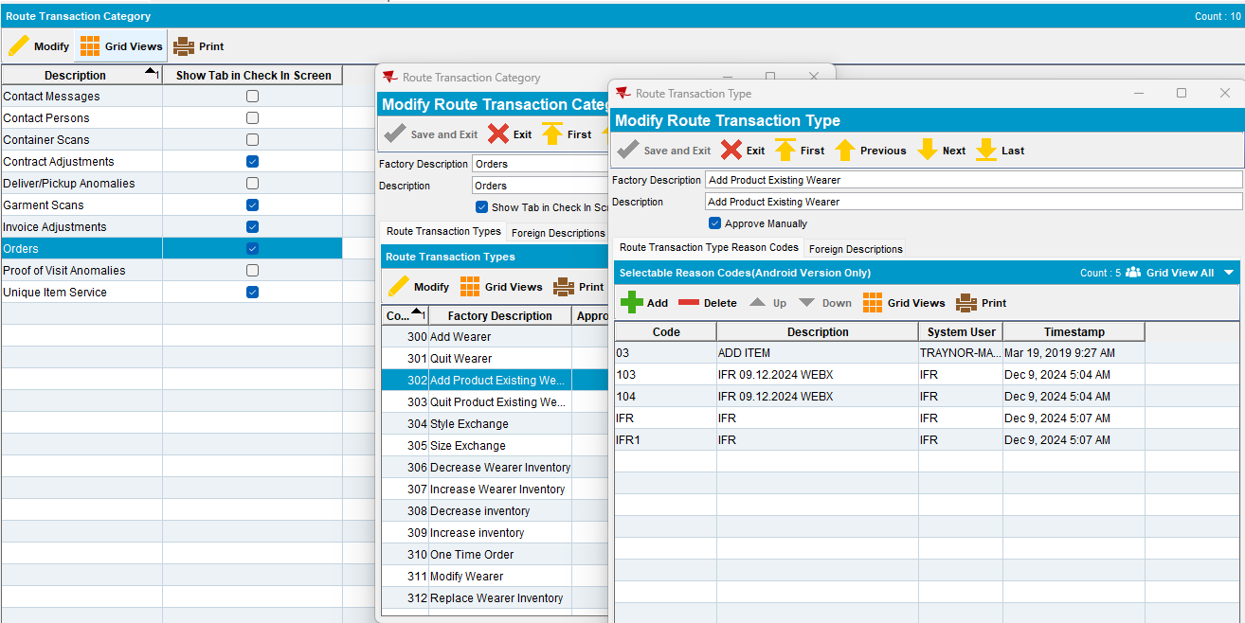

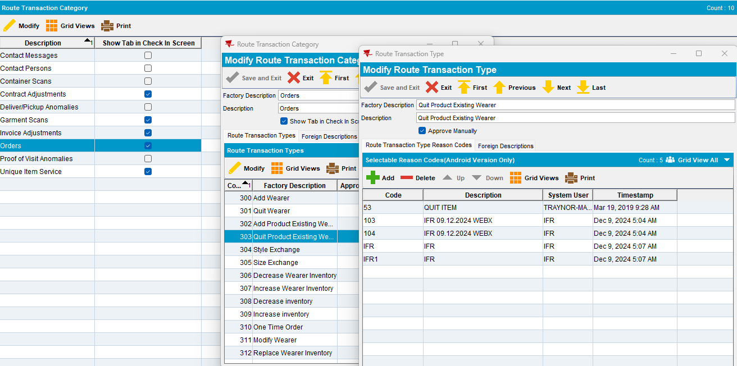

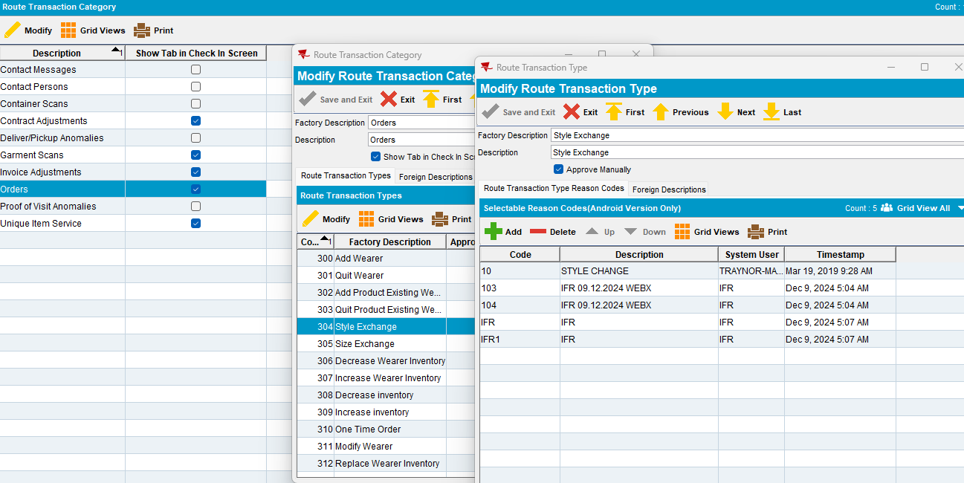

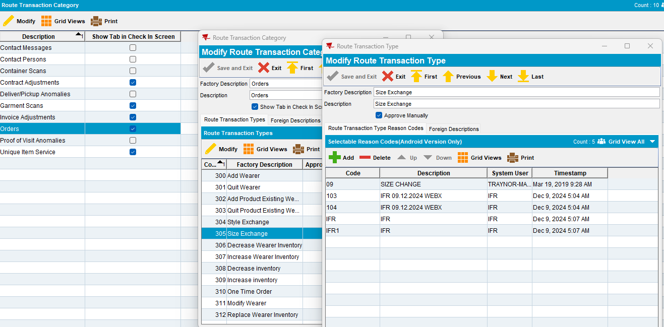

Route 7 from 12.12.2024 & 19.12.2024
Customers: 4685193, 7422637, 5413438
- Downloading route on PDA
- Do some adjustments on PDA
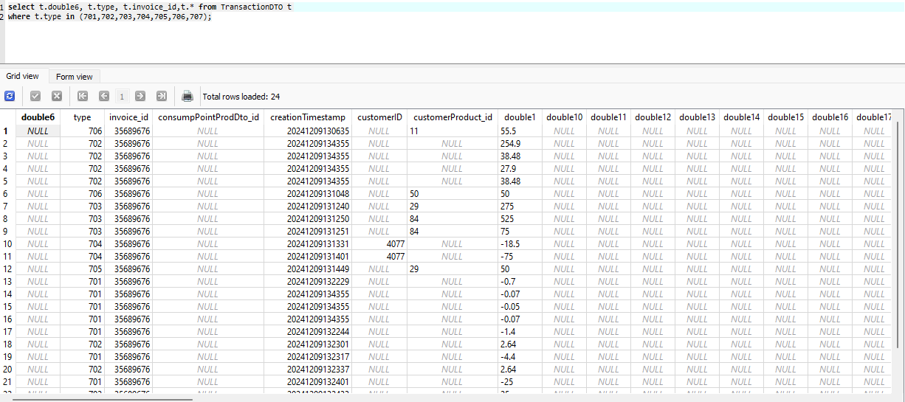
- Settle route, depart route, uploading route
- Open route on Web Client X/ Invoice Adjustments tab:

Adj Reason:
Drop down showing reason code and description
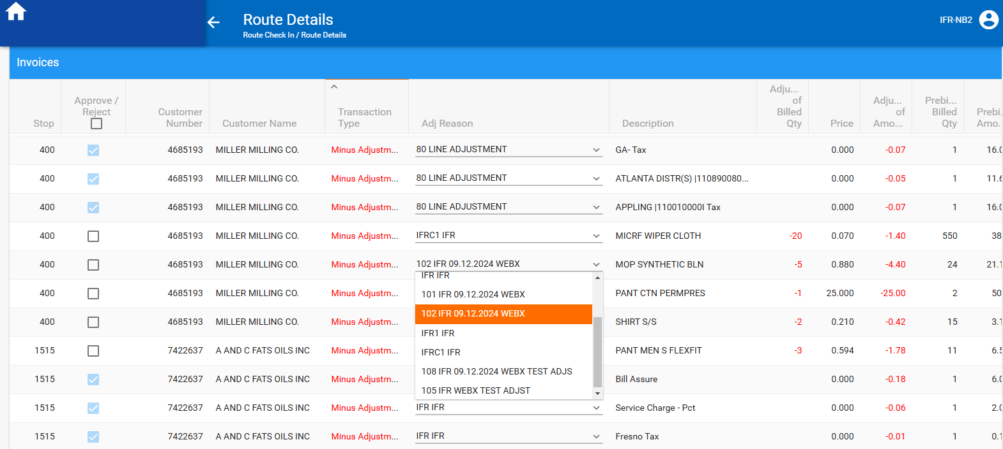

- Do a minus adjustment for a minus transaction, on Modify mode and change also reason code with another with the same description as previously:

Adjustment Reason: Showing reason code and description
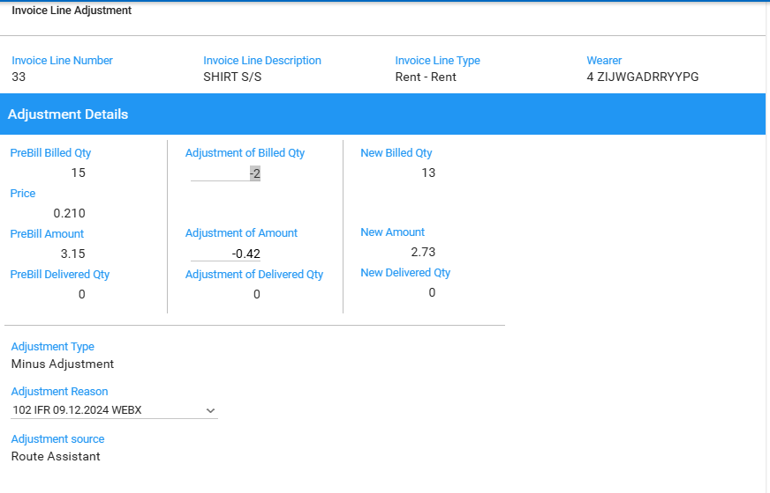

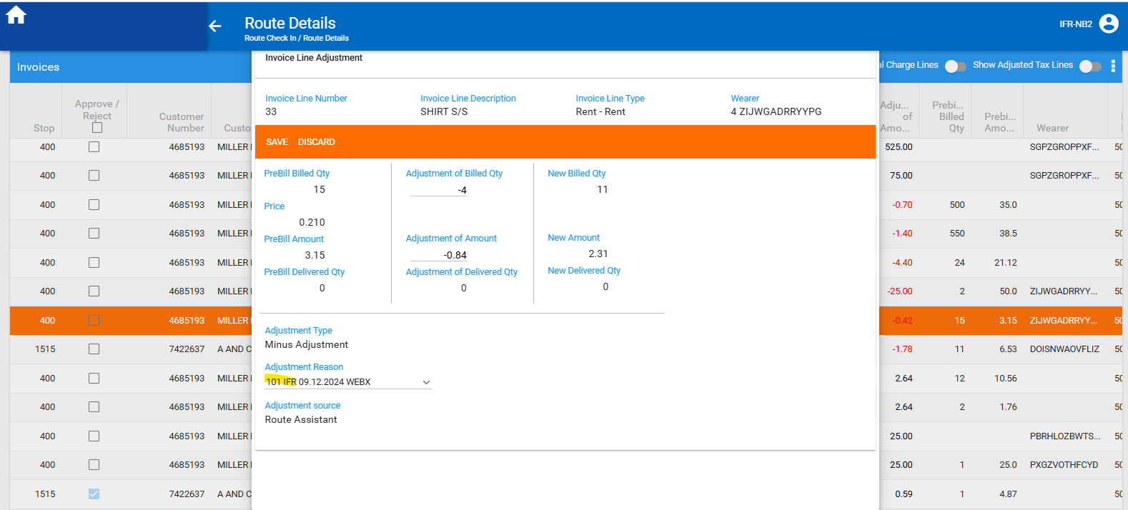

The changes are saved, and the transaction is automatically approved.

- Do another minus adjustment on Modify mode, for a plus transaction:

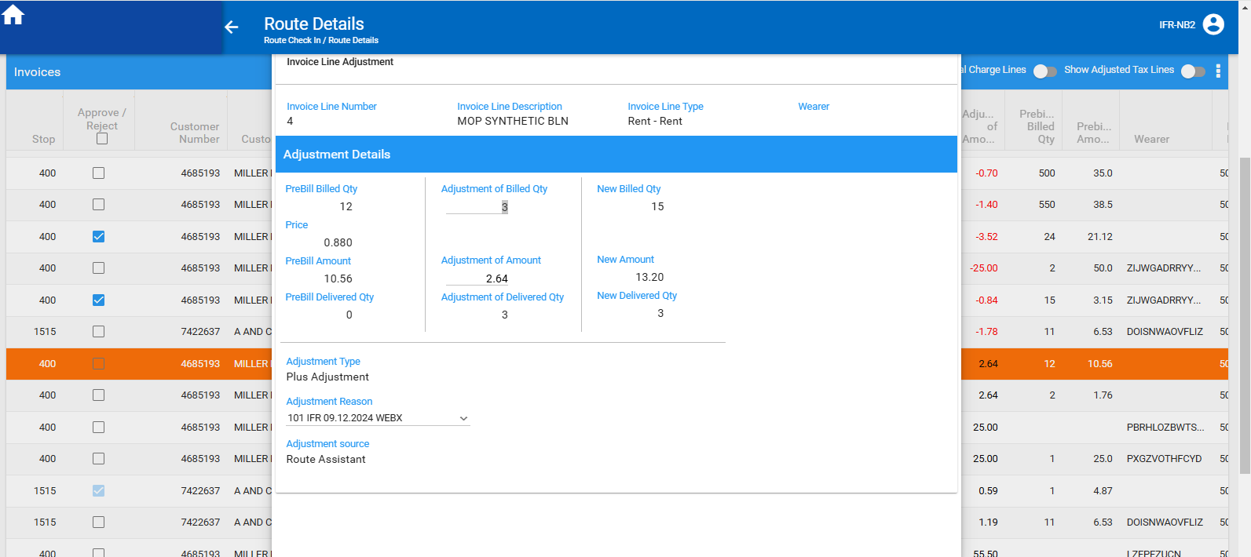

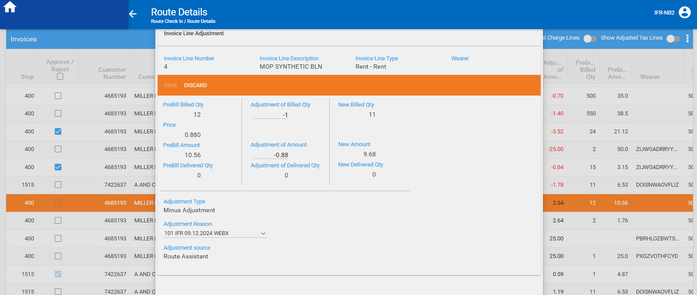

The changes are saved, and the transaction is automatically approved.

- Do a plus adjustment on Modify mode, for a plus transaction and change also reason
code with another with the same description as previously:

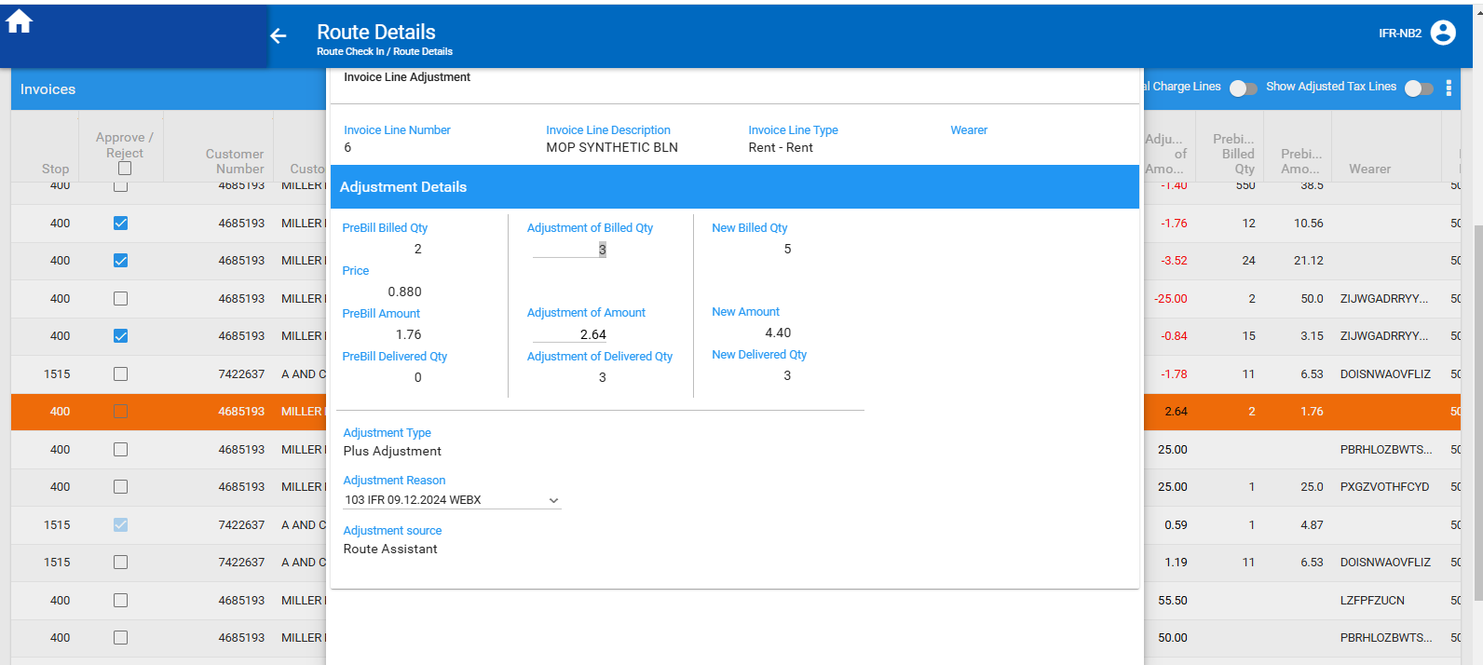

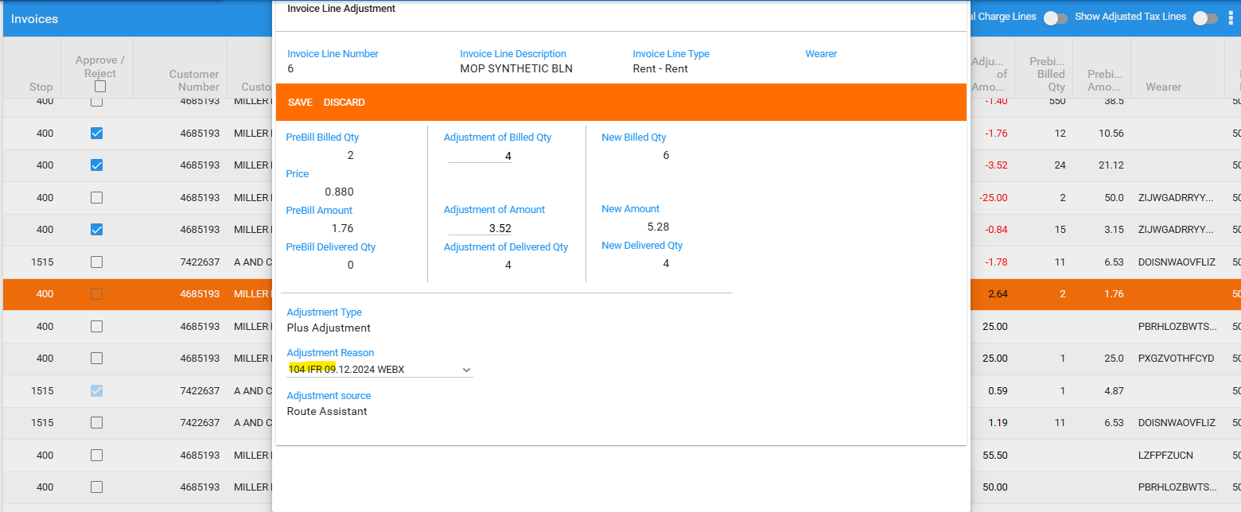

The changes are saved, and the transaction is automatically approved.

- Try to Modify a return loss charge line:
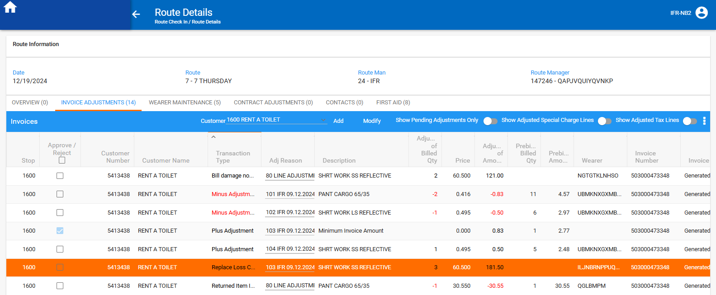

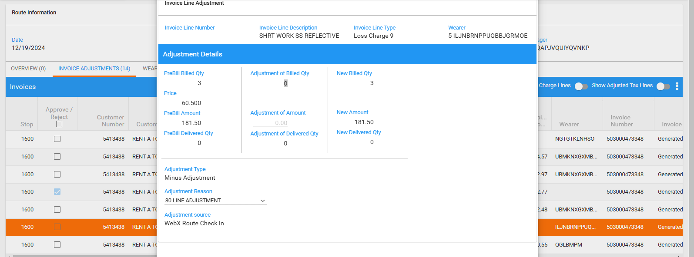
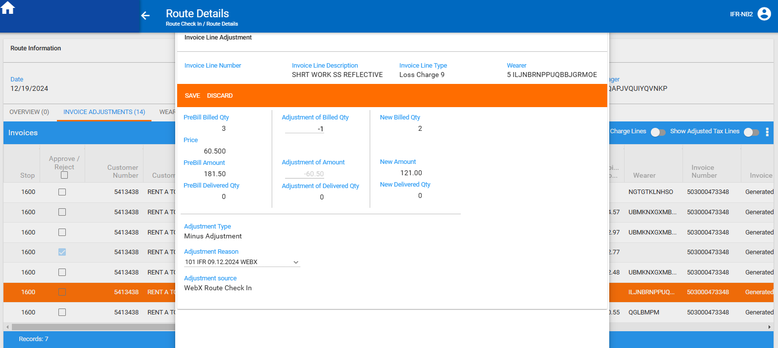

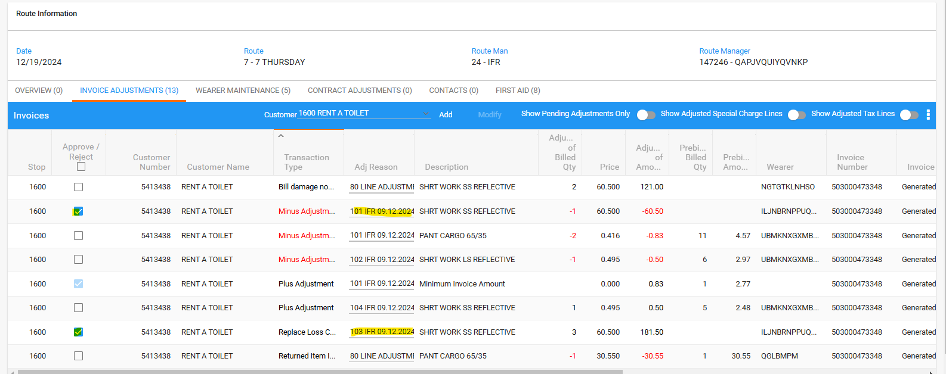

The changes are saved, the new minus transaction line is added, and the transactions are automatically approved.

- Do a minus adjustment for a bill damage transaction:
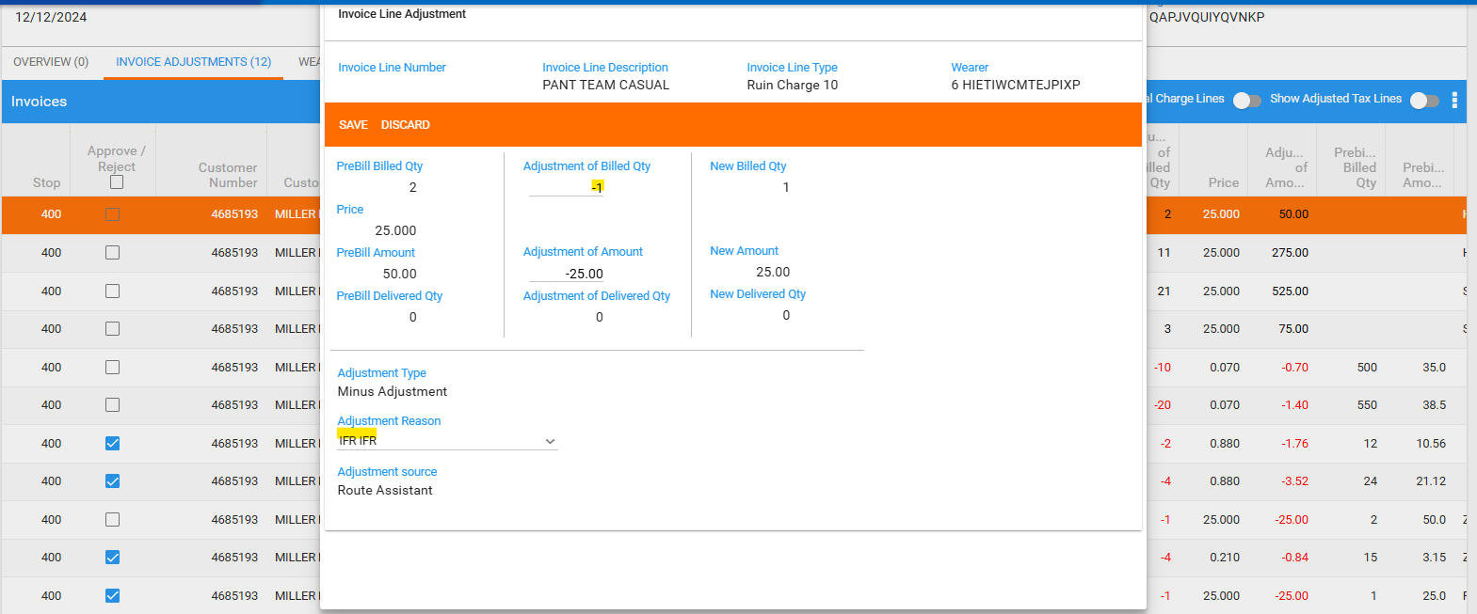

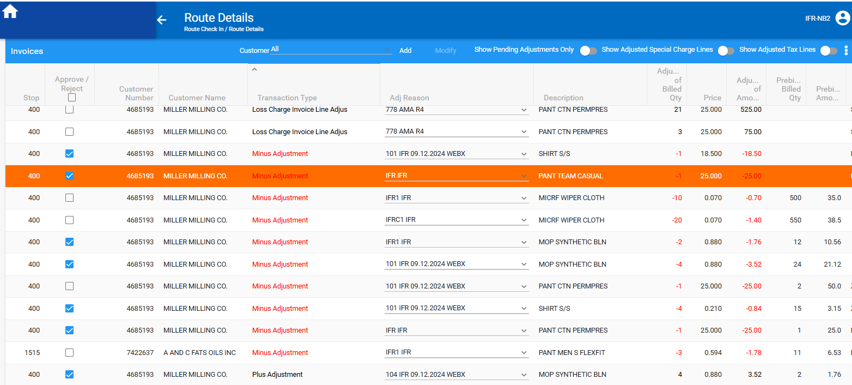
The changes are saved, and the transaction is automatically approved.

- Bill damage transaction:

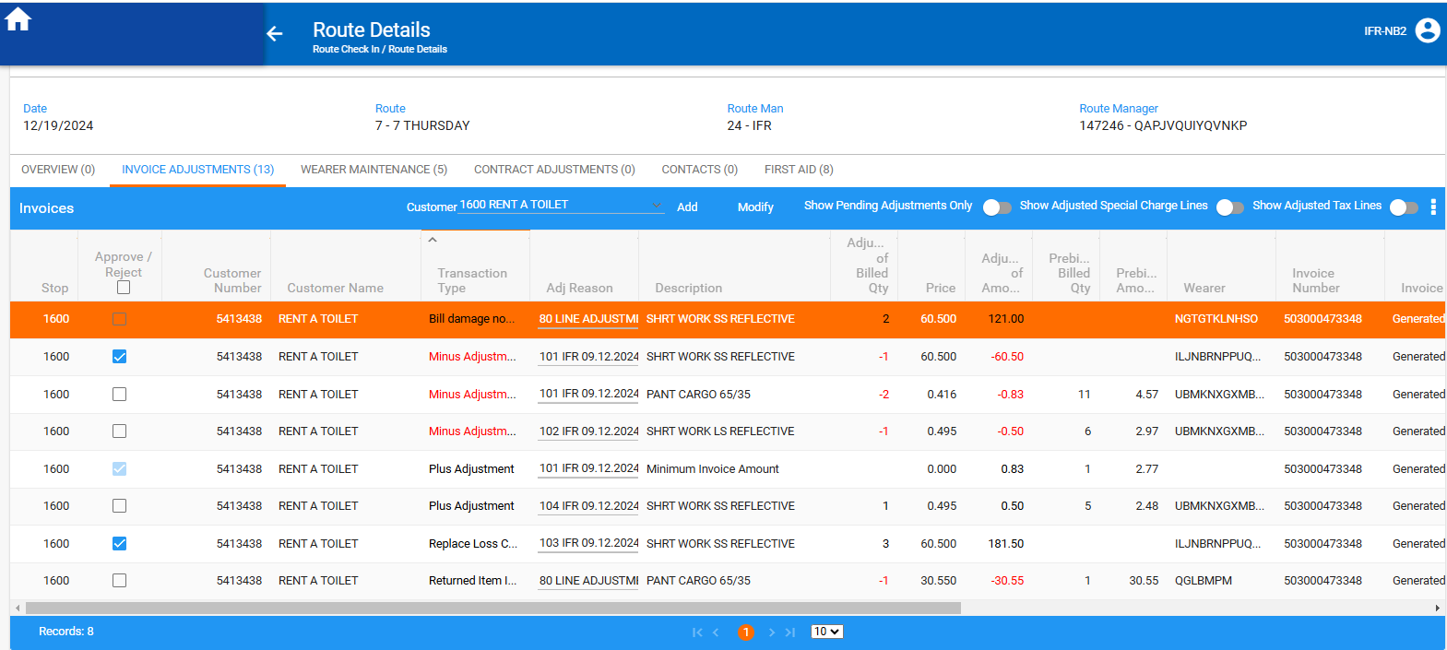

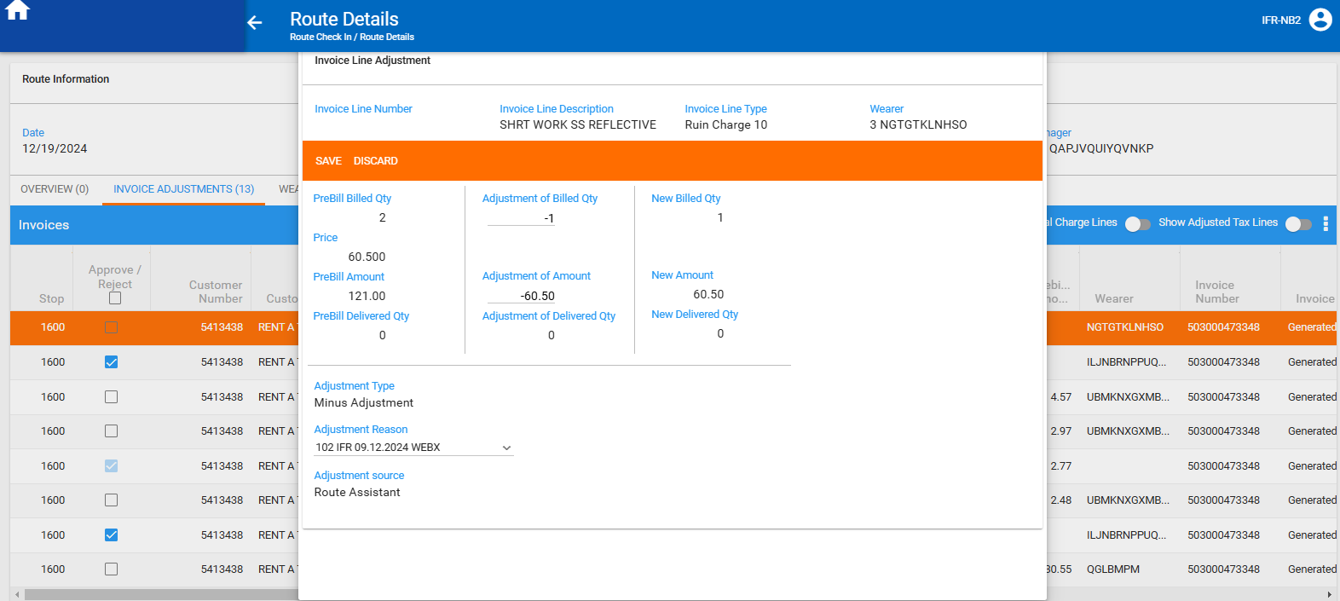

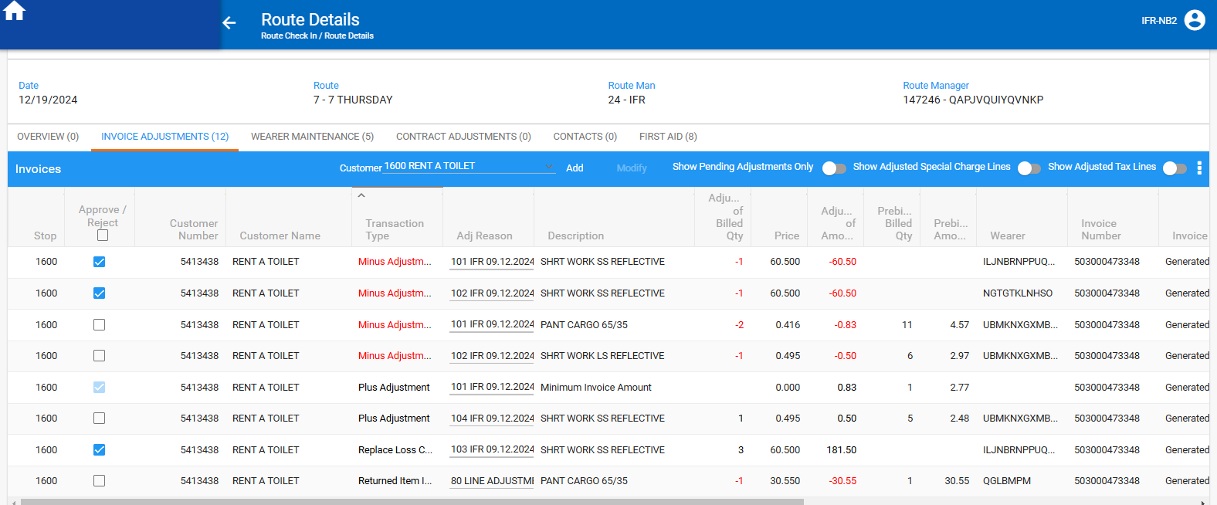
The changes are saved, and the transaction is automatically approved.

- Do the same adjustments on Add mode (Invoice Details page):
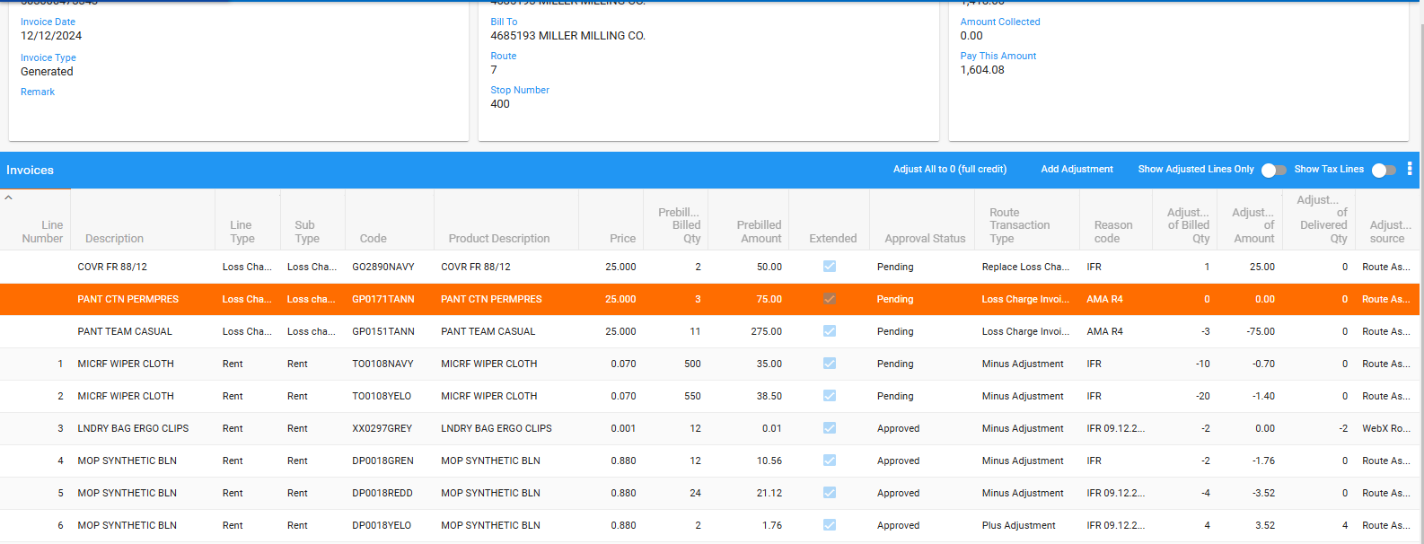

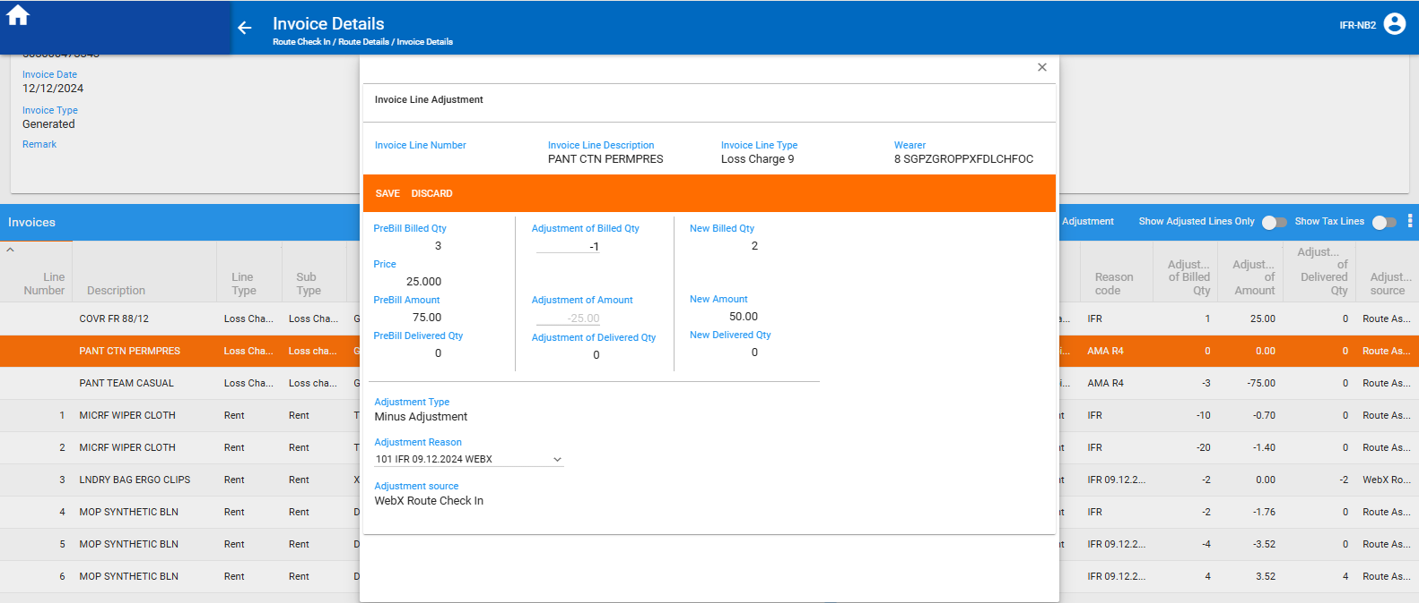
Reason code: Showing reason code and description
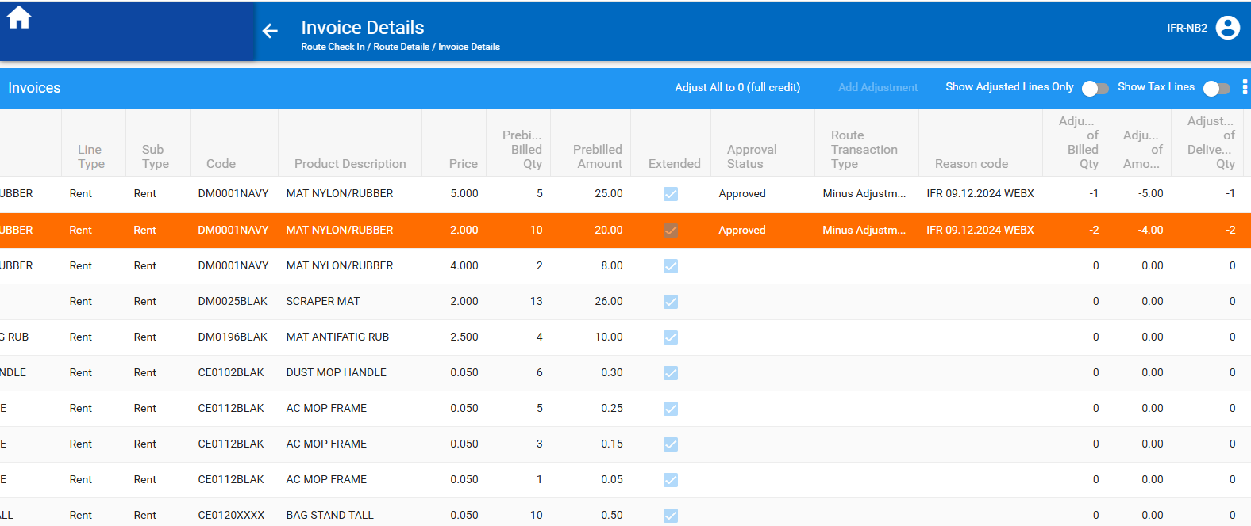
The changes are saved, and the transaction is automatically approved.

- Do the same for Loss charge line:
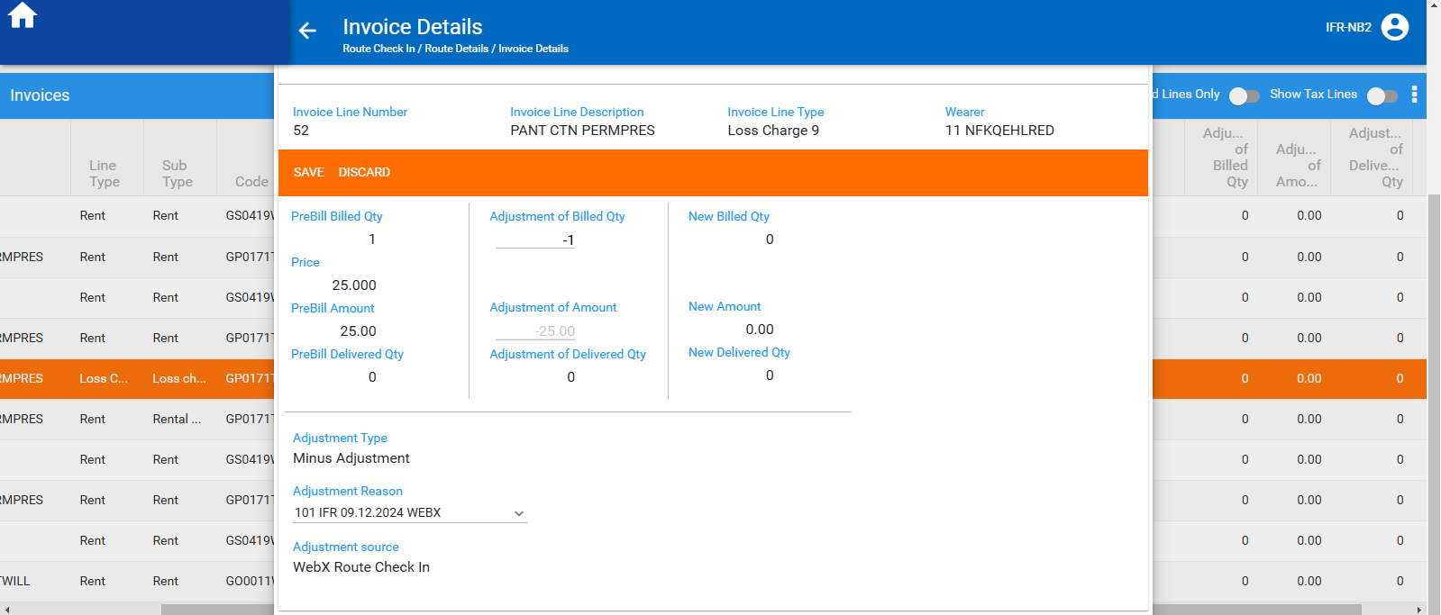

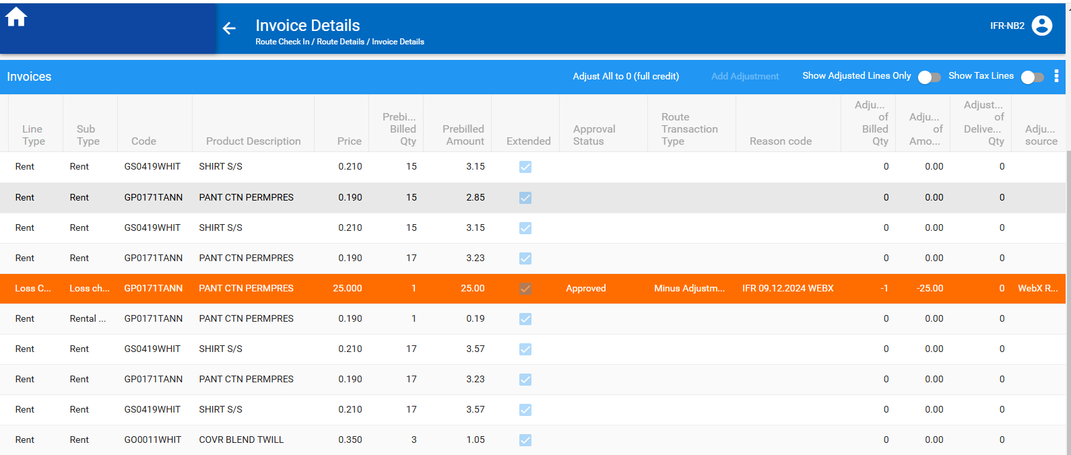
The changes are saved, and the transaction is automatically approved.
Tested ok.

