ABS-171406 WebX Invoice line adjustment reason code issue
Environment | Prerequisites
Version: 9.08.00.RELEASE.p14  Environment=PRODUCTION  DBServerName=abs-srv16.internal.abslbs.com  DBSID=CUST21  DBUser=AUS_ND90502  DBPassword=AUS_ND90502 | - Module: AUSCUSTOM  - Systems setting: -  - Others: BU 503

Contents
Retest after fix 1

Retest after fix

Pre-conditions:
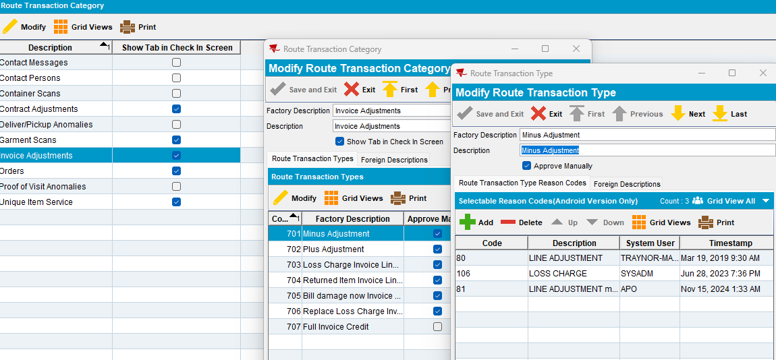

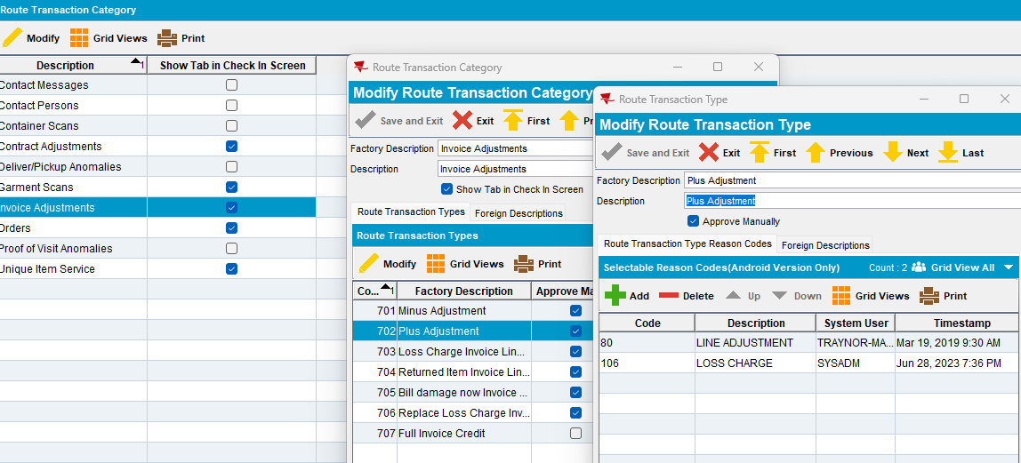

Route 75 from 22.11.2024

- Downloading route on PDA
- Do some +, - adjustments on PDA
- Settle route, depart route, uploading route
- Open route on Web Client X/ Invoice Adjustments tab:

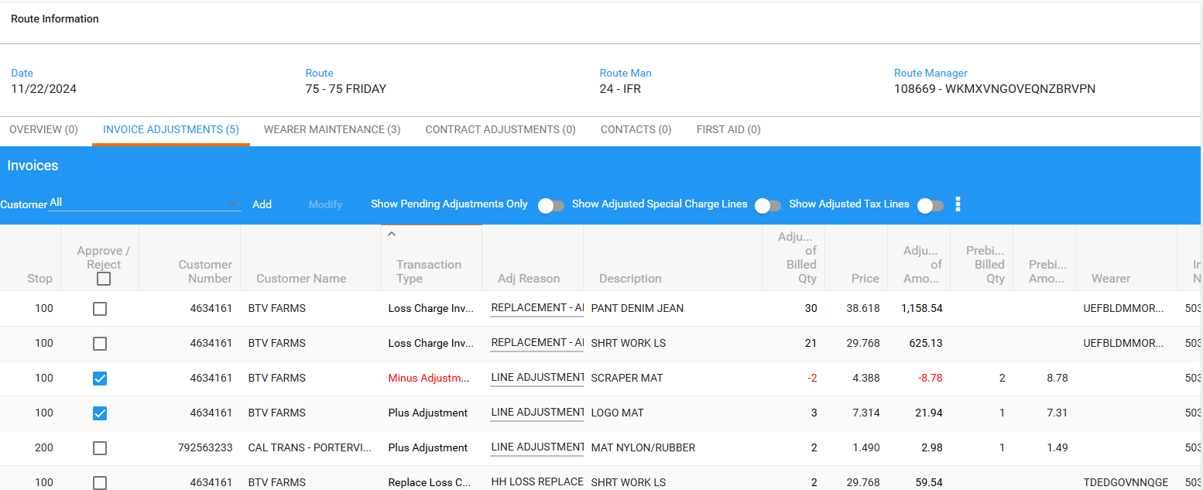

- Do a minus adjustment on Modify mode:

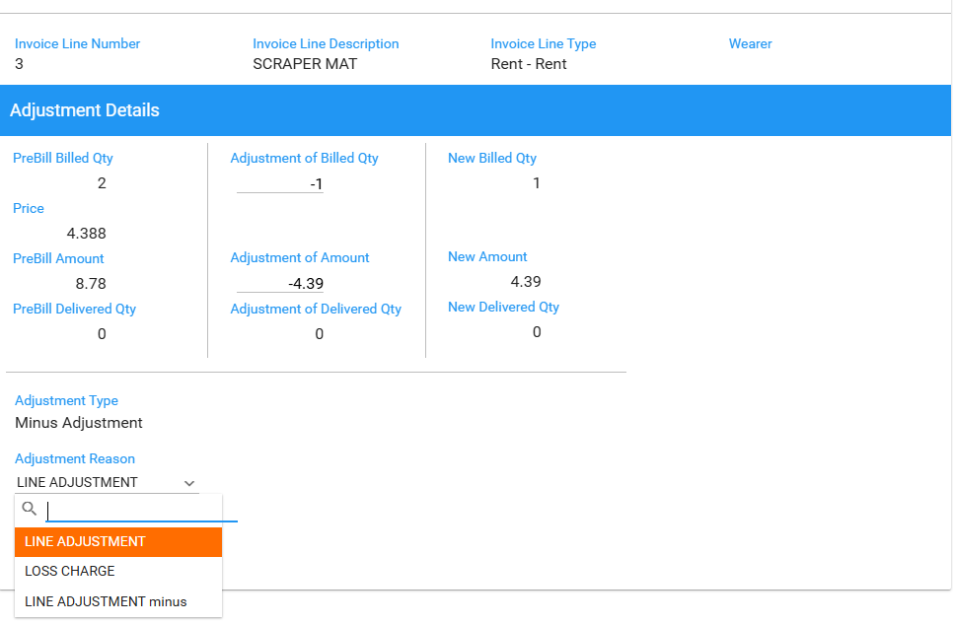

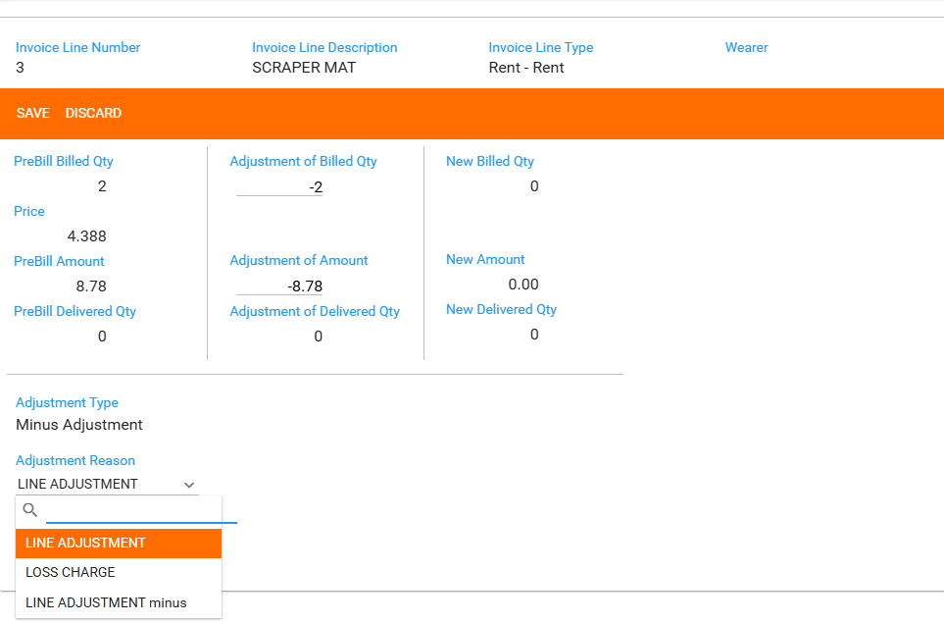

Only the reasons codes for minus adjustment transaction are displayed.
- Do a plus adjustment on Modify mode:

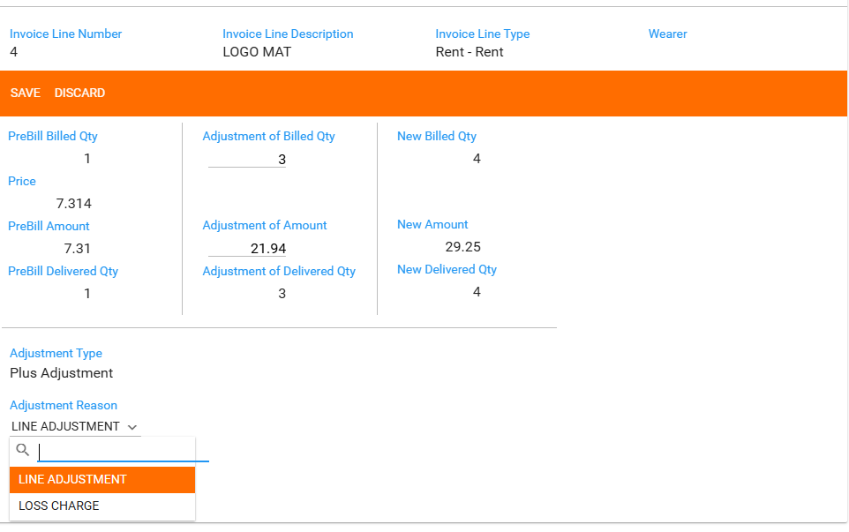

Only the reasons codes for plus adjustment transaction are displayed.

- Do a plus adjustment on Modify mode for a Return Item transaction:

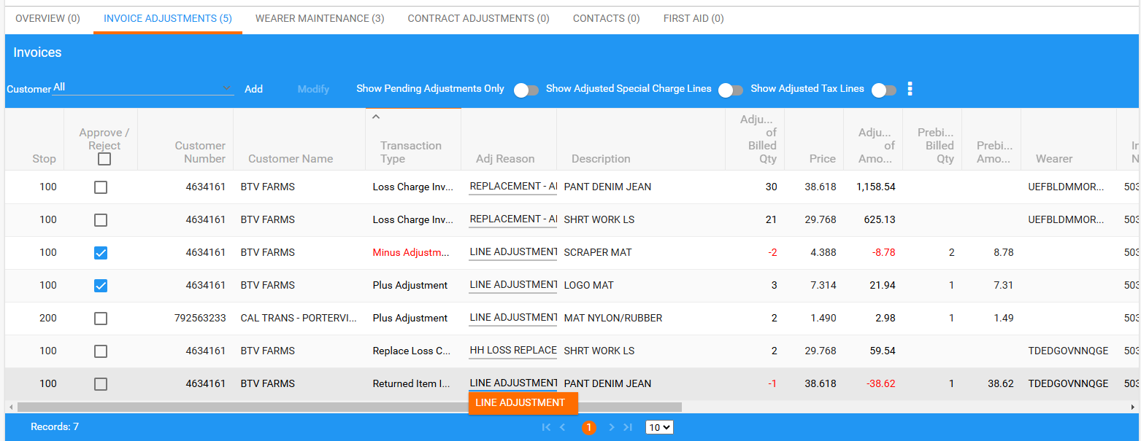

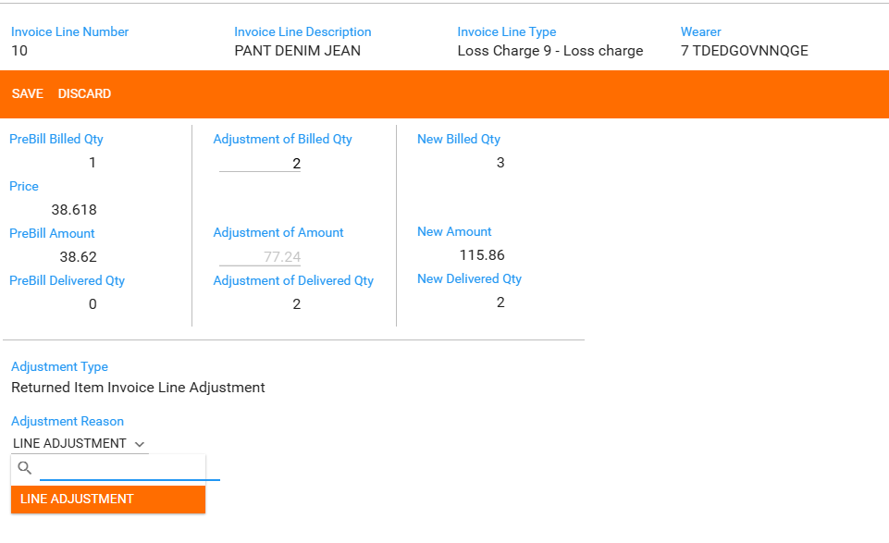

Only the reasons codes for return item adjustment transaction are displayed.

- Do a plus or minus adjustment from Invoice Details page, on Add mode:

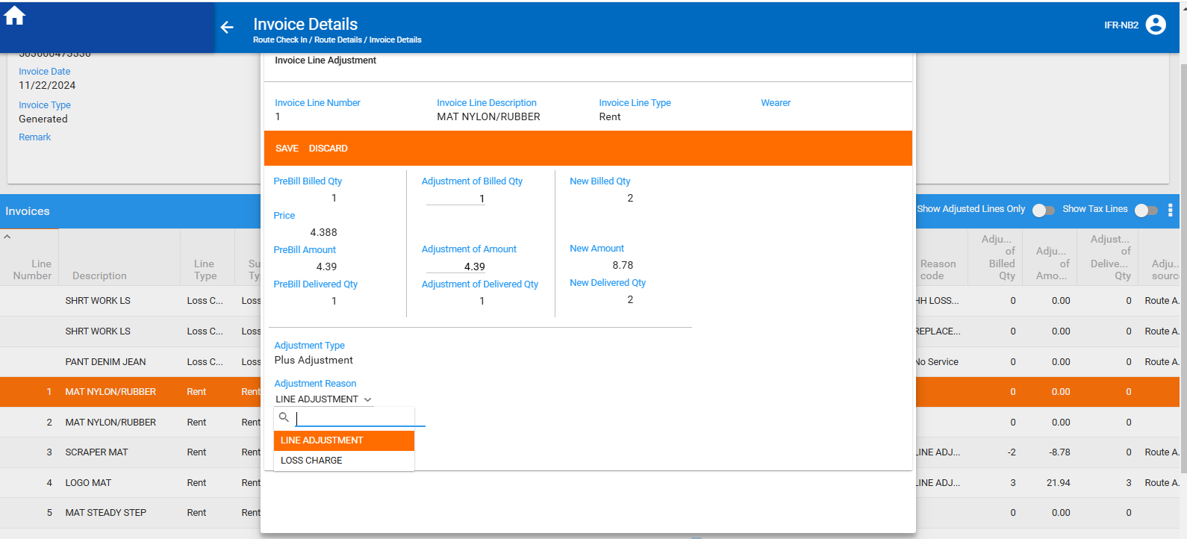

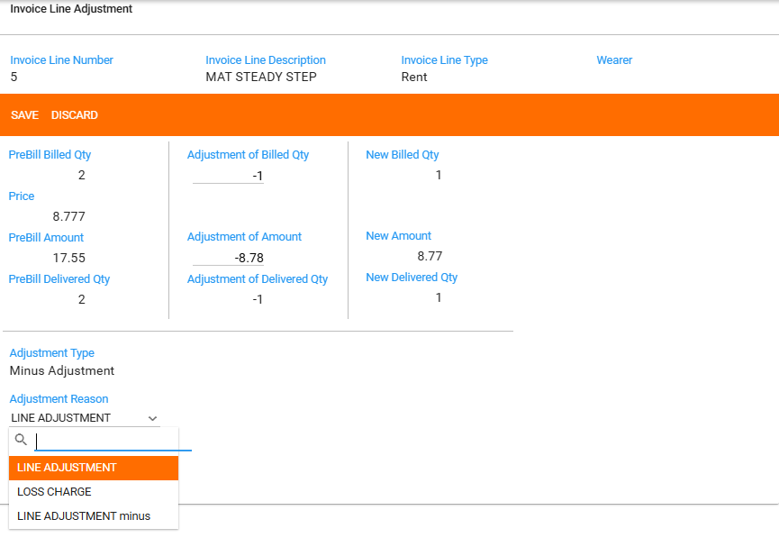

Tested OK.

