ABS-163214 Unexpected Total Amount value (after settlement) for a full credit invoice made on Web Client X
Environment | Prerequisites
Version: 9.08.00.p14  Environment=PRODUCTION  DBServerName=abs-srv16.internal.abslbs.com  DBSID=CUST21  DBUser=AUS_ND90502  DBPassword= AUS_ ND90502 | - Module: AUSCUSTOM  - Systems setting: -  - Others: BU 503

Contents
Reproducing before fix 1
Retest after fix 5

Reproducing before fix
Reproduced on master:
1. Customer: 792179376
Route: 7 from 06.09.2024
- Full credit invoice
- On Maintain Invoice/ Inquiry Invoice screen, Total Amount field doesn’t include Adj. Amount values -> in this example for full credit invoice should be = 0
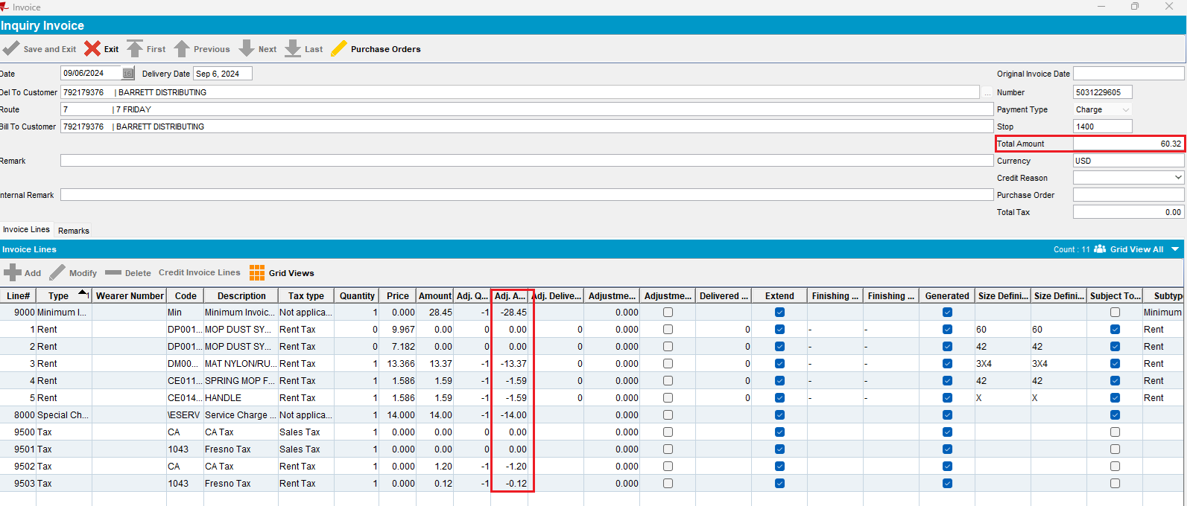

- In Maintain Invoice grid looks ok:
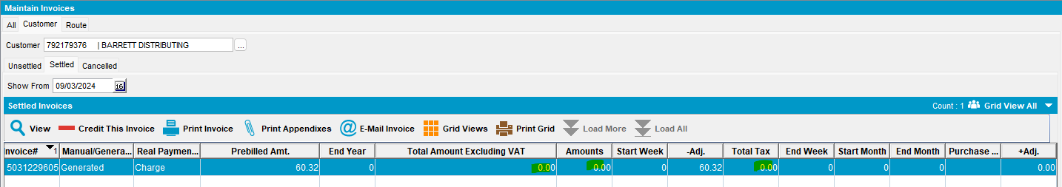
- On Route Check In dlg looks ok, also:
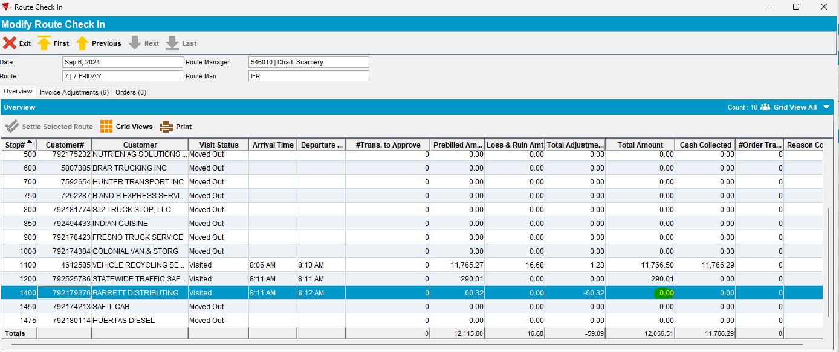

- On Web Client X, full credit invoice -> Pay This Amount field look right = 0, also

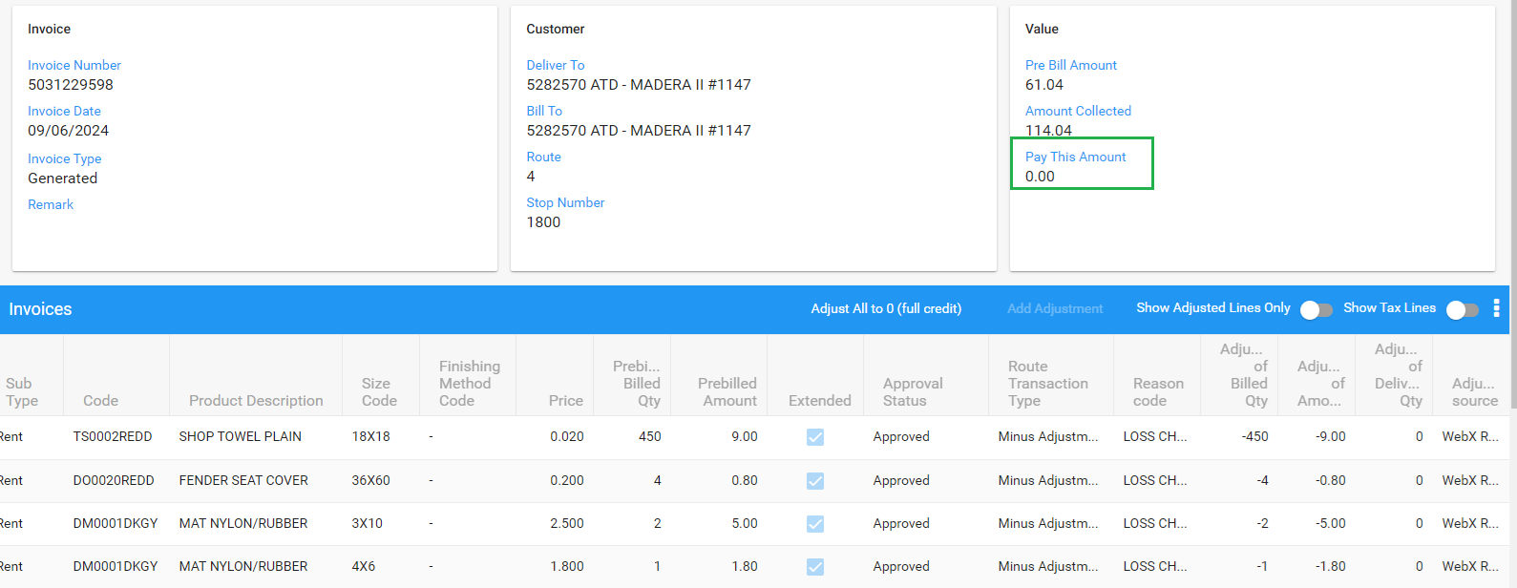

1. Route: 7 from 06.09.2024
Customer: 4612585
- Invoice with some adjustments done on RASA or WebClientX

Prebill: 11,765.27 + Adj. 1.23 = 11,766.50 -> Total Amount field does not include the adjusted values
Now Total Amount = Prebill Amount
But for Total Tax field adjustments are included (see below): 412.52+ 41.25+0.01 = 453.78 (ok)
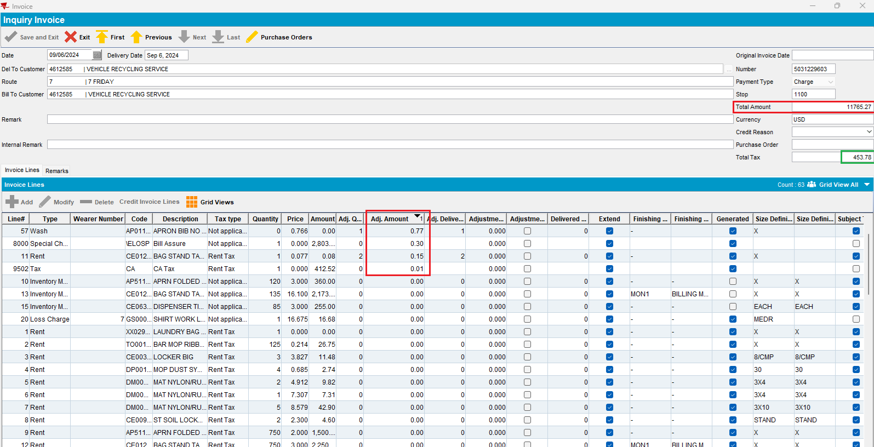
Taxes:

WebX -> Total Amount looks ok:
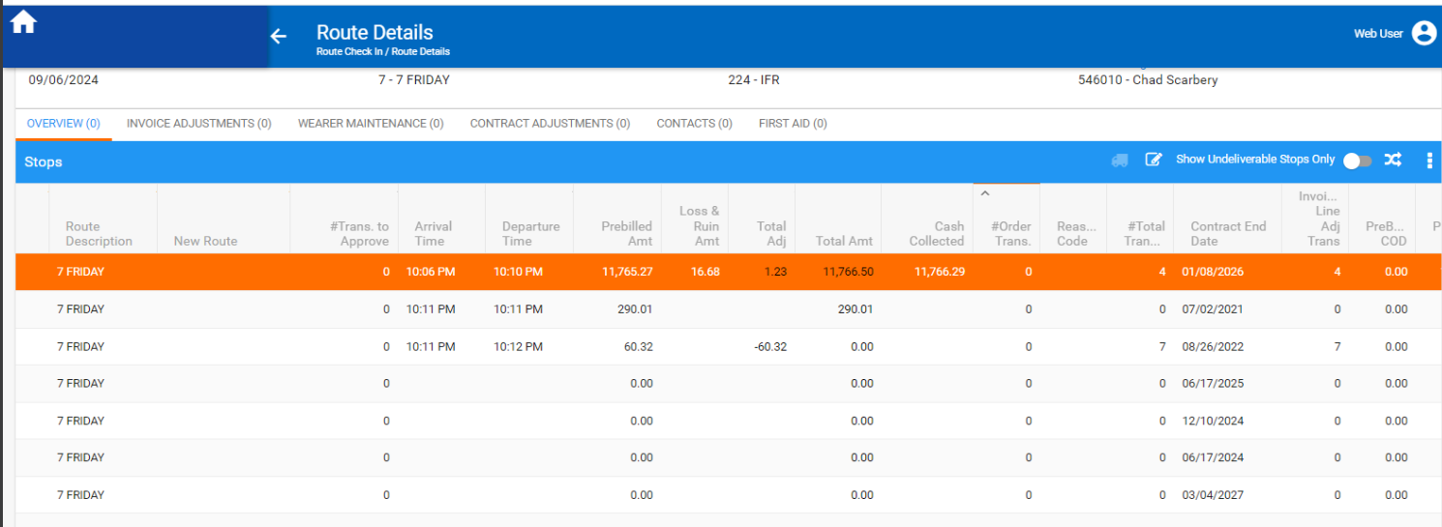

On Maintain Invoice grid all the totals looks ok:
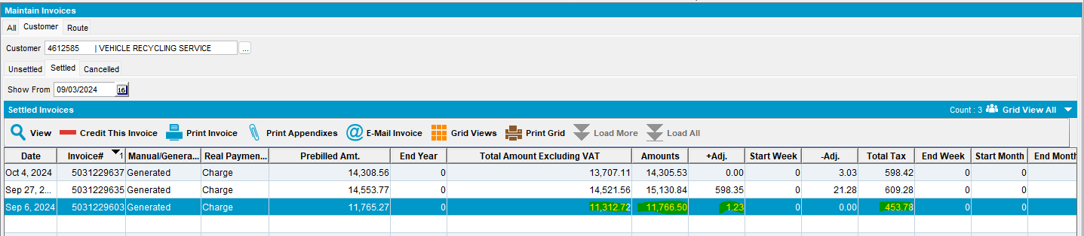
Route Check In dlg -> Total Amount looks ok:
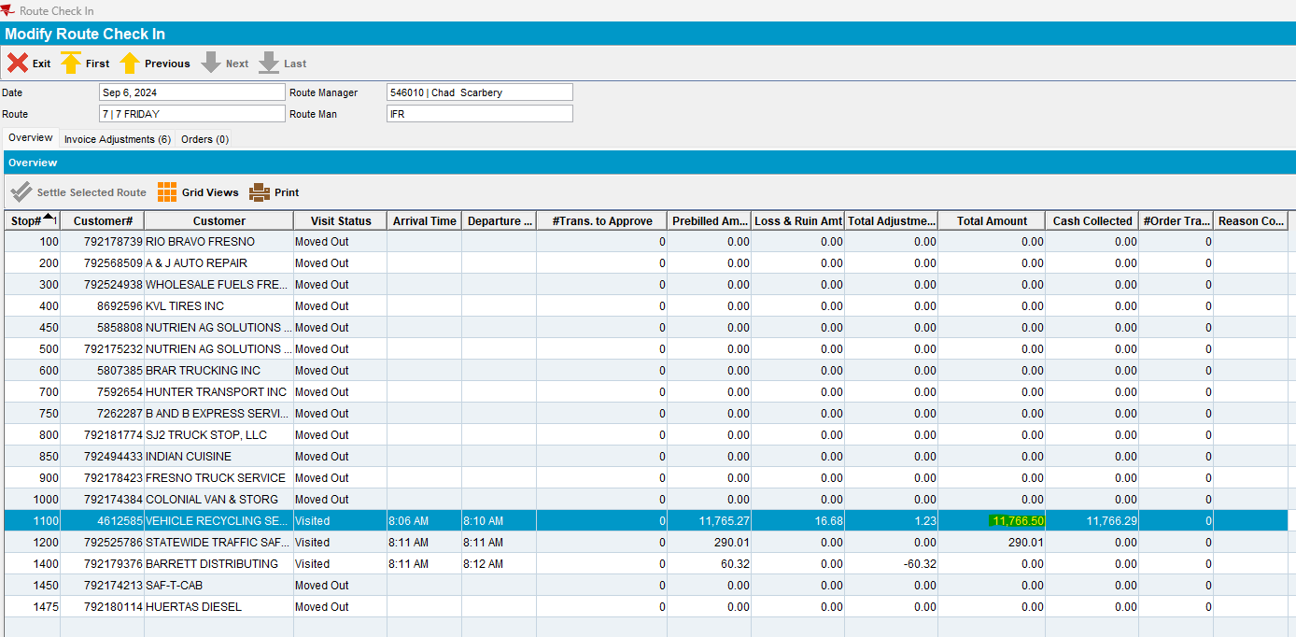

Retest after fix
1. Customer: 792175379
Route: 1 from 09.06.2025
- Full credit invoice on WebX
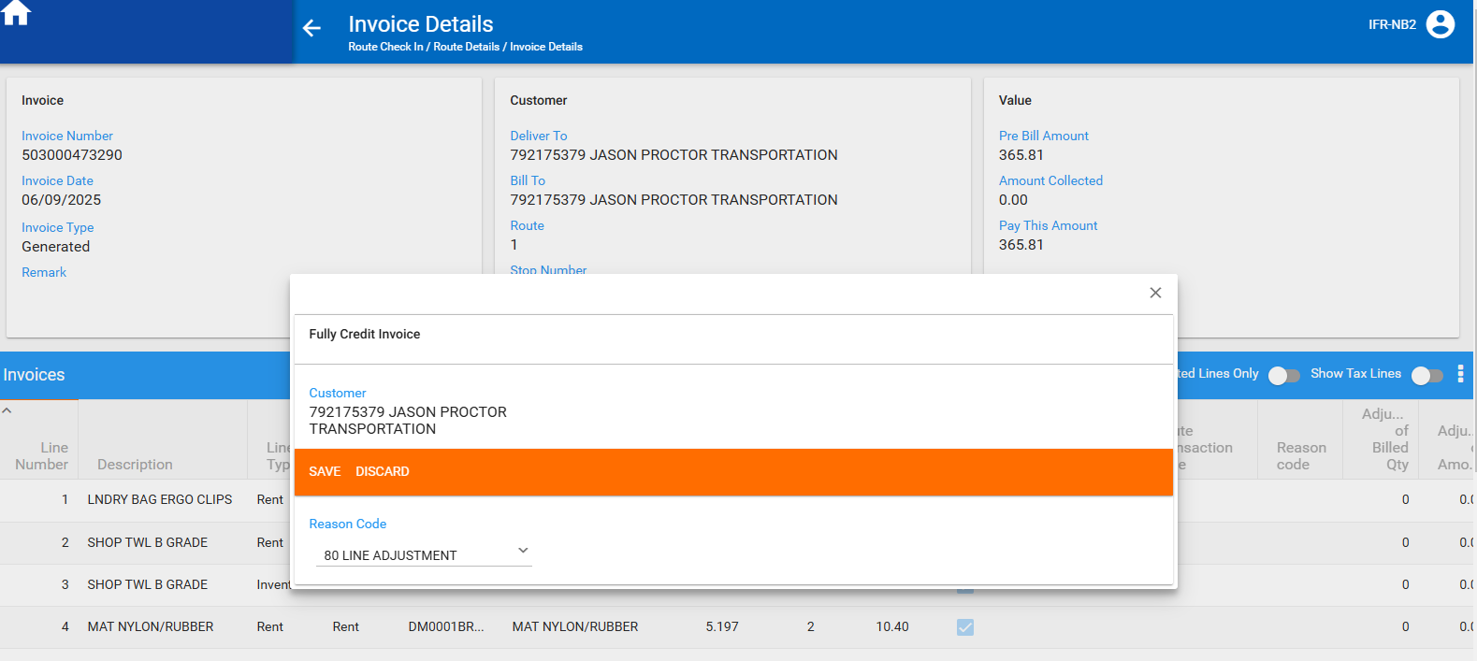
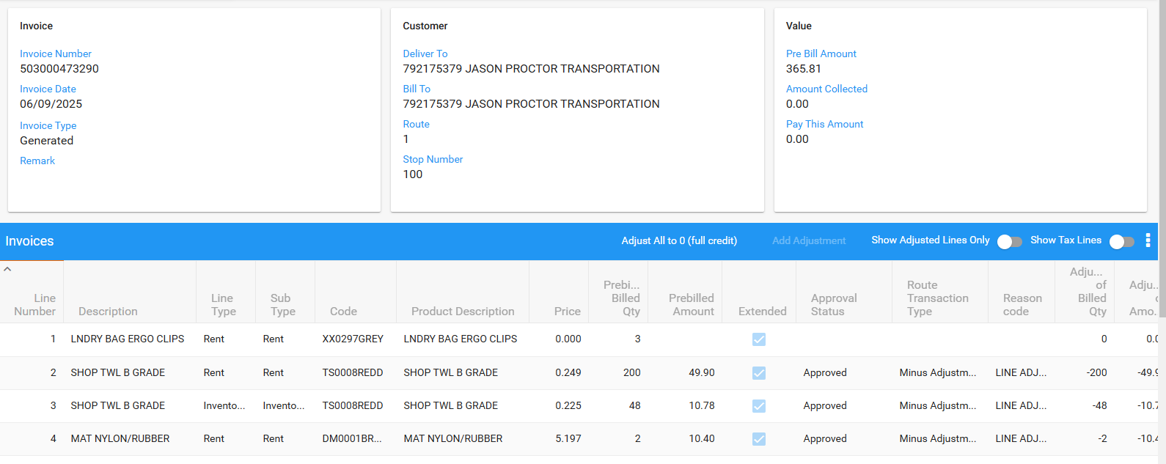
Initial invoice:
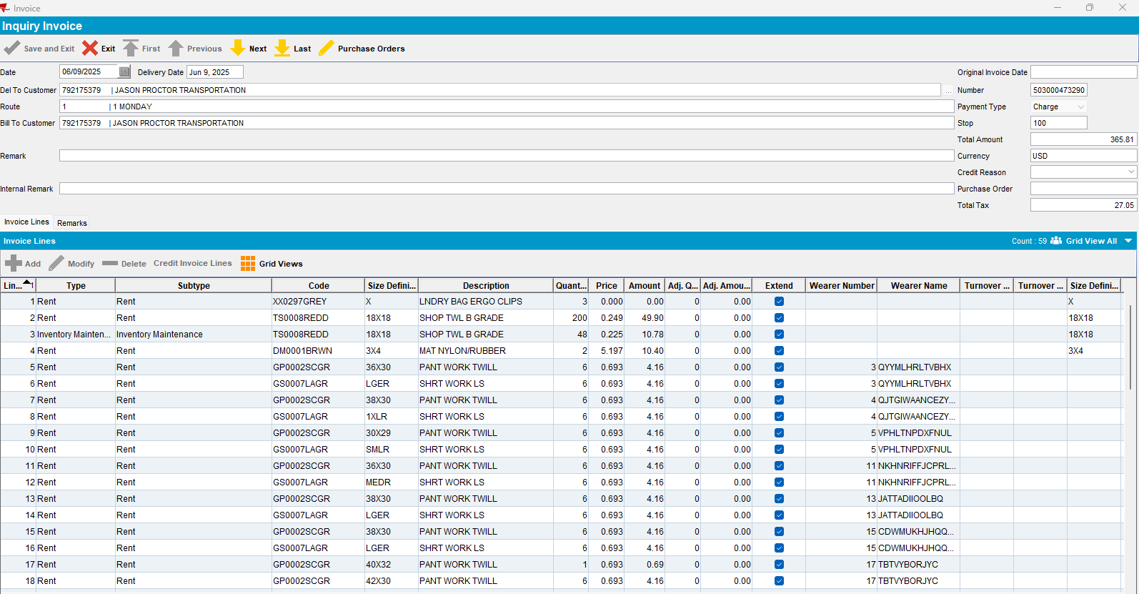
After settlement:
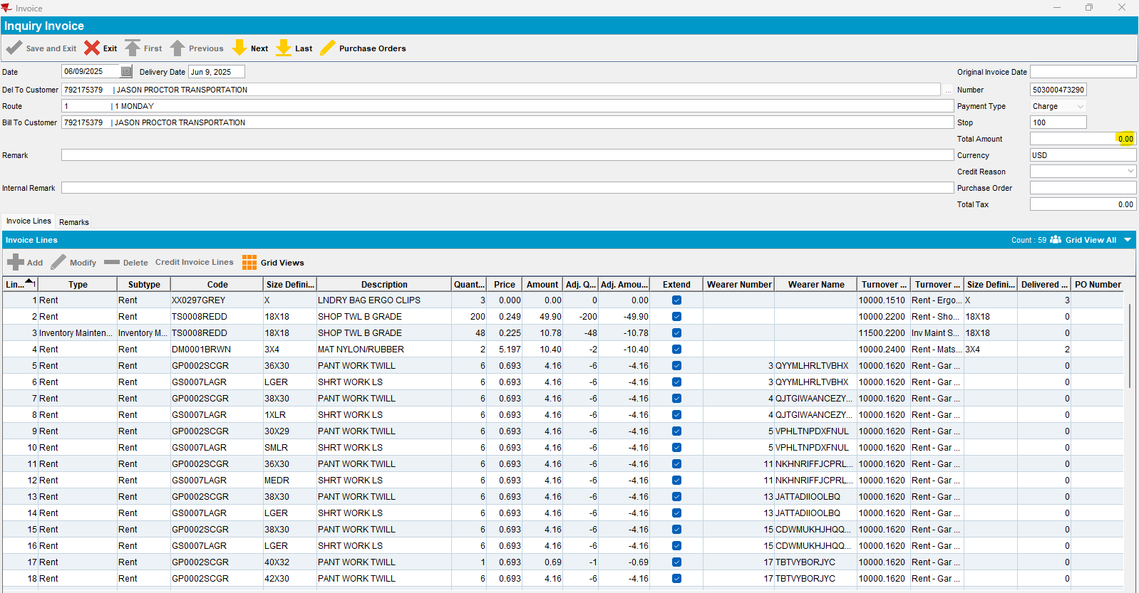
Ok.
- Customer: 792178210
Route: 1 from 09.06.2025
Do some adjustments on PDA and WebX:
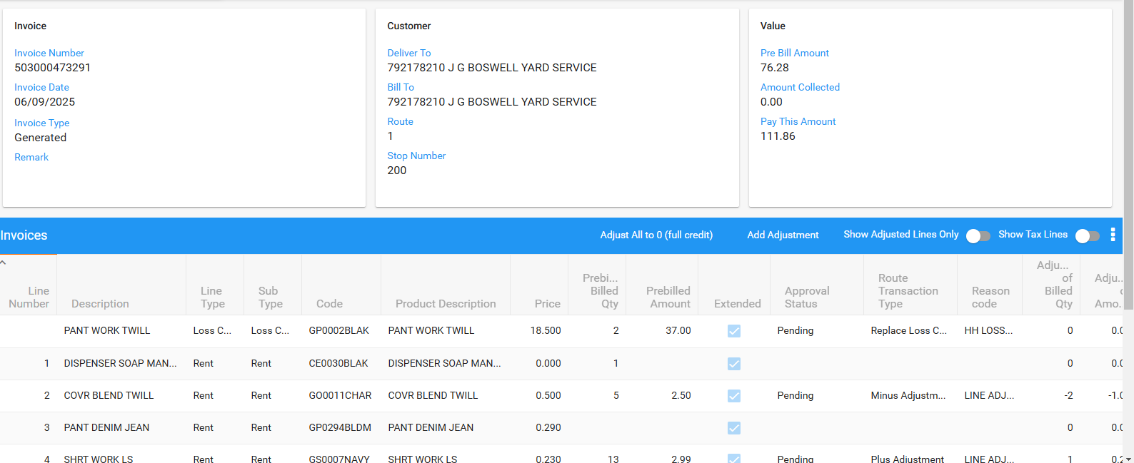
Initial invoice:
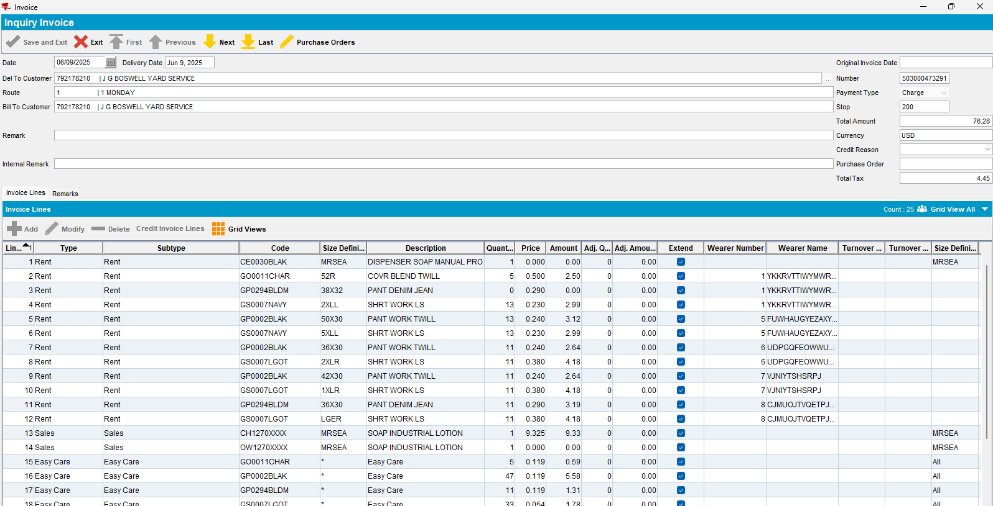
After settlement:
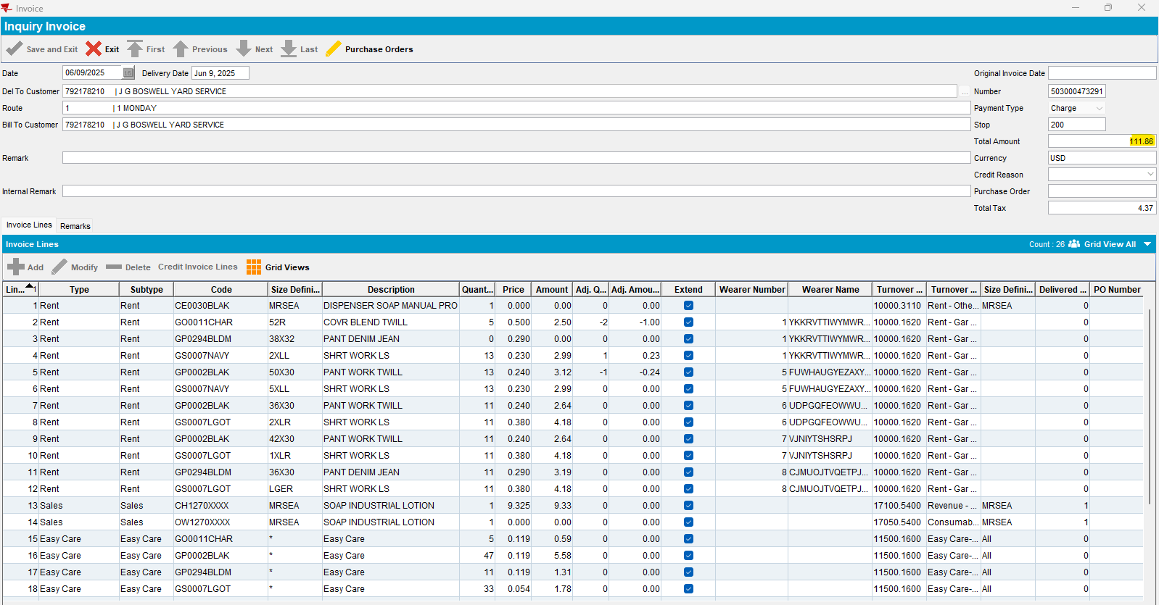
Ok

- Customer: 792563164
Route: 1 from 09.06.2025
Do some adjustments on WebX:
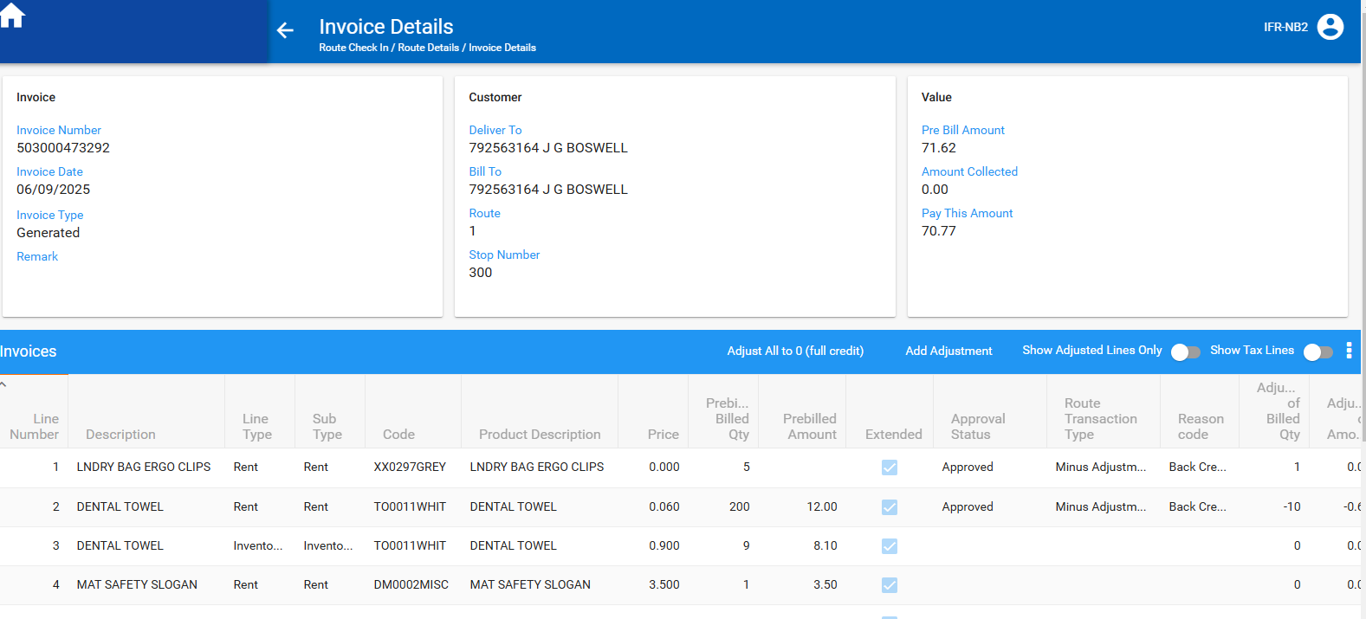
Initial:
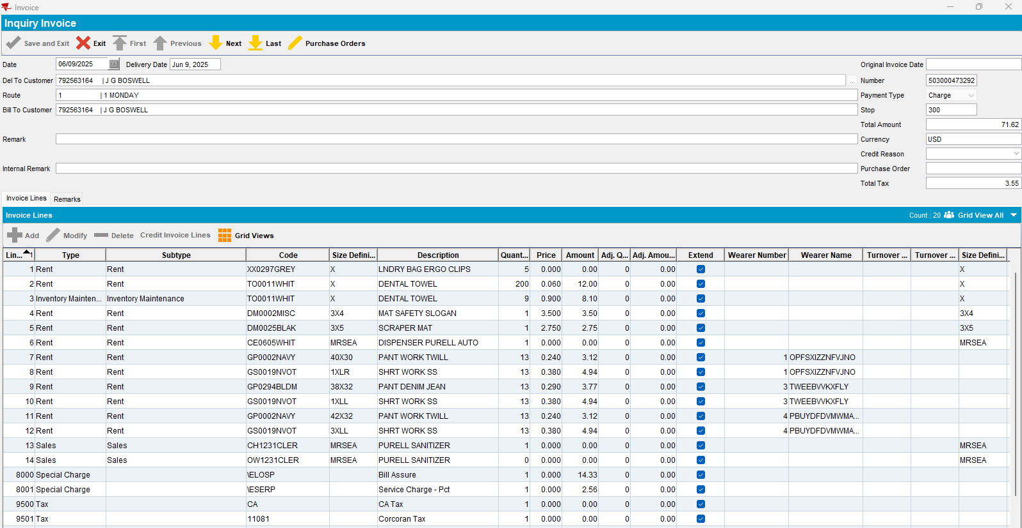

After settlement:
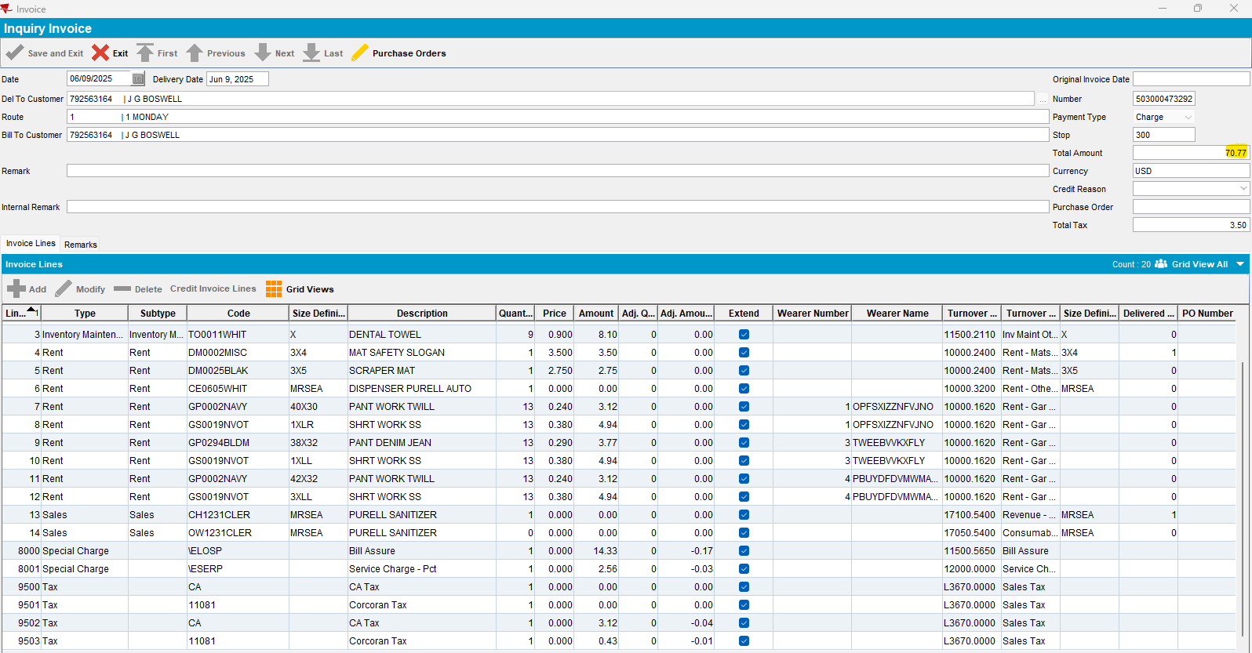
Ok
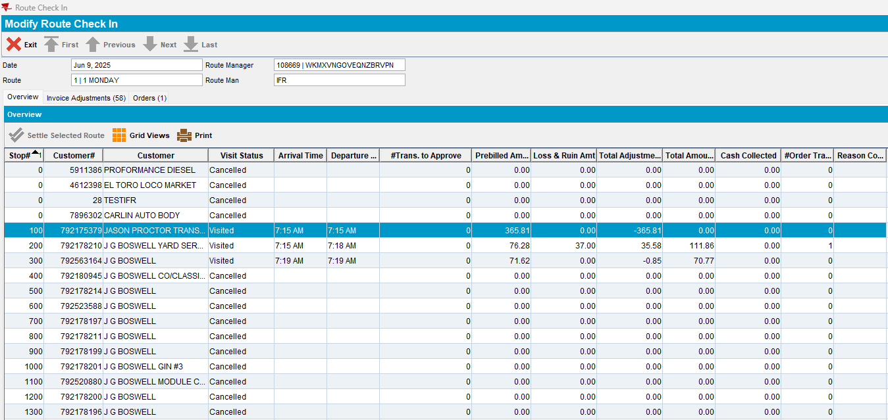
Ok

