ABS-169078 WebX route check in changing tabs with save active
Environment | Prerequisites
Version: 9.08.00.RELEASE.p01  Environment=PRODUCTION  DBServerName=abs-srv16.internal.abslbs.com  DBSID=CUST21  DBUser=AUS_ND90502  DBPassword= AUS_ND90502 | - Module: AUSCUSTOM  - Systems setting: -  - Others: BU 598

Contents
Retest after fix 1

Retest after fix

- Change something on First Aid tab in order to trigger Save and Discard buttons
2. Don't press save and change tab with Invoice Adjustment tab
3. For this message press Stay button and then press Discard button
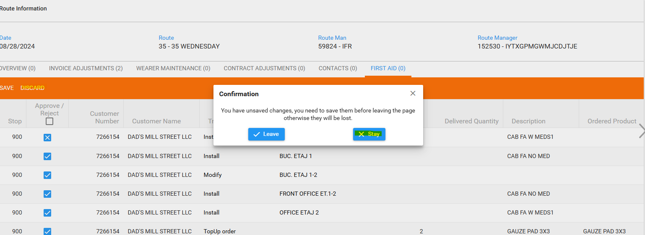
Expected result:
When the user presses Discard on a tab (in the above scenario) the current tab must be kept.
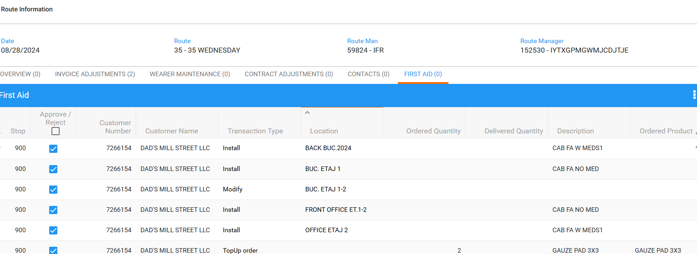
Tested ok.

- Change something on First Aid tab in order to trigger Save and Discard buttons
2. Don't press save and change tab with Invoice Adjustment tab
3. For this message press Leave button

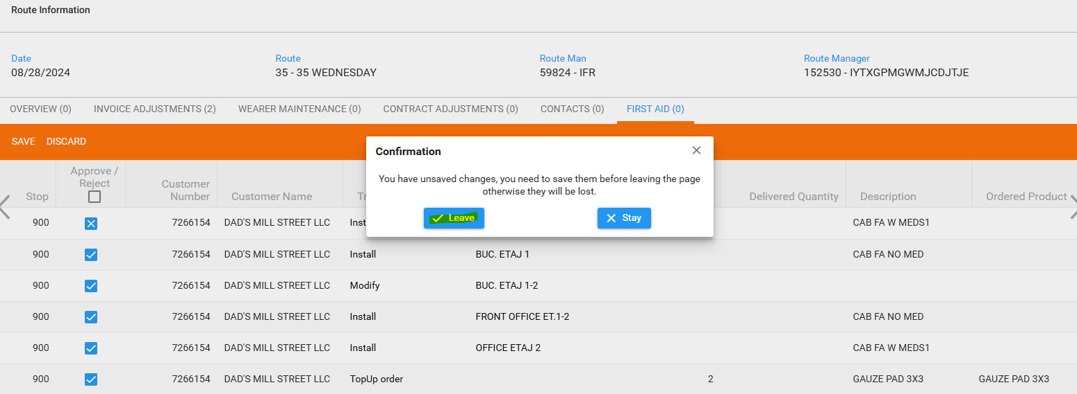
Expected behavior: When making a change in a tab without saving and trying to go to another tab a pop-up appears that warns the users there are changes in their page.

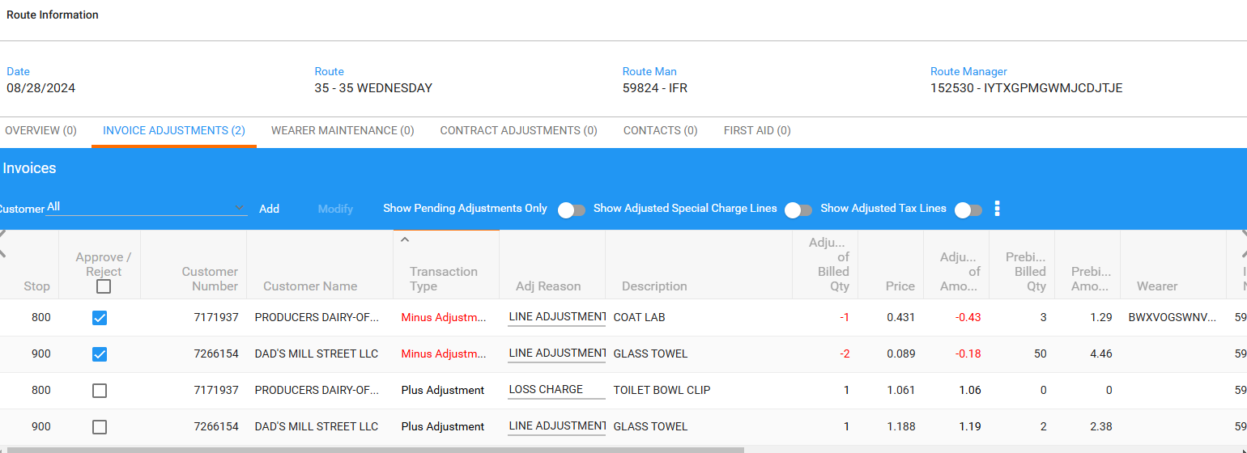
The tab was changed without any saving in the previous tab.
The same behavior for all tabs.
Tested ok.

