ABS-168229 Web Client X - Show System Information
Environment | Prerequisites
Version: 9.08.00.RELEASE.p01  Environment=PRODUCTION  DBServerName=abs-srv16.internal.abslbs.com  DBSID=CUST21  DBUser=AUS_ND90502  DBPassword= AUS_ND90502 | - Module: AUSCUSTOM  - Systems setting: -  - Others: BU 503

Contents
Retest after fix 1

Retest after fix

- WebX: Load to WebX and reach the main page. Look for an option where it shows
- Web server name
- Business Unit
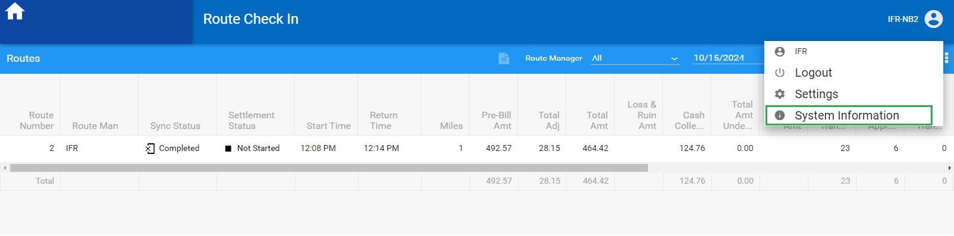
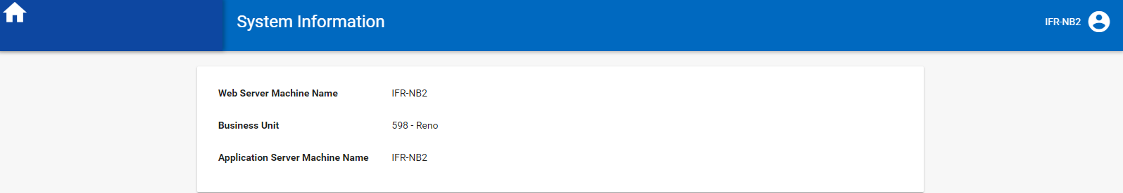
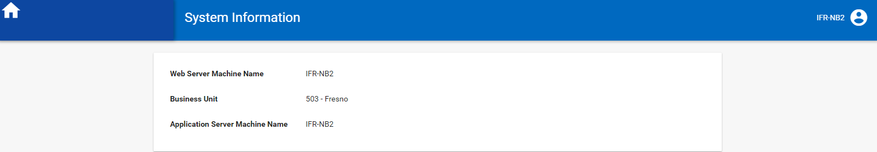
TESTED OK

