ABS-160784 Show logs per RouteControl
Environment | Prerequisites
Version: 9.08.00.RELEASE.p01  Environment=PRODUCTION  DBServerName=abs-srv16.internal.abslbs.com  DBSID= CUST21  DBUser= AUS_ND90502  DBPassword= AUS_ND90502 | - Module: -  - System setting: -  - Others: BU 503
Contents:
Show logs per RouteControl
#1 – Check ABSLOGPROCESSJOBLINE table– Passed 1
#2 – Check View Process Log dlg– Passed 2
Test Case 1 – Generate logs from Client 6
Test Case 2 – Generate logs from Process Scheduler 12

#1 – Check ABSLOGPROCESSJOBLINE table– Passed
Expected result:
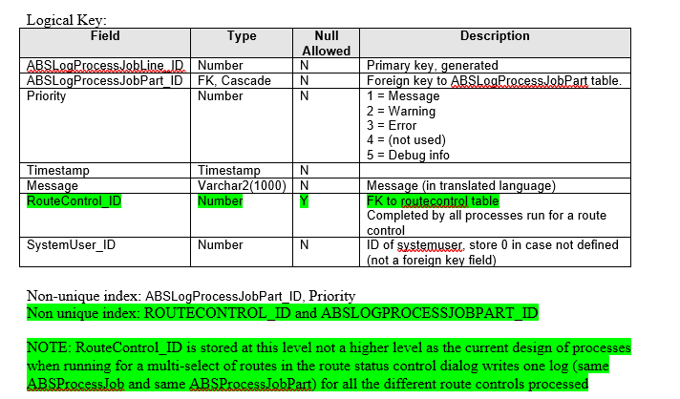

Actual result:
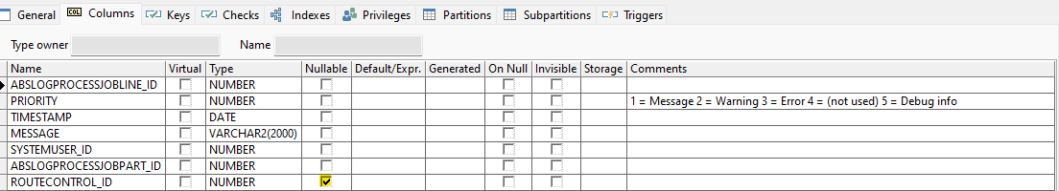
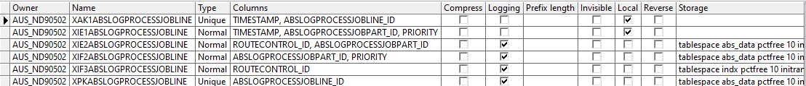

#2 – Check View Process Log dlg– Passed

Expected result:
Attribute Route Control
Business Rules Radio button
When selected, enable the driving date field – default blank
When a date is selected, enable the route combo box
Route combo box shows route number and description for all routes with a RouteControl.OriginalDrivingDate equal to the selected date and in the selected plant.
When a route is selected, load all ABSLogProcessJob records which have a linked (via ABSLogProcessJobPart) record where ABSLogProicessJobLine.RouteControl_ID = RouteControl _ID for the route and date selected.
NOTE: ABSLogProcessJob can contain logs from multiple route controls but in the details, the complete log will be shown if one of the route controls in the log is selected, we do not filter the ABSLogProcessJobLine by route control

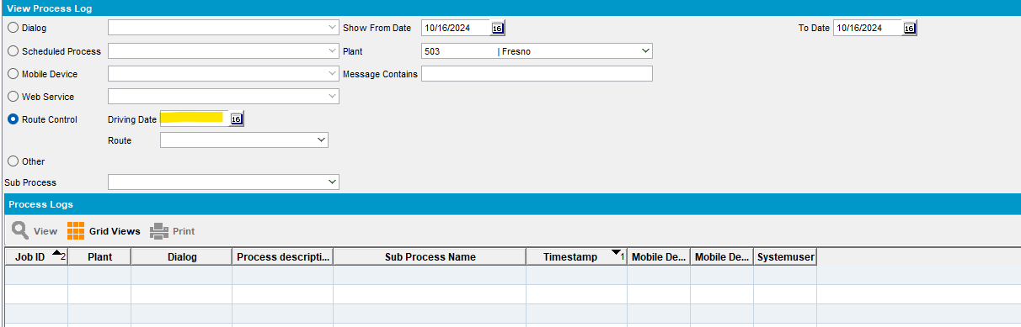
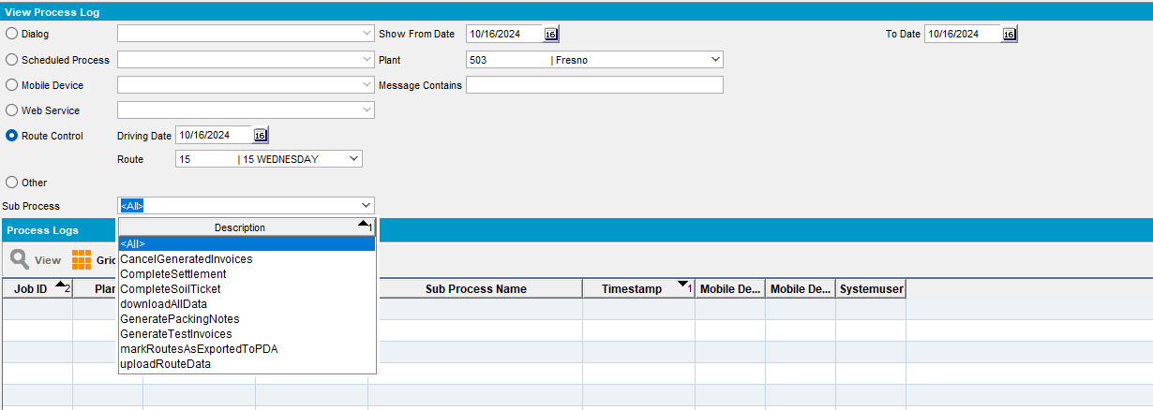
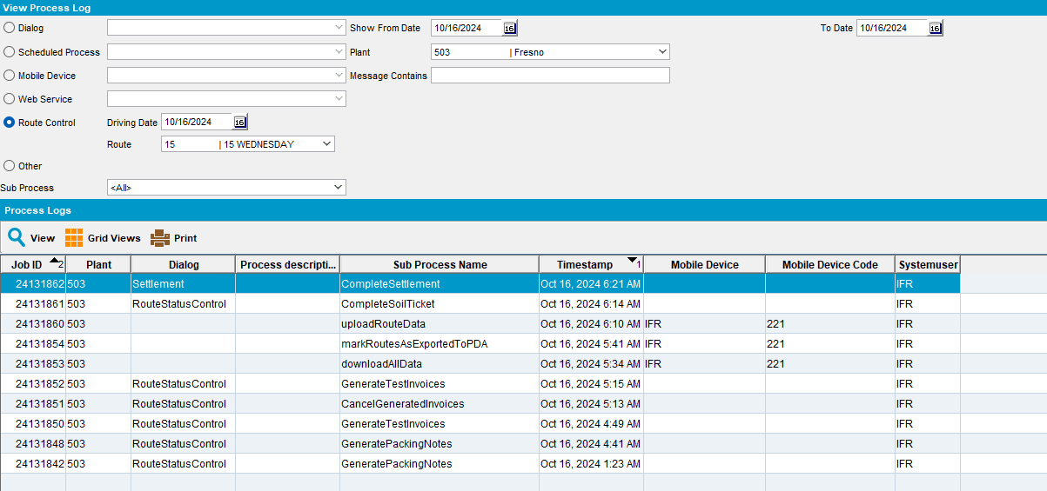

Attribute PLANT_ID
Business Rules Default fill the plant from the current business unit. Fill with Plants defined in BusinessUnitsPerUsergroup.Business_Unit_ID.Plant_ID for the current system user.
If changed and the RouteControl radio button is selected, clear the route combo box, and reload it with routes for the selected date and the new plant selected

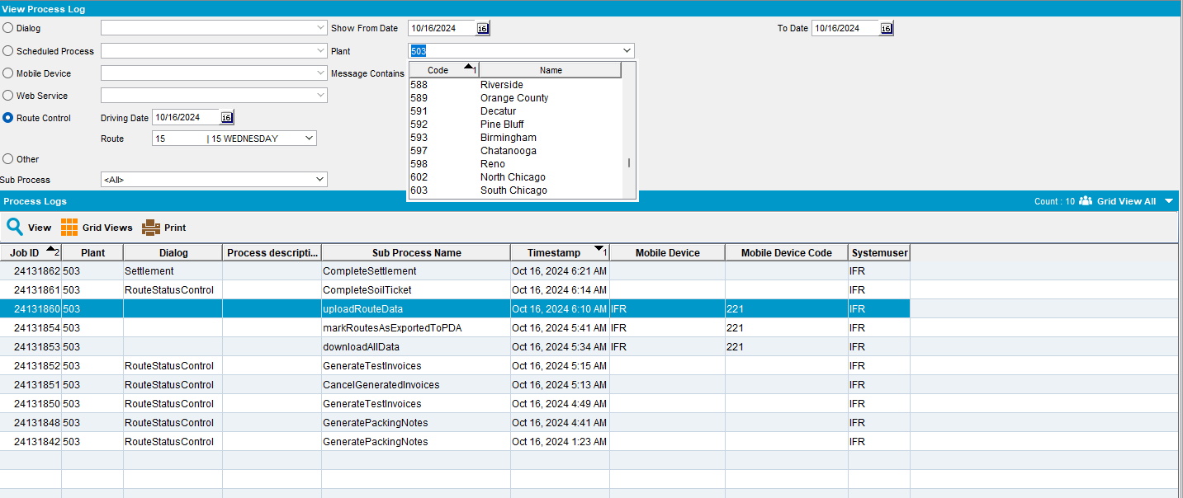
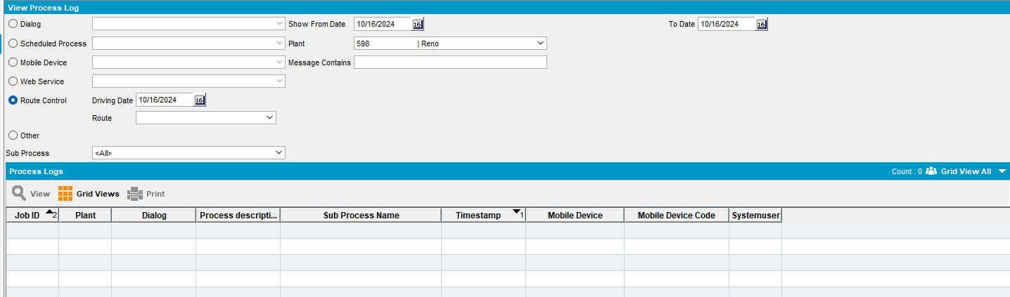
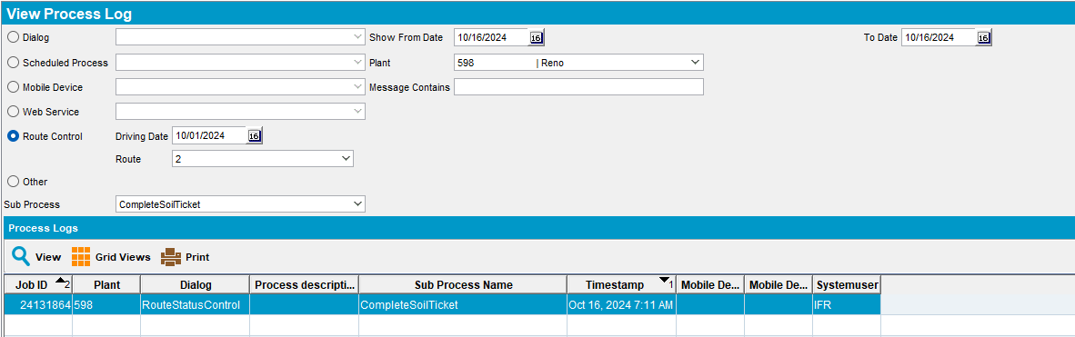

Show in grid

RouteNr – if ABSLogProcessJobLine.RouteControl is not NULL and is greater than 0 then show the route number (same field as shown in route status control). If not, then blank

Route Description - if ABSLogProcessJobLine.RouteControl is not NULL and is greater than 0 then show the route description (same field as shown in route status control). If not, then blank

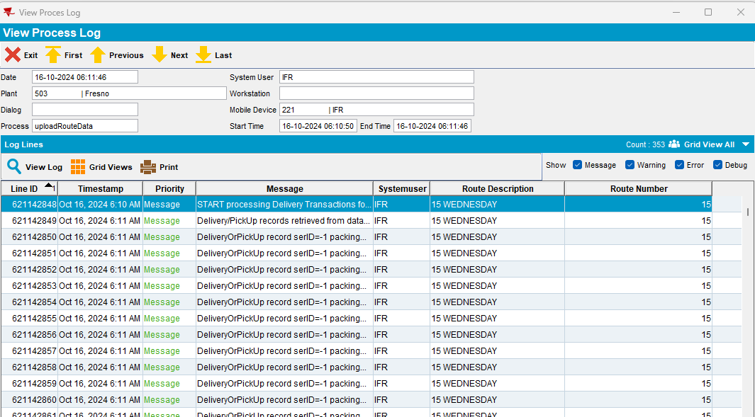

Test Case 1 – Generate logs from Client
- Route Status Control: Add a new route.
- Route Status Control: Go to Packing and Generate and finalize the Put Up Doc.
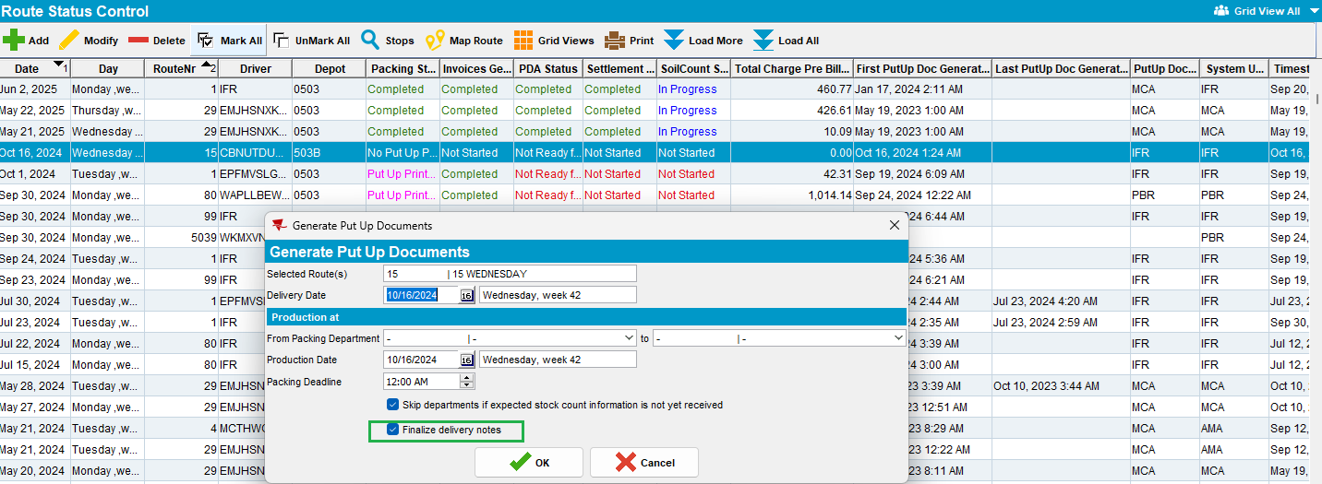
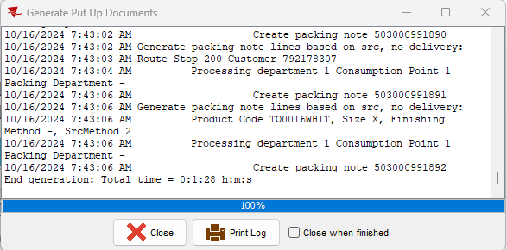
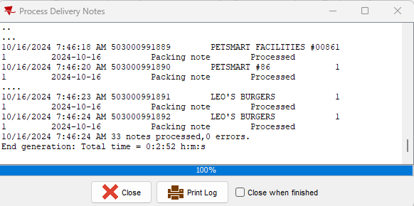
- Route Status Control: Go to Route Preparation and Generate the invoices.
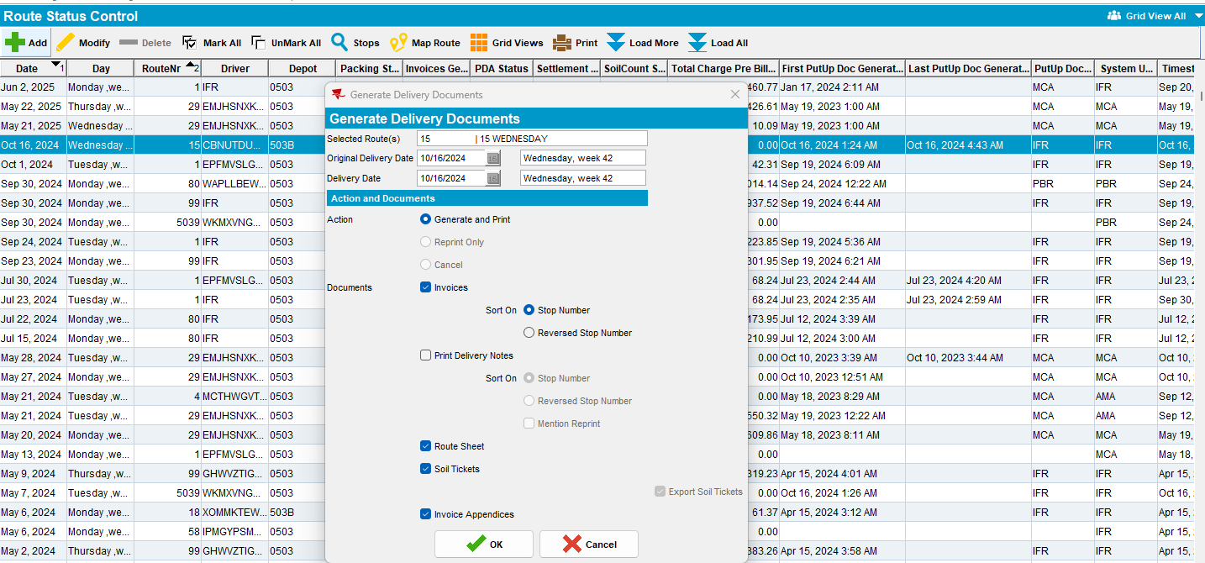
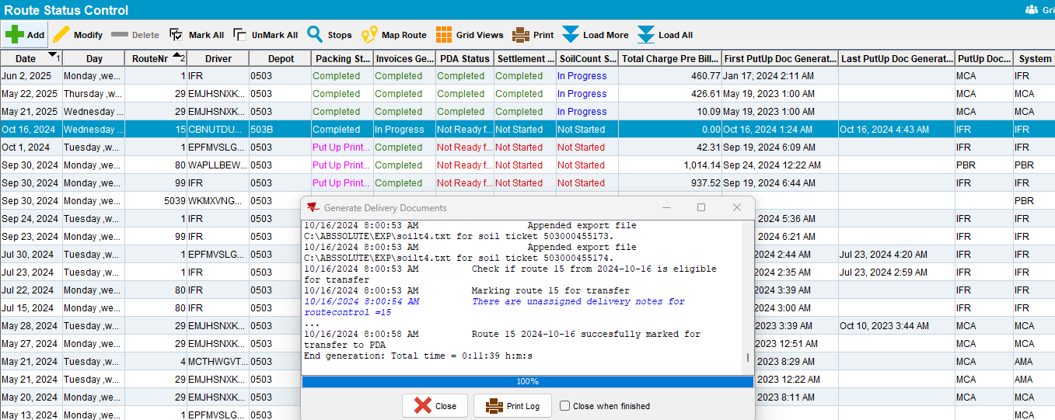
- Route Status Control: Go to Route Preparation and Cancel the generated invoices.
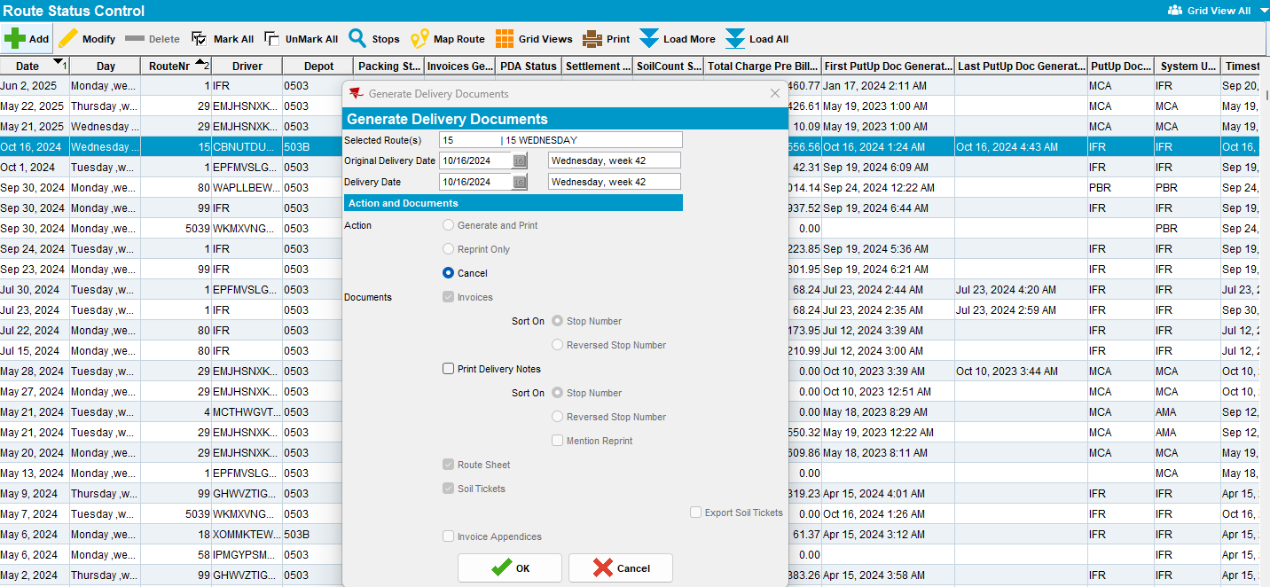
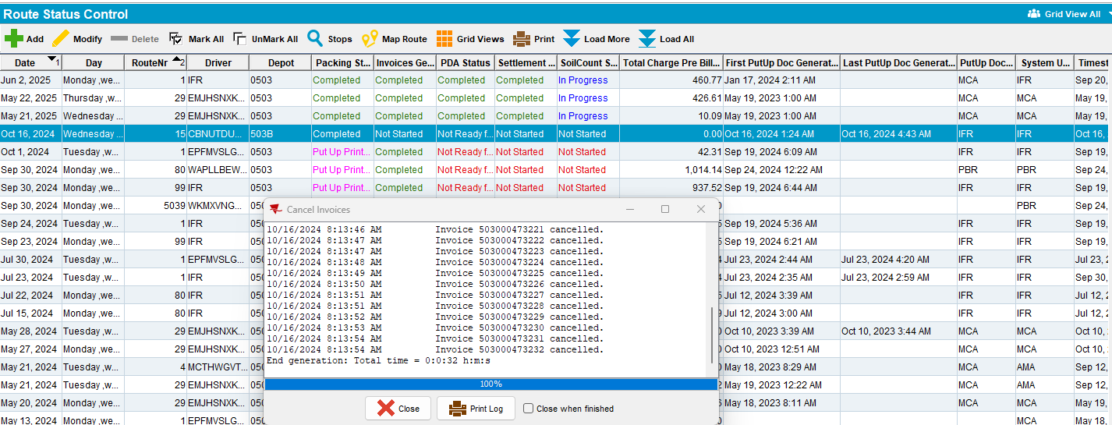
- Route Status Control: Go to Route Preparation and Generate again the invoices.
- Route Status Control: Go to Route Preparation and Mark the route ready for transfer to PDA.
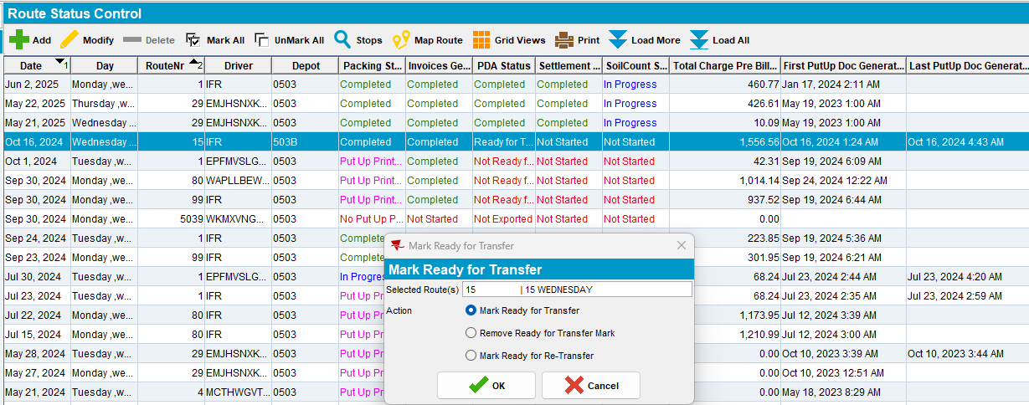
- Route Assistant: Settle the route and upload it.
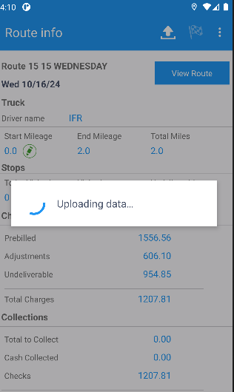
- Route Status Control: Go to Soil Count and Mark Completed.
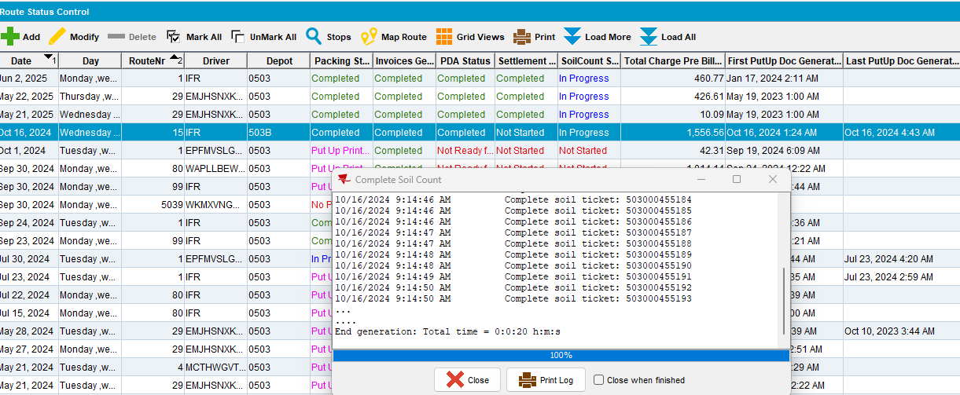
- Web Client X: Settle the route.
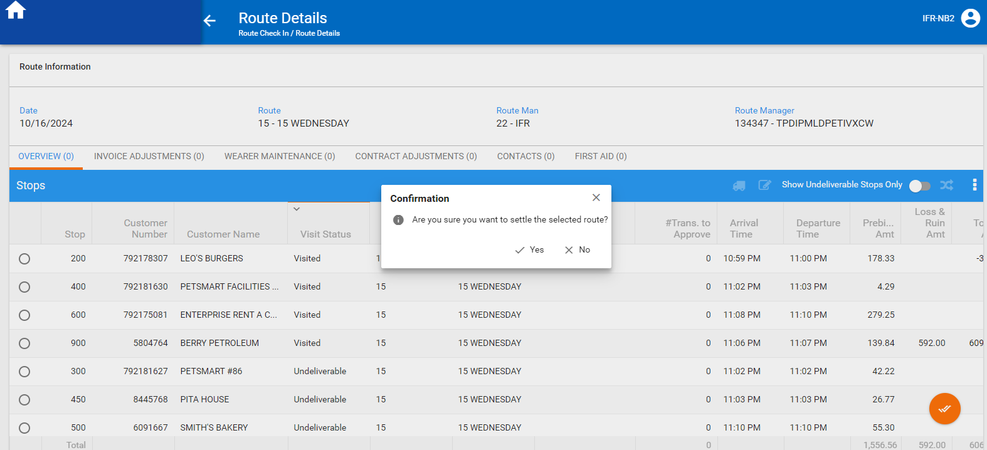
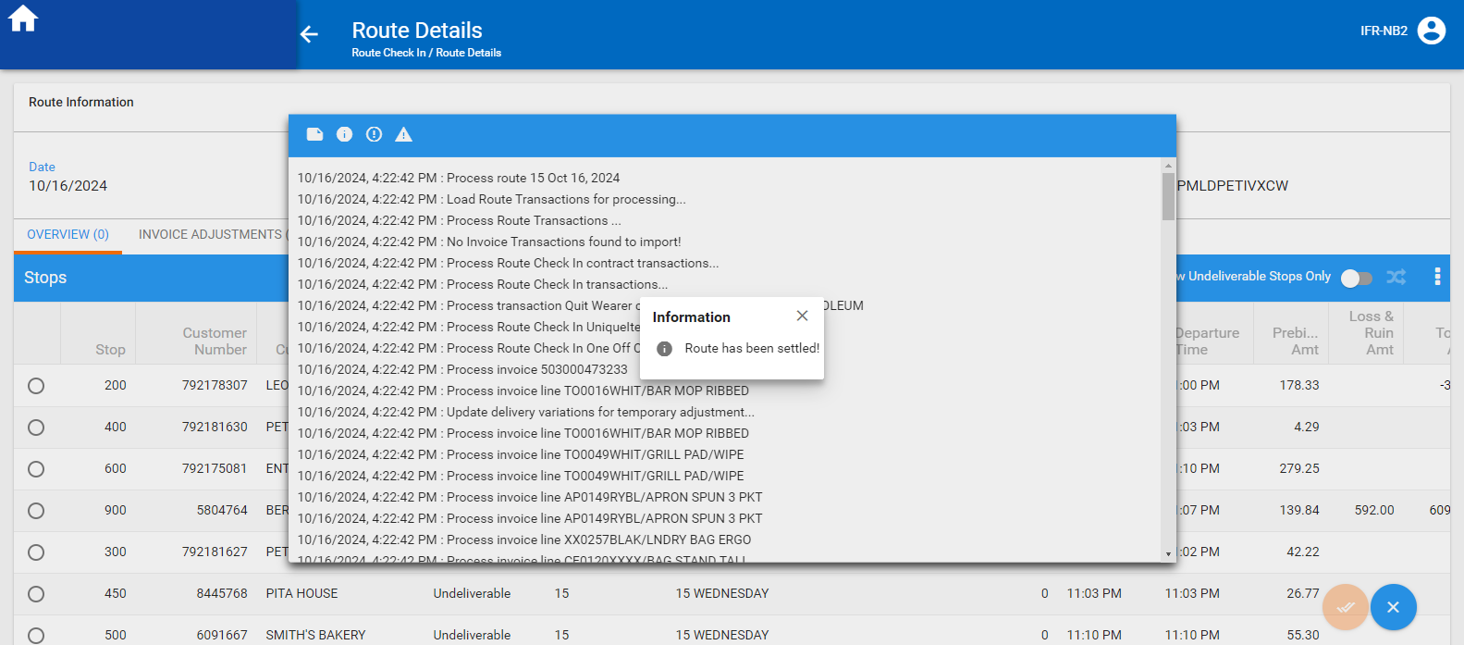

- View Process Log: Check the logs.
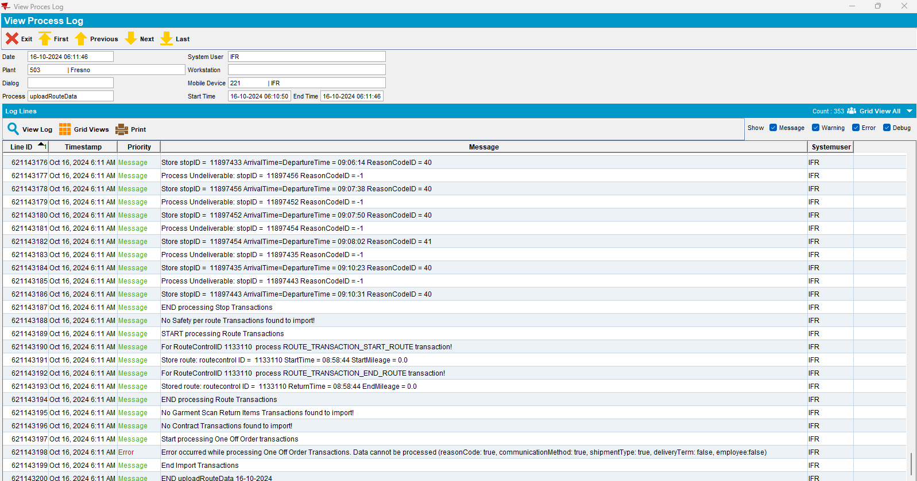
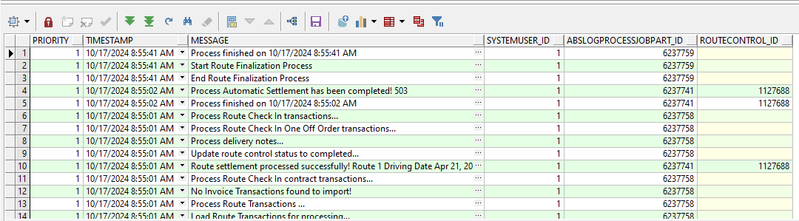
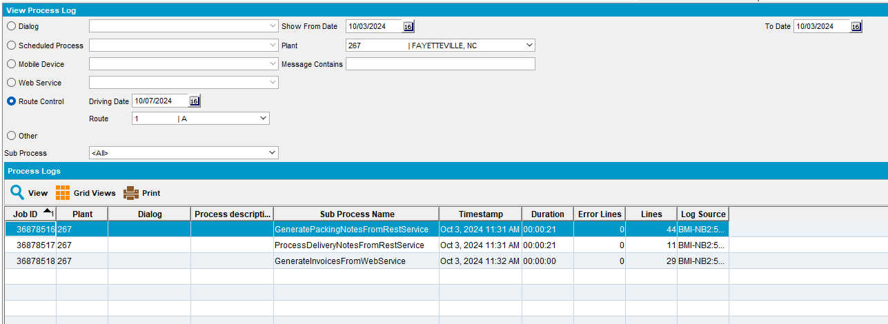

Test Case 2 – Generate logs from Process Scheduler

- Run Automatic Settlement process scheduler
- View Process Log: Check the logs.
