As discussed sending you the required files to install and run the conversion along with conversion documentation

1. Files Provided
- export_9.05.02.zip
  - Contains:
    - Views
    - Functions
    - Packages
    - .BAT files for running the export process
Export from 9.05.02
- Unzip export_9.05.02.zip
- Review .BAT files and configure Database connection info
- Run the .BAT file to generate CSV exports and PL/SQL object definitions

- import_9.08.00.zip
  - Subfolders:
    - ConversionScripts — SQL scripts to prep the target database
    - ConversionProgram
      - CTL/ — Control files for SQL*Loader
      - CSV/ — Place your CSV files here
      - .BAT files:
        - LoadALLdata.bat
        - ConversionLog.bat
        - Conversion.bat
- Unzip import_9.08.00.zip, then:
Run SQL Scripts in Order:
Navigate to ConversionScripts/ and execute the following in order:
1.deleteITables.sql
2.EmptyITableDatabaseScript.sql
3.Plsql_import_packages_9.08.00.sql
Configure for Import
- Copy CSV files into CSV/ folder (Encoding issues: Ensure all CSVs are in UTF-8 and control files use CHARACTERSET UTF8 )
- Edit the following BAT files in ConversionProgram/:
  - LoadALLdata.bat
  - ConversionLog.bat
  - Conversion.bat
Ensure they reference:
- Correct database connection string
- Paths to:
  - CTL/ directory
  - CSV/ directory
Please see an example below
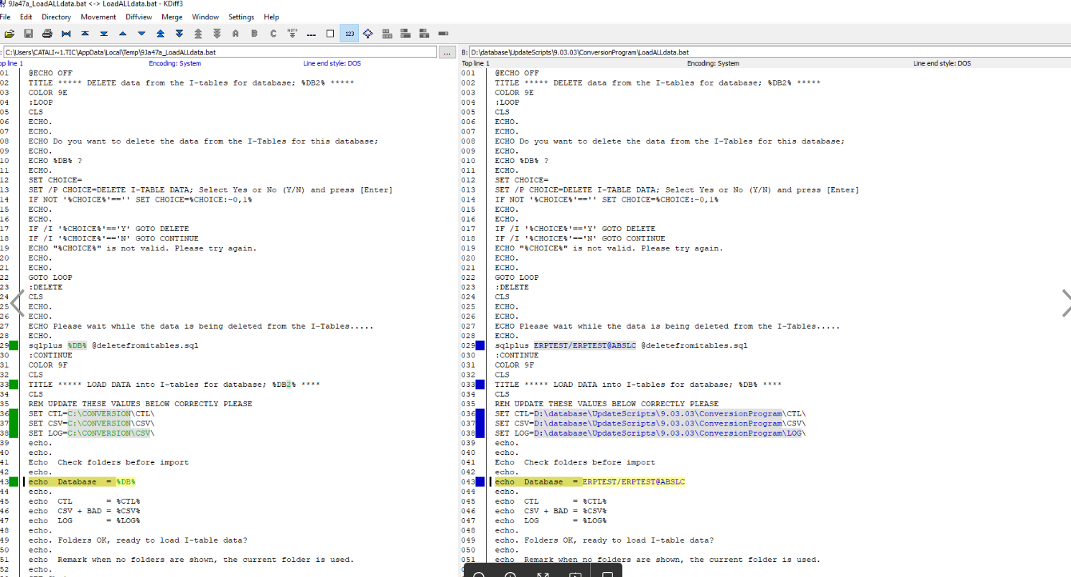

3. Run the Import process
From the ConversionProgram/ folder:
LoadALLdata.bat ,Conversion.bat , ConversionLog.bat

