How to Translate BI repository
Step 1 Export Strings via BI Admin Tool
Step 1a
Select all presentation objects, right click and choose Externalize Display Names - Generate Custom Name
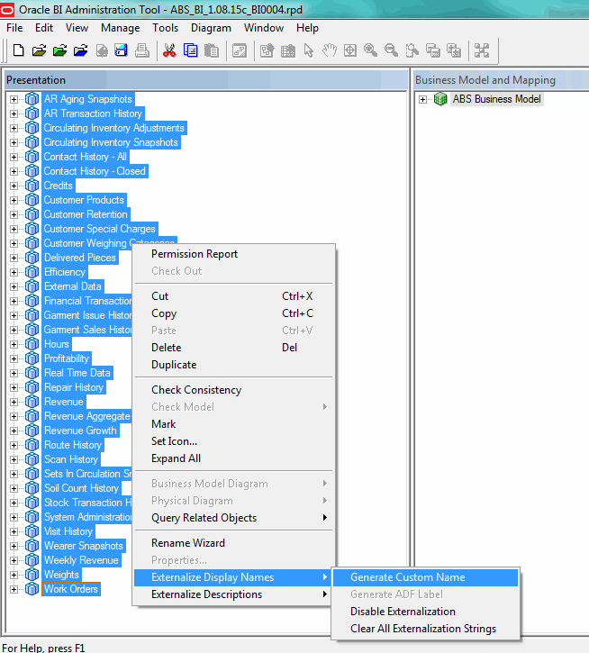

Step 1b
Select Tools - Utilities - Externalize Strings - Execute
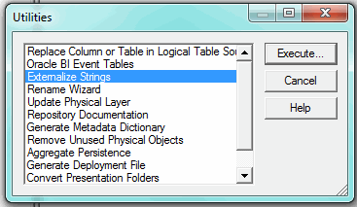
Select All
Then unselect the following:
Employee Efficiency
Employee Planning
Globe Employee Efficiency
Globe Machine Efficiency
All Globe4*
Real Time Employee Efficiency
Real Time Globe Data
Weekly Average Revenue
Weekly Customer Info
Weekly Customer Product Info
Weekly Revenue

and press Save.. and choose file location for CSV file
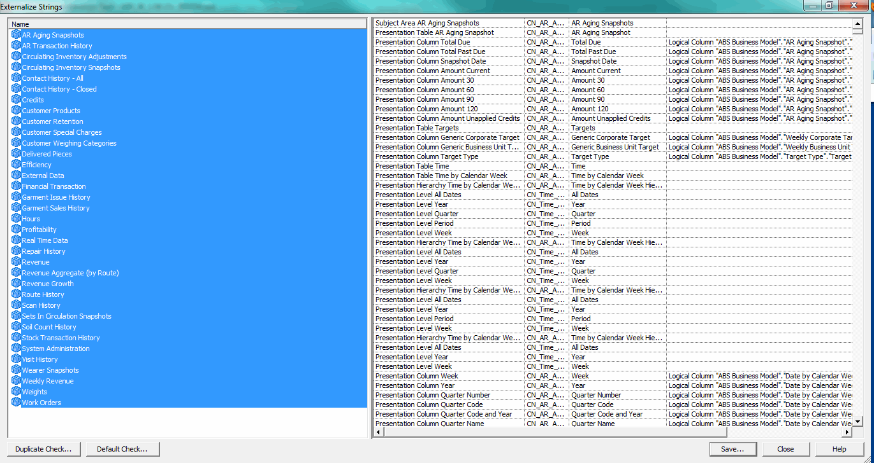

Step 2 Load external_strings_xxx.csv file in reference database
Execute procedure TRANSLATIONKEY_ADMIN. LOAD_TRANSLATIONKEYFILE in ABSDATAWAREHOUSE which holds all translations (master)
Step 3 Execute procedure ABSDATAWAREHOUSE.AUTOTRANSLATE_CATALOG
Step 4 Insert missing strings (mind to change the language code in the select)
insert into presentationcatalog_desc pd
(presentationcatalog_id,
languagecode,
displayname,
systemuser_id,
timestamp)
(select x.min_id,
'nl',
x.factorydisplayname,
2 systemuser_id,
sysdate
from (select d.businessdescription, d.factorydisplayname, min(d.presentationcatalog_id) min_id
from presentationcatalog d
where d.presentationcatalog_id not in
(select dd.presentationcatalog_id
from presentationcatalog_desc dd
where dd.languagecode='nl')
and d.active_yn = ‘Y’
group by d.businessdescription, d.factorydisplayname) X);

Step 5 option a) Translate missing strings using PLSQL Developer
select *
from presentationcatalog_desc d
where d.systemuser_id = 2
and d.languagecode = 'nl'
and exists
(select 1
from presentationcatalog p
where p.presentationcatalog_id = d.presentationcatalog_id
and p.active_yn = 'Y')
for update

Step 5 option b) Translate in Excel

Step 5b1) Export them for external translation
Use the following select to export to Excel for external translation.
select pd.languagecode,
p.businessname,
p.businessdescription,
pd.displayname
from presentationcatalog p, presentationcatalog_desc pd
where p.presentationcatalog_id = pd.presentationcatalog_id
and pd.languagecode = 'nl'
and pd.systemuser_id = 2
Step 5b2) Load translations into I_PRESENTATIONCATALOG_DESC using PLSQL developer
Empty this table first
Step 5b3) Execute load_catalog_translations procedure
Step 6 Execute procedure ABSDATAWAREHOUSE.AUTOTRANSLATE_CATALOG again
Step 7 Test (restart BI instance before changes take effect)
Step 8 Mark New strings as not new
update presentationcatalog_desc d set d.systemuser_id=1 where d.systemuser_id=2;
commit;

Step 9 Export data to csv (previously it were insert statements)

In ABSDATAWAREHOUSE which holds all translations (master) Execute package functions:
TRANSLATIONKEY_ADMIN. WRITE_TRANSLATIONKEYFILE
And
TRANSLATIONKEY_ADMIN. WRITE_TRANSLATIONFILE for each language
CSV files are stored in oracle directory TRANSLATIONFILES

Step 10 Import in customer databases

Put csv files from step 9 in oracle directory ABSDUMPDIR

Then execute package functions:
LOAD_PRESENTATIONCATALOGTRANS.LOAD_TRANSLATIONKEYFILE
and
LOAD_PRESENTATIONCATALOGTRANS.LOAD_TRANSLATIONFILE for language required by customer

