Alexandra Berbec, June 19th 2023, OAS 2023
Before the settings were applied
Administering Oracle Analytics Server
https://docs.oracle.com/en/middleware/bi/analytics-server/administer-oas/configure-display-and-process-data-views.html#GUID-B1DFBF83-03F3-49CD-87FD-7F131AD86645
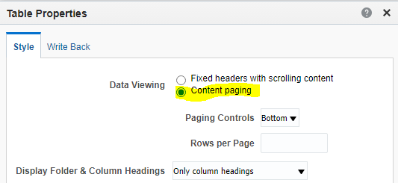

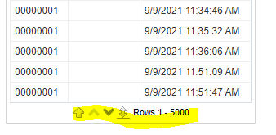
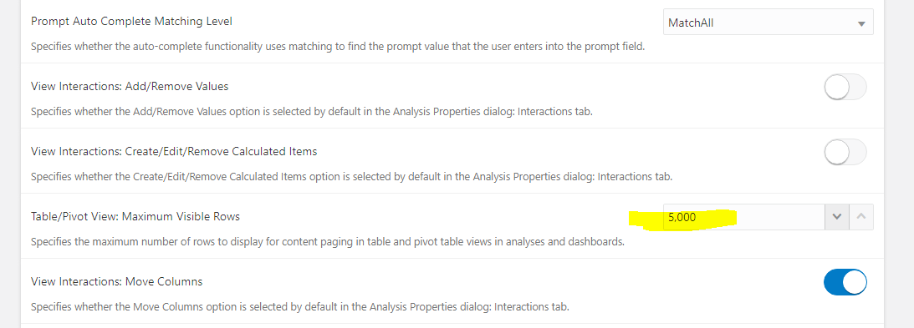

When exported to excel, it exports 541 657 which is the correct no of rows

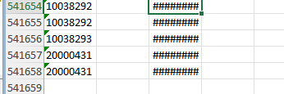

WITH
SAWITH0 AS (select distinct T139967.SECONDARYID as c1,
T139967.SCAN_TIME_STAMP as c2,
T139967.PRIMARYID as c3
from
FACT_CONTAINER_SCAN T139967)
select D1.c1 as c1, D1.c2 as c2, D1.c3 as c3, D1.c4 as c4 from ( select 0 as c1,
D1.c3 as c2,
D1.c2 as c3,
D1.c1 as c4
from
SAWITH0 D1
order by c2, c4, c3 ) D1 where rownum <= 65001;
--
select distinct T139967.SECONDARYID as c1,
T139967.SCAN_TIME_STAMP as c2,
T139967.PRIMARYID as c3
from
FACT_CONTAINER_SCAN T139967;--541 657 correct no of rows

Default values
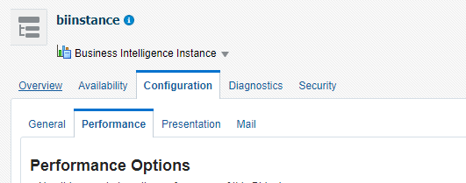

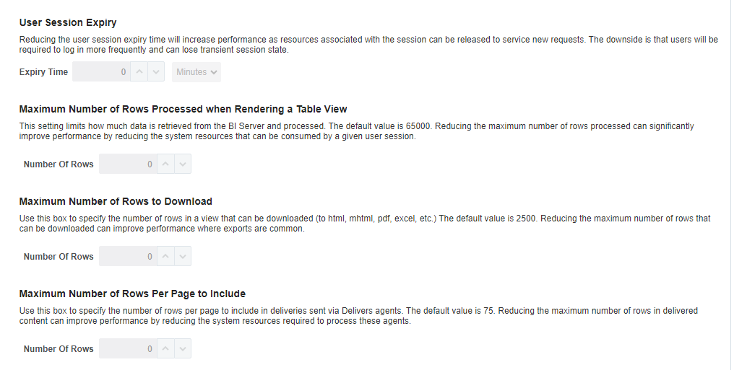
After instanceconfig.xml settings

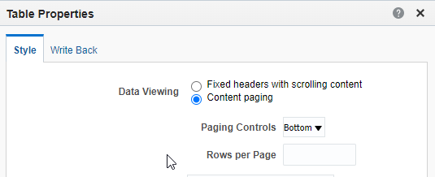

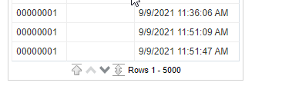

How to Change MaxVisibleRows In Oracle Analytics Server (OAS) (Doc ID 2852874.1)
From Oracle Analytics Server 5.9, MaxVisibleRows can only be changed by clicking System Settings in the Oracle Analytics Server Console.
And according to View Options as below, OAS 5.9 has introduced a limit on MaxVisibleRows as 5000.
Table/Pivot View: Maximum Visible Rows
Specifies the maximum number of rows you want displayed for content paging in table and pivot table views in analyses and dashboards.
The minimum number of rows you can specify to display is 100.
Valid Values: 100-5000
Default: 5000

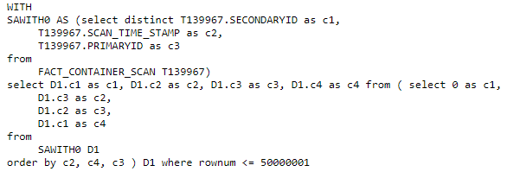
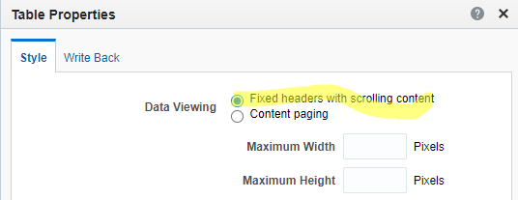

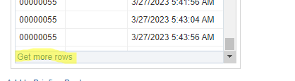
With get more rows all rows are shown.

Export to excel –
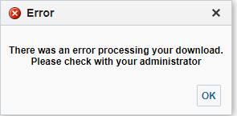
Config.xml
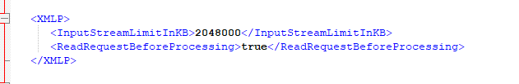

Data Export works a lot faster than Formatted Export.

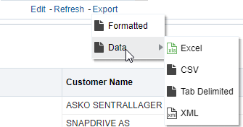

Agents send data as Formatted Excel or Data CSV. Mail server has a file limit of 10MB.
In the documentation, DefaultRowsDisplayedInDelivery is incorrect, it is rows sent by an agent.

