ABSSolute

Installation and Setup Guide for UHFConcentrator

 | Author | Laura Constantinescu, Cristian Vica, Alin Tirlea, Adrian Banciu, Andrei Rosu-Cojocaru, Marius Simion, Alin Fatu, Marius Pîrîtu
 | Function Title
 | E-mail
 | Version | 1.0

Table of Contents
Scope 2
Background 2
Architecture overview 2
Compatibility Matrix 3
Requirements 4
1.1 Hardware Requirements 4
1.2 Software Requirements 4
1.3 Non-Functional Requirements 4
1.4 Communication over HTTPS & Certificates 4
1.4.1 Communication between UHFConcentrator and ABSSolute Server 5
1.4.2 Communication between UHFConcentrator and Web Console (Browser) 7
Technical Installation Consideration(s) 7
Installation Steps 7
Configuration 8
1.1 Configuration in ABSSolute v9 Client 8
1.2 Installation & Configuration 9
Basic Checks after Installation 16
Troubleshooting 16
1.1 Logging 16
1.2 Frequent Problems & Their Solutions 17

Scope
This installation guide describes the necessary steps for the installation of the UHFConcentrator application.

Background
The UHFConcentrator is a Spring Boot application that connects to multiple RFID Readers (typically, Impinj UHF readers) in the laundry and aggregates the information received from them to provide unattended scanning functionality.

Architecture overview
Typically, the UHFConcentrator application is installed in the laundry, near the RFID readers, so that communication with the readers is done in real-time.
Installing it anywhere else might cause the readers to stop scanning without providing any notification to the user.
The UHFConcentrator application provides a web console accessible through the browser, to provide further debugging information.

The UHFConcentrator communicates with the:
- ABSSolute application server through a reverse proxy using the HTTP(S) communication protocol (through the REST port the ABSSolute application server exposes) – in the case of on-premise installations the reverse proxy might not be necessary;
- RFID readers through the LLRP protocol (a TCP protocol based on XML).

The UHFConcentrator can be configured to communicate with a single instance of the application server at a time.
The failover functionality (if needed) should be set up at the reverse proxy level.

Hosted Installation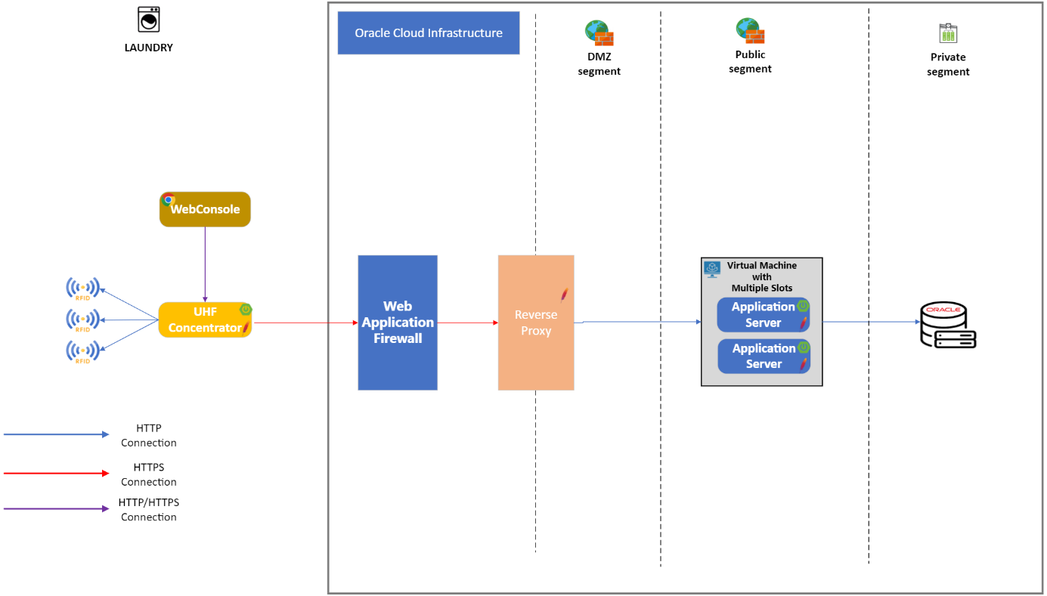
On-Premise Installation
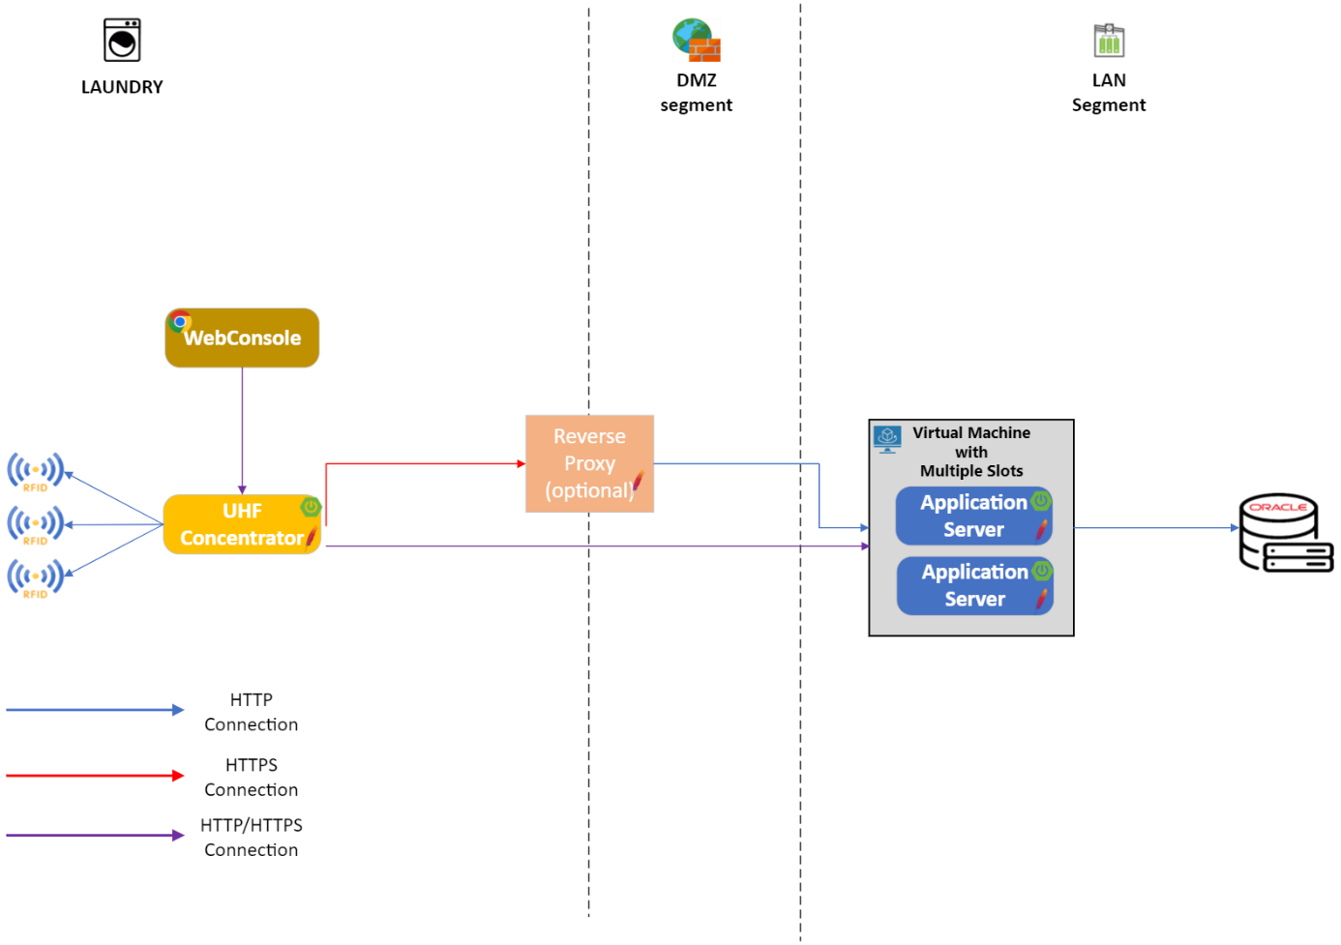
Source: OneDrive

Compatibility Matrix
The compatibility matrix between the UHFConcentrator application and the ABSSolute application server is available on Confluence.
The compatibility matrix includes the following information:
- UHFConcentrator version;
- ABSSolute application server version;
- Java (JRE) version;
- SpringBoot version;
- OctaneSDK version;
- RFID Reader firmware version;
- whether the UHFConcentrator version is supported or not.

Requirements

Hardware Requirements
The UHFConcentrator application’s hardware requirements depends on the number of RFID readers it will be configured with:
- OS version: Windows/Linux
- Machine Type: virtualized or physical
- Storage: 50 GB (out of which 40GB for the operating system and other related applications)
- Network: 1 Gbps

Number of RFID Readers | 1-5 | 6-20 | 21-50
CPU | 2 cores | 4 cores | 8 cores
Memory (RAM) | 8 GB | 12 GB | 16 GB

Software Requirements
The UHFConcentrator application has the following software requirements:
- ABS-related applications: Application Server
- Non ABS-related applications
  - Java 17.0.8 (Zulu 17.44.15)
  - Impinj firmware installed on the RFID reader (check the supported version in the Compatibility Matrix)

Non-Functional Requirements
The UHFConcentrator application has the following non-functional requirements:
- Real-Time Processing: the tags which are picked up by the RFID Readers’ Antennas should be sent to the application server for processing as soon as possible;
- Security: basic authentication using user / password credentials (belonging to a system user, the same as for the application server)
- Load-Balancing: not supported at the moment, the UHFConcentrator works with a single application server which is configured in the properties file
- Fail-Over: not supported at the moment, the UHFConcentrator works with a single application server which is configured in the properties file
- Monitoring – UHFConcentrator provides a web console which can be accessed through any web browser, that displays the status of each connected RFID Reader as well as the operating mode of the UHFConcentrator (online – if it has an active connection to the application server or offline – if the application server is temporarily not available)

Communication over HTTPS & Certificates
There are two types of HTTPS communication for the UHFConcentrator that might be configured:
- the communication between the UHFConcentrator and the ABSSolute Server – this might be different for the hosted environments and the on-premise environments;
- the communication between the UHFConcentrator and the browser for the web console.
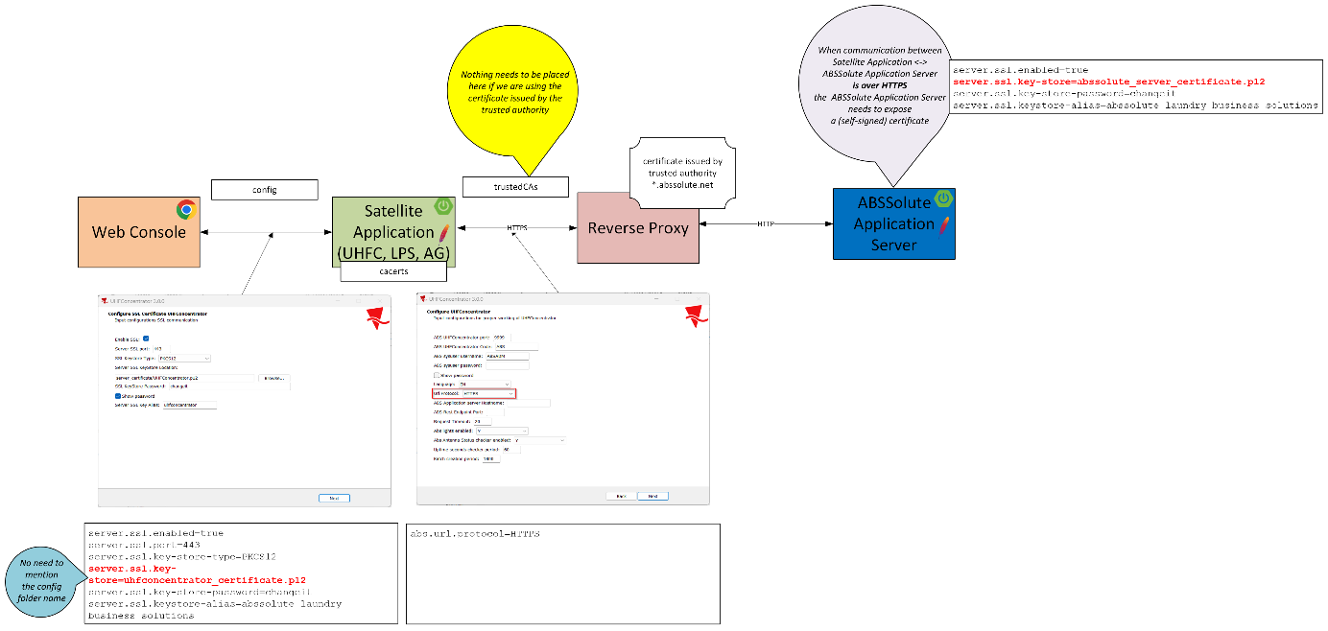
HTTPS Communication Setup for Hosted Environments (OCI)
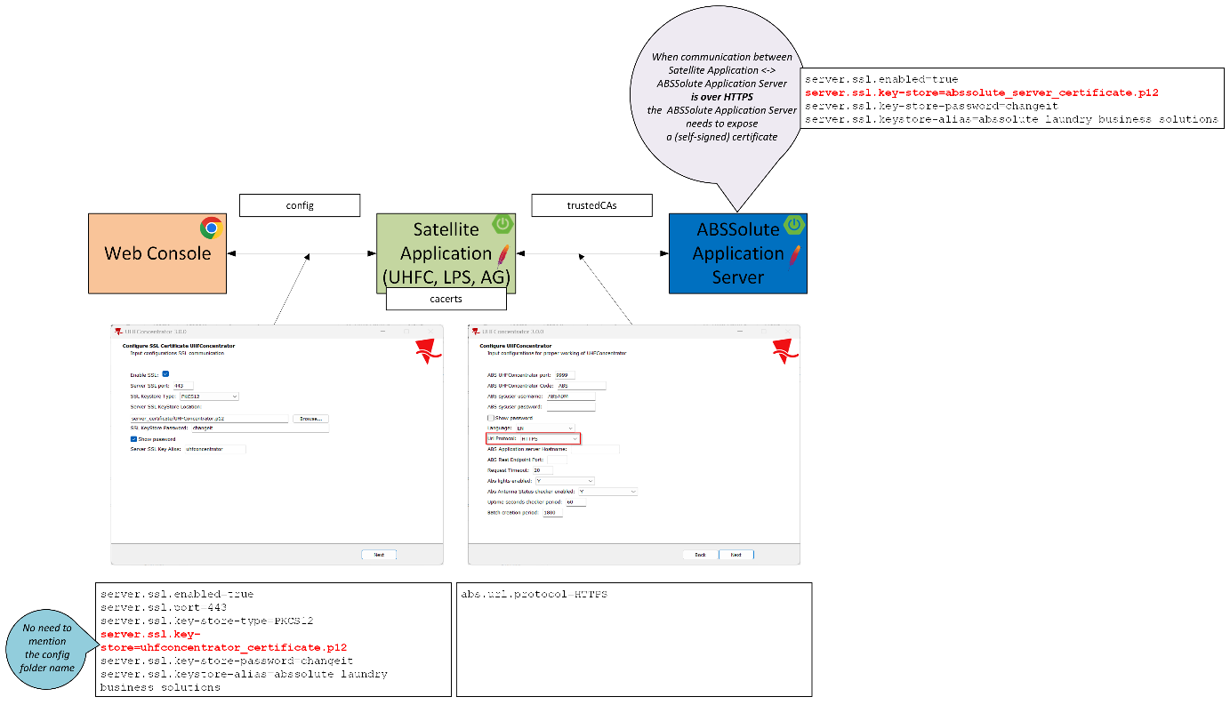
HTTPS Communication Setup for On-Premise Environments
Source: One Drive

Communication between UHFConcentrator and ABSSolute Server

Hosted Environments (OCI)
For the customers which have installations hosted on OCI, we can reuse the existing certificate which is already installed on the Reverse Proxy. This is a wild-card certificate which is issued by a trusted authority and is valid for all *.abssolute.net (sub-)domains, therefore it can be used for all of our customers.
The only thing that needs to be configured is the abs.url.protocol property in the application.properties file in the config folder of the UHFConcentrator which needs to be configured with value HTTPS.
abs.url.protocol=HTTPS
The abs.applicationserver.hostname will be configured with the address of the reverse proxy. Also, make sure that abs.applicationserver.restEndpoint.port is set to the correct value (default, 443).
The communication between the Reverse Proxy and the ABSSolute Application Server can be done through HTTP, since both entities are located in the DMZ.
In this situation, there are no changes that need to be performed in the trustedCAs folder of the UHFConcentrator, nor in the cacerts file of the Java installation that is used to launch UHFConcentrator.

If for any reasons, you need the ABSSolute Application Server to also communicate over HTTPS, please check section 1.4.1.2.1 in order to see how the certificate which is being exposed needs to be configured.

On-Premise Environments
For the customers which are hosting the ABSSolute application server themselves, on their own machines, we need to instruct them to purchase a certificate issued by a trusted authority, preferably valid on all sub-domains of the customers (wild-card certificates). This will ensure the certificate will work whenever the customer will require to re-use it for other installations of UHFConcentrator, which might be installed on other plants and communicating with other slots of the application server.
Since these certificates are valid for a limited amount of time (typically, one year), the customer needs to be informed to make sure that it is being refreshed on-time, to avoid the situation when the communication might not work because of an expired certificate.

Configuration on the ABSSolute Application Server
Typically, the certificate will be provided by the trusted authority in the .cer or .crt format.
Since the ABSSolute Application Server only supports the .p12 format, the TI team needs to export the certificate from the .cer/.crt format to .p12.
An extensive guide for the export of the certificate from the .cer/.crt format to .p12 is already available in Confluence. Make sure to also ask for the customer for the private key (in .key/.pem format), because this will be required during the export. Also, pay attention to the alias which is configured for the certificate because the same alias needs to be specified in the application.properties file of the application server.

Once the certificate has been exported to the .p12 format, it needs to be placed in the config folder of the Server installation (near to the application.properties configuration file).
The following changes need to be done in the application.properties file of the application server:
security.require-ssl=true
server.ssl.key-store=<certificate_file_name.p12>
For example,
server.ssl.key= abssolute_server_certificate.p12
Be aware that you only need to specify the name of the file without the folder it is placed in (because the config folder is implicitly considered to be the location of the certificate).
server.ssl.key-store-password=ENC(6U3JI3KnlL9lyKqYLWUHIO/fk+HY66uxlJY1FxhXGVGlpFI1UjZOYFm5)
The password needs to be the same one that was used when exporting the certificate to the PKCS12 format. It will be encrypted after the first time the ABSSolute application server is started. The default value is changeit.
server.ssl.key-alias=<certificate_alias>
The certificate alias needs to be mentioned only if the PKCS12 file contains multiple certificates. If there is only one certificate, it might remain commented. The alias, if any, needs to be the same one as when exporting the certificate.

Configuration on the UHFConcentrator
The only thing that needs to be configured is the abs.url.protocol property in the application.properties file in the config folder of the UHFConcentrator which needs to be configured with value HTTPS.
abs.url.protocol=HTTPS
The abs.applicationserver.hostname and the abs.applicationserver.restEndpoint.port will point to the installation of the ABSSolute Application Server.
There are no changes that need to be performed in the trustedCAs folder of the UHFConcentrator, nor in the cacerts file of the Java installation that is used to launch UHFConcentrator because the certificate has been used by a trusted authority.

Communication between UHFConcentrator and Web Console (Browser)
If the web console of the UHFConcentrator application needs to be accessed over a HTTPS connection, the UHFConcentrator has to expose a certificate issued by a trusted authority.
The easiest solution would be to reuse the certificate which has been installed on the ABSSolute application server.
The installation of the certificate on the UHFConcentrator will follow the same steps that are already described in section 1.4.1.2.1:
- the certificate needs to be in the PKCS12 format (.p12) and needs to be placed in the config folder of the UHFConcentrator;
- server.ssl.enabled=true
- server.ssl.port=443
- server.ssl.key-store=PKCS12
- server.ssl.key-store==<certificate_file_name.p12>
- server.ssl.key-store-password=changeit
- server.ssl.ley-alias=<certificate_alias>
In order to access the console over HTTPS, you don’t necessarily need to specify the port if it has the default value: https://<domain>/console is equivalent to https://<domain>:443/console or https://<domain>:443/.
Since the certificate is issued by a trusted authority, no further steps need to be performed, except for making sure the certificate is renewed before it expires and configured accordingly.

Technical Installation Consideration(s)
UHFConcentrator has an installer which is available for Windows operating system, providing the installation as a service.
For Linux, UHFConcentrator can be installed from the ZIP archive (although it is not typically installed on this operating system, since it should be placed on a workstation in the laundry).

Installation Steps
The deliverable for UHFConcentrator is either a ZIP archive or an executable that contains:
- The WAR file of the UHFConcentrator including the self-contained application server (Tomcat) – UHFConcentrator.war;
- A sample for configuring the application (see next section);
- Batch files for starting/stopping the application (both Windows/Linux);
- A sample certificate for the HTTPS configuration (when this is required to be done at the application level).

Configuration

Configuration in ABSSolute v9 Client

In order to install UHFConcentrator, you need to define a record in the UHFConcentrator dialog in the Swing Client with the appropriate code and then link workstations (with various RFID readers attached) to the previously created UHFConcentrator record.

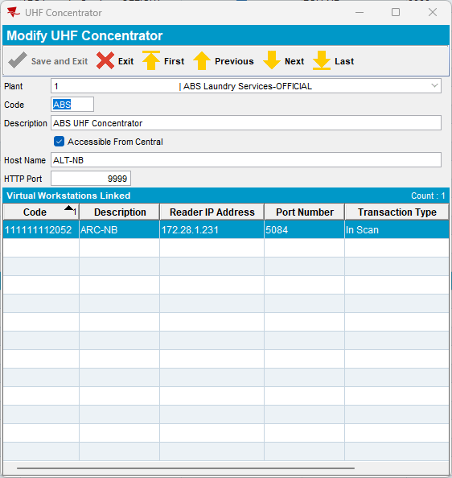

When defining the UHFConcentrator record, the Host Name and the HTTP Port will be left empty! They will be filled automatically once the UHFConcentrator application successfully connects to the application server.

Initially, the Virtual Workstations Linked table is left empty (it is not editable) and automatically fills when a workstation is linked to the UHFConcentrator record from the Workstation dialog > Tag Reading > Unattended Scan Station.
Also make sure that you check at least one transaction type that is going to be used for the scans made by the UHFConcentrator, for the products, for the containers or for both.

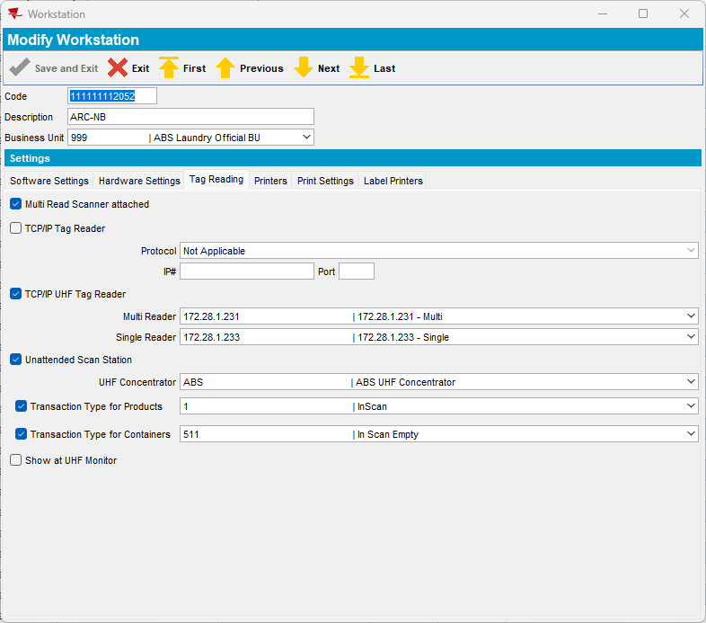

Installation & Configuration

In order to install the UHFConcentrator >= 3.0.0, you can use the provided installer, having the following name format UHFConcentrator-<major.minor.release>.exe.
(!) This installer may ony be used for the upgrade of versions greater of equal to 3.0.0. If you need to upgrade from versions 1.x or 2.x, please remove (uninstall) that version completely and proceed with a fresh installation.

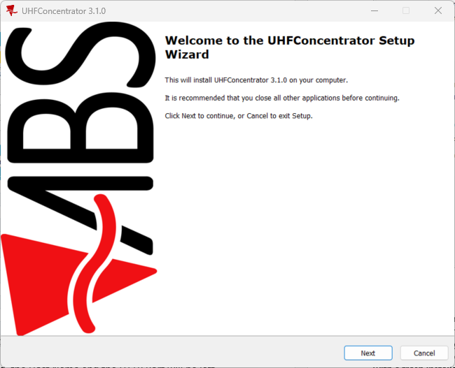

You need to select the type of the environment among 4 preselected options (Live, Test, FutureLive or Conversion).
This does not affect the installation except for the location name where it is going to be placed.

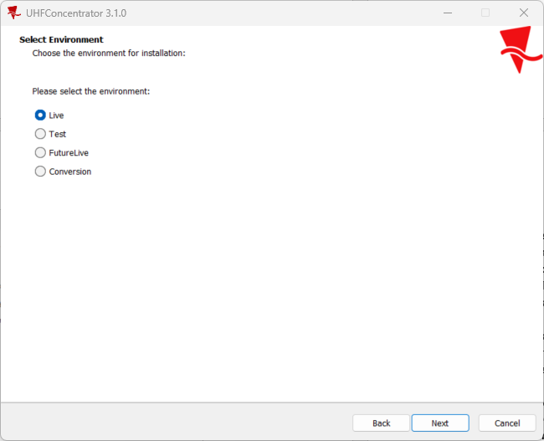
The location of the installation can be customized to a desired location. The installation type is added to the folder name.

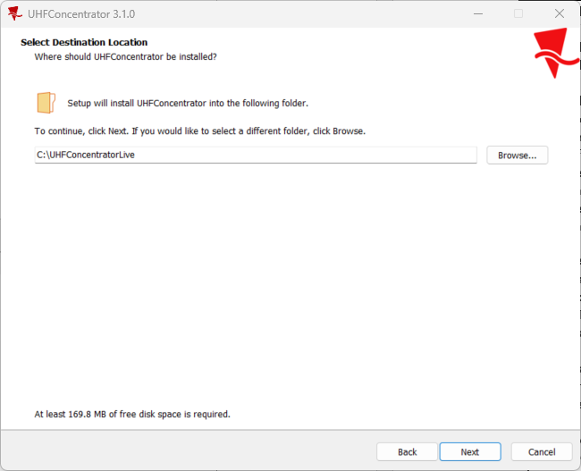

The files are copied to the previously specified location:

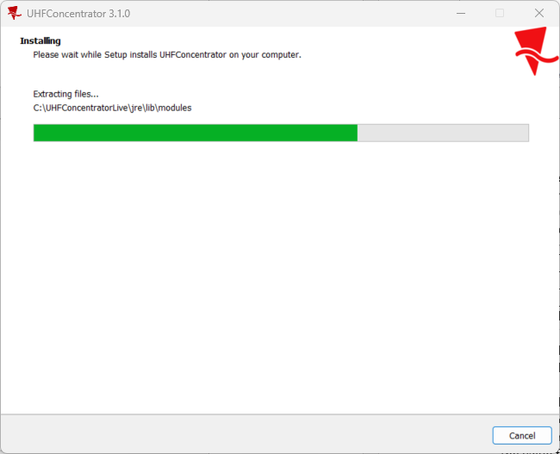
The next configuration screen refers to the HTTPS communication between the UHFConcentrator and the web console (browser). This is to say that you are going to configure this screen only if the web console of the UHFConcentrator is going to be accessed via HTTPS.

If the web console of the UHFConcentrator will be accessed via HTTP, leave the next screen as below:

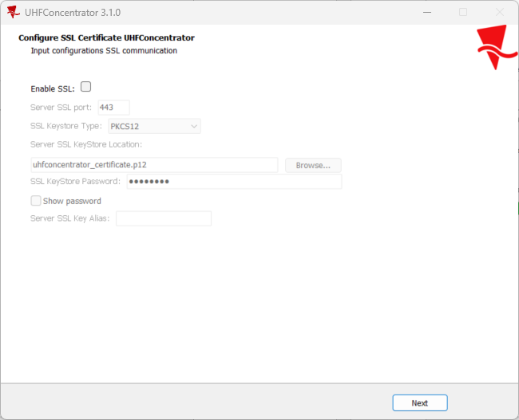

If the UHFConcentrator needs to expose a certificate (issued by a trusted authority):
- select the Enable SSL checkbox;
- specify a (free) port which will be used to access the web console of UHFConcentrator through the browser via HTTPS (or you can leave the default value of 443);
- select the certificate type (PKCS12 or JKS) – the certificate needs to be exported in .p12 format (see section 1.4.2);
- indicate the location where the certificate has been exported – it is going to be copied to the config folder of the UHFConcentrator installation;
- specify the password of the certificate (the default value is changeit);
- if there are multiple certificates enclosed in the .p12 file, you need to indicate the alias of the certificate that you want to expose; if the .p12 file only contains a single certificate, the alias section might be left empty.

The next screen contains the configuration of the UHFConcentrator:
- ABS UHFConcentrator port – is the port where the web console where the UHFConcentrator can be accessed over HTTP (if it is configured via HTTPS, it cannot be accessed through HTTP as well);
- ABS UHFConcentrator code – needs to have the same value as the one defined in the ABSSolute v9 client (so the configurations are taken from the ABSSolute application server);
- ABS sysuser username / ABS sysuser password – the credentials being used to communicate with the ABSSolute application server;
- Language – the language in which the web console of the UHFConcentrator is displayed;
- URL Protocol – the communication protocol between the UHFConcentrator and the ABSSolute Application Server; can be HTTP or HTTPS; pay attention to the fact that when selecting HTTPS, the ABSSolute Application Server must be preconfigured to communicate using this protocol (so it must expose a certificate);
- ABS Application server Hostname – the hostname of the ABSSolute application server; for the hosted environments (OCI), you can specify the name of the reverse proxy; hostnames are preferred to IP addresses, especially in the case where dynamic allocated IP addresses are used;
- ABS Rest Endpoint Port – the REST port where the ABSSolute application server accepts HTTP requests; make sure not to mistake it to the RMI port;
- Request Timeout – the duration (in seconds) the UHFConcentrator will wait for the response of HTTP requests made to the ABSSolute application server; if no response is received within this timeframe, the HTTP request is discarded;
- Abs lights enabled – configures whether the UHFConcentrator will indicate whether it is currently reading tags and the connection status to the ABSSolute application server through the GPIO lights; can have the Yes/No values;
- Abs Antenna Status checker enabled – configures whether the UHFConcentrator checks the status of the antennas attached to the readers, as they may be marked as disconnected due to a bug in the Impinj firmware; when an antenna appears to be disconnected, this information is displayed in the web console of the UHFConcentrator and the connection to the reader is rebooted;
- Uptime seconds checker period – the amount of time (in seconds) the UHFConcentrator checks whether the readers were disconnected from the network or rebooted; this requires a SSH connection to the readers;
- Batch creation period – the amount of time (in seconds) when a new batch of tags is created (typically 1800 seconds = 30 minutes).

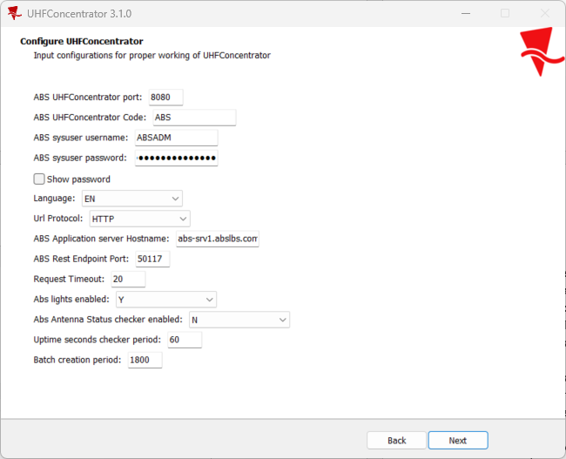
The JMX port is an available port on the operating system where a developer can connect using VisualVM in order to profile the application.

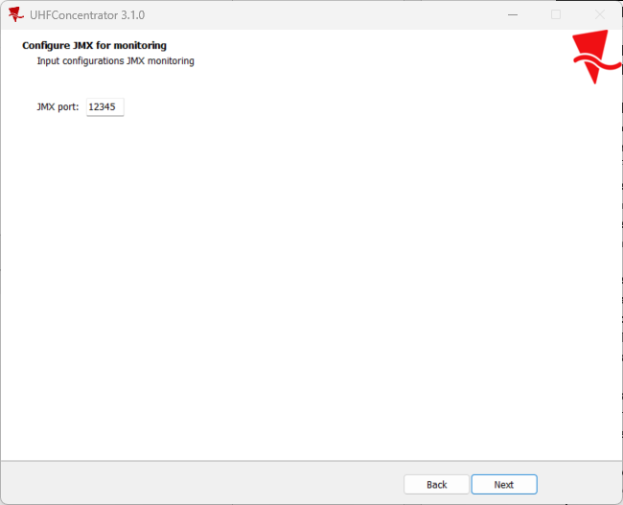

The next screen configures a user of the operating system that will own the UHFConcentrator service. It needs to have the full-admin rights to the location where the UHFConcentrator is installed because some of the files in that folder will be overridden. Also, it needs to have the permissions to run services.

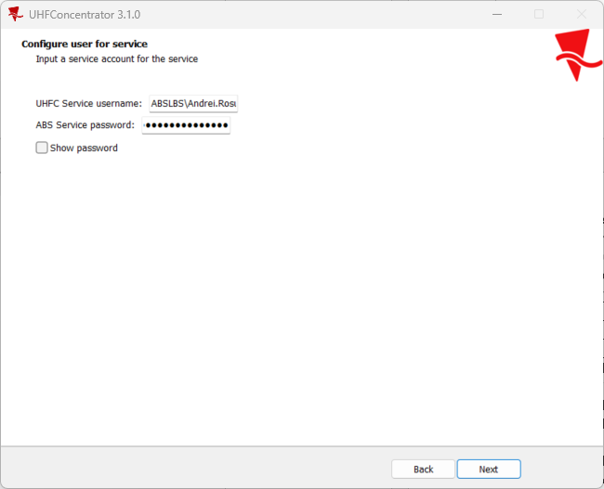
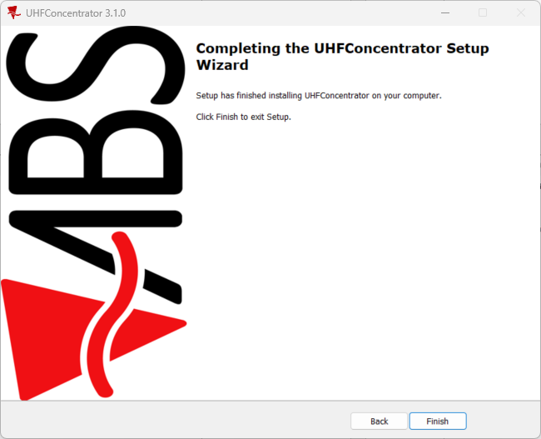

The configuration of the UHFConcentrator application is enclosed in the application.properties file that contains the following properties:
- server.port – the port where the UHFConcentrator web console will be accessible (e.g. 8080);
- server.ssl.enabled – indicates whether the UHFConcentrator web console will be accessed via HTTP or HTTPS
server.ssl.enabled | Protocol
true | HTTPS
false | HTTP
- server.ssl.key-store-type – indicates the suported type of the certificate (e.g. PKCS12) – TODO: to check the supported certificate types
- server.ssl.key-store – indicates the location where the certificate is stored
- server.ssl.key-store-password – indicates the password of the certificate file (e.g. default value in the enclosed certificate = changeit)
- server.ssl.key-alias – indicates the alias inside the certificate file (e.g. default value in the enclosed certificate = apigateway)
- abs.concentrator.code – indicated the code for the UHFConcentrator, must match the value from the Swing client, for the current plant;
- abs.sysuser.username – the name of the system user, which will be used to authenticate on the application server;
- abs.sysuser.password – the password of the system user, which will be used to authenticate on the application server; after UHFConcentrator is started, this field will be left empty and the password will be encrypted and placed in the abs.sysuser.encrypted.password (do not change this value!)
- abs.language – the language used for the web console of the UHFConcentrator;
- abs.url.protocol – the protocol used for communicating with the application server (either HTTP or HTTPS);
- abs.applicationserver.hostname – the name (or the IP address) of the machine where the ABSSolute application server is running;
- abs.applicationserver.restEndpoint.port – the HTTP port where the ABSSolute application server exposes its endpoints;
- abs.request.timeout – the amount of time after which an HTTP request to the ABSSolute application server is interrupted if it did not complete;
- abs.lights.enabled – controlls whether the GPIO functionality of UHFConcentrator is used or not;
- abs.antenna.status.checker.enabled – configures whether the status of the antennas is periodically checked and displayed on the web console (to make sure they are still operating);
- abs.uptime.seconds.checker.period – the amount of time (in seconds) the UHFConcentrator checks the UptimeSeconds property of the reader to verify whether it was disconnected from the network or rebooted;
- abs.batch.creation.period – the amount of time (in seconds) after which a new batch of tags will be created

Basic Checks after Installation

After installing the UHFConcentrator application and launching it you need to access the web console to check the status of the application and the attached readers.
The URL looks like <protocol>://<hostname>:<port>/console/ (e.g. http://localhost:8080/console/).
Also, you need to open the UHFConcentrator dialog in the v9 client to make sure the host name and port number have been updated accordingly and they have the correct values.

Troubleshooting

The logs of the UHFConcentrator application can be accessed:
- in the ABSSOLUTE database, in the ABSLOG table – this only happens when the MULTIREADDEBUGLEVEL system setting is set on 6 for the current plant – you need to filter for the records having source = ‘PACK_MULTIREAD’;
- on the local storage, at the location indicated by the appender.rolling.fileName property in the log4j2.properties file.

Logging

The logging is implemented via Log4j2 and can be configured in the log4j2.properties file to include more information when needed.

The logging level should be configured via the following properties, depending on the problem/package which is being investigated:
- logger.abs.name=INFO (problems related to the UHFConcentrator application itself);
- logger.llrp.name=INFO (problems related to the communication with the RFID readers over the LLRP protocol)
- logger.springframework.name=INFO (problems related to the Spring Framework).

Frequent Problems & Their Solutions

If the UHFConcentrator service fails to start:
1.2.1 please make sure there isn’t another application running on the same port as the one configured for UHFConcentrator; also check the user under which the service is running has the appropriate rights to execute services and over the folder where the UHFConcentrator is installed;
1.2.2 please make sure the credentials provided for the application server are correct and, if the communication is done over HTTPS, the certificates are correct.

If you are getting 404 Not Found when opening the web console of the UHFConcentrator, make sure there isn’t a “/” after “console” in the URL.
Valid examples of URLs are:
- http://<domain>:<port>/console
- http://<domain>:<port>/
- https://<domain>/console
- https://<domain>:443/console
- https://<domain>:443/

If the UHFConcentrator is not able to connect to the ABSSolute Application Server (you get an exception in the console / logs about a connection timeout), from the same machine where UHFConcentrator is installed, check any of the following links in the browser (or using CURL) for testing the connectivity with the application server:
- http://<AppServerHostname:ApplicationServerRESTPort>/monitoring/serverStatus
- http://<AppServerHostname:ApplicationServerRESTPort>/monitoring/webServerStatus
- http://<AppServerHostname:ApplicationServerRESTPort>/monitoring/dbConnectionStatus
- http://<AppServerHostname:ApplicationServerRESTPort>/monitoring/version
(if the ABSSolute Application Server is using HTTPS, please use this protocol instead)
If those link don’t return any result or time out, there is a connectivity problem with the ABSSolute Application Server that needs to be further investigated (configuration of REST HTTP endpoint of the ABSSolute Application Server, firewall issues).

